Section A: Concept Application
1. Explain how relational databases help maintain accuracy in expense records.
Ans. Reduces Data Duplication: User and category information is stored only once in separate tables, avoiding repeated and inconsistent data.
Maintains Data Integrity: Primary keys and foreign keys ensure that every expense is linked to a valid user and category, preventing invalid records.
Ensures Data Consistency: Changes made to user or category information are reflected wherever they are referenced, keeping the data accurate.
Supports Accurate Queries: Relationships between tables allow users to retrieve correct expense details using SQL joins.

2. Why are constraints important in personal finance data?
Ans. Constraints are important in personal finance data because they ensure the data is accurate, consistent, and reliable.
- Maintain Data Integrity: Constraints prevent invalid or incorrect data from being entered into the database.
- Prevent Duplicate Records: The UNIQUE constraint ensures that values such as email addresses are not duplicated.
- Ensure Required Data: The NOT NULL constraint makes sure important fields like amount, expense_date, and category_id are never left empty.
- Maintain Relationships: PRIMARY KEY and FOREIGN KEY constraints ensure that every expense is linked to a valid user and category.
- Validate Data: CHECK constraints can prevent invalid values, such as negative expense amounts.
- Improve Data Accuracy: Constraints help keep financial records correct and consistent, making reports and analysis more reliable.

3. How does GROUP BY help analyze spending patterns?
Ans. SELECT category_name, SUM(amount) AS total_expense
FROM expenses
INNER JOIN categories
ON expenses.category_id = categories.category_id
GROUP BY category_name;

4. Explain a scenario where rollback is required during expense entry.
Ans. START TRANSACTION;
INSERT INTO expenses (user_id, category_id, amount, expense_date)
VALUES (1, 2, 5000, '2026-06-29');
-- An error occurs here
ROLLBACK;
Suppose a user is entering a new expense of ₹5,000 under the Rent category. While saving the record, the system detects that the category_id is invalid or the database connection fails.

5. How do views help users track monthly expenses efficiently?
Ans. Simplifies Data Access: Users can view monthly expense reports without writing complex SQL queries.
Shows Monthly Spending: A view can display the total expenses for each month, making it easy to monitor spending. Improves Performance: Frequently used reports can be accessed quickly through a view.
Enhances Security: Users can access only the required data without direct access to the underlying tables.
Supports Better Financial Planning: Monthly summaries help users identify spending trends and manage their budgets effectively.
CREATE VIEW monthly_expenses AS
SELECT
MONTH(expense_date) AS month,
SUM(amount) AS total_expense
FROM expenses
GROUP BY MONTH(expense_date);

6. Why use triggers for automatic category or balance updates?
Ans. CREATE TRIGGER update_balance
AFTER INSERT ON expenses
FOR EACH ROW
UPDATE users
SET balance = balance - NEW.amount
WHERE user_id = NEW.user_id;
Automatic Updates: Triggers can automatically update the account balance or category totals whenever a new expense is added, updated, or deleted.
Maintains Data Consistency: They ensure that related tables remain synchronized without requiring manual updates. Reduces Human Errors: Since updates happen automatically, the chances of forgetting to update balances or totals are minimized.
Saves Time: Users and developers do not need to write extra SQL queries to update related data.
Improves Data Accuracy: Triggers ensure that financial records are always up to date after every transaction.

Section B: SQL Hands-On
- DDL understanding
Ans.
1.preventing “ orphaned ”data
2.ensuring data consistency(cascading action).
3.reliable data joins.
4.moving the logic to the database level.

If foreign keys are removed from the database schema, the system loses its ability to enforce data integrity automatically. The primary risk that emerges is the creation of Orphaned Records.
The Risk of Orphaned Records
When the foreign key constraint on user_id in the expenses table is removed, the database no longer verifies if an expense belongs to a valid user.
If a user account is deleted from the users table, any expenses previously associated with that user_id will remain entirely untouched in the expenses table.
This leads to several critical issues:
- Inaccurate Financial Reporting: Standard queries using INNER JOIN to calculate totals or display user expenses will completely omit these records because the corresponding user_id no longer exists in the users table.This results in missing financial data and distorted overall spending metrics.
- Wasted Storage & Data Pollution: The database accumulates "ghost" data—records that consume space but have no context, meaning, or owner.
- Application Errors: If the application attempts to fetch or display details for that specific expense, it will likely crash or throw errors when it tries to look up a user name or email that is missing from the system.

- DML operations answers:
  - insert 5 users name and emails
ans. 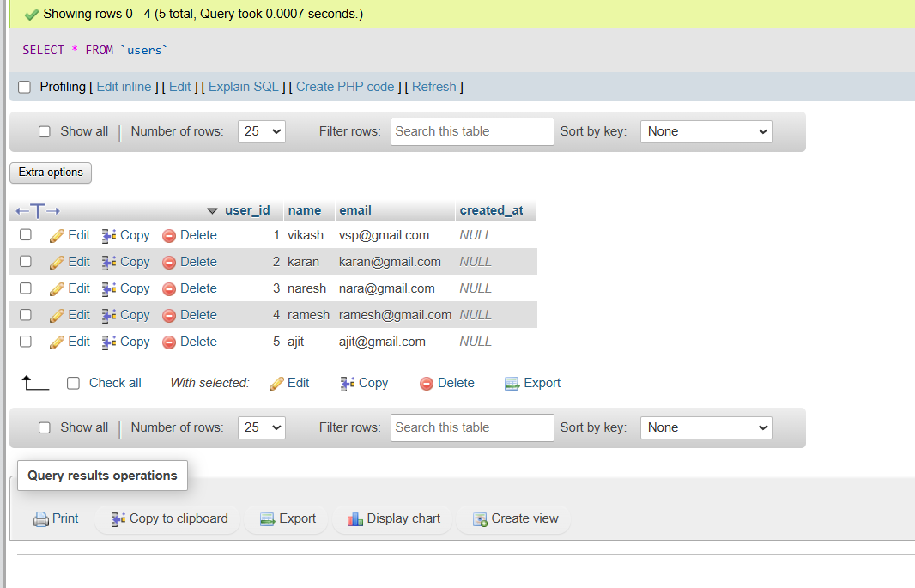
  - insert 3 categories.
Ans. 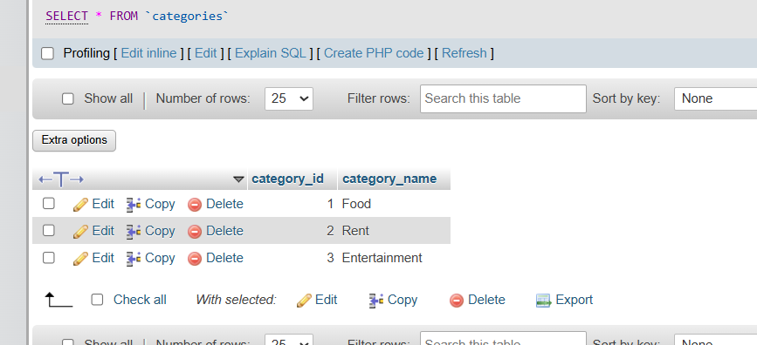
  - insert 10 expense record
ans. 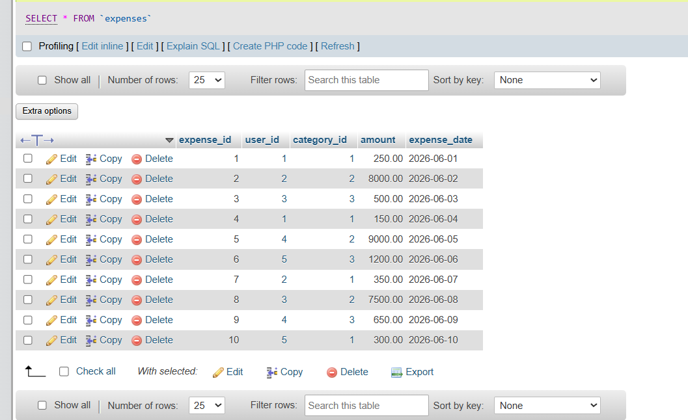
  - update query use

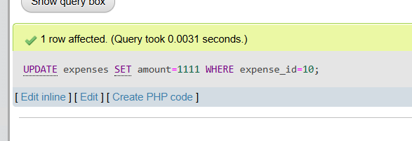
  - delete one expense
ans. 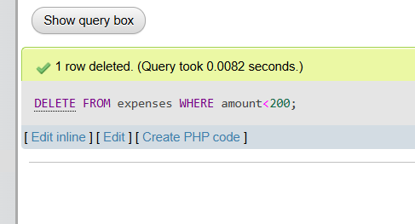

- data retrivals.
Ans. 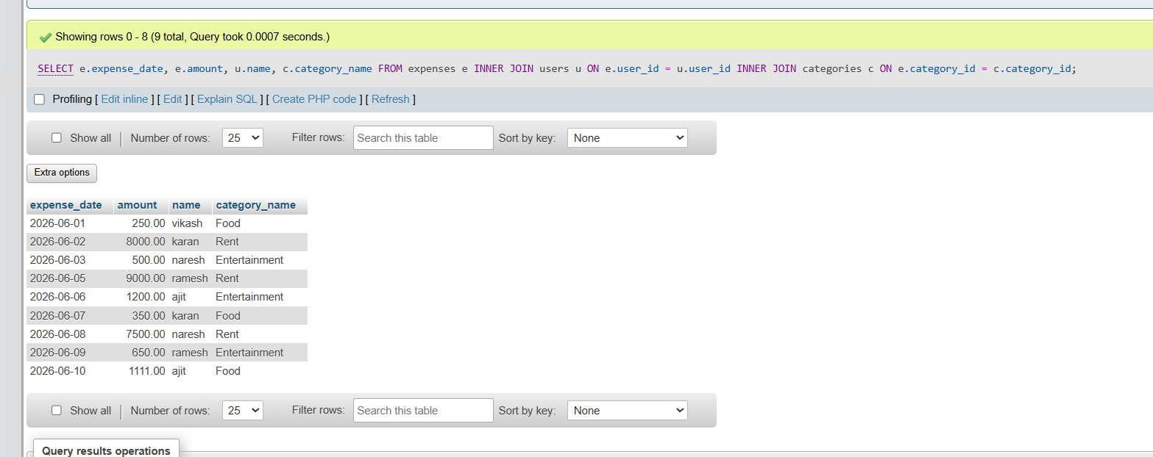
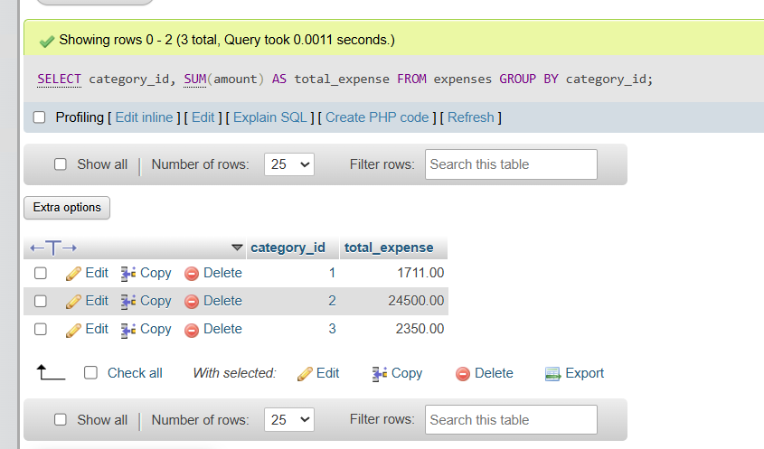

Section-c mini-Project
Crud program
- insert data
ans. 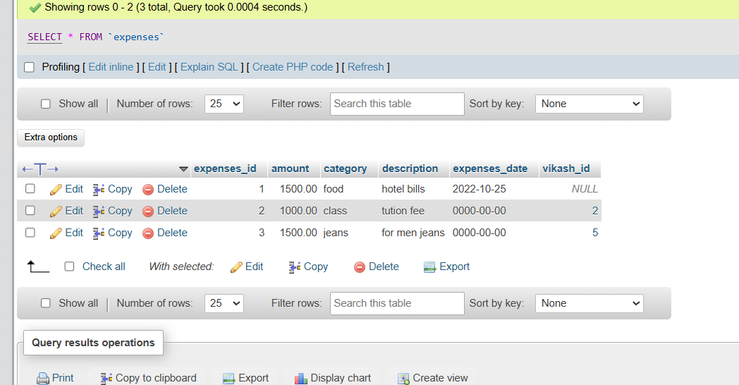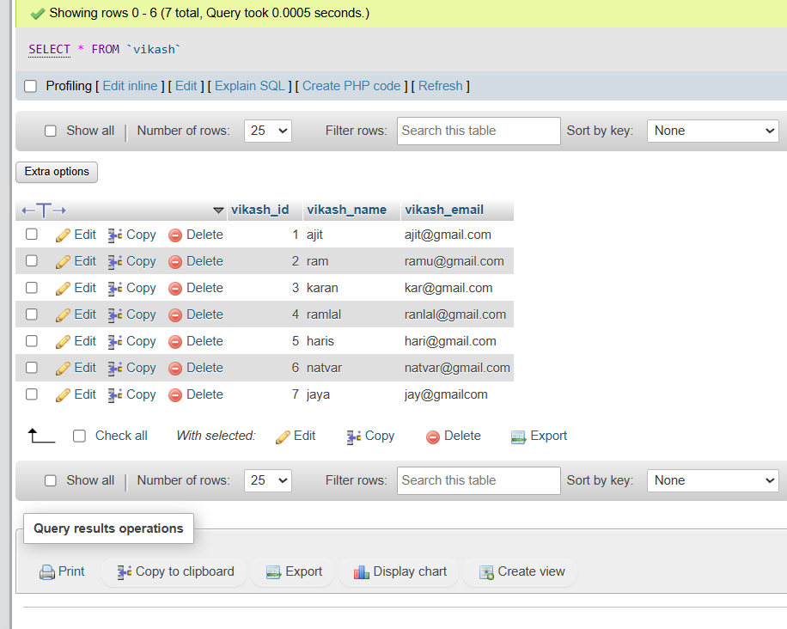

- update data for table.
Ans.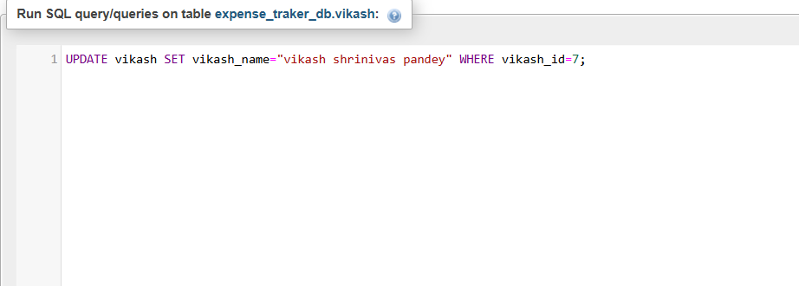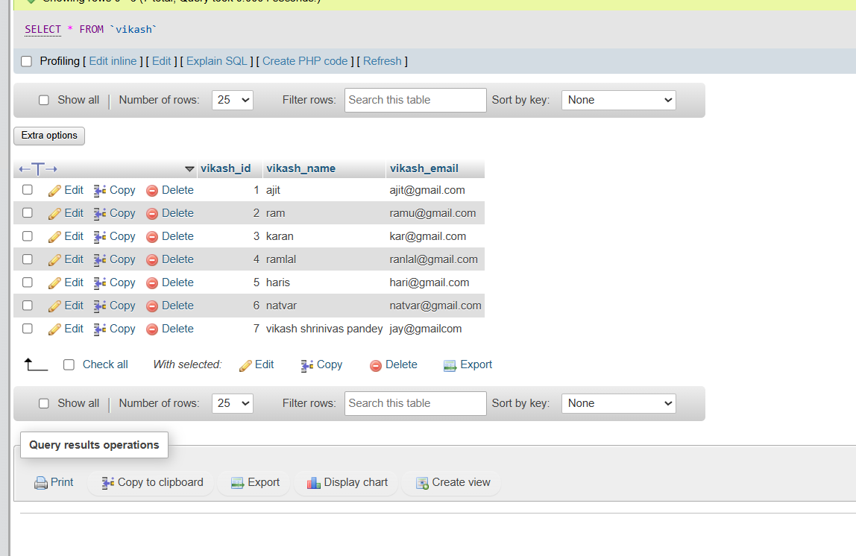

- delete data for a table.
Ans. 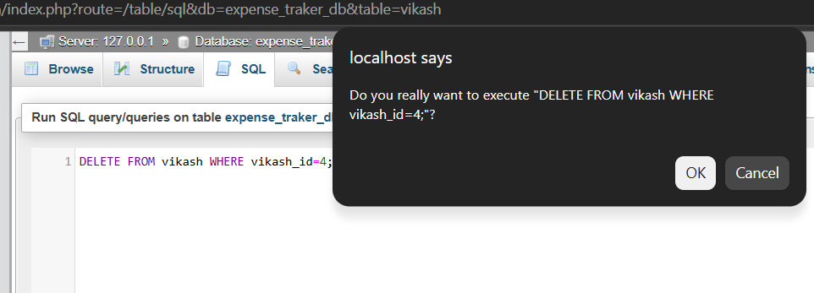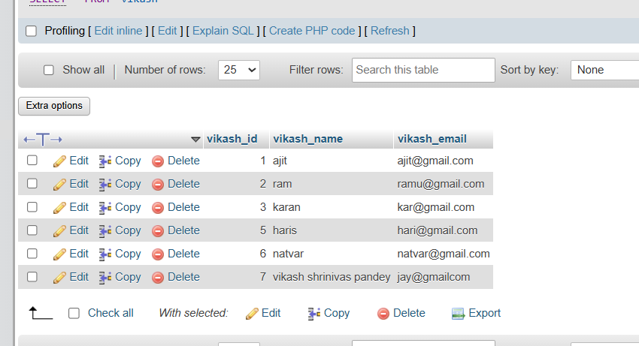

Write a store procedure to calculate monthly user expense:
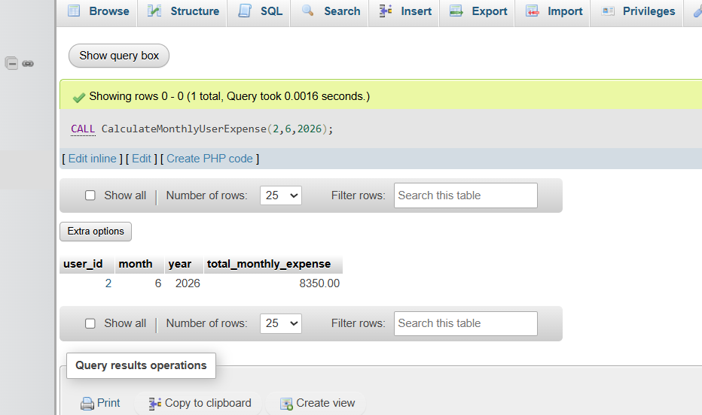

Commit and rollback
