Open VS Code and create a new folder called:

import_sfs3

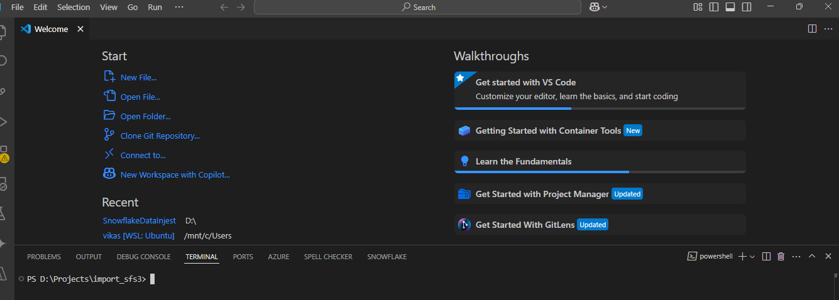

Inside VS Code terminal, initialize a virtual environment:

python -m venv venv

venv\Scripts\activate # On Windows

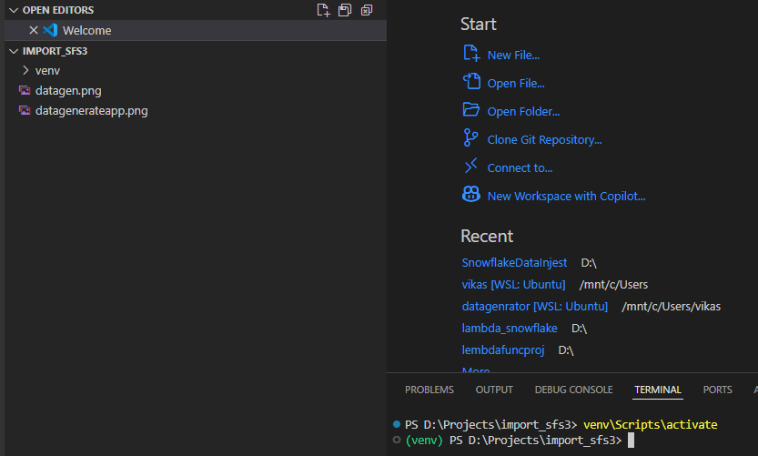

Create a file named requirements.txt in the root of your project folder with the following content:

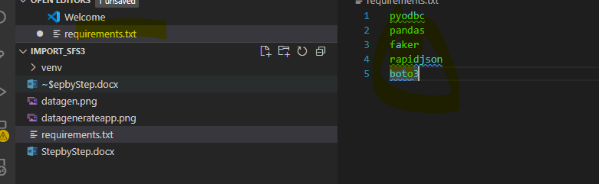

**Install all dependencies from it:**

**pip install -r requirements.txt**

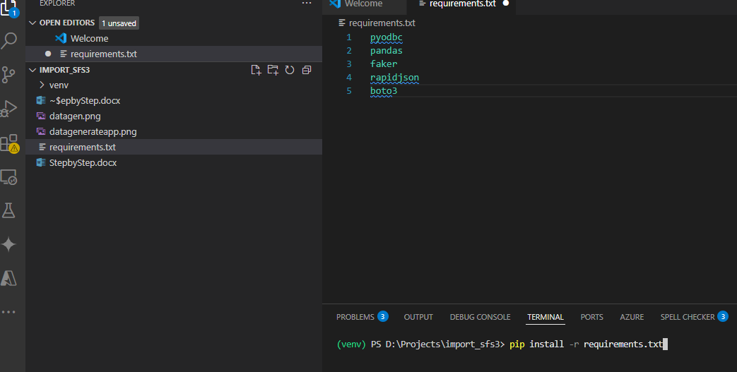

Create a python file **generatedata.py.**

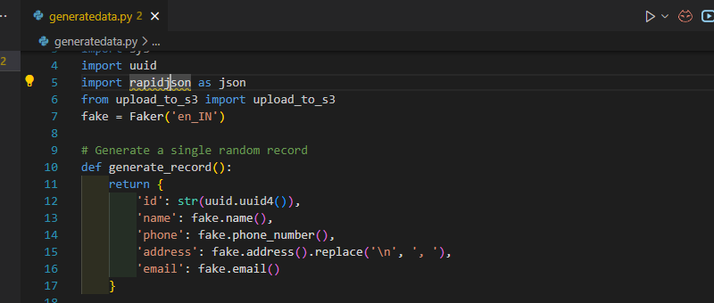

Create a python file **upload_to_s3.py**.

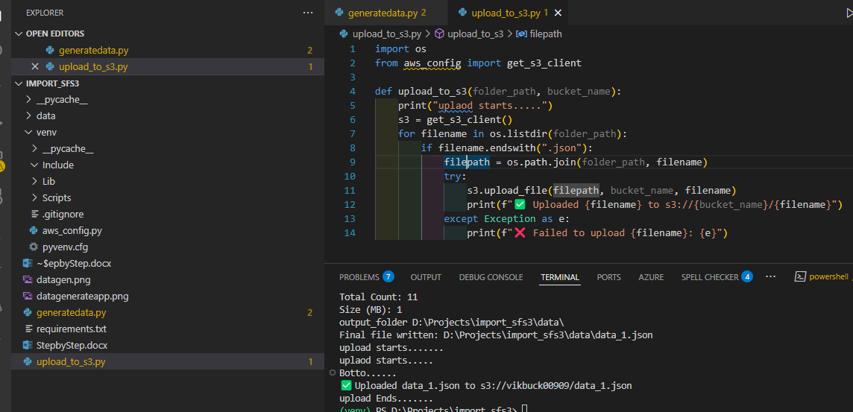

Create a python file **venv\aws_config.py**

The above **generatedata.py file will save data in local folder and upload the data in s3 buckets as per the below screen shots**

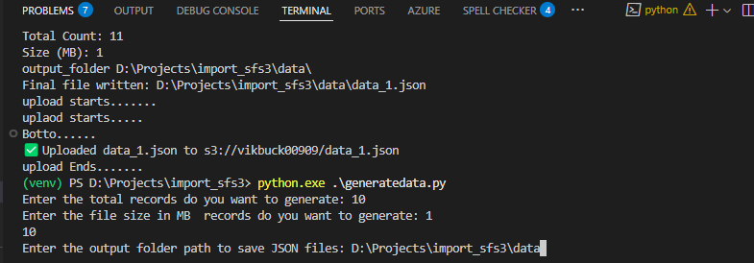

Enter the total records do you want to generate: 10

Enter the file size in MB, Do you want to generate: 1

Enter the output folder path to save JSON files: D:\Projects\import_sfs3\data

Once the files will be uploaded on S3 buckets lambda function will be trigger and save the data into snowflake data base.