# TypeScript

### **Null and undefined ─ Are they the same?**

*null and undefined are not the same*. A variable initialized with undefined means that the variable has no value or object assigned to it while null means that the variable has been set to an object whose value is undefined...

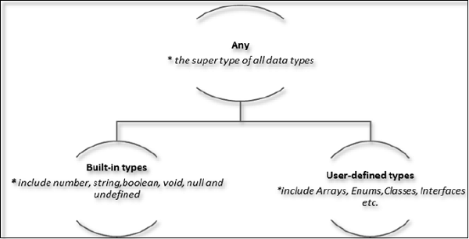

### **Null and undefined ─ Are they the same?**

# When you declare a variable, you have four options –

|  |  |
| --- | --- |
| S.No. | Variable Declaration Syntax & Description |
| 1. | var name:string = ”mary”  The variable stores a value of type string |
| 2. | var name:string;  The variable is a string variable. The variable’s value is set to undefined by default |
| 3. | var name = ”mary”  The variable’s type is inferred from the data type of the value. Here, the variable is of the type string |
| 4. | var name;  The variable’s data type is any. Its value is set to undefined by default. |

Type Change:

var str = '1'

var str2:number = <number> <any> str //str is now of type number

console.log(typeof(str2))

## **Inferred Typing in TypeScript**

var num = 2; // data type inferred as number

console.log("value of num "+num);

num = "12";

console.log(num);

* The code declares a variable and sets its value to 2. Note that the variable declaration doesn’t specify the data type. Hence, the program uses inferred typing to determine the data type of the variable, i.e., it assigns the type of the first value that the variable is set to. In this case, **num** is set to the type number.
* When the code tries to set the variable’s value to string. The compiler throws an error as the variable’s type is already set to number

## **TypeScript Function**

Optional parameter : A parameter can be marked optional by appending a question mark to its name. The optional parameter should be set as the last argument in a function.

### **Example: Optional Parameters**

function disp_details(id:number,name:string,mail_id?:string) {

console.log("ID:", id);

console.log("Name",name);

if(mail_id!=undefined)

console.log("Email Id",mail_id);

}

disp_details(123,"John");

disp_details(111,"mary","mary@xyz.com");

## **Rest Parameters**

Rest parameters are similar to variable arguments in Java.

### **Example: Rest Parameters**

function addNumbers(...nums:number[]) {

var i;

var sum:number = 0;

for(i = 0;i<nums.length;i++) {

sum = sum + nums[i];

}

console.log("sum of the numbers",sum)

}

addNumbers(1,2,3)

addNumbers(10,10,10,10,10)

## **Default Parameters**

Function parameters can also be assigned values by default. However, such parameters can also be explicitly passed values.

function calculate_discount(price:number,rate:number = 0.50) {

var discount = price * rate;

console.log("Discount Amount: ",discount);

}

calculate_discount(1000)

calculate_discount(1000,0.30)