Photoshop

1. Text operations

* For Insert text on layer click on  icon.
* For movement of inserted text click on move tool .
* Then edit text font and fount style click on  icon again then select the entire text or text you want to change the format and style. After selecting text a window roller will appear on the top near tool bar. Like below



If select pixel will not appear the follow the below steps:

Click on move tool(De select the Text) then Edit -> preferences -> General -> Units & Rulers -> set Rulers and type as pixels.

* For performing advance operations upon Text on right side there should one icon  (Character) should be visible. If not visible then

Windows -> character (should be clicked).

Now click on  the following sub window will appear:

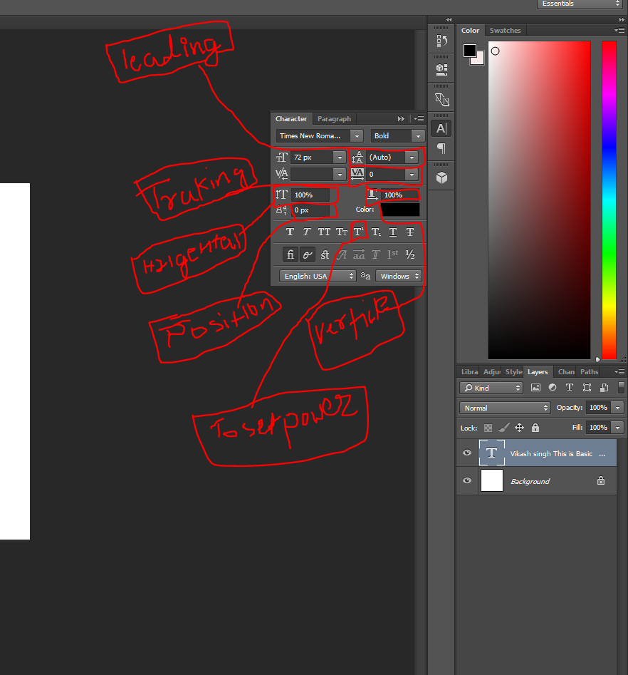

Leading -> Is used for manage the space between two lines.

Tracking -> Is used to manage the space between the two character.

Horizontal -> Is used to increase the size of word horizontally.

Vertical -> Is used to increase the size of word vertically.

Position -> To set the position of word between multiple lines.

Color -> Is used to Set the color of Text.

1. Layer

If Layer option is not showing then go to windows -> layer.

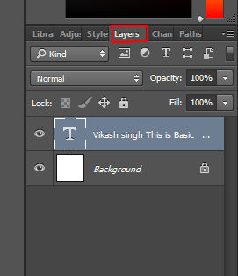

* What is layer – Photoshop document is bundle of multiple layers.
* If we want to any layer to come to top then then drag that later to top.
* If we want to hide of show any layer the click on  .
* If we want to move only selected layer then “Auto select” option should be unselected. If we want to move all the layers then select the “Auto select” option.

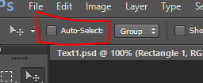

* If we want to move the background layer then we will have to unlock the background.
* We can lock any layer using  icon on top.
* We can copy the layer by using Ctrl+j
* **Layer Group**

Is used to group the similar type of layer. We can give it proper name and so we can manage the big files.

For making group press Ctrl+click Then click on  icon on below roller.

We can rename this folder by using double click.

1. Shapes

* We can use different shapes using

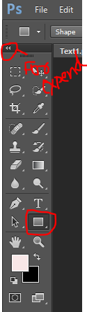Just write click on icon below Text icon we will get all the shapes options.

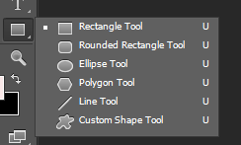 For expand these all icons click >> which marked red in above image.

* For filling color in the shapes just select fill option from top of roller.



But we will have to click on . We can increase of decrease the strokes pixels. Strokes means just border. Similarly there are lots of options for shapes on above strip.

* For alter the rounded edges we will have to modify the pixels. If we want to edit the single edge then we will have to use lock  then shape will give different look.

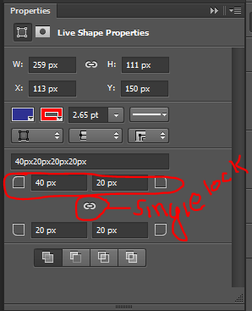

* If we want to draw the circle the use shift + drag button means use shift + drag for drawing the circle.
* For draw line use line tool + shift.
* We can draw custom shape using option available option at same place.
* For reshaping the shapes we can use ctrl+T.

1. Eye dropper tool and Crop Tool

Eye drop tool is used for select the color of any color present on any image.

For getting the actual color hascode of any image just select the color using Eye drop tool and then click on  we will get the actual color hascode .

When we right click on eye dropper tool then we will get other options as well later we will talk about it.

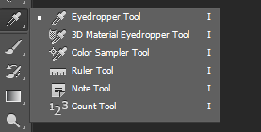

* Crop tool is use to crop image.

Undo -> ctrl +z.

Redo -> ctrl+shift+z

1. Brush

 is used for brushing, pencil and other option brushes when we right click on brush icon.



1. Gradient Tool 

This tool is used for blending of colors. We can directly click on gradient tool or we can simply go there by pressing g.

We can customise gradient using different operations present in below riven.



1. Clipping mask

Clipping mask is amazing feature of photoshop.

We can create standard images inside a square frame or other frames we can create amazing text like:



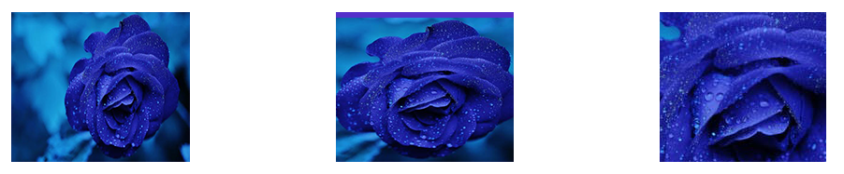

For using clipping mask we just need to draw text shape or whatever we want then copy one image on same page and then keep the image layer just on top of row shape then go to tool bar and then select Layer -> create clipping mask/ Release clipping mask or can simply use Ctrl+alt+g.

1. Selection Tool

For use of selection tool click on  it has different options like then we can click on blow ribbon to select plus or – icons to select the entire shapes of any image.



After click and hold of left click on  we will get following options for selection tool.

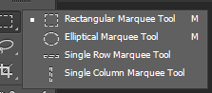

We can use all the options accordingly.

Note :

1. Recommended is to select after zoom the image.
2. For remove the any selection it could be Lasso or other Lasso tool just use ctrl+d .
3. Lasso , Polygon Lasso , Magnetic Lasso Tool

These are different option of selection tool.

Lasso tool icon is  This is fastest way to select the shape. When we right click on Lasso tool the we will get different options like polygon lasso and Magnetic lasso tool.

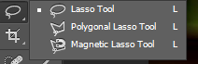

1. Polygon lasso tool is the best way for selection the image .

We just need to click on selection are and select if we are not satisfied with selection the using back we can go back.

1. Magnate Lasso tool is also used for selection purpose. We just need to follow the path and move forward if not satisfied then click back space.
2. Quick selection tool & Magic bind tool

These selection tools are used mainly these tools are used for quick selection for the shape of image. We can get these by clicking on



In Quick selection tool we can increase or decrease the brush size for selection if selection went wrong then we can select then we can use negative selection present in ribbon that is properties below the tool bar.

Magic bind tool is the quickest way of selection if image contains not much buzzy colors then we just need to click on image and select if this tool not select properly then again click on the deselected area it will get selected.

1. Drop shadow

For using drop shadow use just double click on Layer on which you want to apply drop shadow.

Then one window will appear then tick on drop shadow then press ok. Then again double click on drop shadow which came below layer.



Now manipulate the shadow accordingly.



1. Outer glow and pattern overlay

These option will come in same way as drop shadow came. We will have to follow the same steps then manipulate these options.

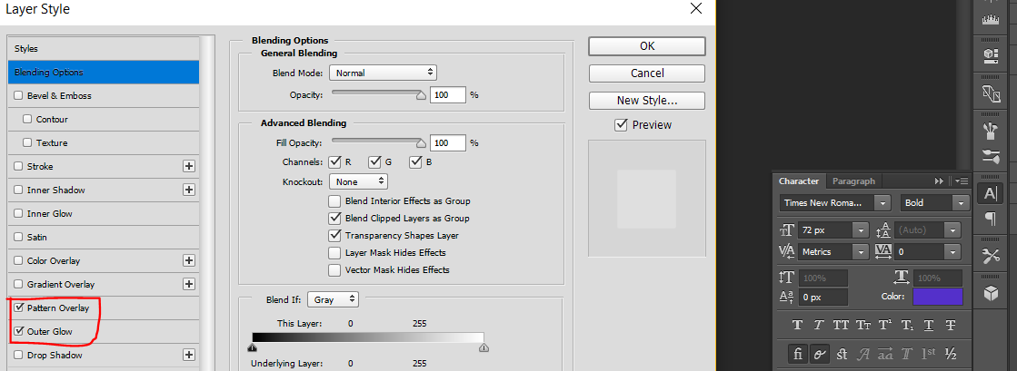

Then follow the same steps as we did for drop shadow.

We can copy this method by just copy the effects below the layer and then just paste that on Layer on which you want to apply the same effects.

1. Gradient Overlay & Color Overlay

We can get this option as we did for pattern overly and others as we can see in above image then we can manage the these both overlay using different options.

Color overly is very-very important for web designing tool since using this we change the color of icon easy.

So,

Q. How we can change the color the icons?

Answer – Using Color overlay.