STEP 1.   
  
set property file for vaccination start and end time

And email configuration through *application.properties* file.

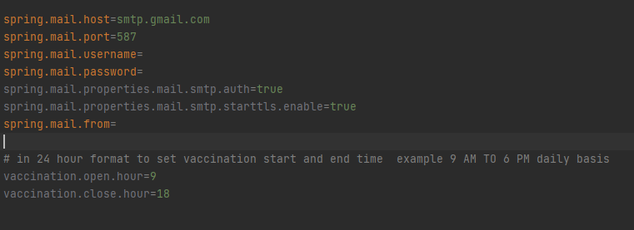

Step 2 . Run application .  
  
java -jar -Dspring.config.location={location to property file} covidvac-0.0.1-SNAPSHOT.jar

java -jar -Dspring.config.location=D:\vikash_\application.properties covidvac-0.0.1-SNAPSHOT.jar

Step 3 . Add branches through All Branch menu   
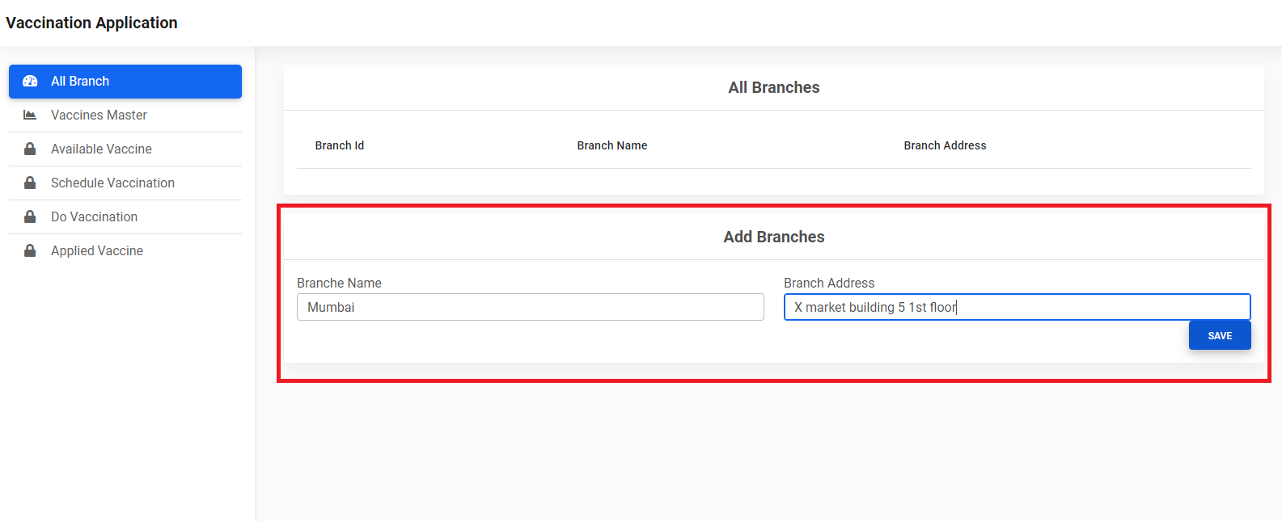

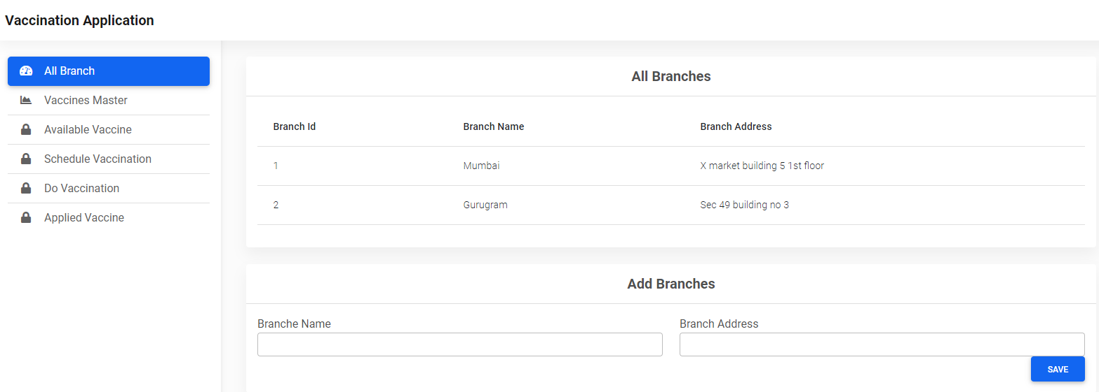

Step 4. Add Vaccines Through vaccine master   
Same as Branches

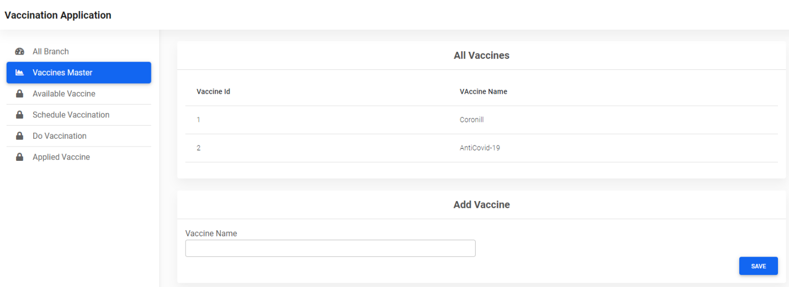

Step 5. Mentain Vaccine Stock branch wise .  
 just provide Id of branch and vaccine and total quantity of vaccine

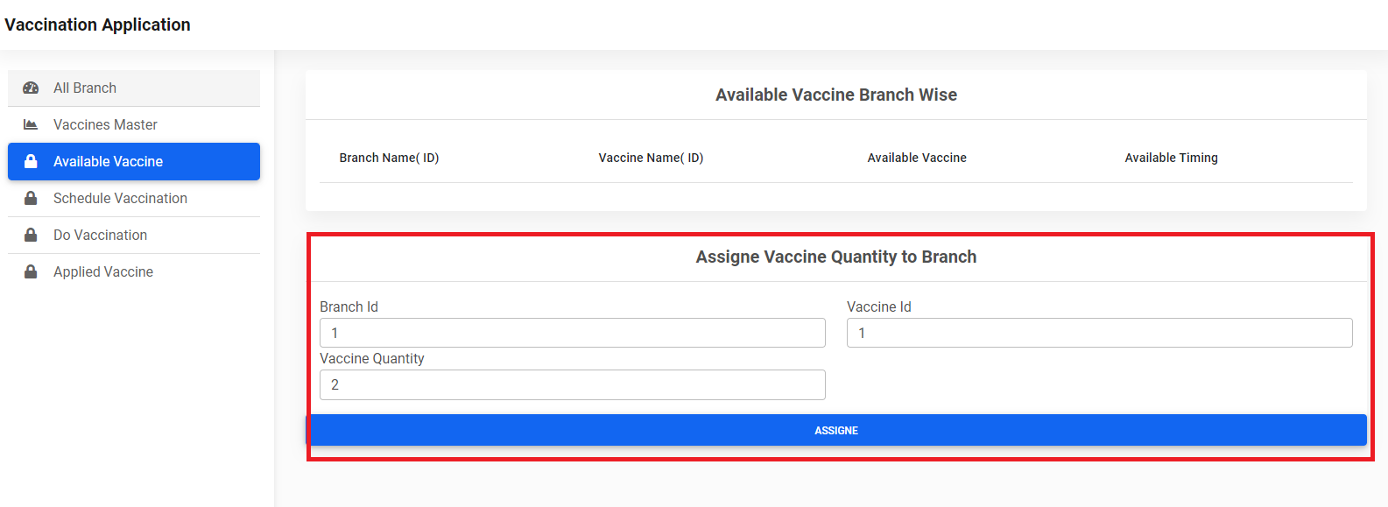

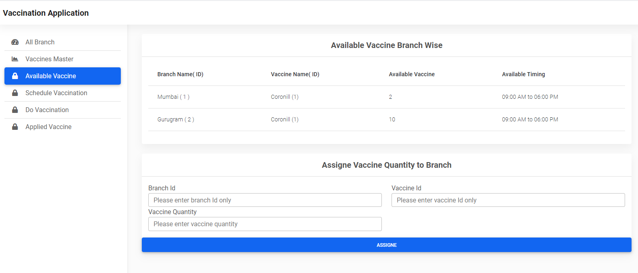

Step 6. Schedule Vaccination

You will get alert msg respectively if   
  
vaccine does not available   
time slot not available  
Already Scheduled for vaccination as per email id   
  
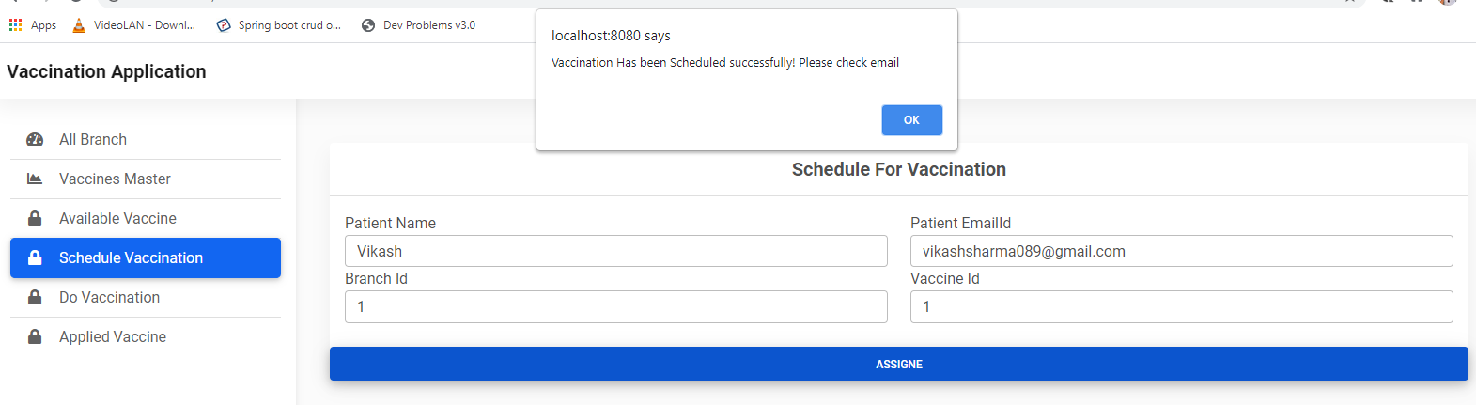

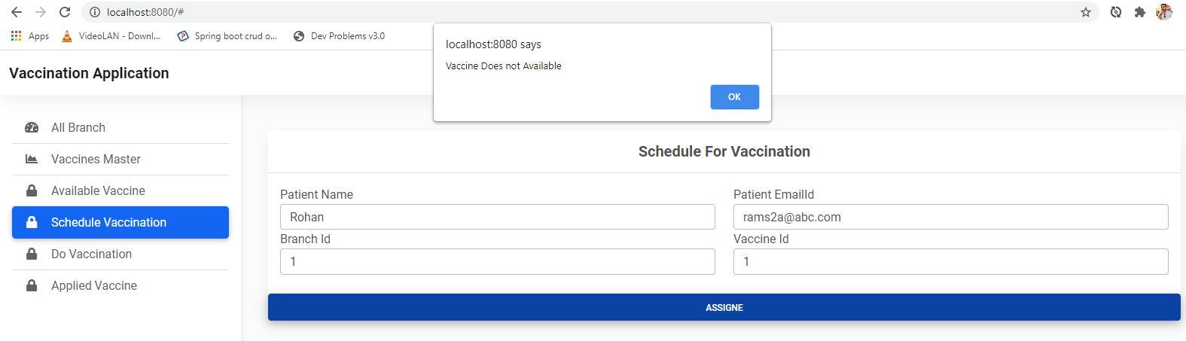

Avail able timing and vaccine would reflect on behalf of scheduling 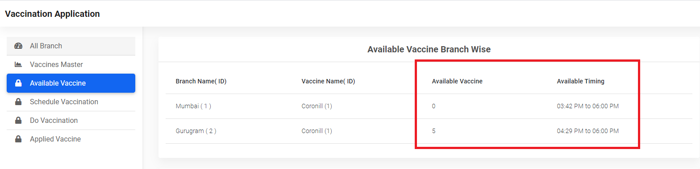

Step 7. Do vaccination   
where all scheduled vaccination will be listed sorted by timing  
  
just provide branch id and click on vaccinate . (follow first come first served )  
it will marked and vaccinated as per branch wise remove record

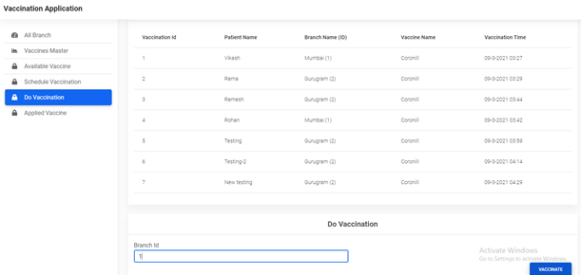

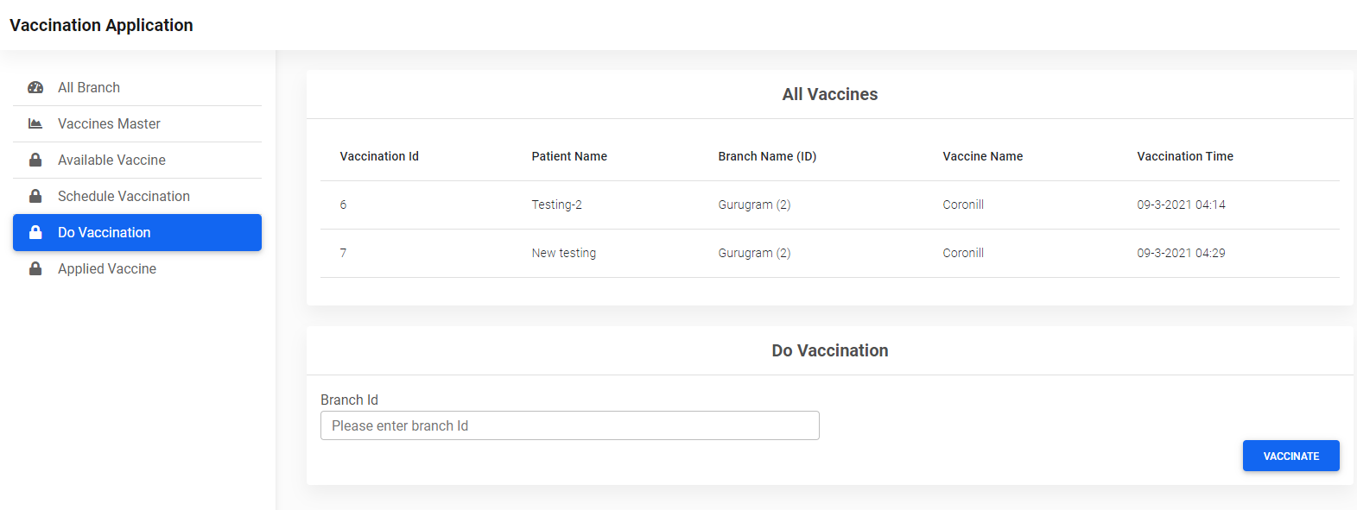

Step 8 . Applied vaccine will show you report   
