ECS Project :
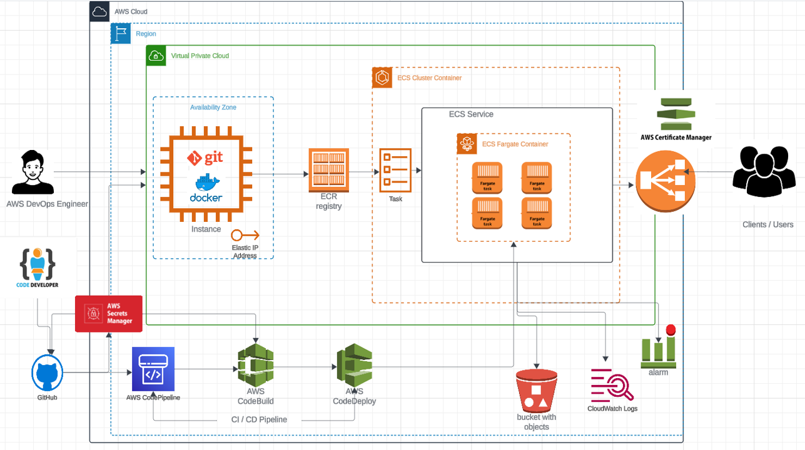

EC2:
Launch a EC2 :
Install git docker : -- yum install git docker -y
start docker : -- service start docker
git clone https://github.com/vikashsuman23/website.git
go inside website which is cloned in EC2 machine
Build Image : -- docker build -t website:latest .
In AWS ECR :
Go to ECR create repository websitecreate
Before pushing to ECR the image create a role (TI :EC2 Permission : ecr/admin) and attach it to EC2.
Select website repository in ECS and click on view push commands
Execute all commands in EC2 machine : latest image will be there inside website repo.

In AWS ECS:
Go to ECS
Create Cluster
Cluster name : websiteclusterv1
Infrastructure : Fargate only
Click :create
Task Definition
Create new task definition
Task definition family : website-task-df-v1
Launch type : AWS Fargate
Task Size : CPU : .25vCPU Memory : .5GB
Task role : select the role
Container -1
Name : website
Image URI : Browse ECR image ( choose repo ,select image) or (from ECR use website URI)
Click on Create

Create Service ( including Task)
Go to Cluster
Click on service
Create service :
Task Definition family : website-task-df-v1
Service name : website-service
Compute option : launch type –FARGATE—LATEST
Deployment Configuration – Replica
Desired Tasks: 2
Availability zone rebalancing: uncheck
Networking : delete subnet 1c
Load balancing: use load balancing
Load balancer name : myecsalb
TG name : ECSTG
Service auto scaling : use service auto scaling
Min Task : 2 Max Task: 4
Scaling policy Type : Target Tracking
Policy name : Sample
ECS service metric : ECSServiceAvergaeCPUUtilization
Target value : 70
Create
Go to ALB and browse dns name

Buil Automated CI/CD pipeline on AWS
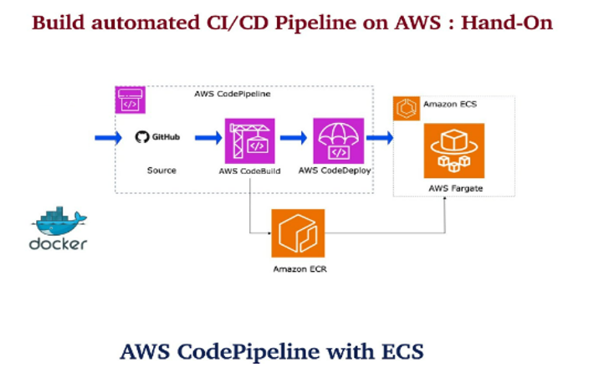
In AWS go to codepipeline
Setting --Connections create connection—GitHub—connection name : ecsconnection —connect to github—install new app --AWS connector for Github—Repository access –All Repositories—save –connect

Code -Build – Build project – create project –project name -website – source -Github – select website repository
Webhook event filter groups --Event type – push
Service role : ( After creation of Build give immediately admin permissions to below role )
Role name : codebuild-website-service role-23
Buildspec : use buildspec file : buildspec.yml
Create
Note : Give admin access to role and start build.

Pipelines : Create Pipeline – build custom pipeline – pipeline name : website ,
Role name: AWSCodePipelineServiceRole-ap-south-1-website ( give admin permission immediate after pipeline create)
Source provider: Github
Select connection: ecsconnection
Repository name : website
Branch :master
Webhook events : push
Start pipelines under these conditions : filter branch :master

Builds – other build provider – AWS code build
Project name : website
Deploy : Amazon ECS
Clustername : websiteclusterv1
Servicename : websiteservice
Imagedefination file : imagedefinitions.json
Create pipeline
Give admin permission to role

For Free Tier clean up steps :

🟥 STEP 1: STOP & DELETE CODEPIPELINE (Highest Cost Risk)
Services involved: CodePipeline, CodeBuild
1. Delete CodePipeline
- Go to AWS Console → CodePipeline
- Select pipeline website
- Click Delete
- Type pipeline name → Confirm
✅ This stops auto builds & deployments.

2. Delete CodeBuild Project
- Go to CodeBuild
- Select project website
- Click Delete build project
- Confirm

3. Delete CodePipeline & CodeBuild IAM Roles
Go to IAM → Roles and delete:
- AWSCodePipelineServiceRole-ap-south-1-website
- codebuild-website-service-role-23
⚠️ Detach policies first, then delete role.

🟥 STEP 2: DELETE ECS SERVICE & TASKS
ECS services keep running → continuous billing
1. Scale ECS Service to ZERO
- Go to ECS → Clusters → websiteclusterv1
- Click Services → website-service
- Click Update
- Set Desired tasks = 0
- Save
Wait until RUNNING tasks = 0

2. Delete ECS Service
- Select website-service
- Click Delete
- Type delete
- Confirm

3. Deregister Task Definition
- ECS → Task Definitions
- Select website-task-df-v1
- Select all revisions
- Deregister

🟥 STEP 3: DELETE ECS CLUSTER
- ECS → Clusters
- Select websiteclusterv1
- Click Delete cluster
- Confirm

🟥 STEP 4: DELETE LOAD BALANCER (VERY IMPORTANT 💰)
ALB costs money even if idle.
1. Delete ALB
- EC2 → Load Balancers
- Select myecsalb
- Click Delete
- Confirm

2. Delete Target Group
- EC2 → Target Groups
- Select ECSTG
- Delete

🟥 STEP 5: DELETE ECR (Docker Images)
Docker images consume storage = cost
- Go to ECR
- Select repository website
- Click Delete
- Enable Force delete
- Confirm

🟥 STEP 6: TERMINATE EC2 INSTANCE
- EC2 → Instances
- Select your EC2
- Instance State → Terminate
- Confirm

🟥 STEP 7: DELETE EC2 IAM ROLE
- IAM → Roles
- Delete role attached to EC2
(ECR Admin role)

🟥 STEP 8: DELETE SECURITY GROUPS (If Not Used)
- EC2 → Security Groups
- Delete:
  - ALB SG
  - ECS Service SG
  - Custom SG (if unused)
⚠️ Default SG cannot be deleted (ignore)

🟥 STEP 9: CHECK CLOUDWATCH LOGS
CloudWatch logs can silently cost money.
- CloudWatch → Log groups
- Delete:
  - /ecs/website
  - /aws/codebuild/website
  - Any ECS / CodeBuild related logs

