Tutorial 4

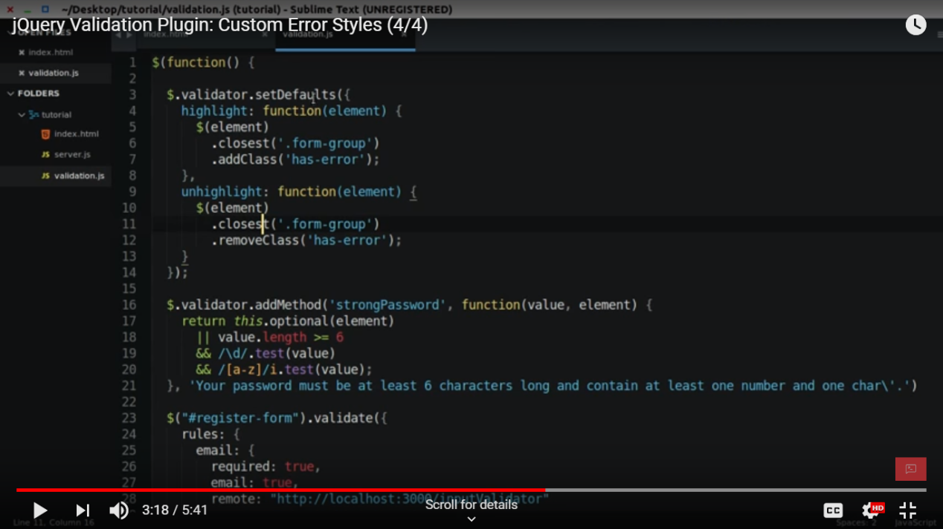

Now it will change the color of the error to red .

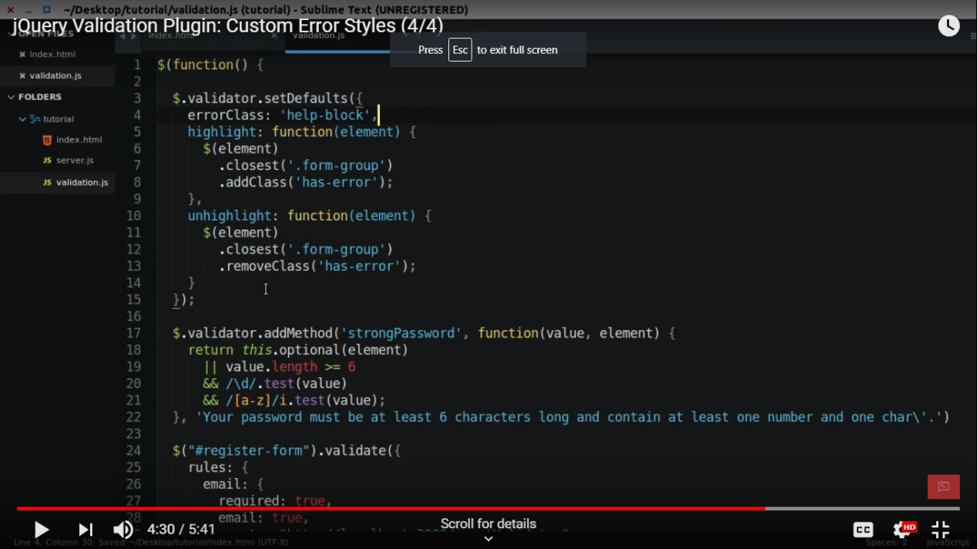

Now for the checkbox

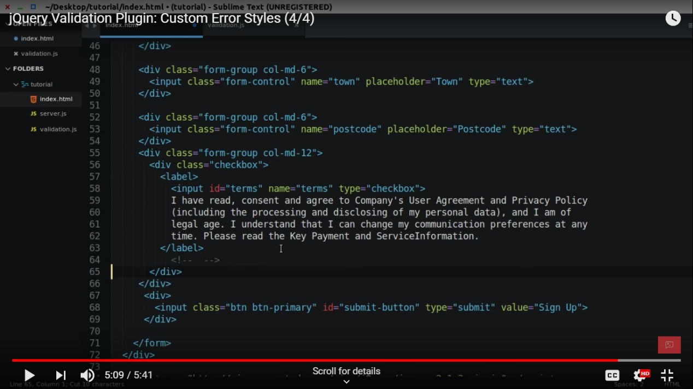

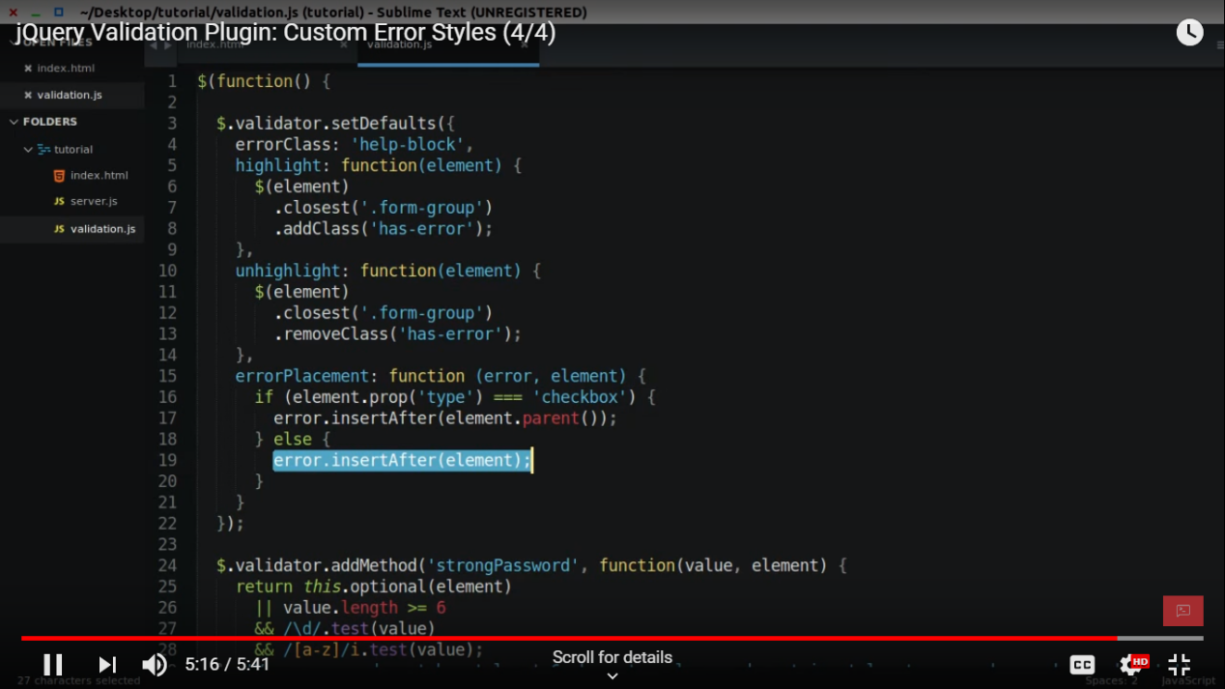

//////////////////

https://www.youtube.com/watch?v=xNSQ3i-BWMo

https://github.com/jquery-validation/jquery-validation

For implementing the addional method.js we need to add a file(we are checking username that contains only charcter, no white space )

* Js file(site link https://docs.microsoft.com/en-us/aspnet/ajax/cdn/jquery-validate/cdnjqueryvalidate1130)
* <https://ajax.aspnetcdn.com/ajax/jquery.validate/1.13.0/additional-methods.min.js>

/\* pass must contain character ,digit | \*/

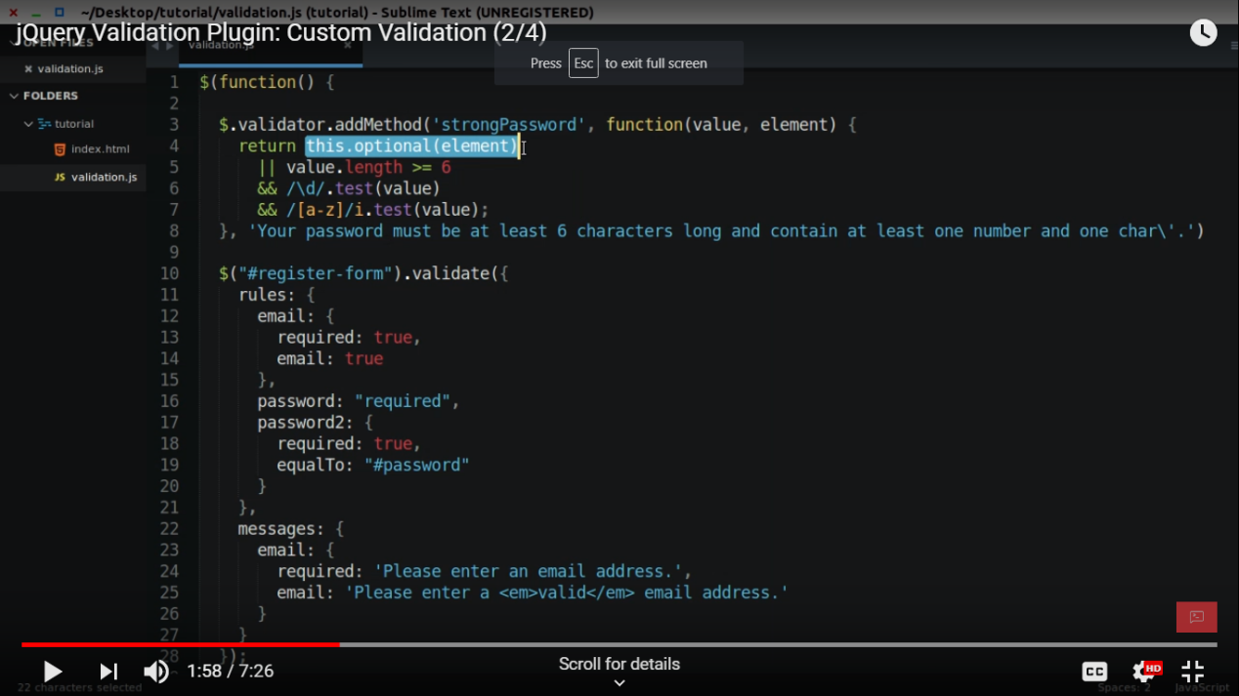

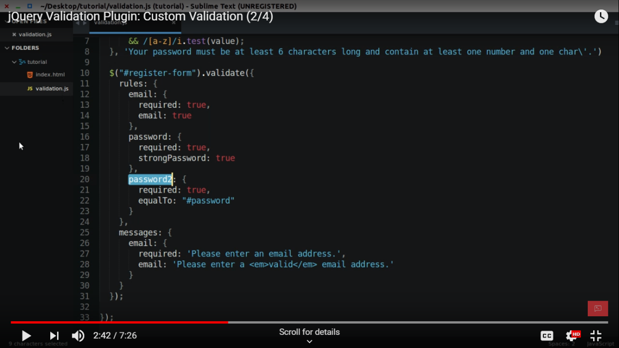

/\*\*

<div>

<select id="eligiblebranch" name= "eligiblebranch" multiple="multiple" class="form-control" >

<option value="A">A</option>

<option value="B">B</option>

<option value="BB">BB</option>

<option value="AA">AA</option>

</select>

</div>

<div>

<input name="topic" id = "subject" placeholder="number" type="checkbox">car<br>

<input name="topic" id = "subject" placeholder="number" type="checkbox">van<br>

<input name="topic" id = "subject" placeholder="number" type="checkbox">santro<br>

</div>

<div>

\*/

////

eligiblebranch:{

required:true

},

topic:{

required: "#subject:checked",

minlength:2

}

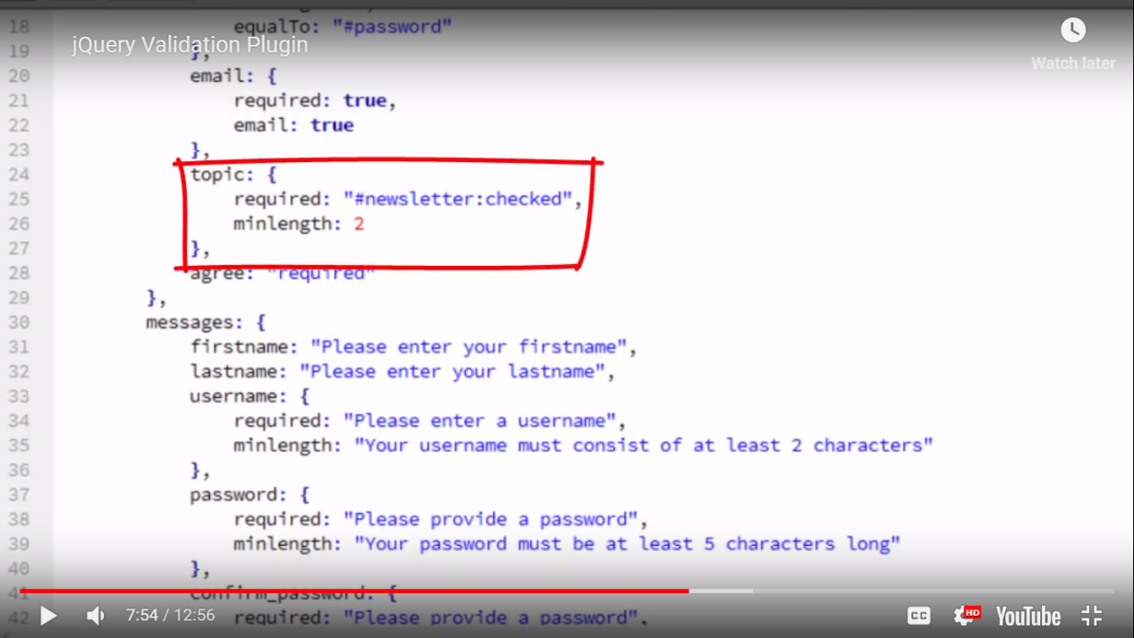

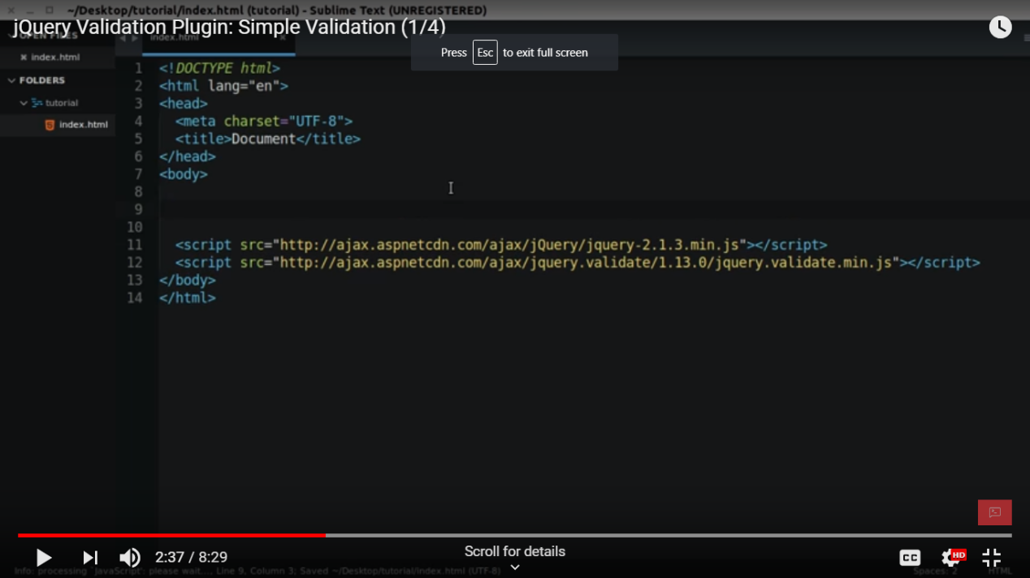

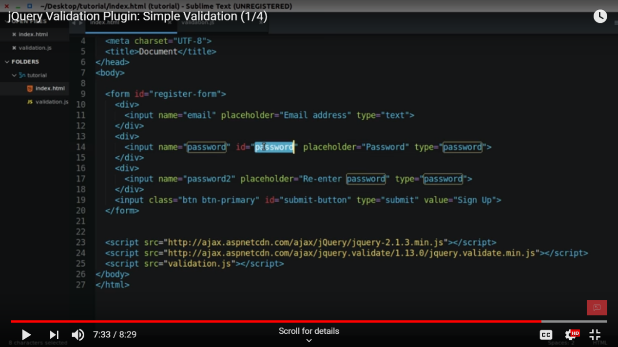

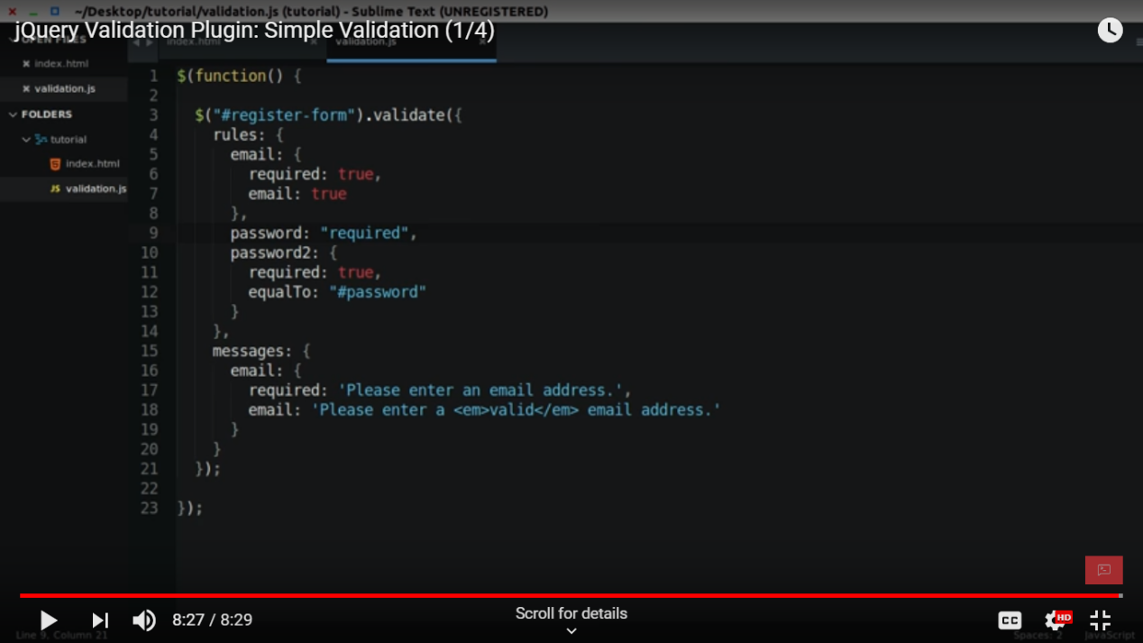

<!DOCTYPE html>

<html>

<body>

<form id="register-form">

<div>

<input name="email" placeholder="email" type="text">

</div>

<div>

<input name="password" id ="password" placeholder="password" type="text">

</div>

<div>

<input name="password1" placeholder="password1" type="text">

</div>

<div>

<input name="number" placeholder="number" type="number">

</div>

<input type="submit" name="submit">

</form>

<!--<script src="https://code.jquery.com/jquery-1.11.1.min.js"></script>

<script src="https://cdnjs.cloudflare.com/ajax/libs/jquery-validate/1.19.0/jquery.validate.min.js"></script> -->

<script src="https://code.jquery.com/jquery-1.11.1.min.js"></script>

<script src="https://cdn.jsdelivr.net/jquery.validation/1.16.0/jquery.validate.min.js"></script>

<script src="validation.js"></script>

</body>

</html>

///////////////////

$(function(){

$("#register-form").validate({

rules:{

email:{

required:true,

email:true

},

password:{

required:true,

},

password1:{

required:true,

equalTo: "#password"

},

number:{

required: true,

number:true,

maxlength: 4

}

},

messages:{

email:{

required: 'enter the email add',

email: 'valid valid'

},

password:{

required: 'enter the pass add',

},

number:{

required: 'atleast 10 digit',

number:'must be number',

maxlength: "4 digit number"

}

}

});

});