**Tutorial 9**

To enable authentication we make use of command

**php artisan make:auth**

Its purpose is to genrate user_id from the user.

From that user_id we can create the posts for that particular user .

We can create diffreent user_id for the diffrent 2 users

For that we create a user_id column in the posts table.

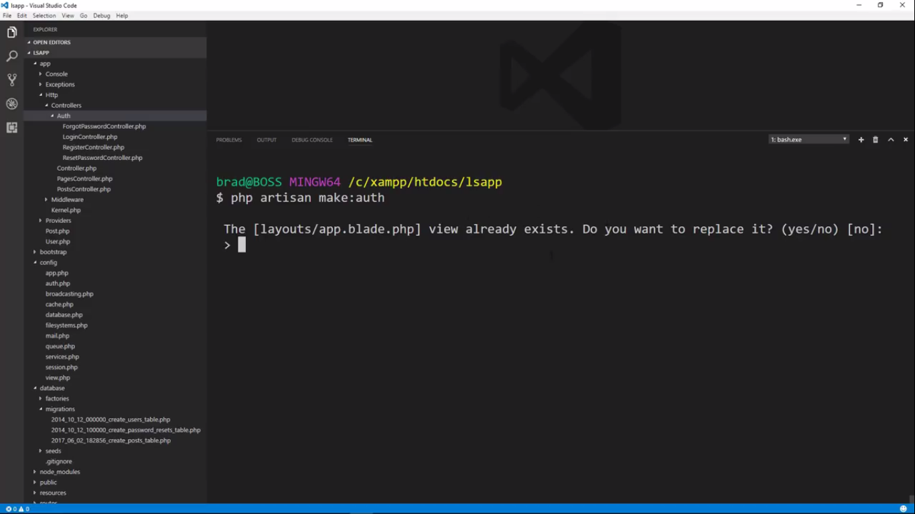

It creates a layout for us which is similar to that we had.

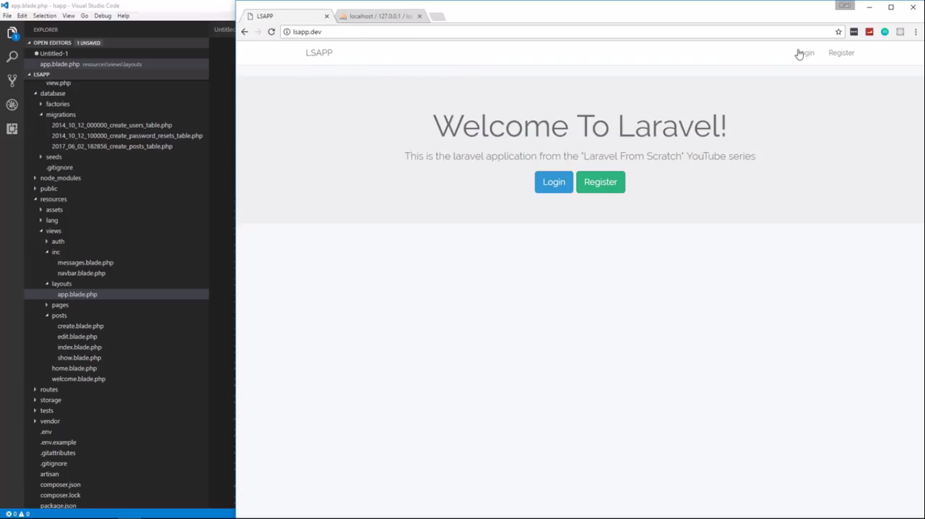

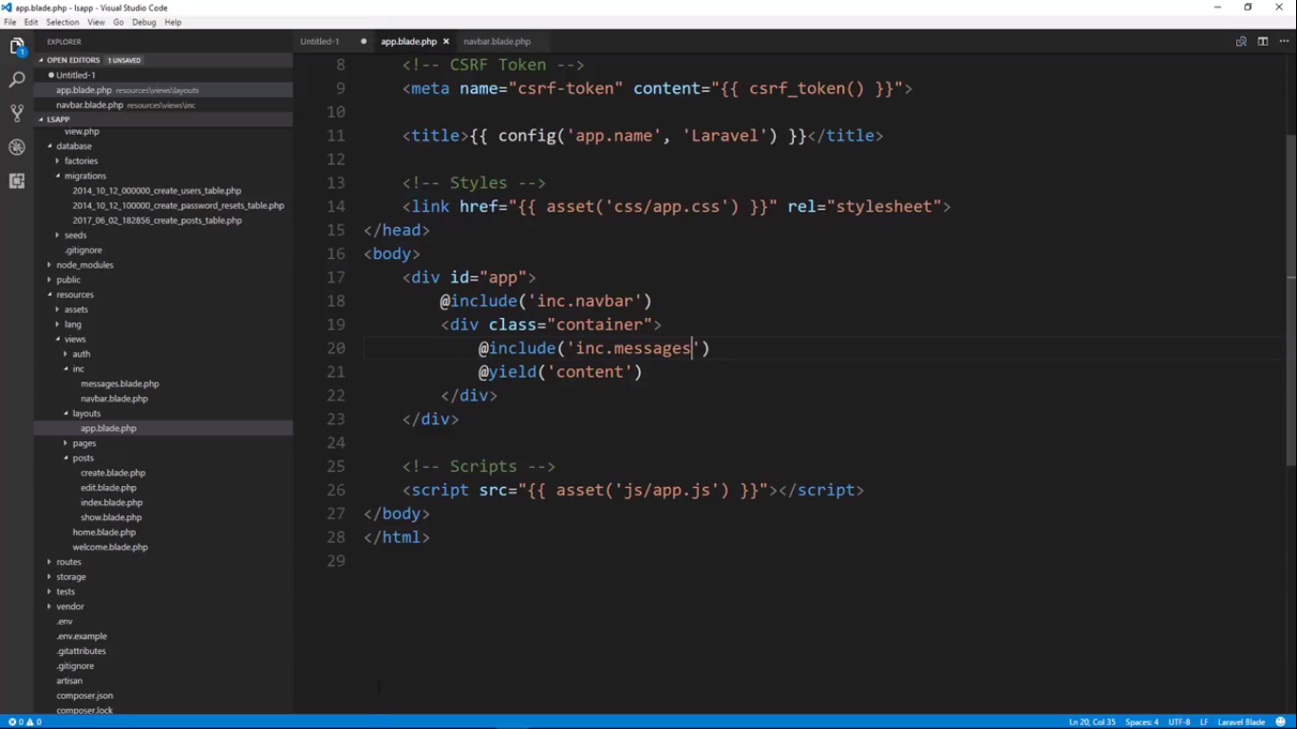

Now we are changing the home to dashboard

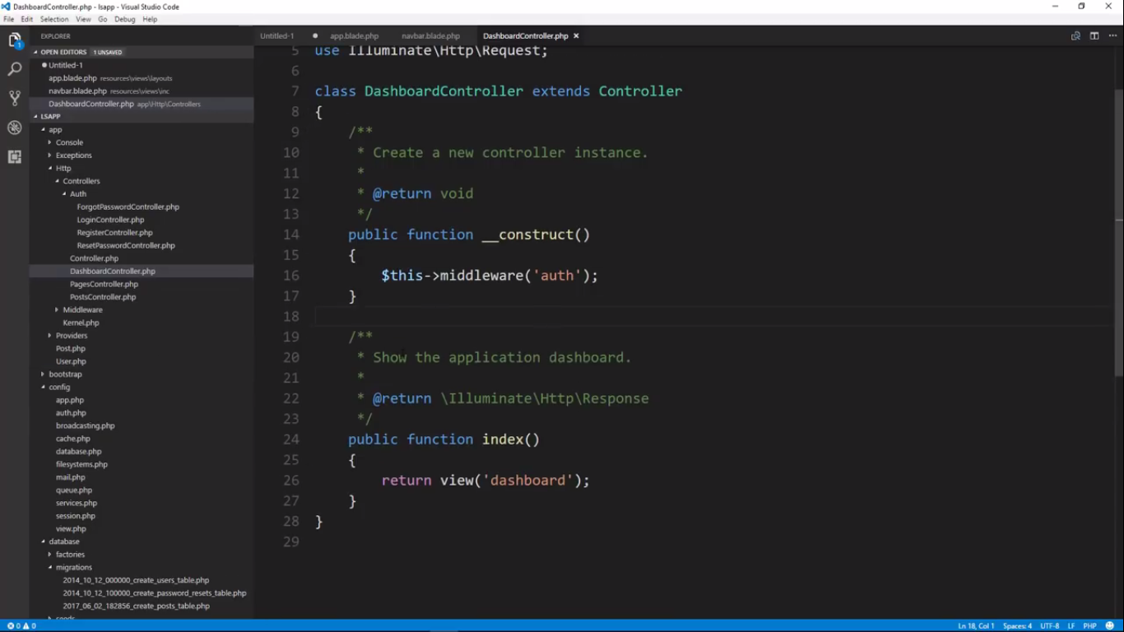

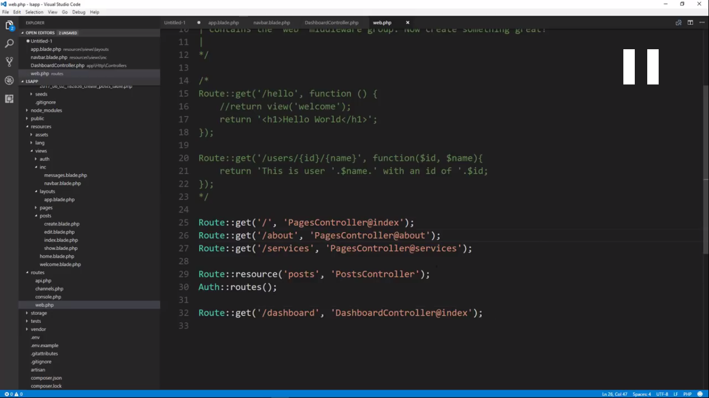

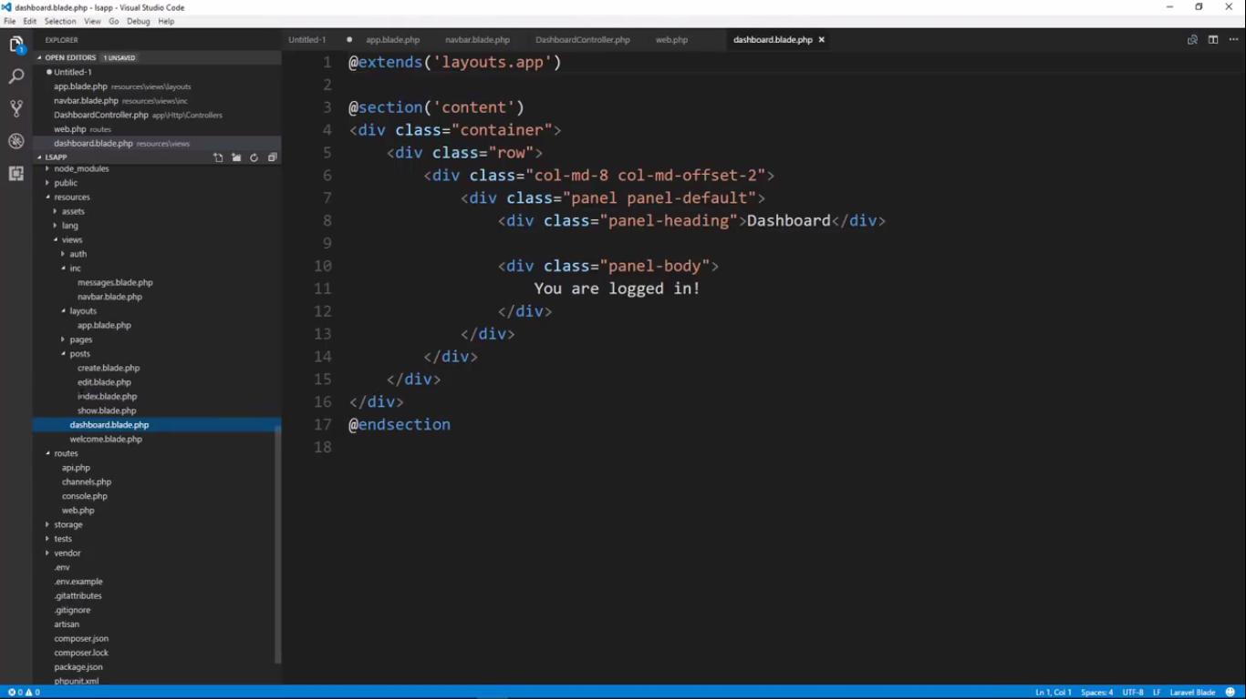

Now after logged in we want to create a posts with the users logged in id. For that we want to make a column in the posts table in db

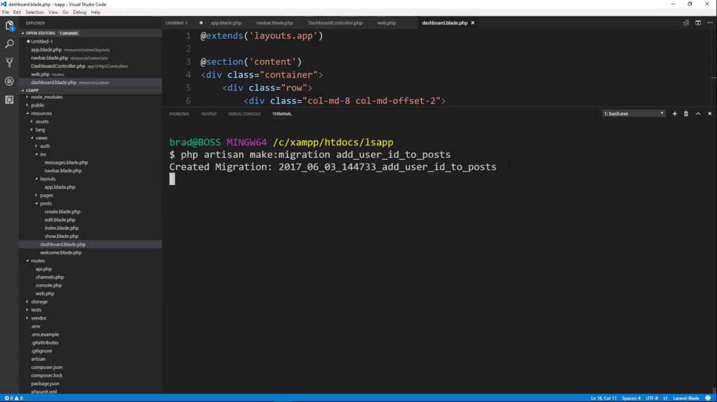

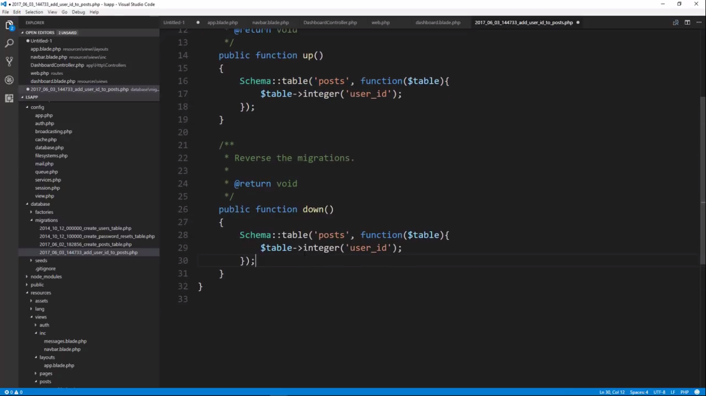

Inside down() wewill use dropColumn instaed of integer

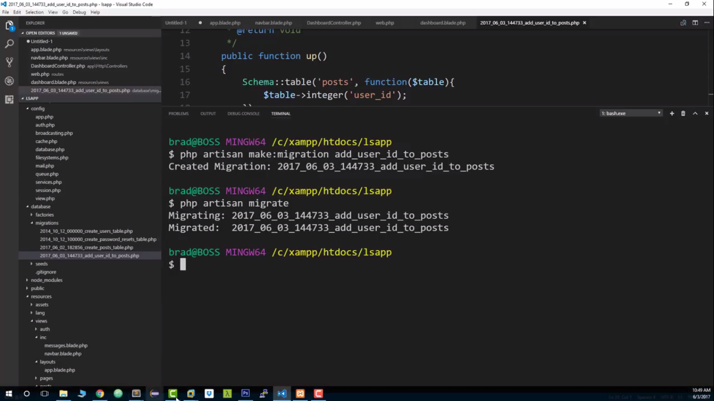

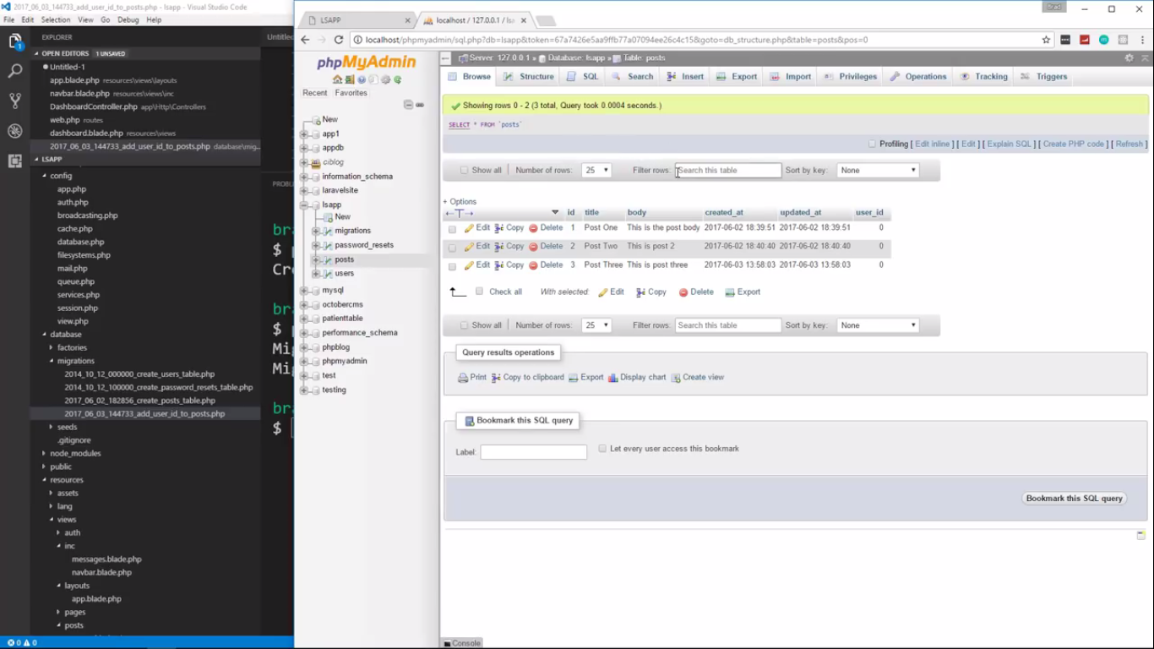

For rollback

Php artisan migrate:rollback

Under postcontroller under create method

Now below it will give the currently logged in user id inputted to the $post->user_id.

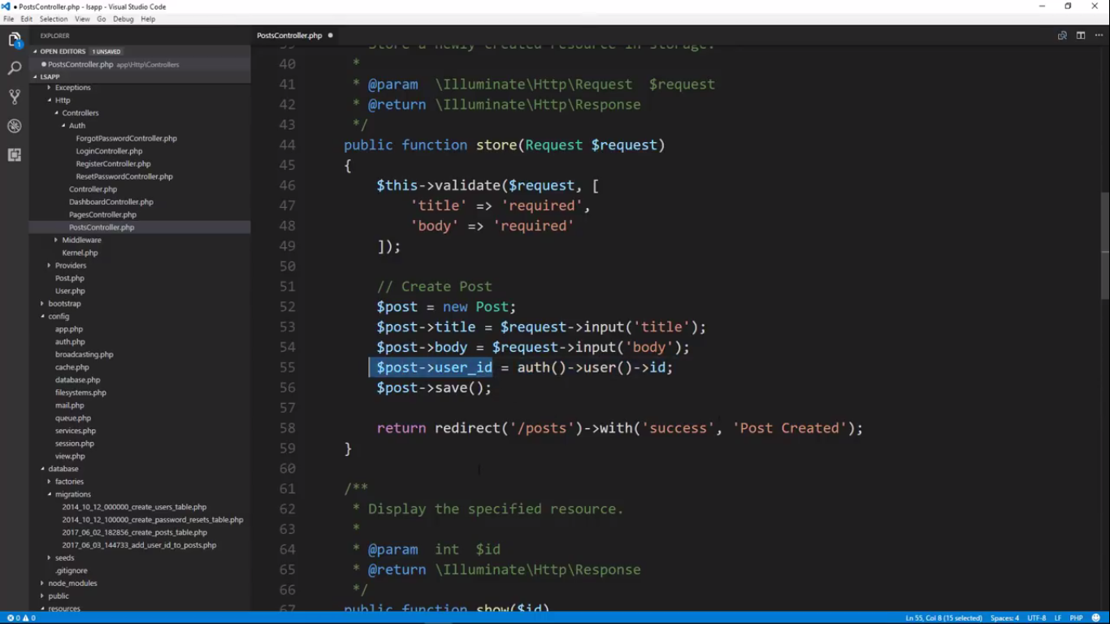

We includin the dashboard link in the dropdown so that we can add a post to the current logged in user .

