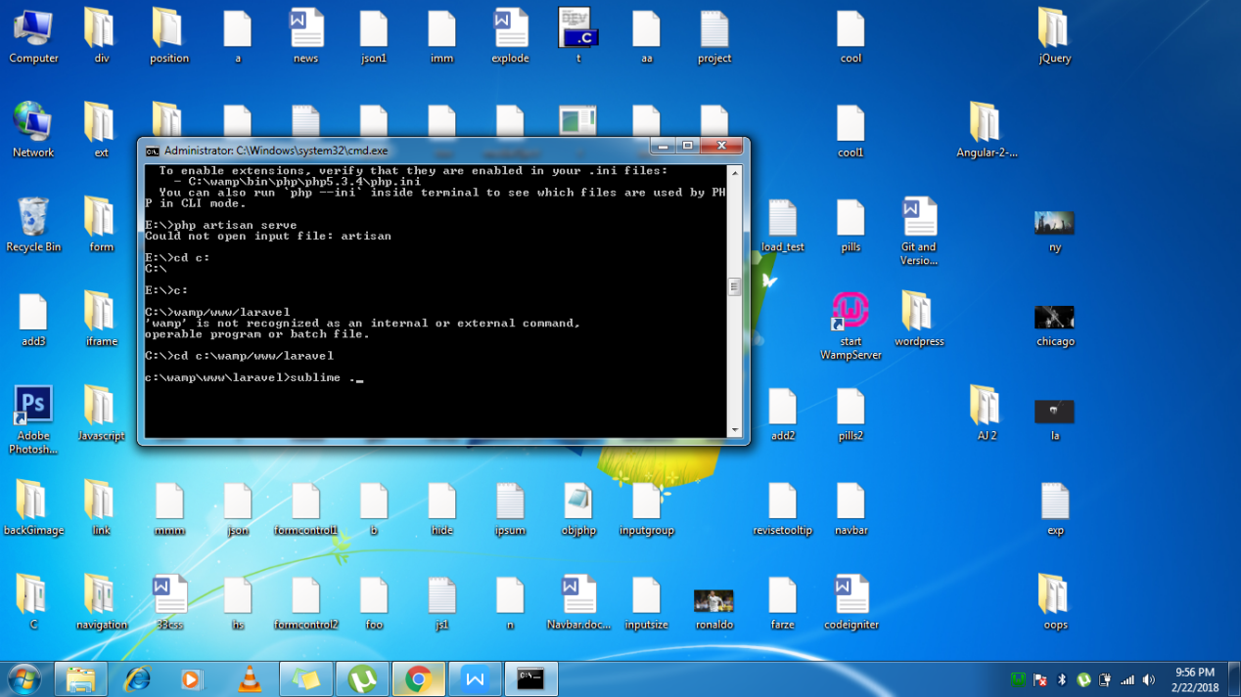

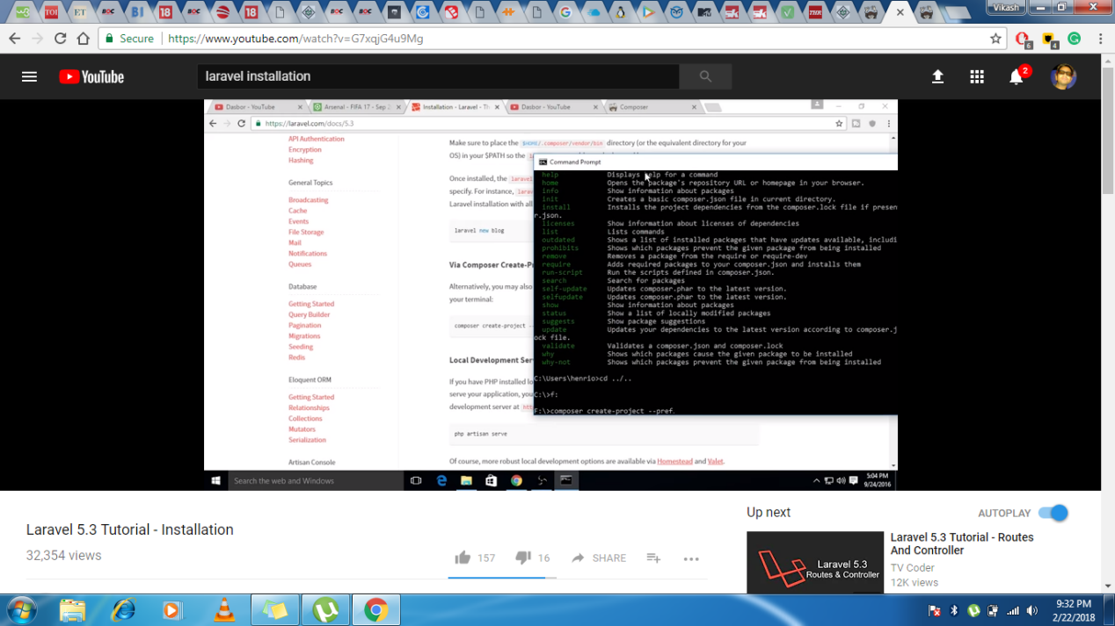

To create new folder mkdir composer

To remove dir rmdir composer

Folders within a folder cd composer

cd ..\..

**Composer** is a dependency manager for **PHP**. **Composer**will manage the dependencies you require on a project by project basis. This means that **Composer** will pull in all the required libraries, dependencies and manage them all in one place

Namespace

For creating new package composer init

//

