**Electricity Billing System**

**OBJECTIVE**

The aim of our project is to develop a system that is meant to partially computerize the work performed in the Electricity Board like generating monthly electricity bill, record of consuming unit of energy, store record of the customer and previous unpaid record.

**SCOPE AND LIMITATIONS**

In the proposed management system the admin can add customer and track all the information of customer. So, admin is having full control over data while customer is having limited access. Customer can register himself with some basic details and he can view his /her bill and payment history. Admin can change his details and he can manage all modules of the project i.e. managing customer, bills and payment. Further admin can generate reports on them for statistical.

**REQUIREMENT ANALYSIS**

Technologies will be used :

* Java 8
* Spring Boot
* Angular
* Bootstrap
* POSTMAN (RESTApi)

Software Requirement for this Project :

* jdk 1.8
* STS-4
* Angular CLI 9
* Node js 10+
* POSTMAN
* Visual Code Studio 1.45

|  |
| --- |
|  |

**Diagrams :**

1. **Use Case Diagram**

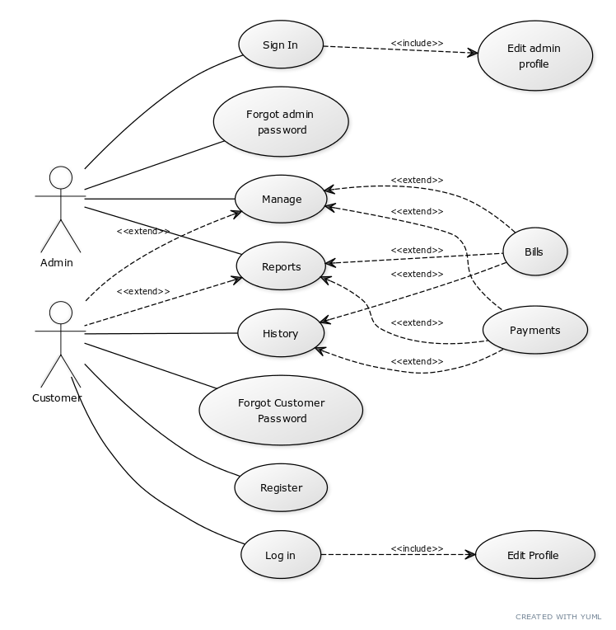

**Modules**

1. **Customer Module**

The main aim of this module is provide all the functionality related to customer. It tracks all the information of the customer. You should develop all type of CRUD (Create, Read, Update and Delete) operations of the customer. This is a role based module where admin can perform each and every operations on data but the customer will be able to view only his/her data, so access level restrictions should be implemented in the project.

**Functional Requirements**

|  |  |  |
| --- | --- | --- |
| **REQUIREMENT** | **DESCRIPTION** | **PRIORITY** |
| SIGN  UP | The user should be able to sign up to set up a new account | **HIGH** |
| LOG IN | All users should be able to log in into the system by username and password | **HIGH** |
| EDIT PROFILE | Users should be able to update their profile information including changing of password and other info. | **HIGH** |
| CHANGE PASSWORD | User have also access to change their password | **HIGH** |
| FORGET PASSWORD | If user forget their password , he/she can reset the password by entering essential credentials | **HIGH** |
| PAYMENT HISTORY | User can see all the payment that has been done | **HIGH** |
| BILL HISTORY | User can also access to see the bill history which are pending or which has been paid | **HIGH** |
| PDF DOWNLOAD | For payment history and bill history user can download the pdf format of receipt | **Medium** |

1. **Bill Module**

The main purpose of the bill module is to manage the bills of the customers. All bills are managed by admin. All CRUD operations regarding bills will be performed by admin. Customers can only view the previous and current bills.

• Generating a Bill:

Admin will generate the bill for customers on the basis of how much units of electricity a

Customer of given CustomerId, consumed.

• Edit/Update the Bill:

Admin can edit and update the bill. If admin found any data or information is wrong in

the generated bill, like wrong CustomerId or wrong Bill amount etc., then admin can

edit the bill to correct it. Admin can also update the bill when fine will be included in bill.

• Delete the Bill:

Only admin can delete the bill.

• View the List of Bill:

Both Admin and Customers can view the list of bills.

• *As Admin*: Admin can view the list of bills of all the customers.

• *As Customer*: Customer can view only his list of bills(previous or current).

1. **Payment Module:**

The main purpose of the payment module is to manage the payments of the customers. All payments are managed by admin. All CRUD operations regarding bills will be performed by admin. Customers can only view the previous and current payments. After successful payment, a confirmation message with the amount will be sent to the customer.

• Generating a Payment:

Admin will generate the bill for customers on the basis of bill and bill cycle. For each bill there will be a payment id.

• Edit/Update the Payment:

Admin can edit and update the payment. If admin found any data or information is wrong in the generated payment or late payment date etc., then admin can edit the payment to correct it.

• View the List of Payment:

Both Admin and Customers can view the list of payments.

• *As Admin*: Admin can view the list of payments of all the customers.

• *As Customer*: Customer can view only his list of payments (previous or current).