
Central university of Haryana
Department of Computer Science & Engineering

(Village Jant-Pali, Mahendergarh, Haryana-123031)

Object Oriented Programming Lab File
Subject Code :- (BT CS 405)

Submitted by :- Submitted to :-
Vikas Singh Mr. Anant R. Bara
B.Tech CSE (Assistant Professor)
Roll No:- 24150 Department of CSE

INDEX
S,No | Program Titles | Page No.
1 | WAP to demonstrate inline function for basic arithmetic operations. | 2-3
2 | WAP to demonstrate default arguments using simple interest calculation. | 4-5
3 | WAP to demonstrate function overloading for area, sum, and volume calculations. | 6-7
4 | WAP to demonstrate static data member and static member function. | 8-9
5 | WAP to demonstrate default, parameterized, copy, and overloaded constructors. | 10-12
6 | WAP to demonstrate dynamic initialization using constructors. | 13-15
7 | WAP to demonstrate operator overloading for +, -, ++, ==, and << operators. | 16-18
8 | WAP to demonstrate single, multiple, multilevel, hierarchical, and hybrid inheritance. | 19-22
9 | WAP to demonstrate function overriding and runtime polymorphism. | 23-24
10 | WAP to demonstrate virtual functions and abstract classes using Shape example. | 25-27
11 | WAP to demonstrate containership using real-life classes (Car–Engine). | 28-29
12 | WAP to develop a Currency Converter using menu-driven approach. | 30-32
13 | WAP to design a Bank Management System using OOP concepts. | 33-37

Program 1: WAP to demonstrate inline function for basic arithmetic operations.

// Author :- Vikas Singh (241504)

#include <iostream>

using namespace std;

// Calculator Class to Implement Inline Function

class Calculator {

public:

inline double add(double a, double b) { return a + b; }

inline double subtract(double a, double b) { return a - b; }

inline double multiply(double a, double b) { return a * b; }

inline double divide(double a, double b) {

if (b == 0) {

cout << "Error: Division by zero!" << endl;

return 0;

}

return a / b;

}

};

// Main Function

int main() {

Calculator calc;

double num1, num2;

cout << "Enter two numbers: ";

cin >> num1 >> num2;

cout << "\n--- Results ---\n";

cout << "Addition: " << calc.add(num1, num2) << endl;

cout << "Subtraction: " << calc.subtract(num1, num2) << endl;

cout << "Multiplication: " << calc.multiply(num1, num2) << endl;

cout << "Division: " << calc.divide(num1, num2) << endl;

return 0;

}

OUTPUT:-

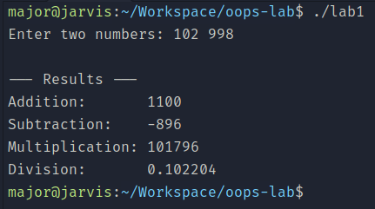

GitHub Link : -

https://github.com/vikasingh0897/OOPs-Lab-Repo/blob/main/lab1.cpp
Program 2: WAP to demonstrate default arguments using simple interest code.

// Author :- Vikas Singh (241504)

#include <iostream>

using namespace std;

// Simple Intrest Class to Implement Default Arguments

class InterestCalculator {

public:

double calculateSI(double principal, double rate = 5.0, double time = 1.0) {

return (principal * rate * time) / 100;

}

};

// Main Function

int main() {

InterestCalculator calc;

double p, r, t;

cout << "Enter Principal amount: ";

cin >> p;

cout << "\n--- Scenario 1: Default Rate (5%) and Time (1yr) ---\n";

cout << "Interest: " << calc.calculateSI(p) << endl;

cout << "\nEnter Rate of Interest: ";

cin >> r;

cout << "--- Scenario 2: Custom Rate, Default Time (1yr) ---\n";

cout << "Interest: " << calc.calculateSI(p, r) << endl;

cout << "\nEnter Time period (years): ";

cin >> t;

cout << "--- Scenario 3: Custom Principal, Rate, and Time ---\n";

cout << "Interest: " << calc.calculateSI(p, r, t) << endl;

return 0;

}

OUTPUT :-

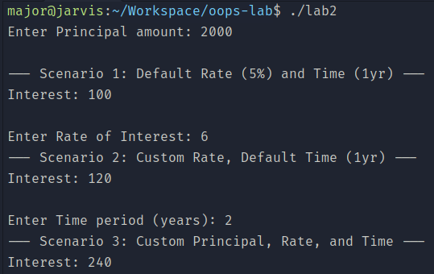
GitHub Link : -

https://github.com/vikasingh0897/OOPs-Lab-Repo/blob/main/lab2.cpp
Program 3: WAP to Demonstrate function overloading for area, sum, and volume calculation.

// Author :- Vikas Singh (241504)

#include <iostream>

using namespace std;

// Geometry Class to Implement Function Overloading

class Geometry {

public:

int calculateSum(int a, int b){ return a + b;}

double calculateSum(int a, double b){ return a + b;}

double calculateSum(double a, int b){ return a + b;}

double calculateSum(double a, double b){ return a + b;}

double calculateArea(double length){ return length*length;}

double calculateArea(double length, double width){ return length * width;}

double calculateVolume(double l, double w, double h){ return l * w * h;}

};

// Main Function

int main() {

Geometry geo;

cout << "Square Area (side 5): " << geo.calculateArea(5.0) << endl;

cout << "Rectangle Area (4x6): " << geo.calculateArea(4.0, 6.0) << endl;

cout << "Sum (int + int): " << geo.calculateSum(10, 20) << endl;

cout << "Sum (double + double): " << geo.calculateSum(10.5, 20.7) << endl;

cout << "Box Volume (2x3x4): " << geo.calculateVolume(2.0, 3.0, 4.0) << endl;

return 0;

}

OUTPUT:-
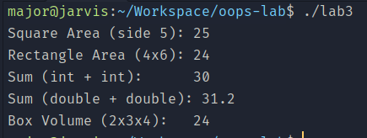
GitHub Link : -
https://github.com/vikasingh0897/OOPs-Lab-Repo/blob/main/lab3.cpp

Program 4: WAP to demonstrate static data member & static member function.

// Author :- Vikas Singh (241504)

#include <iostream>
using namespace std;

// Counter Class to Implement static data member & static member function
class Counter {
private:
static int count;
int id;

public:
Counter() {
count++;
id = count;
}

static int getCount() {
return count;
}

void displayId() {
cout << "Object ID: " << id << endl;
}
};

int Counter::count = 0;

// Main Function
int main() {
cout << "Initial Count: " << Counter::getCount() << endl;
Counter c1, c2, c3;

c1.displayId();
c2.displayId();
c3.displayId();

cout << "Final Count: " << Counter::getCount() << endl;

return 0;
}

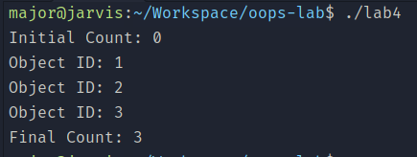
OUTPUT:-
GitHub Link : -
https://github.com/vikasingh0897/OOPs-Lab-Repo/blob/main/lab4.cpp

Program 5: WAP to demonstrate default, parameterized, copy, and overloaded constructors.

// Author :- Vikas Singh (241504)

#include <iostream>

#include <string>

using namespace std;

// Student Class to Implement default, parameterized, copy, and overloaded constructors

class Student {

private:

string name;

int roll;

public:

Student() {

name = "Unknown";

roll = 0;

cout << "Default Constructor Called" << endl;

}

Student(string n, int r) {

name = n;

roll = r;

cout << "Parameterized Constructor Called" << endl;

}

Student(const Student &s) {

name = s.name;

roll = s.roll;

cout << "Copy Constructor Called" << endl;

}

Student(int r) {

name = "No Name";

roll = r;

cout << "Overloaded Constructor (Single Param) Called" << endl;

}

void display() {

cout << "Name: " << name << ", Roll: " << roll << endl << endl;

}

};

// Main Function

int main() {

Student s1;

s1.display();

Student s2("Alice", 101);

s2.display();

Student s3(s2);

s3.display();

Student s4(202);

s4.display();

return 0;

}

OUTPUT:-
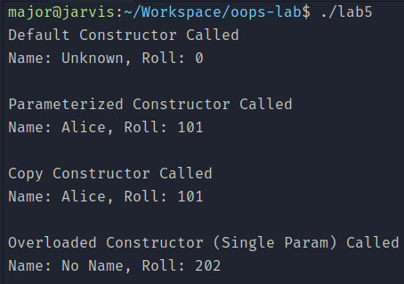
GitHub link: https://github.com/vikasingh0897/OOPs-Lab-Repo/blob/main/lab5.cpp
Program 6: WAP to demonstrate dynamic initialization using constructors.

// Author :- Vikas Singh (241504)

#include <iostream>

using namespace std;

// FixedDeposit Class to Implement dynamic initialization using constructors

class FixedDeposit {

long int principal;

int years;

float rate;

float returnValue;

public:

FixedDeposit() {}

FixedDeposit(long int p, int y, float r) {

principal = p;

years = y;

rate = r;

returnValue = principal;

for (int i = 0; i < y; i++) {

returnValue = returnValue * (1.0 + r);

}

}

FixedDeposit(long int p, int y, int r) {

principal = p;

years = y;

rate = float(r) / 100;

returnValue = principal;

for (int i = 0; i < y; i++) {

returnValue = returnValue * (1.0 + rate);

}

}

void display() {

cout << "Principal: " << principal << endl;

cout << "Return Value: " << returnValue << endl << endl;

}

};

// Main Function

int main() {

long int p;

int y, R;

float r;

cout << "Enter principal, years, and rate (decimal): ";

cin >> p >> y >> r;

FixedDeposit fd1(p, y, r);

fd1.display();

cout << "Enter principal, years, and rate (percentage): ";

cin >> p >> y >> R;

FixedDeposit fd2(p, y, R);

fd2.display();

return 0;

}

OUTPUT:-
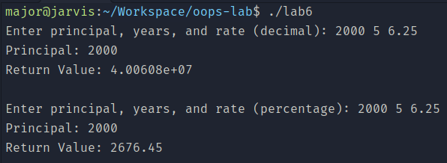

GitHub Link :-

https://github.com/vikasingh0897/OOPs-Lab-Repo/blob/main/lab6.cpp
Program 7: WAP to demonstrate operator overloading for +, -, ++, ==, and << operators.

// Author :- Vikas Singh (241504)

#include <iostream>

using namespace std;

// Point Class to Implement operator overloading

class Point {

private:

int x, y;

public:

Point(int x = 0, int y = 0) : x(x), y(y) {}

Point operator+(const Point& other) {

return Point(x + other.x, y + other.y);

}

Point operator-(const Point& other) {

return Point(x - other.x, y - other.y);

}

Point& operator++() {

x++;

y++;

return *this;

}

bool operator==(const Point& other) {

return (x == other.x && y == other.y);

}

friend ostream& operator<<(ostream& os, const Point& p) {

os << "(" << p.x << ", " << p.y << ")";

return os;

}

};

// Main Function

int main() {

Point p1(10, 20), p2(5, 5);

Point p3 = p1 + p2;

Point p4 = p1 - p2;

cout << "p1: " << p1 << endl;

cout << "p2: " << p2 << endl;

cout << "p1 + p2: " << p3 << endl;

cout << "p1 - p2: " << p4 << endl;

if (p1 == p2) {

cout << "p1 and p2 are equal" << endl;

} else {

cout << "p1 and p2 are not equal" << endl;

}

++p1;

cout << "p1 after ++: " << p1 << endl;

return 0;

}

OUTPUT:-
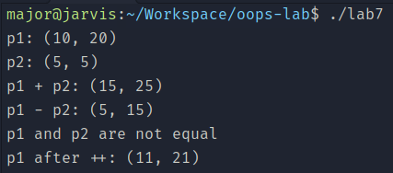
GitHub Link: -
https://github.com/vikasingh0897/OOPs-Lab-Repo/blob/main/lab7.cpp

Program 8: WAP to demonstrate single, multiple, multilevel, hierarchical and hybrid inheritance.

// Author :- Vikas Singh (241504)

#include <iostream>

#include <string>

using namespace std;

// Base class for Single, Multilevel, Hierarchical, and Hybrid

class Animal {

public:

void eat() { cout << "Eating..." << endl; }

};

// SINGLE INHERITANCE

class Dog : public Animal {

public:

void bark() { cout << "Barking..." << endl; }

};

// MULTILEVEL INHERITANCE

class Puppy : public Dog {

public:

void weep() { cout << "Weeping..." << endl; }

};

// MULTIPLE INHERITANCE

class Mammal {

public:

void breathe() { cout << "Breathing..." << endl; }

};

class Bat : public Animal, public Mammal {

public:

void fly() { cout << "Flying..." << endl; }

};

// HIERARCHICAL INHERITANCE

class Cat : public Animal {

public:

void meow() { cout << "Meowing..." << endl; }

};

// HYBRID INHERITANCE

class HybridPet : public Dog, public Cat {

public:

void show() { cout << "I am a hybrid pet." << endl; }

};

// Main Function

int main() {

cout << "--- Single Inheritance ---" << endl;

Dog d;

d.eat();

d.bark();

cout << "\n--- Multilevel Inheritance ---" << endl;

Puppy p;

p.eat();

p.bark();

p.weep();

cout << "\n--- Multiple Inheritance ---" << endl;

Bat b;

b.eat();

b.breathe();

b.fly();

cout << "\n--- Hierarchical Inheritance ---" << endl;

Cat c;

c.eat();

c.meow();

cout << "\n--- Hybrid Inheritance ---" << endl;

HybridPet hp;

hp.bark();

hp.meow();

hp.show();

return 0;

}

OUTPUT:-
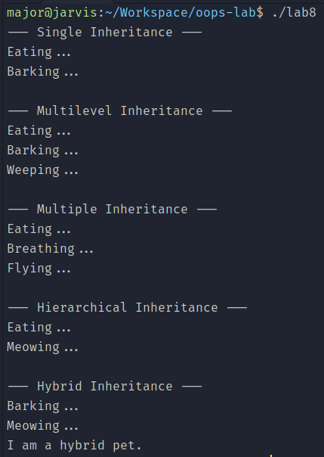
GitHub Link:- https://github.com/vikasingh0897/OOPs-Lab-Repo/blob/main/lab8.cpp
Program 9: WAP to demonstrate function overriding & runtime polymorphism.

// Author :- Vikas Singh (241504)

#include <iostream>

using namespace std;

// Base class for virtual functions

class Base {

public:

virtual void display() { cout << "Display from Base class \n"; }

virtual void show() { cout << "Show from Base class \n" ; }

};

// Derived class to implement runtime overriding and polymorphism

class Derived : public Base {

public:

void display() override { cout << "Display from Derived class (Overridden) \n"; }

void show() override { cout << "Show from Derived class (Overridden) \n" ; }

};

// Main Function

int main() {

Base* ptr;

Base baseObj;

Derived derObj;

ptr = &baseObj;

ptr->display();

ptr->show();

cout << "----------------------------" << endl;

ptr = &derObj;

ptr->display();

ptr->show();

return 0;

}

OUTPUT:-
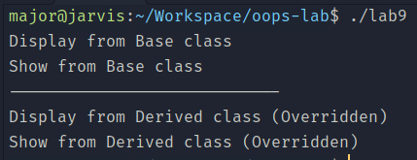
GitHub Link:- https://github.com/vikasingh0897/OOPs-Lab-Repo/blob/main/lab9.cpp

Program 10: WAP to demonstrate function virtual functions and abstract classes using shape example.

// Author :- Vikas Singh (241504)

#include <iostream>

using namespace std;

// Base Class

class Shape {

protected:

double width, height;

public:

void setDimensions(double w, double h) {

width = w;

height = h;

}

virtual void calculateArea() = 0;

};

// Abstract class

class Rectangle : public Shape {

public:

void calculateArea() override {

cout << "Area of Rectangle: " << width * height << endl;

}

};

// Abstract class

class Triangle : public Shape {

public:

void calculateArea() override {

cout << "Area of Triangle: " << 0.5 * width * height << endl;

}

};

// Main Function

int main() {

Shape* ptr;

Rectangle rect;

Triangle tri;

ptr = &rect;

ptr->setDimensions(10, 5);

ptr->calculateArea();

ptr = &tri;

ptr->setDimensions(10, 5);

ptr->calculateArea();

return 0;

}

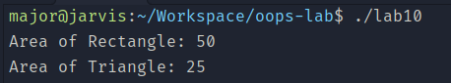
OUTPUT:-
GitHub Link:- https://github.com/vikasingh0897/OOPs-Lab-Repo/blob/main/lab10.cpp

Program 11: WAP to demonstrate containership using real-life classes.

// Author :- Vikas Singh (241504)

#include <iostream>

#include <string>

using namespace std;

// Contained Class

class Engine {

private:

int horsepower;

string type;

public:

Engine(int hp, string t) : horsepower(hp), type(t) {}

void showEngineDetails() {

cout << "Engine: " << type << " (" << horsepower << " HP)" << endl;

}

};

// Container Class

class Car {

private:

string model;

Engine eng;

public:

Car(string m, int hp, string t) : model(m), eng(hp, t) {}

void showCarDetails() {

cout << "Car Model: " << model << endl;

eng.showEngineDetails();

}

};

// Main function

int main() {

Car myCar("Mustang GT", 450, "V8");

myCar.showCarDetails();

return 0;

}

OUTPUT:-
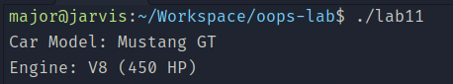
GitHub Link:- https://github.com/vikasingh0897/OOPs-Lab-Repo/blob/main/lab11.cpp

Program 12: WAP to develop a Currency Converter using menu-driven approach.

// Author :- Vikas Singh (241504)

#include <iostream>

#include <iomanip>

using namespace std;

// Currency Converter Class

class CurrencyConverter {

public:

void usdToInr(double amount) {

cout << fixed << setprecision(2);

cout << amount << " USD = " << (amount * 83.50) << " INR" << endl;

}

void inrToUsd(double amount) {

cout << fixed << setprecision(2);

cout << amount << " INR = " << (amount / 83.50) << " USD" << endl;

}

void usdToEur(double amount) {

cout << fixed << setprecision(2);

cout << amount << " USD = " << (amount * 0.92) << " EUR" << endl;

}

void eurToUsd(double amount) {

cout << fixed << setprecision(2);

cout << amount << " EUR = " << (amount / 0.92) << " USD" << endl;

}

};

// Main Function

int main() {

CurrencyConverter cc;

int choice;

double amount;

while (true) {

cout << "\n--- CURRENCY CONVERTER MENU ---" << endl;

cout << "1. USD to INR" << endl;

cout << "2. INR to USD" << endl;

cout << "3. USD to EUR" << endl;

cout << "4. EUR to USD" << endl;

cout << "5. Exit" << endl;

cout << "Enter your choice: ";

cin >> choice;

if (choice == 5) {

cout << "Exiting program..." << endl;

break;

}

if (choice >= 1 && choice <= 4) {

cout << "Enter amount: ";

cin >> amount;

}

switch (choice) {

case 1: cc.usdToInr(amount); break;

case 2: cc.inrToUsd(amount); break;

case 3: cc.usdToEur(amount); break;

case 4: cc.eurToUsd(amount); break;

default: cout << "Invalid choice! Please try again." << endl;

}

}

return 0;

}

OUTPUT:-
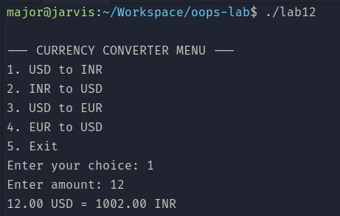
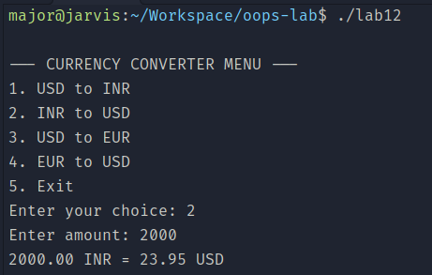
GitHub Link:- https://github.com/vikasingh0897/OOPs-Lab-Repo/blob/main/lab12.cpp

Program 13: WAP to design a Bank Management System using OOP concepts.

// Author :- Vikas Singh (241504)

#include <iostream>

#include <string>

#include <iomanip>

using namespace std;

// Banc Account Class

class BankAccount {

private:

string accountHolder;

int accountNumber;

double balance;

public:

BankAccount(string name, int accNum, double initialDeposit) {

accountHolder = name;

accountNumber = accNum;

balance = initialDeposit;

cout << "\nAccount created successfully for " << accountHolder << endl;

}

void deposit(double amount) {

if (amount > 0) {

balance += amount;

cout << "Successfully deposited: $" << amount << endl;

} else {

cout << "Invalid deposit amount!" << endl;

}

}

void withdraw(double amount) {

if (amount > balance) {

cout << "Insufficient balance! Current balance: $" << balance << endl;

}

else if (amount <= 0) {

cout << "Invalid withdrawal amount!" << endl;

}

else {

balance -= amount;

cout << "Successfully withdrawn: $" << amount << endl;

}

}

void displayBalance() {

cout << fixed << setprecision(2);

cout << "\n--- Account Details ---" << endl;

cout << "Account Holder: " << accountHolder << endl;

cout << "Account Number: " << accountNumber << endl;

cout << "Current Balance: $" << balance << endl;

}

};

// Main Function

int main() {

string name;

int accNum;

double amount;

int choice;

cout << "--- Welcome to the Bank Management System ---" << endl;

cout << "Enter Account Holder Name: ";

getline(cin, name);

cout << "Enter Account Number: ";

cin >> accNum;

cout << "Enter Initial Deposit: ";

cin >> amount;

BankAccount myAccount(name, accNum, amount);

do {

cout << "\n1. Deposit Money" << endl;

cout << "2. Withdraw Money" << endl;

cout << "3. Check Balance" << endl;

cout << "4. Exit" << endl;

cout << "Enter your choice: ";

cin >> choice;

switch (choice) {

case 1:

cout << "Enter amount to deposit: ";

cin >> amount;

myAccount.deposit(amount);

break;

case 2:

cout << "Enter amount to withdraw: ";

cin >> amount;

myAccount.withdraw(amount);

break;

case 3:

myAccount.displayBalance();

break;

case 4:

cout << "Thank you for using our banking services!" << endl;

break;

default:

cout << "Invalid choice! Please try again." << endl;

}

} while (choice != 4);

return 0;

}

OUTPUT:-
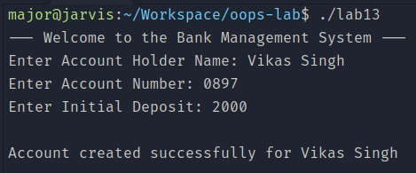
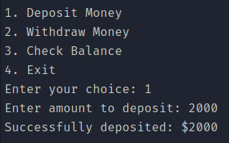
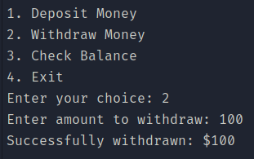
GitHub Link:- https://github.com/vikasingh0897/OOPs-Lab-Repo/blob/main/lab13.cpp

