**1. Harvard Law School courses often have assigned seating to facilitate the “Socratic method.”**

**Suppose that there are 100 first year Harvard Law students, and each takes two courses:**

**Torts and Contracts. Both are held in the same lecture hall (which has 100 seats), and the**

**seating is uniformly random and independent for the two courses.**

**(a) Find the probability that no one has the same seat for both courses (exactly; you should**

**leave your answer as a sum).**

🡪

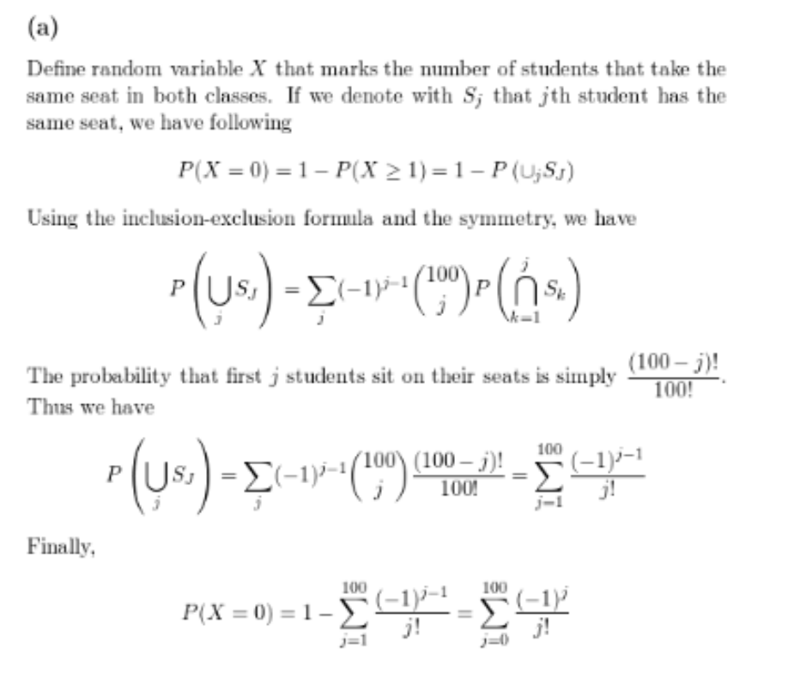

**(b) Find a simple but accurate approximation to the probability that no one has the same**

**seat for both courses.**

**(c) Find a simple but accurate approximation to the probability that at least two students**

**have the same seat for both courses.**

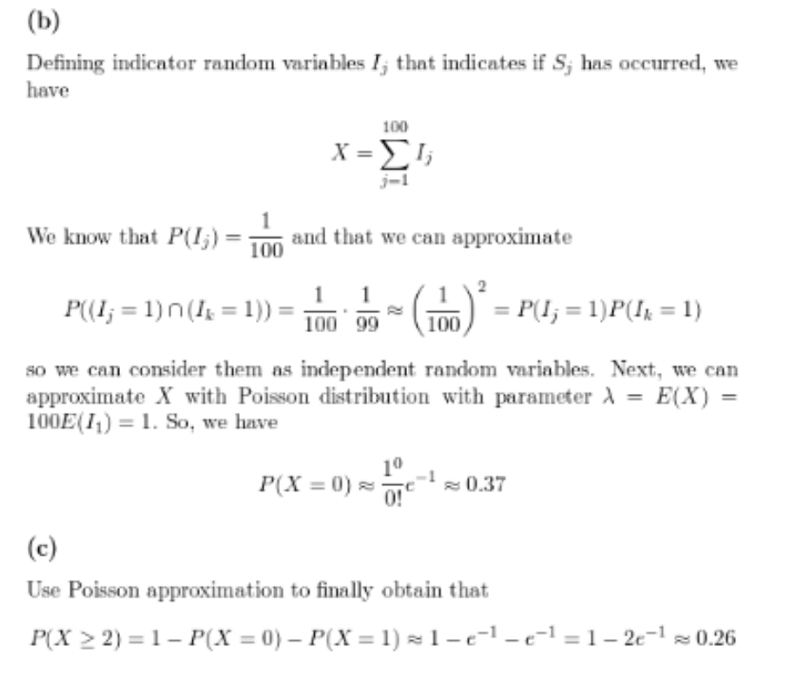

**2. There are 100 passengers lined up to board an airplane with 100 seats (with each seat**

**assigned to one of the passengers). The first passenger in line crazily decides to sit in a**

**randomly chosen seat (with all seats equally likely). Each subsequent passenger takes his or**

**her assigned seat if available, and otherwise sits in a random available seat. What is the**

**probability that the last passenger in line gets to sit in his or her assigned seat?**

**🡪**

This is probably the ugliest solution possible to this problem but here goes. Let’s first consider a special case where there are only 2 people (Alice and Bob) and 2 seats on the airplane. Alice picks a seat at random. The only way Bob gets to pick his designated seat is if Alice correctly picks hers. Since there are only 2 choices for Alice she picks her own seat correctly with probability 1/21/2

Therefore P(P( Bob gets his seat)=P()=P(Alice chooses her own seat)=1/2)=1/2

Now lets consider one more special case where we now have 3 people (Alice, Bob and Carlos) boarding the flight in that order and Alice picking a random seat first up. In this scenario, Carlos gets to sit on his designated seat in one of the following two possibilities:

·  Alice picks her own seat

·  Alice picks Bob’s seat and Bob picks Alice’s seat.

In all other cases the probability of Carlos picking his seat is 0. So we have :

P(P( Carlos gets his seat )=P()=P( Alice picks her own seat )+P()+P( Alice picks Bob’s seat )∗P()∗P( Bob picks Alice’s seat))

This reduces to :

P(P( Carlos gets his seat )=1/3+(1/3)∗(1/2)=(1/3+1/6)=1/2.