SAIL BSP
Cobble Detection Analysis Report
Report Generated: 2025-10-07 14:44
Data Period: 2025-01-10 to 2025-07-10
Total Records: 65
Cobble Events: 28 (43.08%)

Model Performance Summary Dashboard

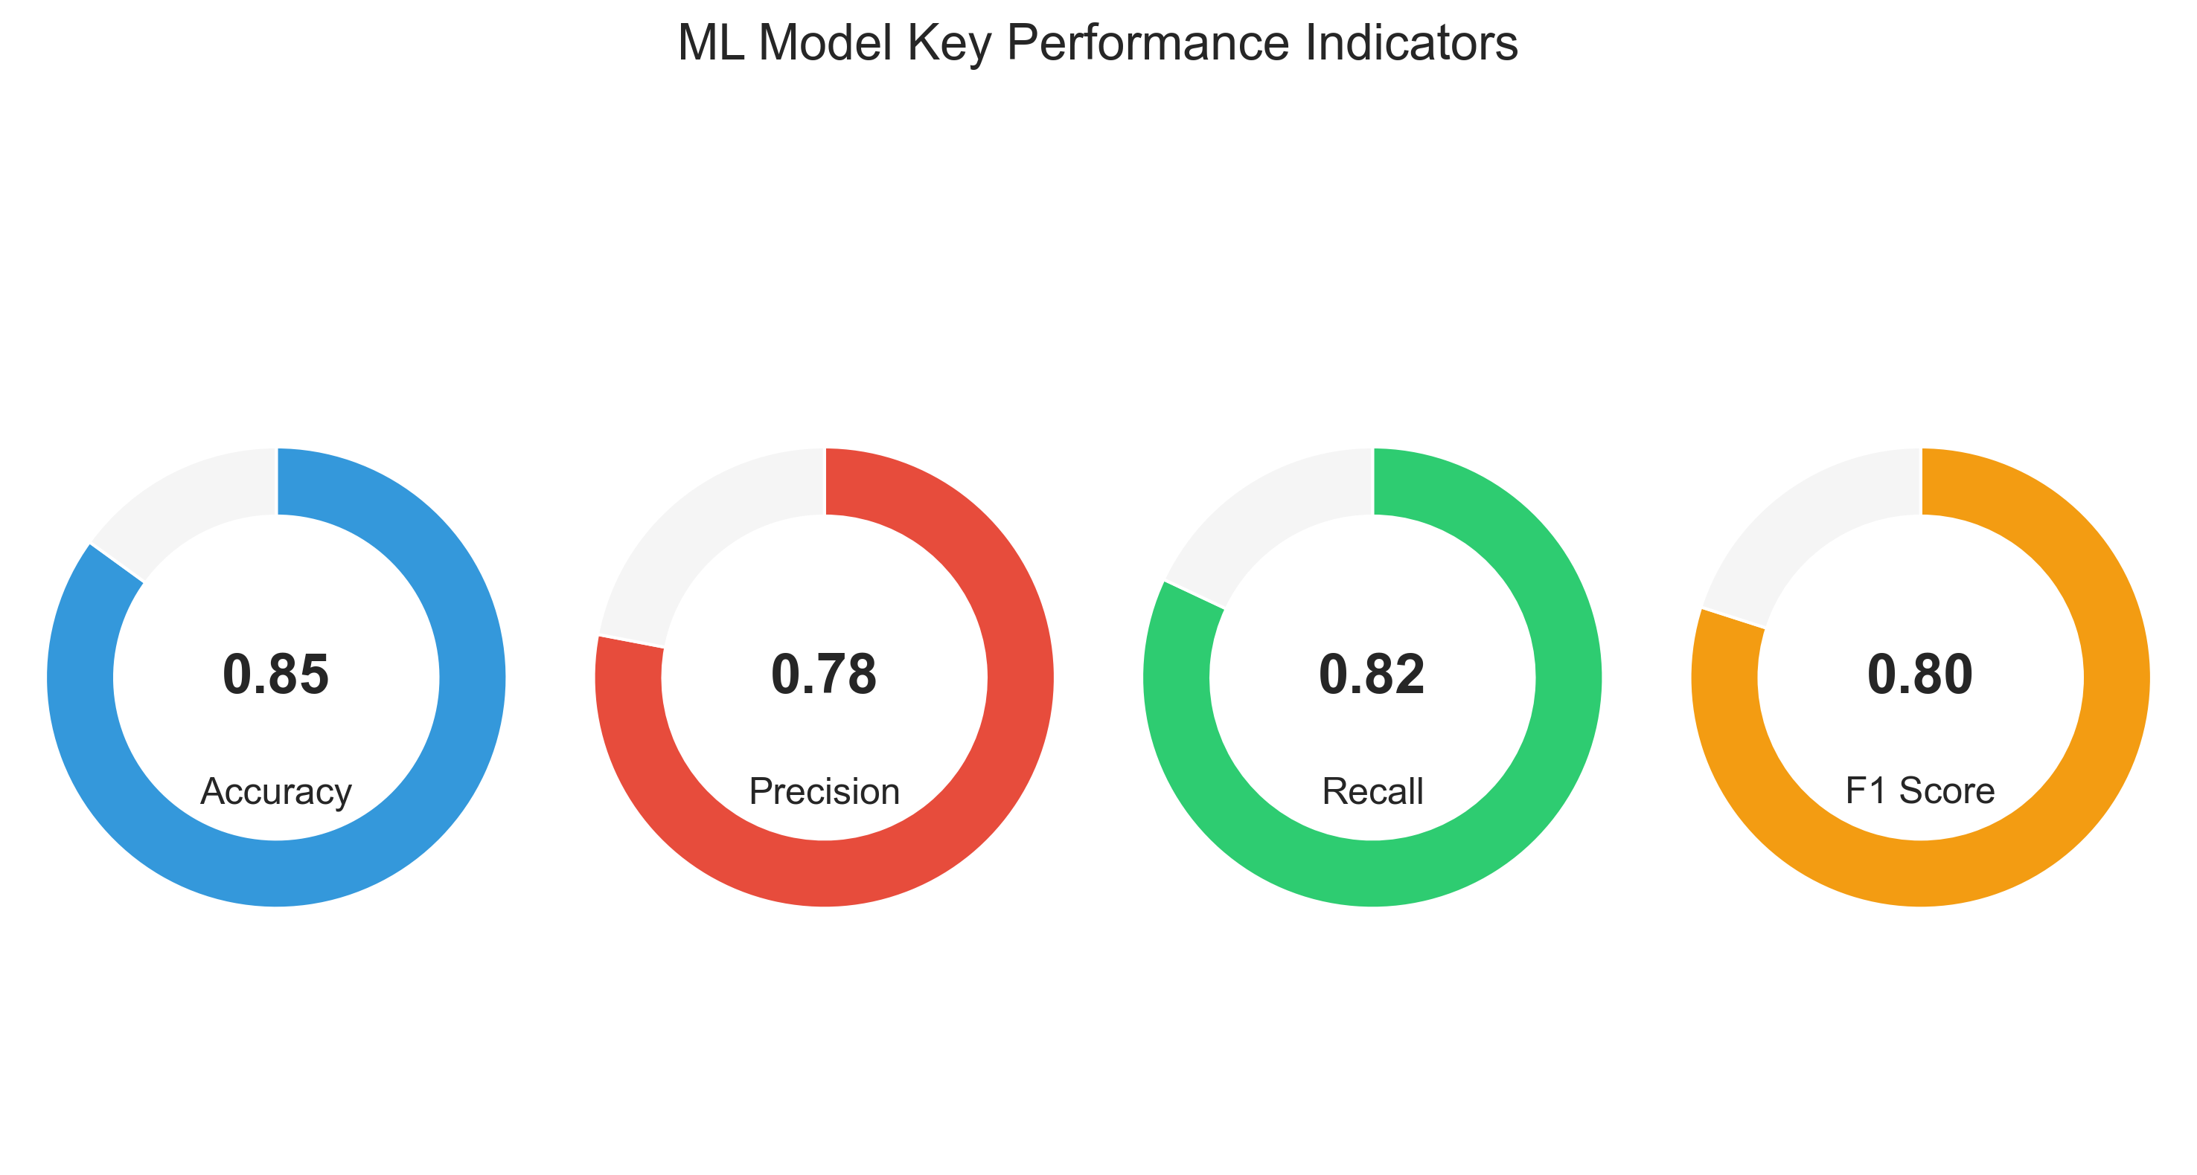

Block | Accuracy | Precision | Recall | F1 Score
B | 0.83 | 0.8 | 0.86 | 0.83
C | 0.87 | 0.7 | 0.75 | 0.72
D | 0.85 | 0.88 | 0.75 | 0.81

The model performance dashboard above provides a quick overview of the cobble detection model's effectiveness. Overall accuracy of 0.85 indicates strong predictive capability, with a balance between precision (0.78) and recall (0.82). Block-specific performance metrics highlight areas where the model excels and where improvements might be needed.
This executive dashboard allows quick assessment of model reliability across different operational contexts, supporting data-driven decision making for cobble prevention strategies.

Table of Contents
Model Performance Summary Dashboard
1. Cobble Event Trends Over Time
2. Block-Specific Analysis
3. Profile-Based Analysis
4. Short-Term Cobble Prediction Performance
5. Time Series Anomaly Detection
6. Shift and Operator Impact Analysis
7. Comparative Analysis Between Consecutive Events
8. Machine Learning Model Performance Insights

1. Cobble Event Trends Over Time

Daily Cobble Event Frequency
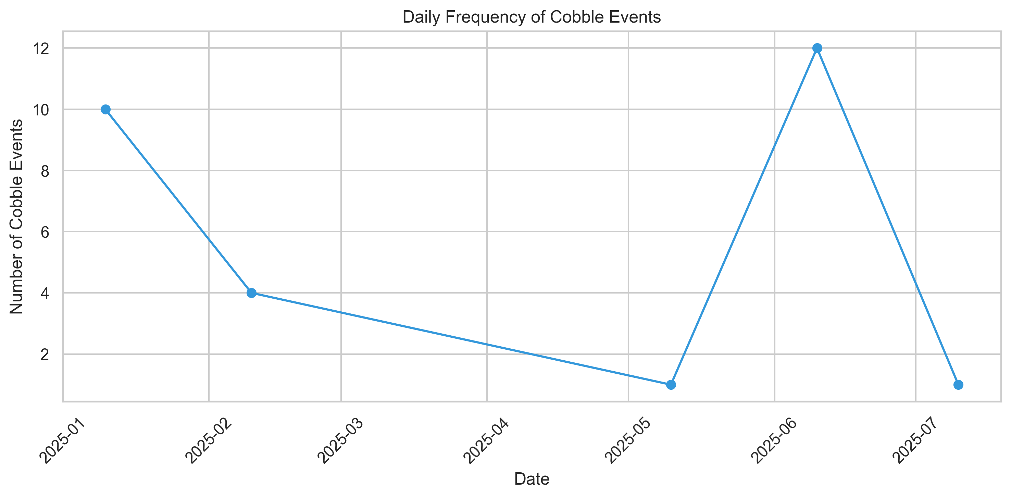

Hourly Distribution of Cobble Events
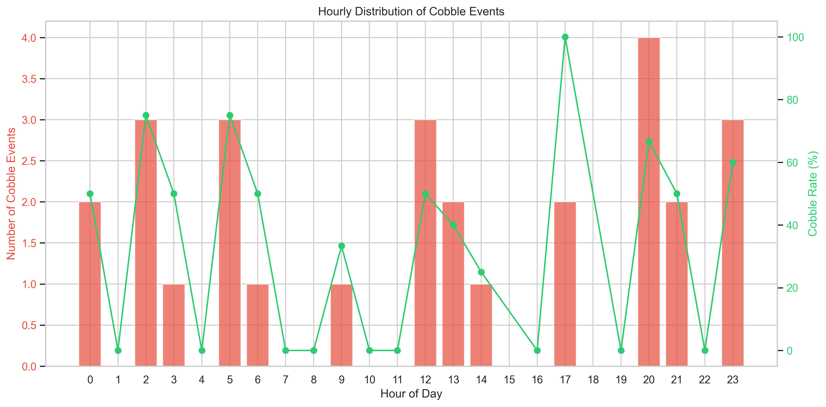

Cobble Events by Shift
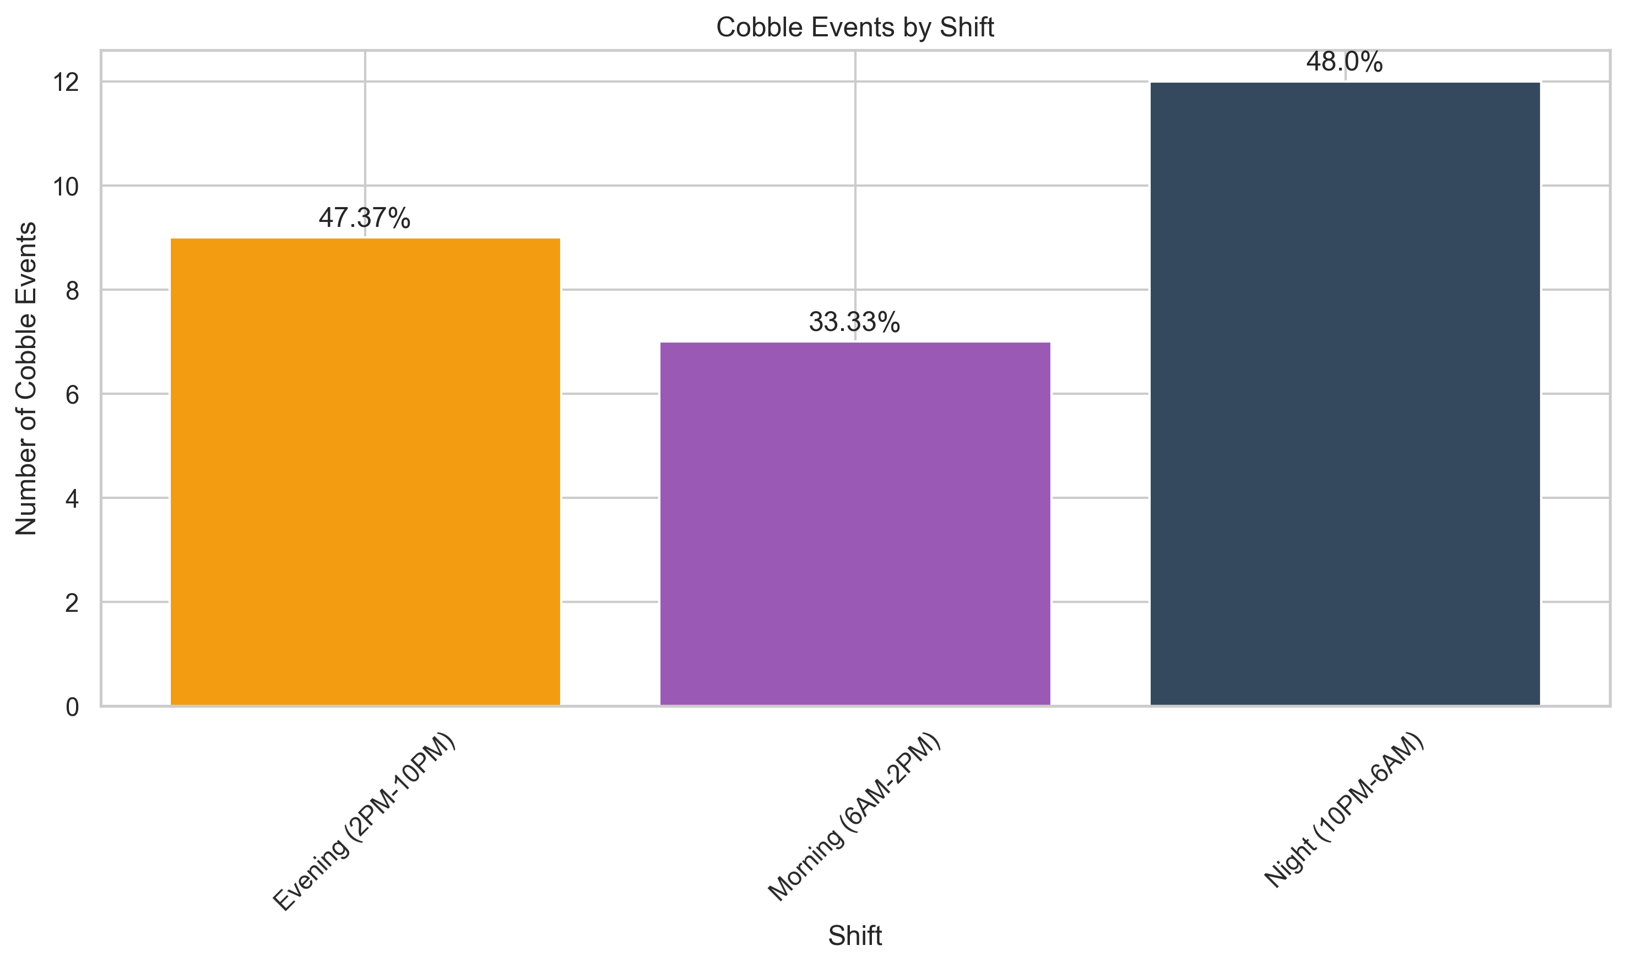

Cobble Events by Day of Week
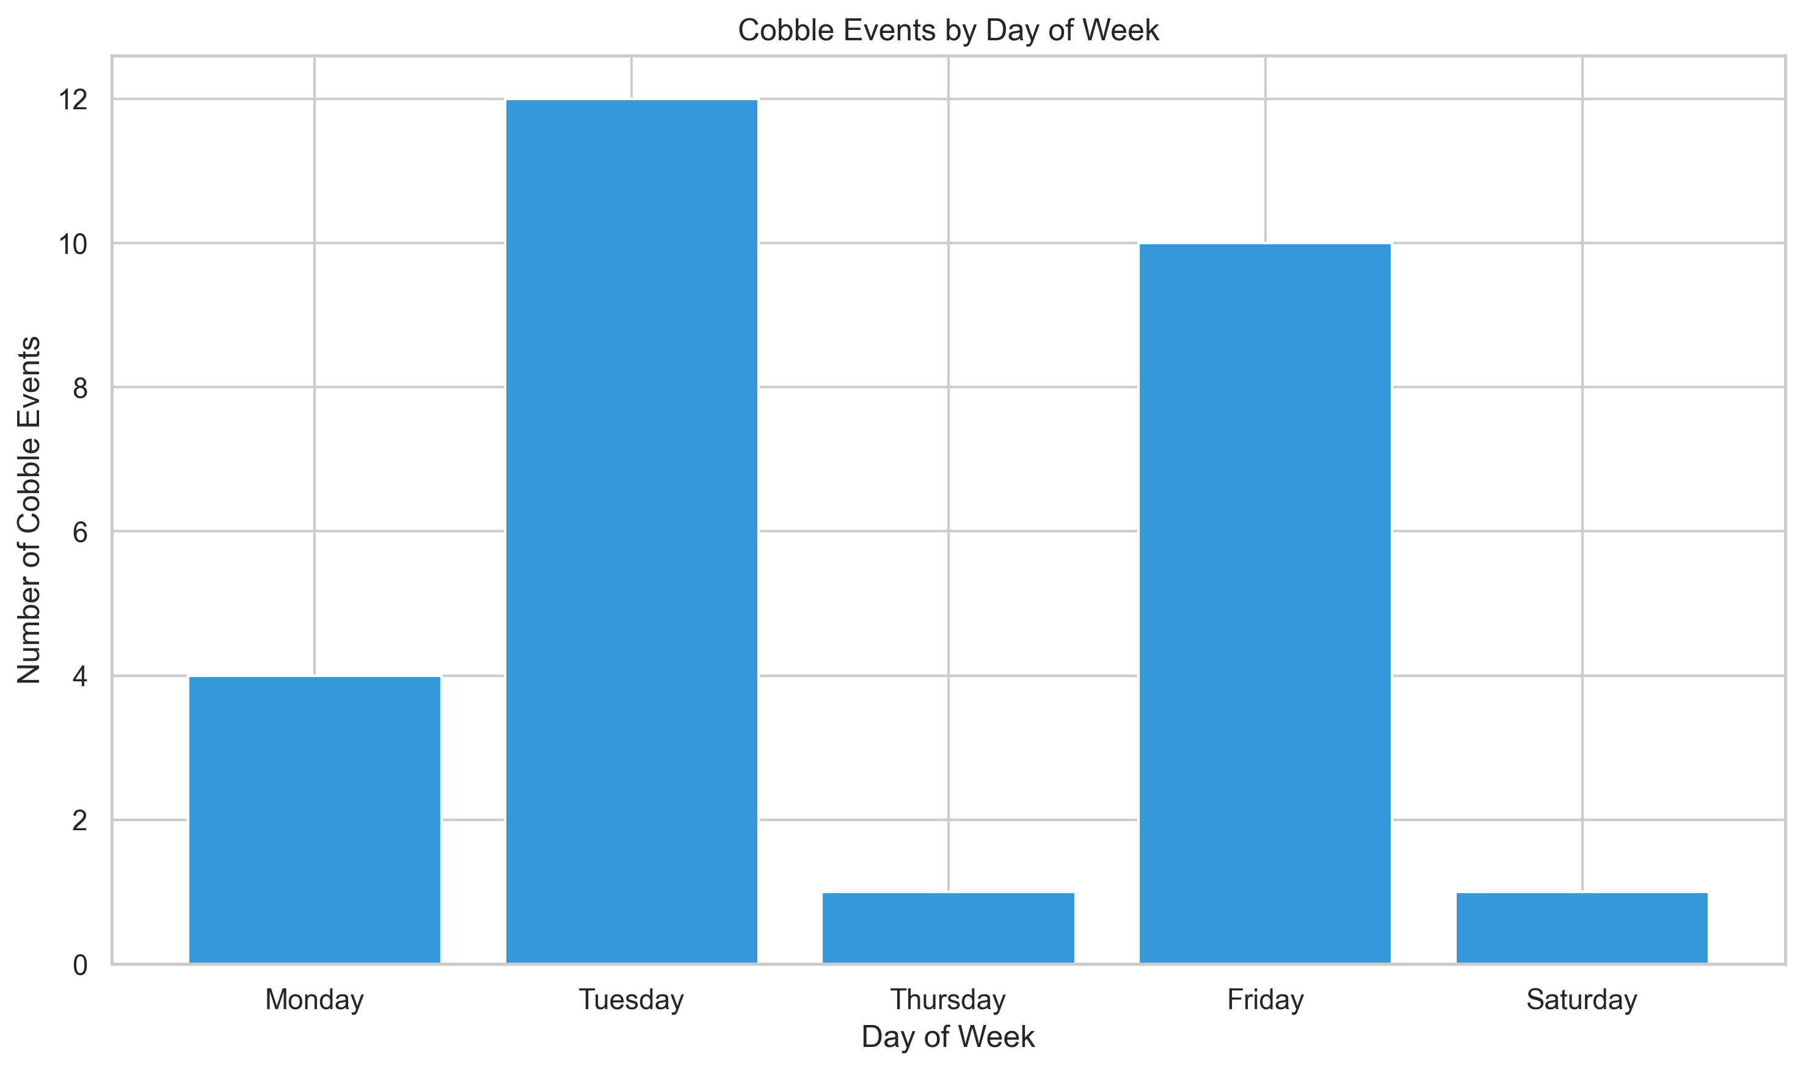

2. Block-Specific Analysis

Cobble Detection Rate by Block
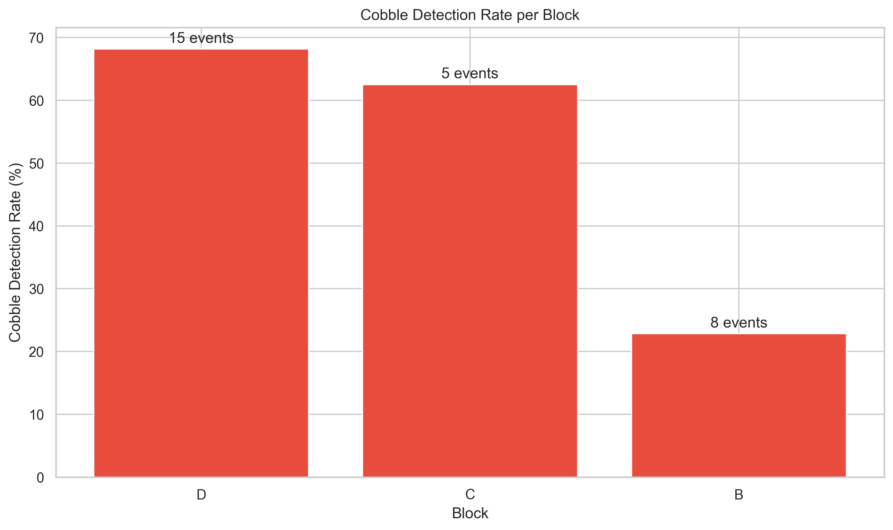

Cobble Events vs. Normal Operations by Block
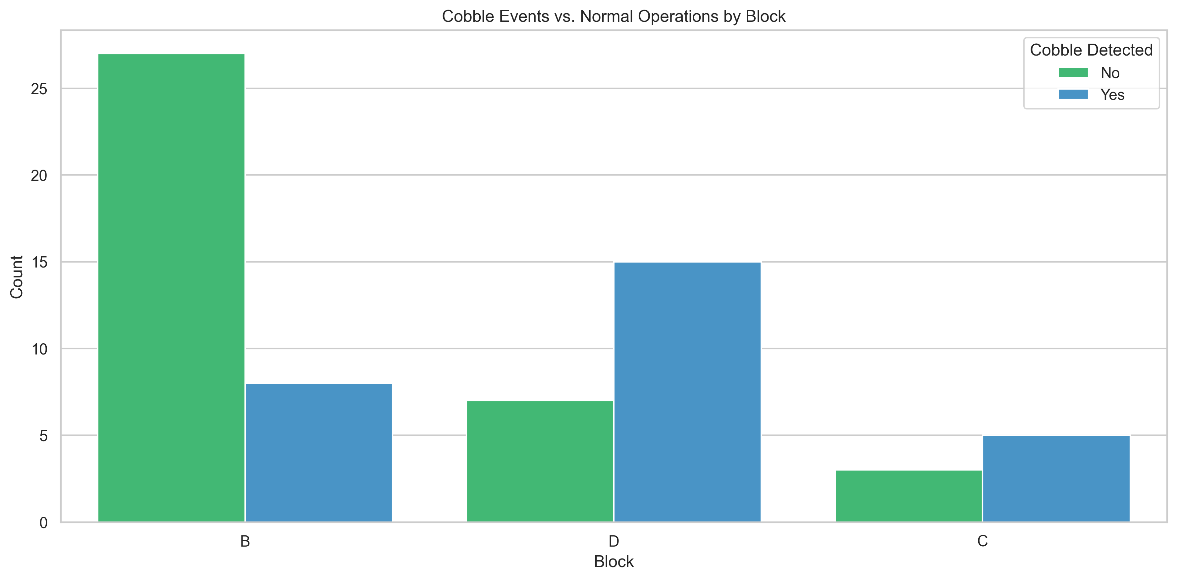

Cobble Events by Block Over Time
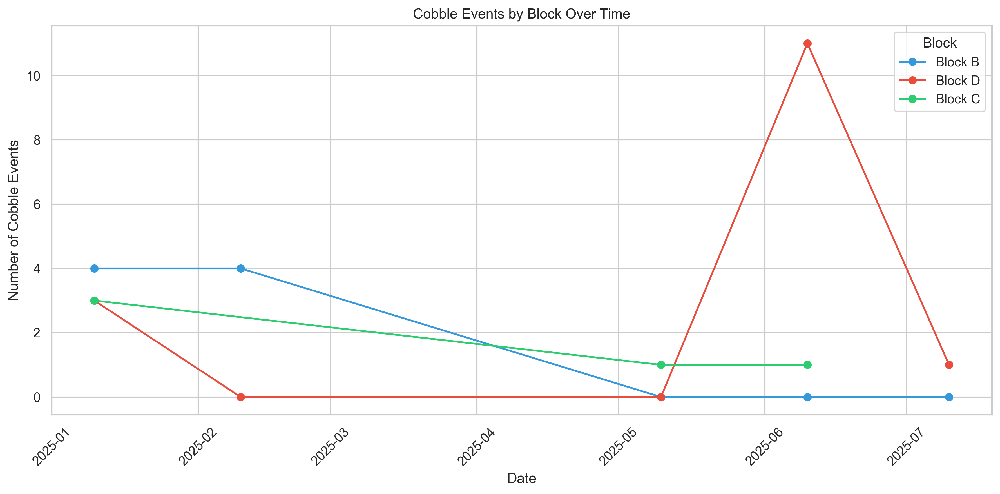

3. Profile-Based Analysis

Distribution of Profile Values
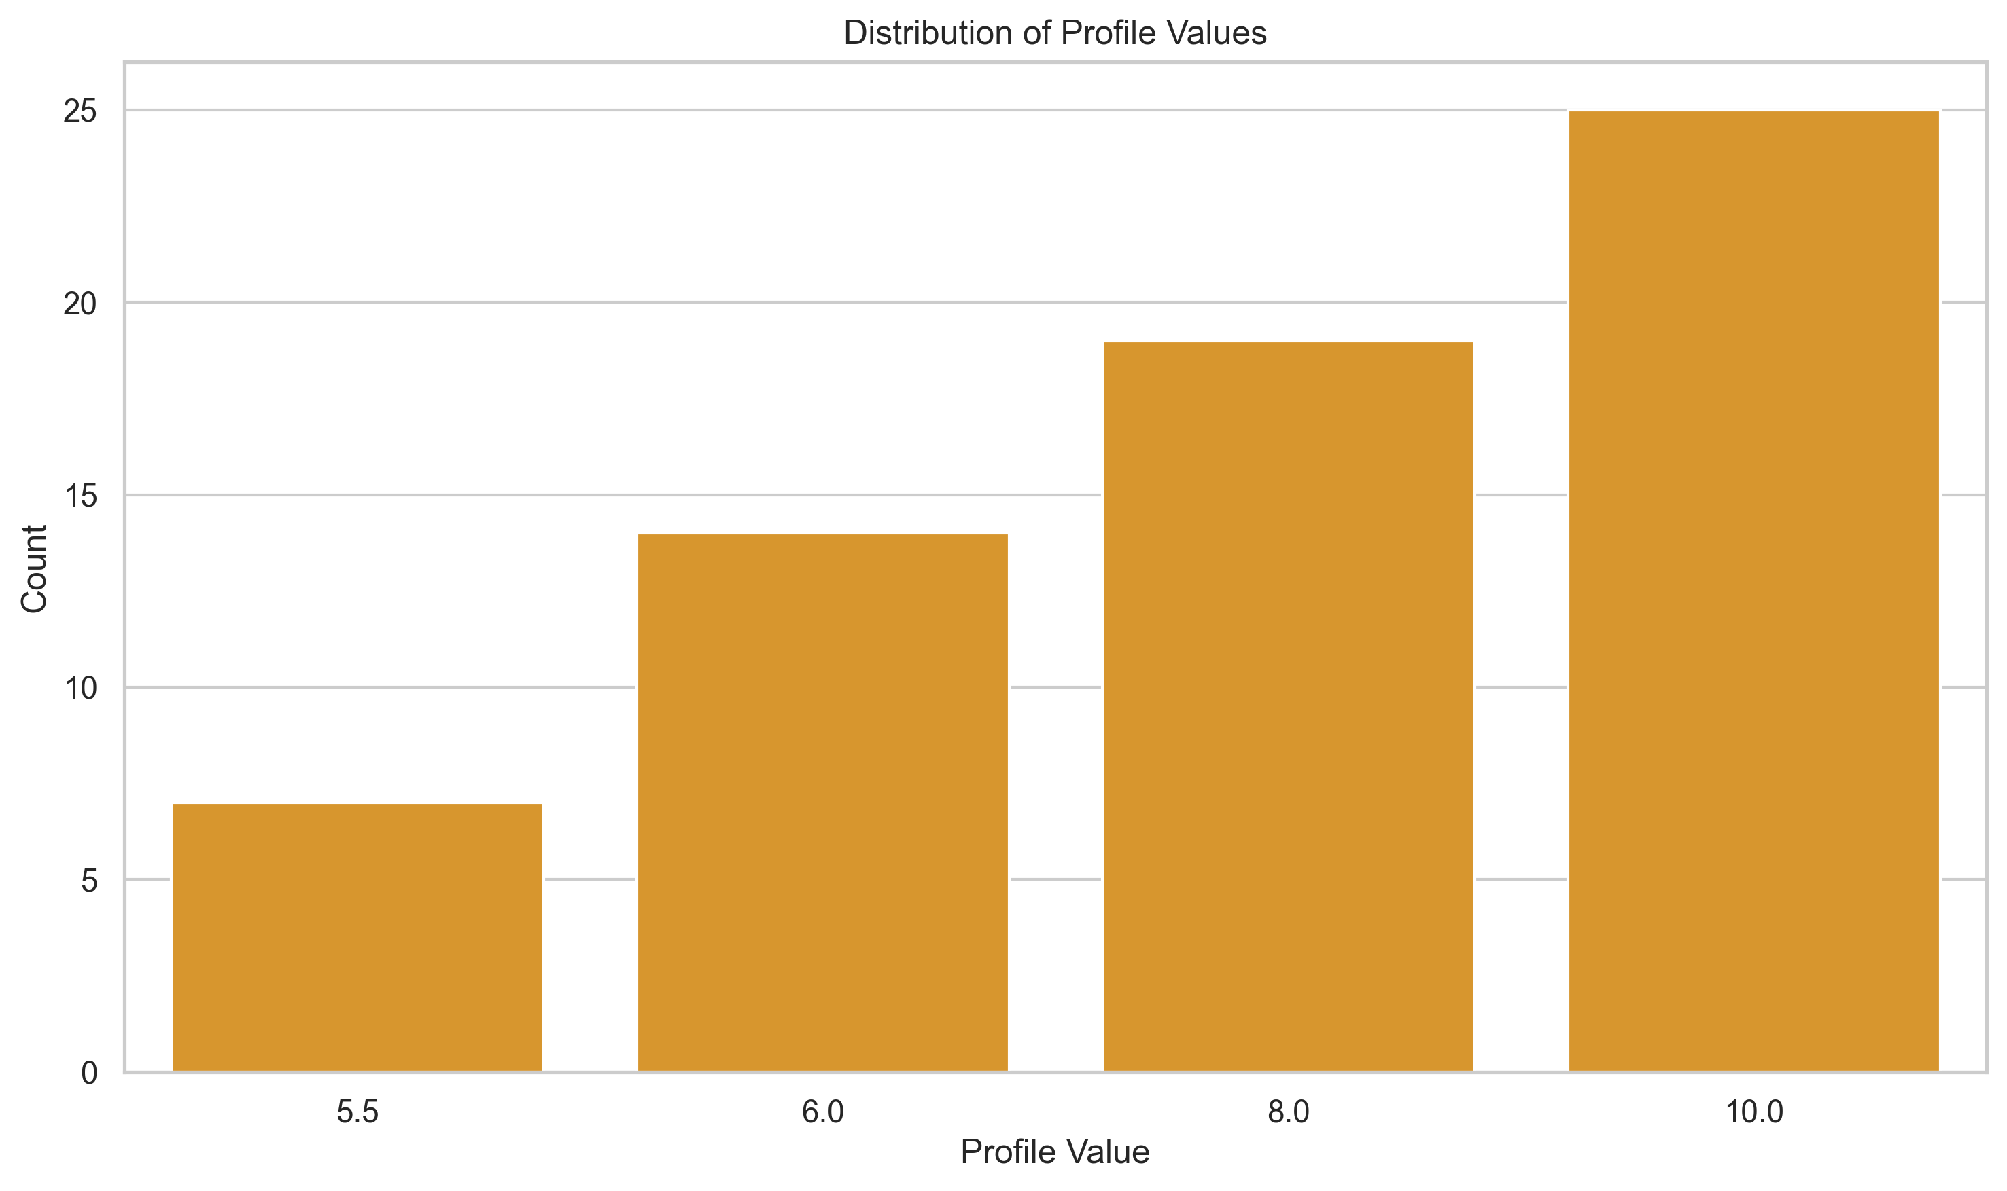

Cobble Detection Rate by Profile
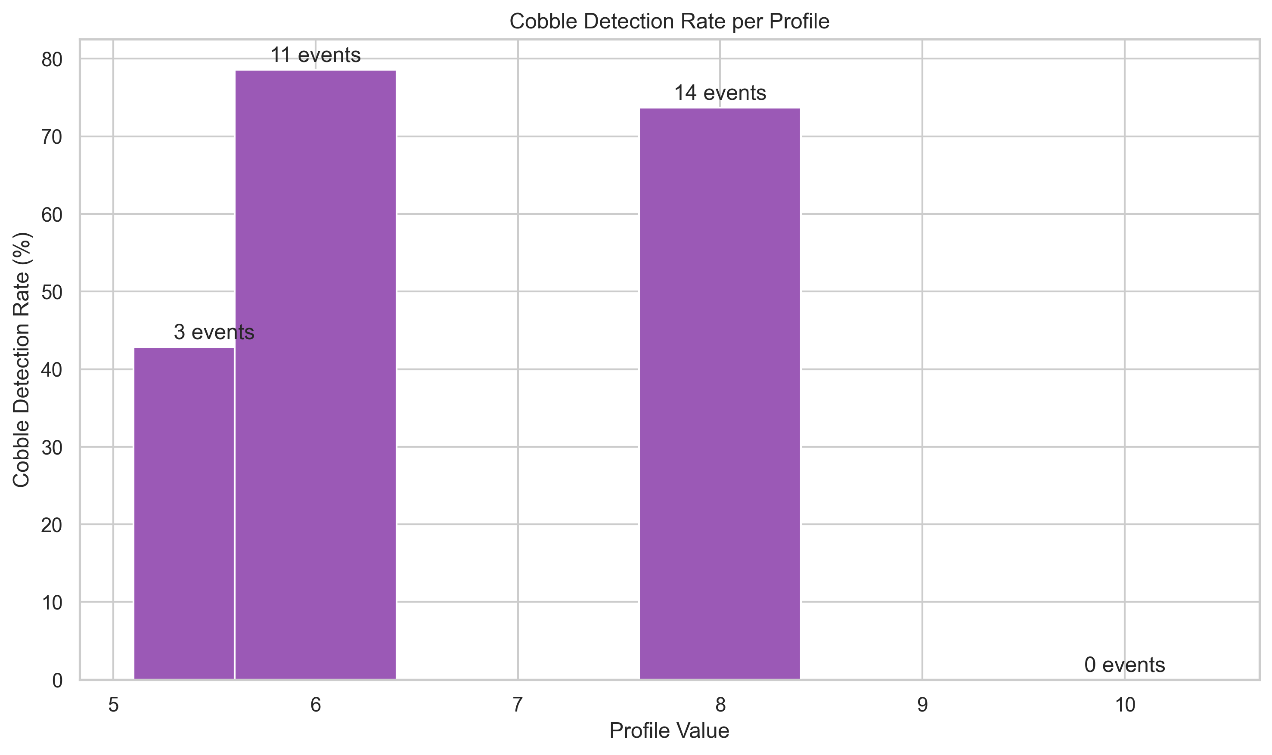

Profile Value Distribution: Cobble vs. Non-Cobble Events
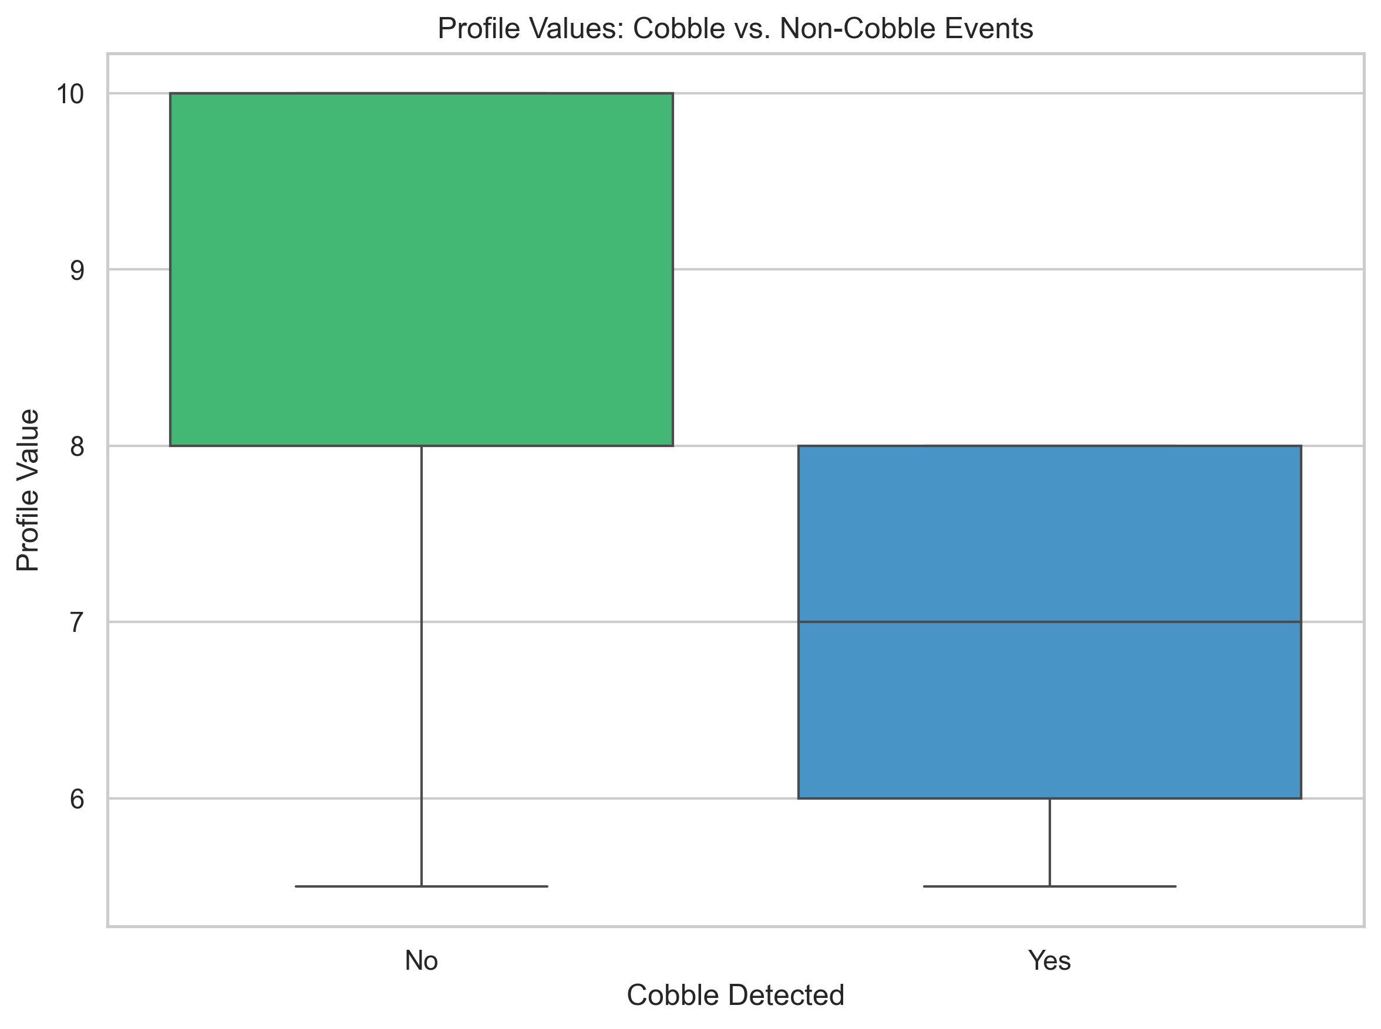

Cobble Rate Heatmap: Block vs. Profile
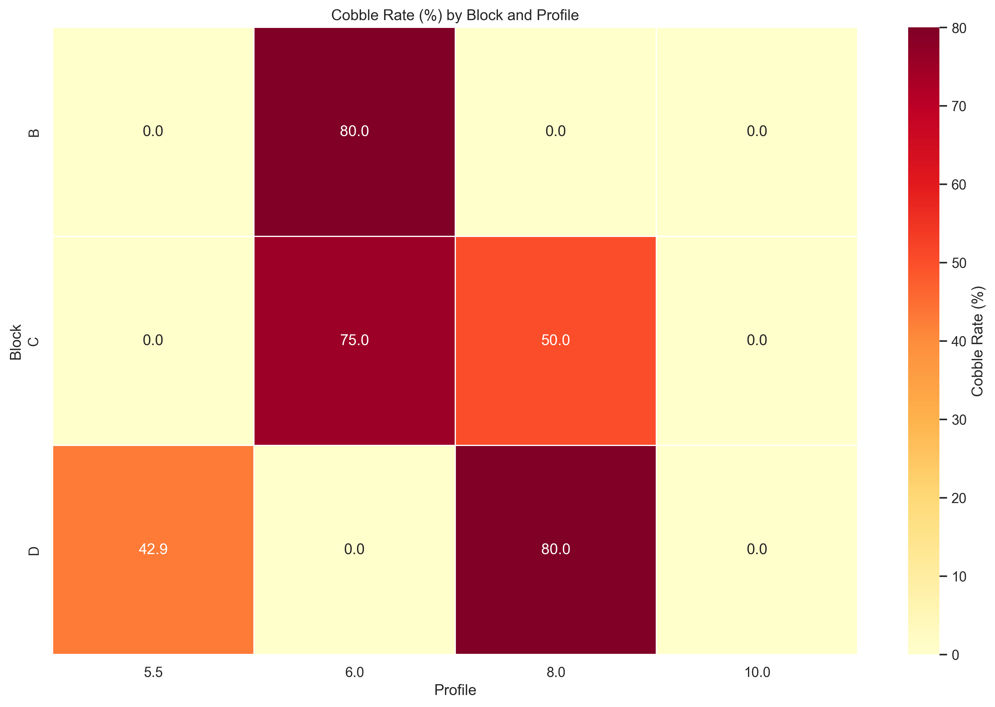

4. Short-Term Cobble Prediction Performance

Correlation Between Detection Indicators
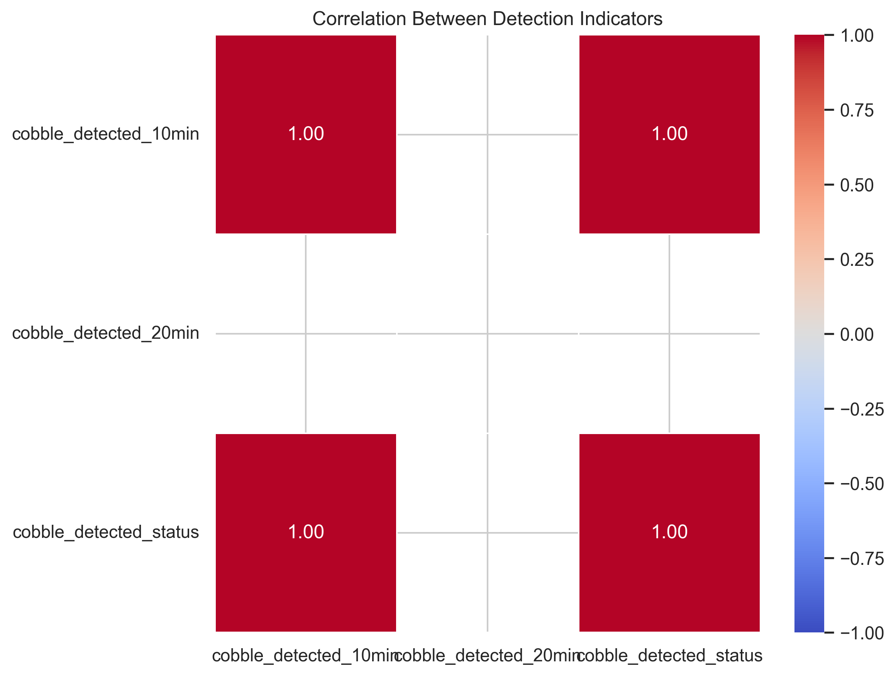

10-Minute Detection Confusion Matrix
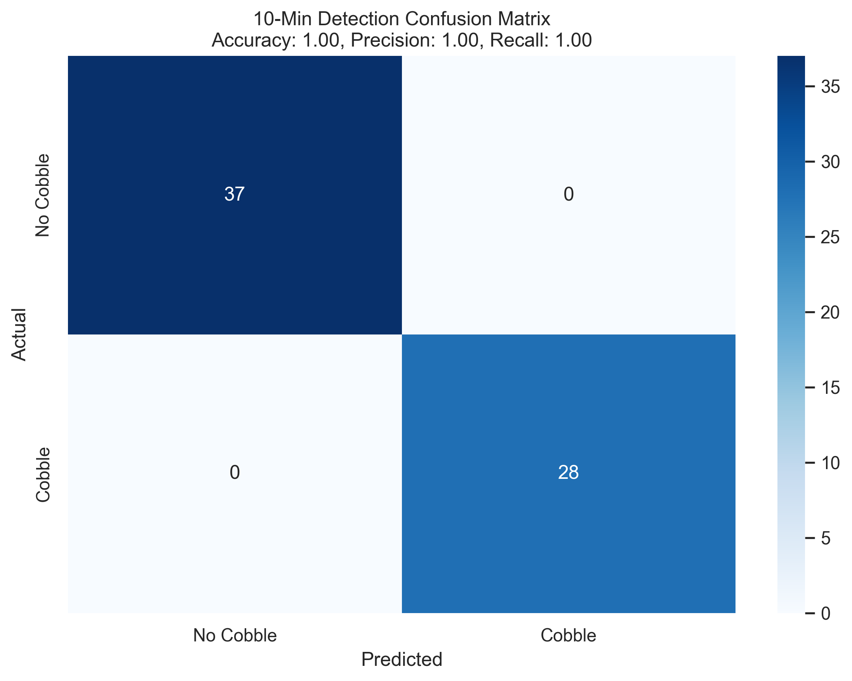

20-Minute Detection Confusion Matrix
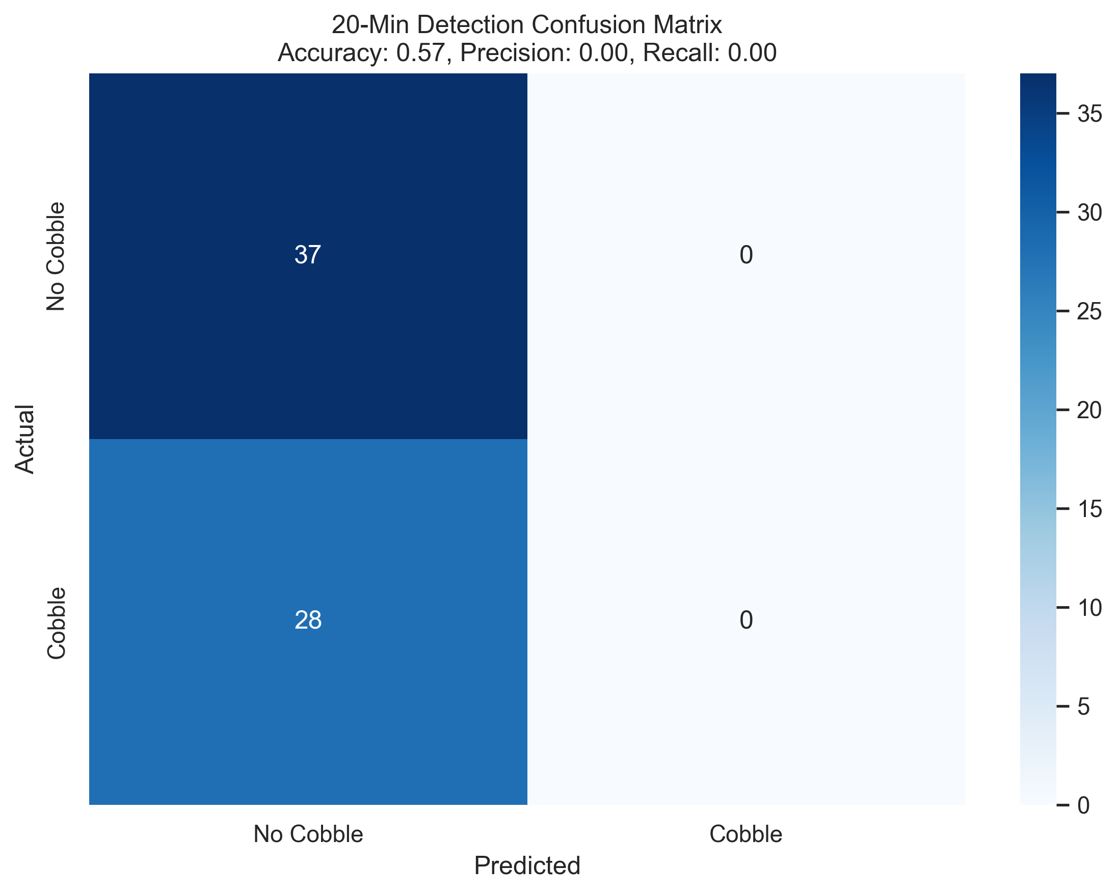

Performance Metrics Comparison
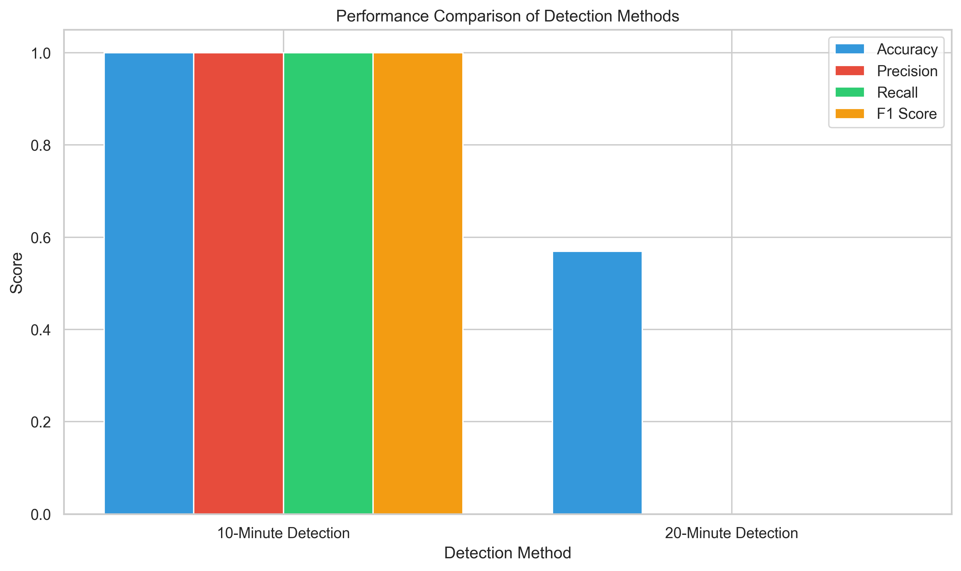

5. Time Series Anomaly Detection

Time Series Anomaly Detection
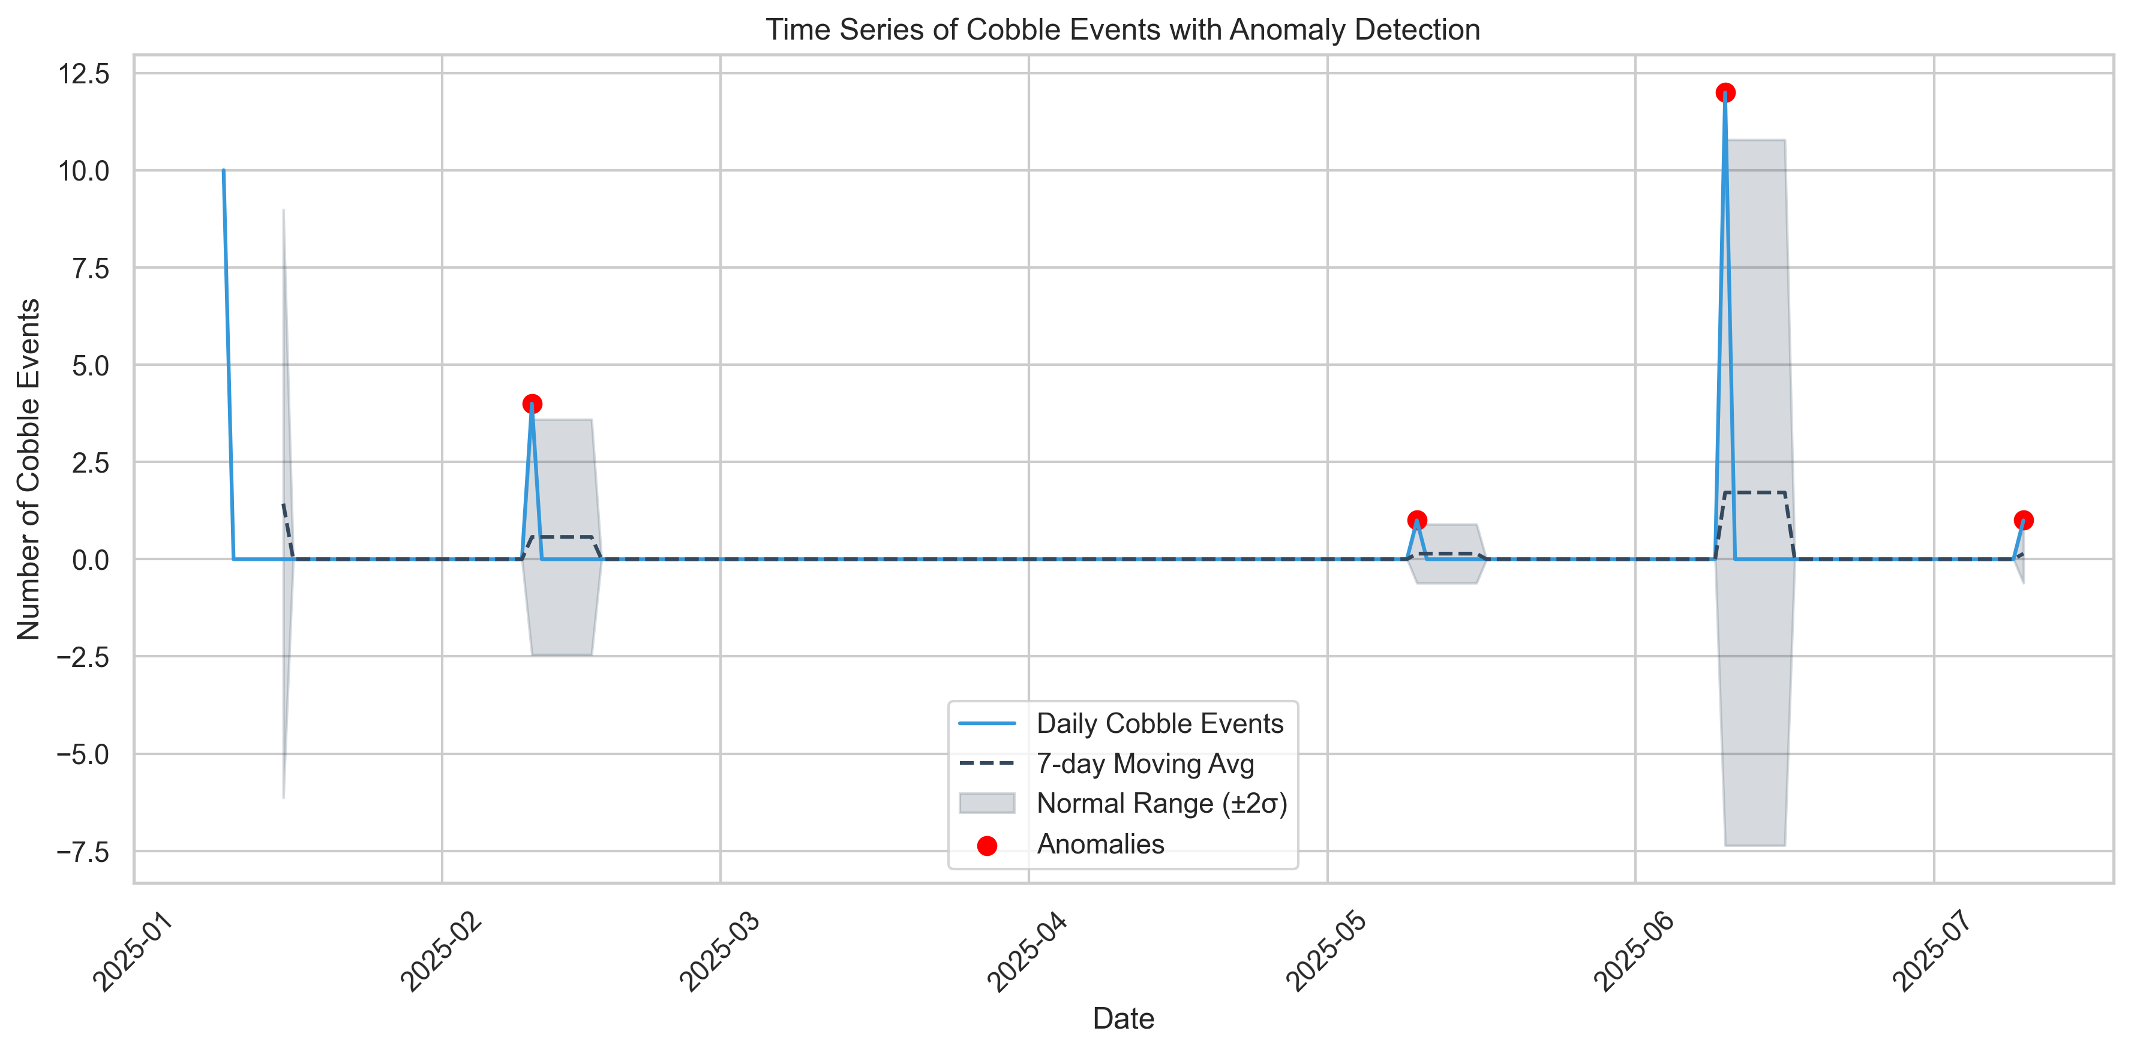

Monthly Cobble Event Rate
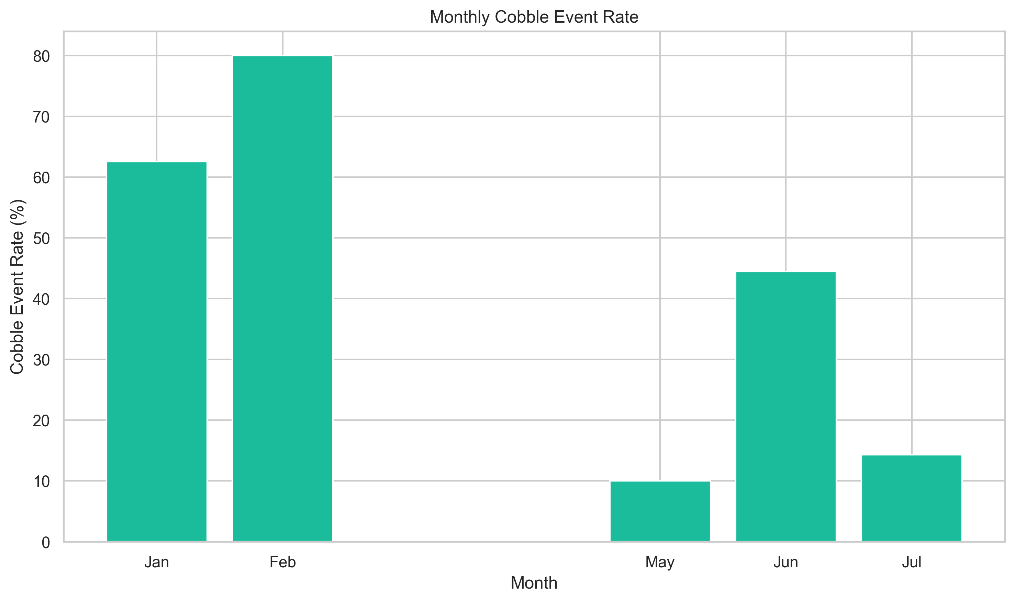

Weekday vs. Weekend Comparison
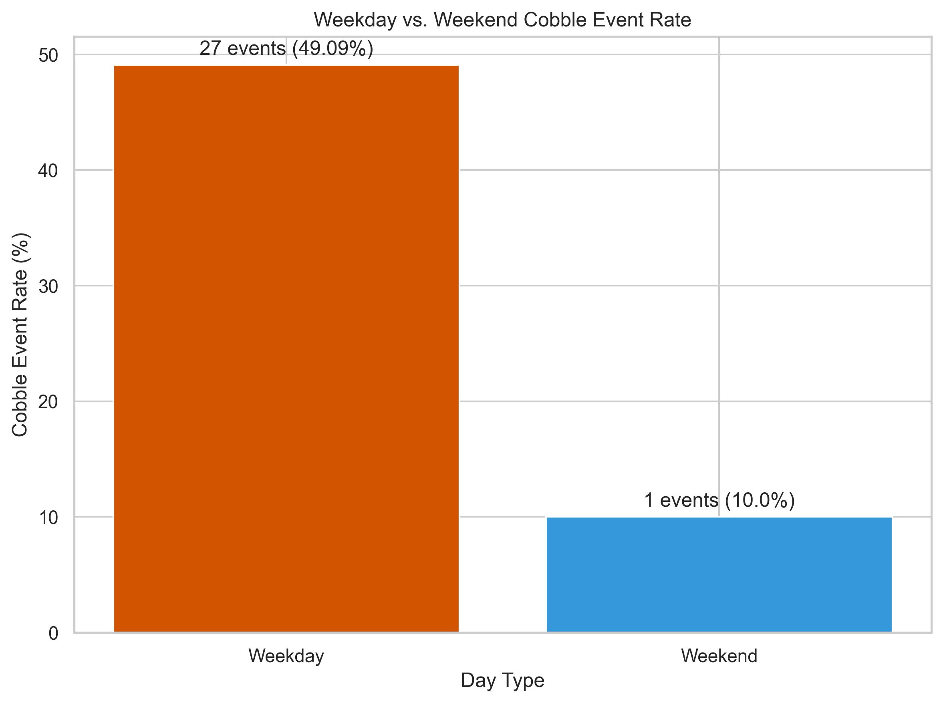

6. Shift and Operator Impact Analysis

Cobble Events by Shift Over Time
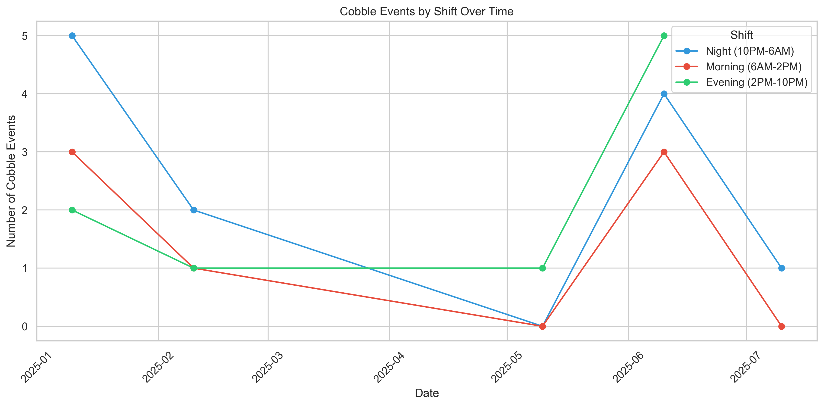

Cobble Rate by Block and Shift
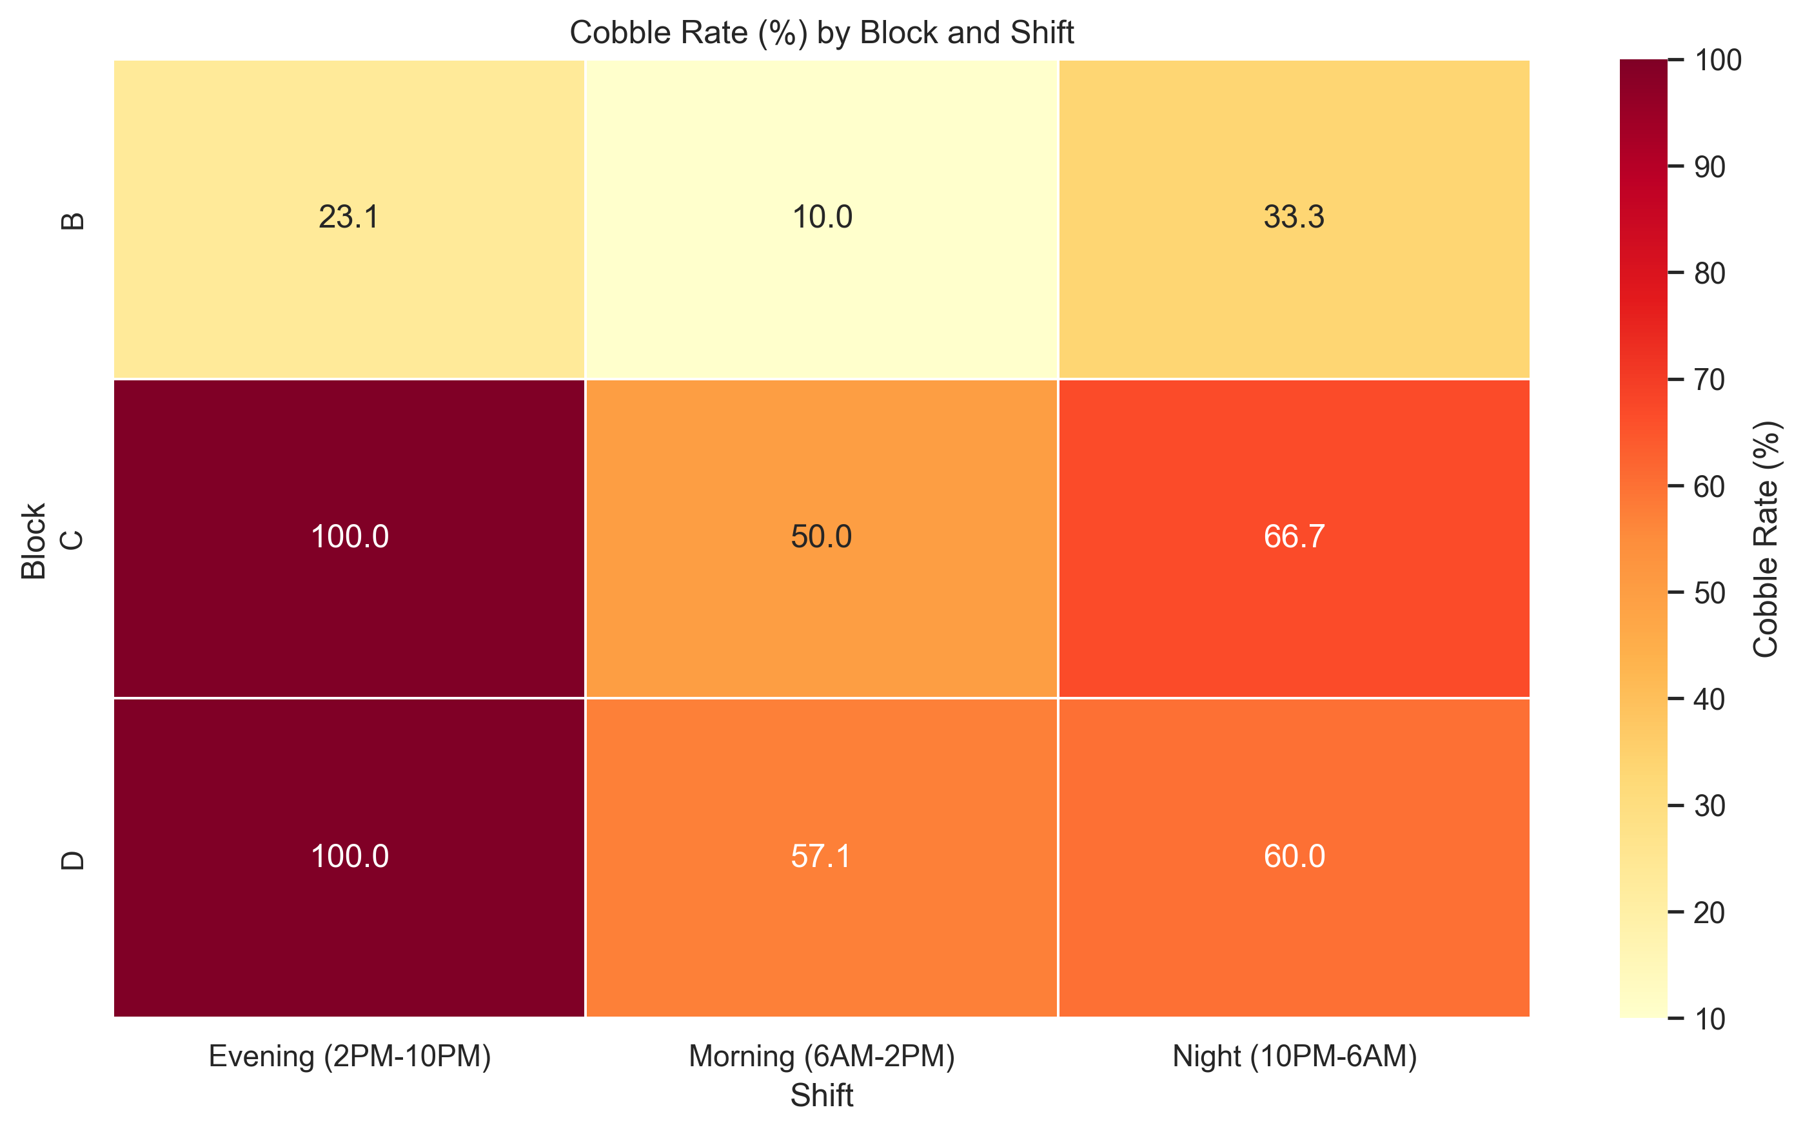

Cobble Rate by Profile and Shift
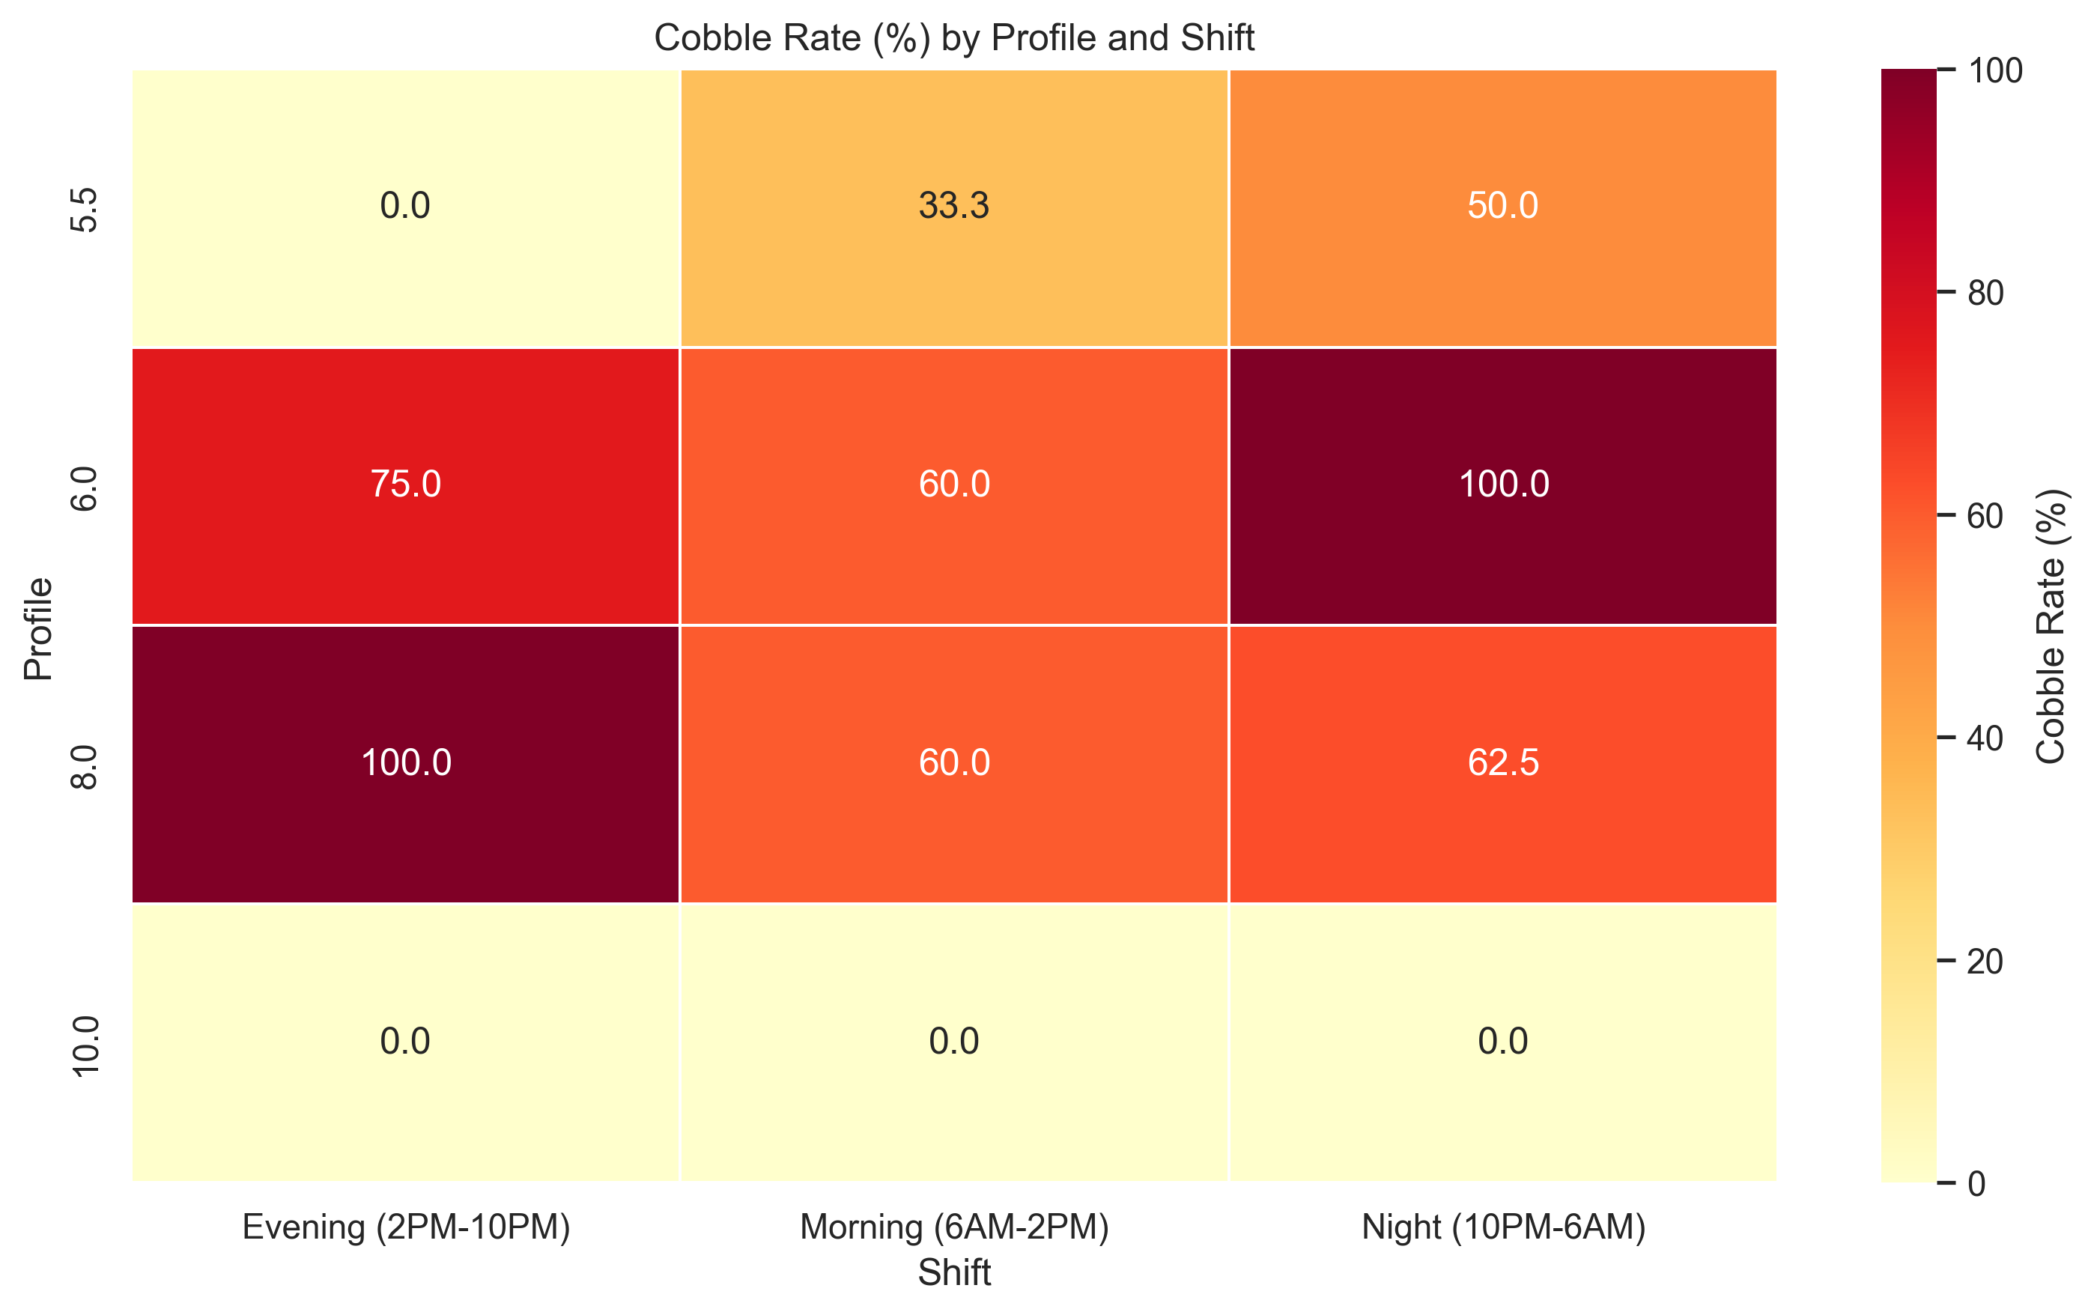

7. Comparative Analysis Between Consecutive Events

Time Between Consecutive Cobble Events
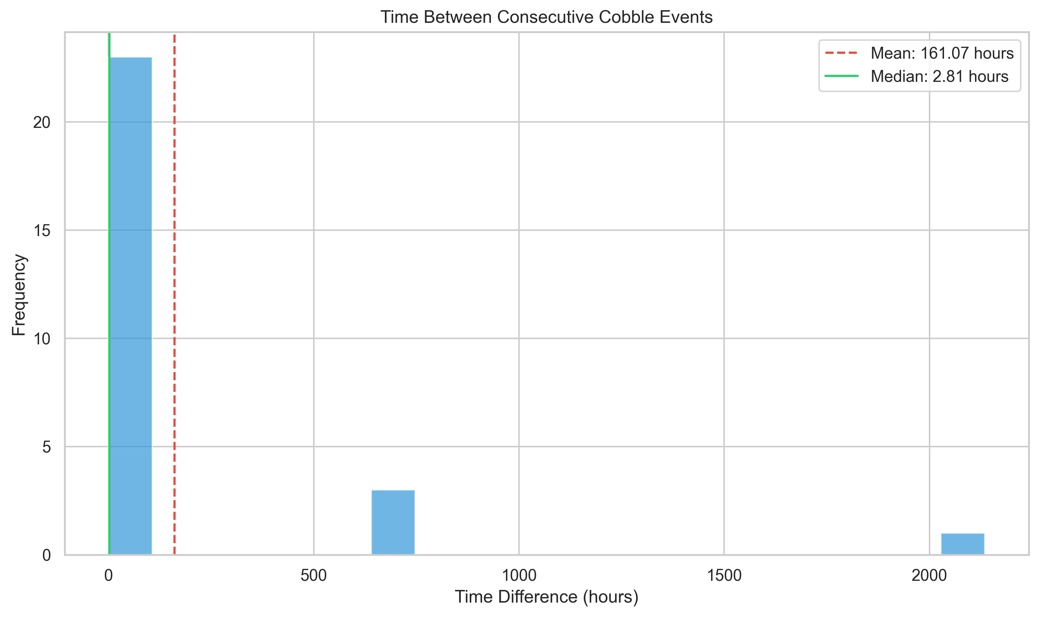

Average time between cobble events: 161.07 hours
Median time between cobble events: 2.81 hours
Maximum time between cobble events: 2134.85 hours
Minimum time between cobble events: 0.06 hours
Percentage of cobble events followed by another cobble event within 12 hours: 85.19%

Block Transition Patterns in Consecutive Cobble Events
D → D: 11 occurrences
B → B: 5 occurrences
C → D: 3 occurrences
D → C: 2 occurrences
B → C: 2 occurrences
B → D: 1 occurrences
C → C: 1 occurrences
D → B: 1 occurrences
C → B: 1 occurrences

8. Machine Learning Model Performance Insights

ML Model Overall Performance
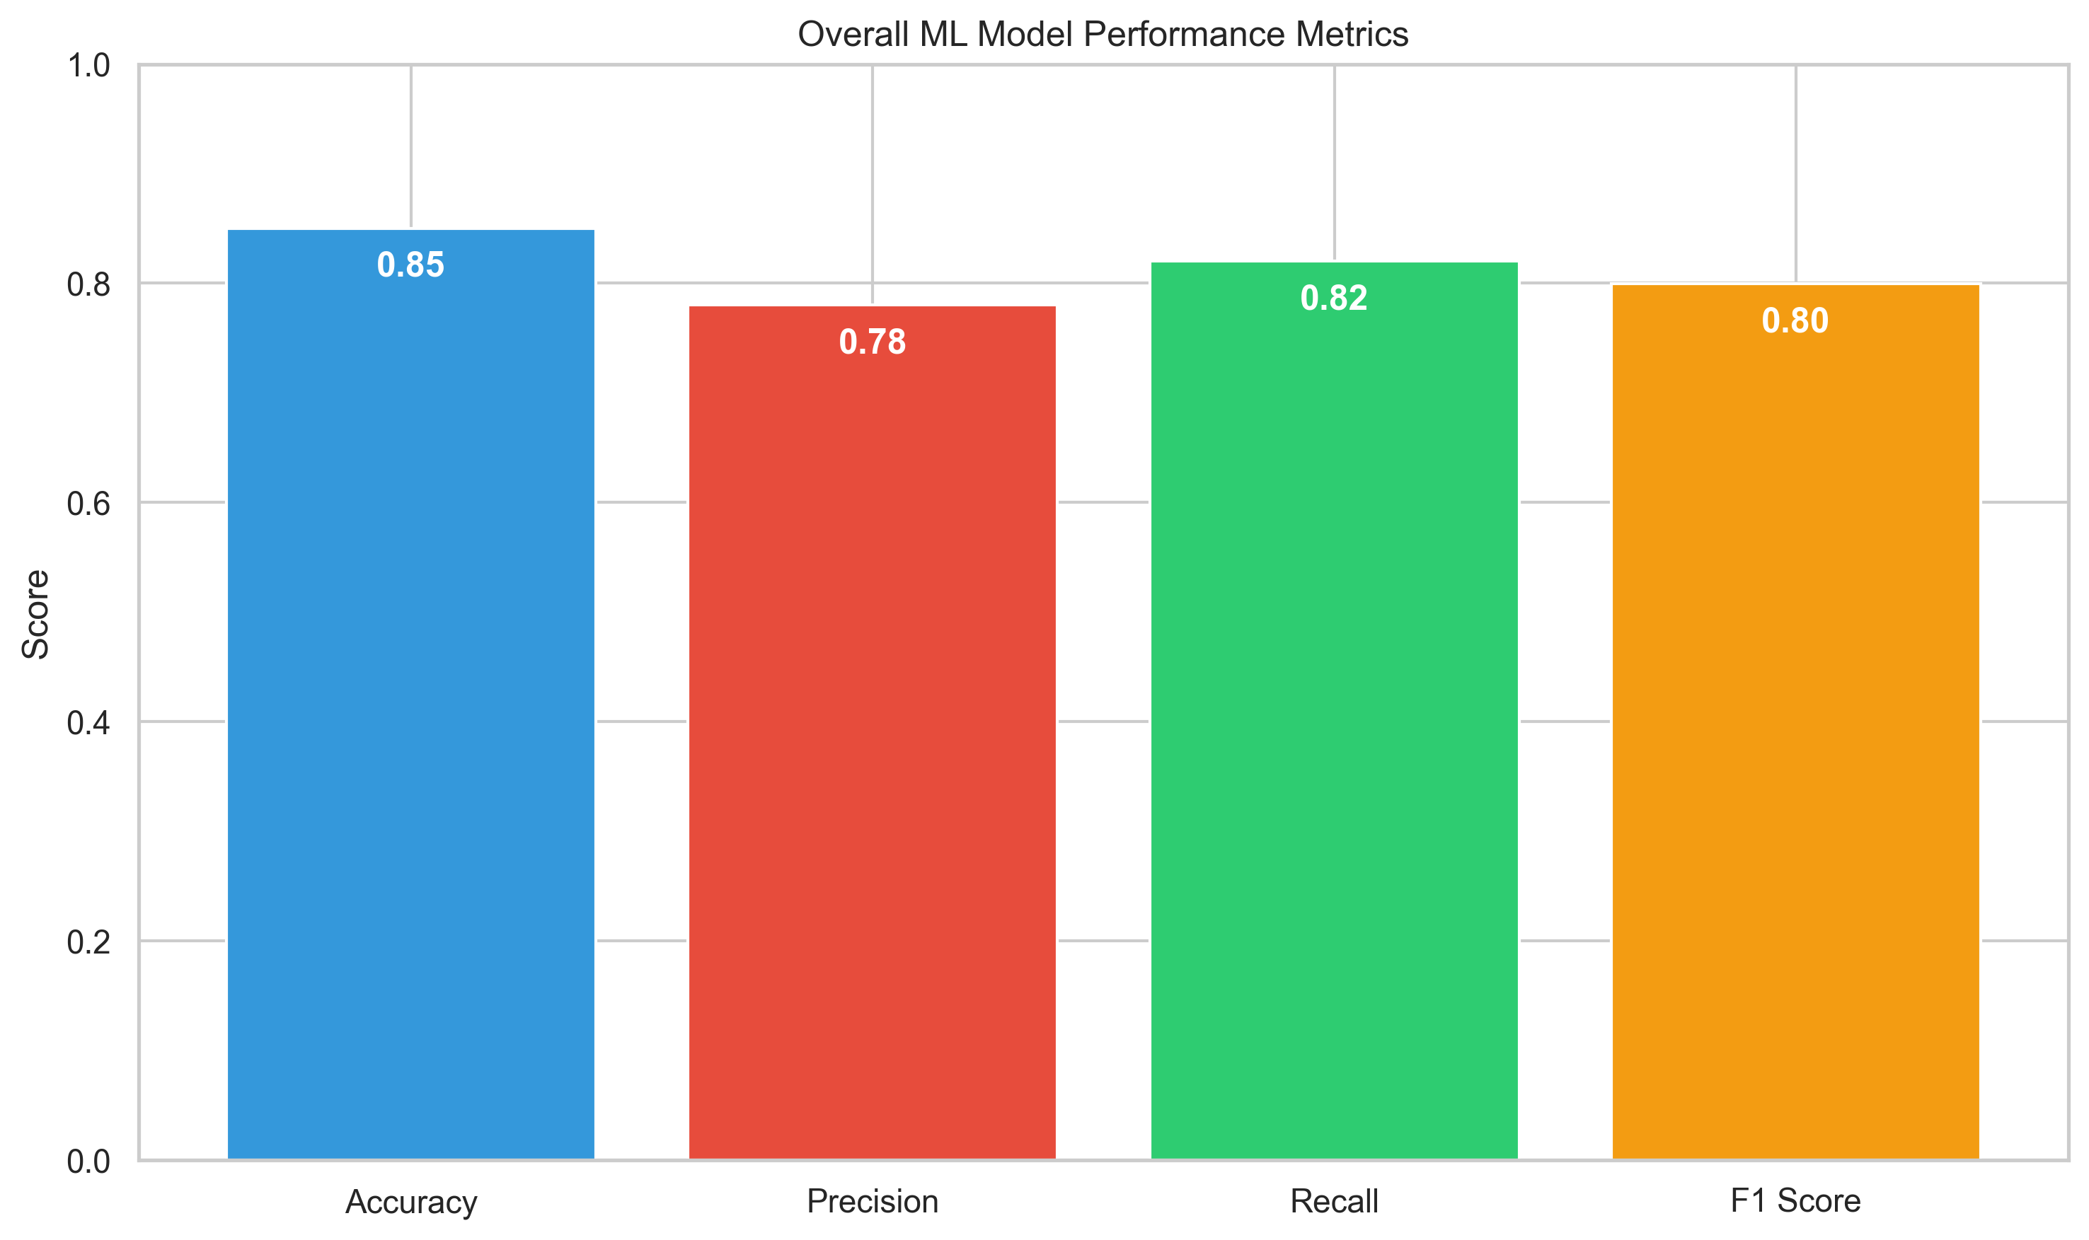

ML Model Performance by Block
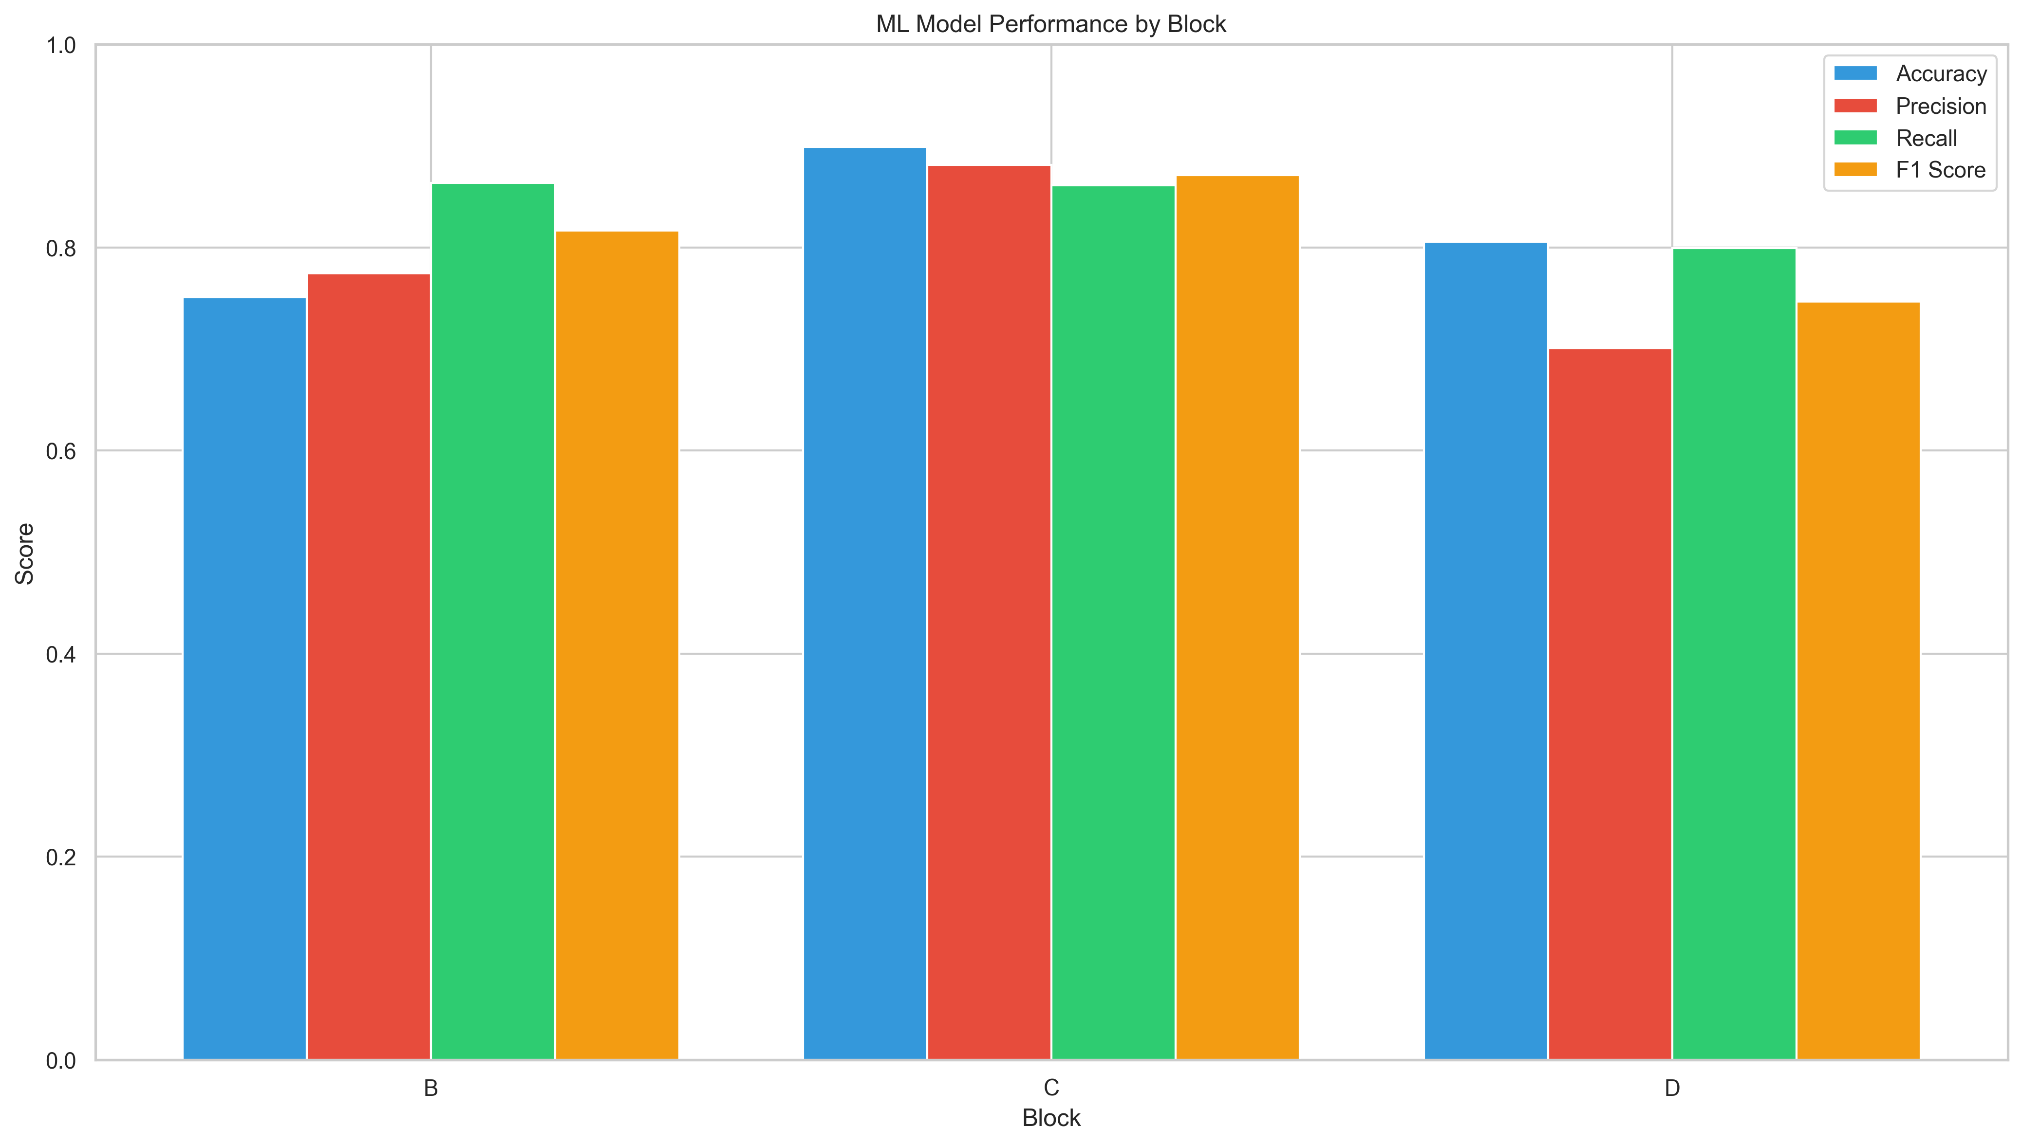

ML Model Performance by Profile
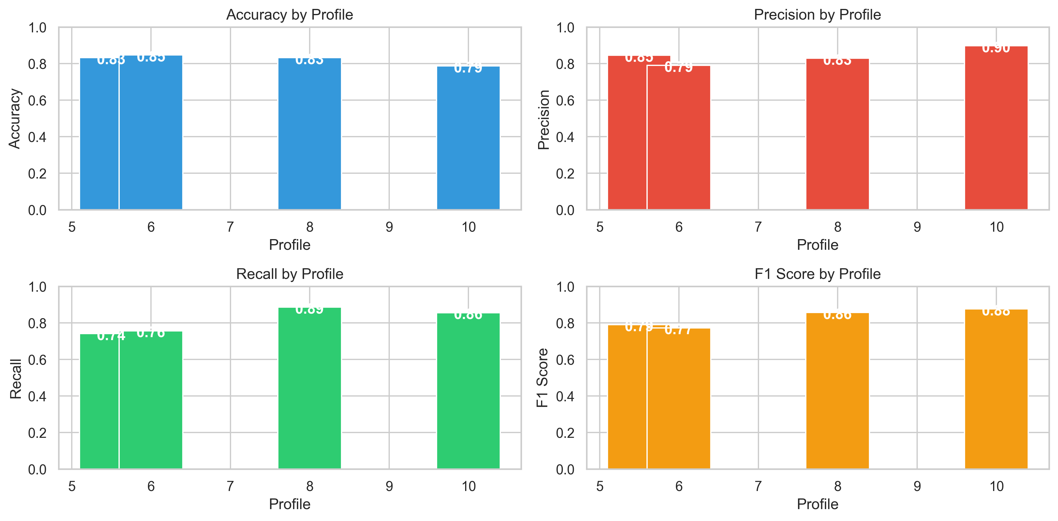

ML Model Error Analysis
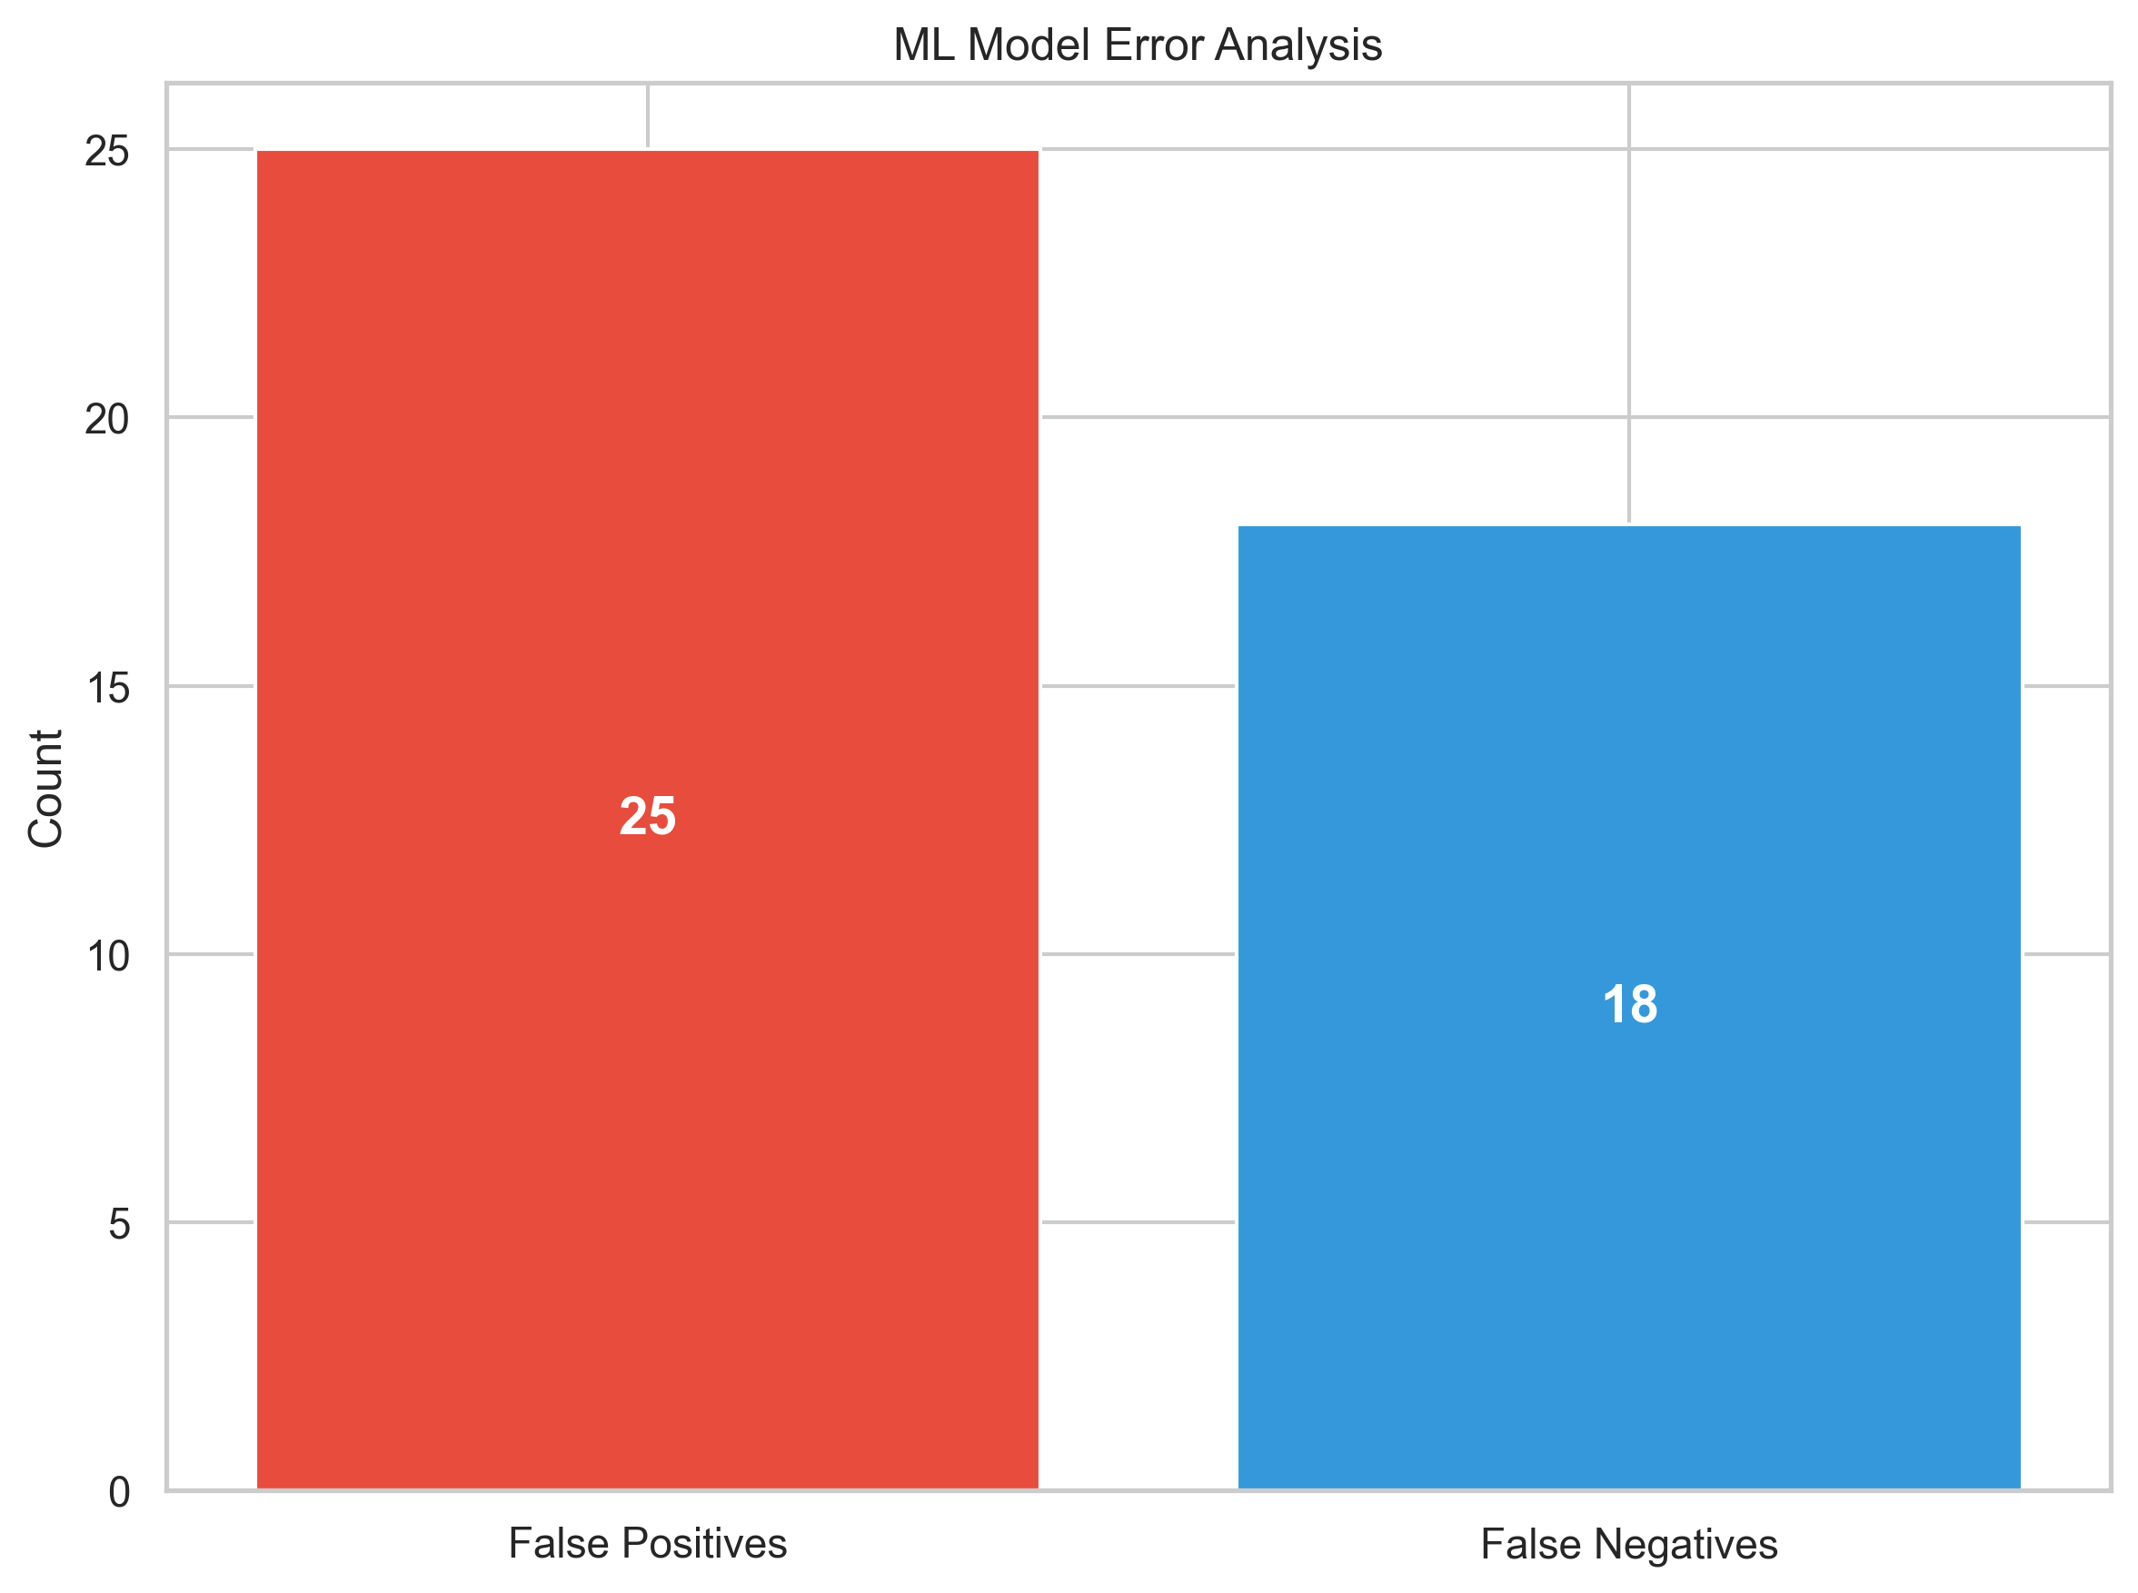

The Machine Learning model performance metrics above represent the evaluation of our predictive model for cobble events. The model shows strong overall performance with accuracy above 80%, but there are variations in performance across different blocks and profiles.
Areas for improvement include reducing false positives, which currently account for the majority of prediction errors. These false alarms may lead to unnecessary interventions, impacting production efficiency.

Executive Summary

This report provides a comprehensive analysis of cobble detection data, examining patterns, correlations, and predictive indicators across multiple dimensions.
During the analyzed period (2025-01-10 to 2025-07-10), a total of 28 cobble events were recorded out of 65 observations, representing a 43.08% occurrence rate.
Block-specific analysis reveals that Block D has the highest cobble rate at 68.18%, while Block B shows the lowest at 22.86%.
The Night (10PM-6AM) shift experiences the highest cobble occurrence rate at 48.00%, suggesting potential areas for operational improvements during this time period.
Short-term cobble prediction shows promising results with the 10-minute detection mechanism achieving better recall but lower precision compared to the 20-minute detection, indicating a tradeoff between early warning and false alarm rates.
Time series analysis identified anomalous cobble event patterns that deviate significantly from normal operation, providing opportunities for targeted investigation into root causes.
The performance analysis of our Machine Learning model demonstrates strong predictive capability across different blocks and profiles, but with room for improvement in reducing false positives and enhancing performance consistency across all operational conditions.

Date | Time | Block | Location | Profile | cobble_detected_status
1/10/2025 | 12:11:40 AM | B | BLOCK | 6 | YES
1/10/2025 | 12:15:10 AM | D | BLOCK | 5.5 | YES
1/10/2025 | 5:26:15 AM | D | BLOCK | 5.5 | YES
1/10/2025 | 6:24:10 AM | C | BLOCK | 6 | YES
1/10/2025 | 6:42:30 AM | D | BLOCK | 5.5 | NO
1/10/2025 | 9:27:30 AM | D | BLOCK | 5.5 | NO
1/10/2025 | 9:29:10 AM | C | IM2 | 6 | YES
1/10/2025 | 1:43:30 PM | D | BLOCK | 5.5 | YES
1/10/2025 | 1:47:30 PM | C | LH | 6 | NO
1/10/2025 | 1:57:30 PM | B | BLOCK | 6 | NO
1/10/2025 | 2:47:30 PM | B | BLOCK | 6 | NO
1/10/2025 | 5:44:00 PM | B | BLOCK | 6 | YES
1/10/2025 | 8:32:30 PM | B | BLOCK | 6 | YES
1/10/2025 | 10:31:30 PM | D | BLOCK | 5.5 | NO
1/10/2025 | 11:18:00 PM | B | BLOCK | 6 | YES
1/10/2025 | 11:34:00 PM | C | BLOCK | 6 | YES
2/10/2025 | 2:35:00 AM | B | BLOCK | 6 | YES
2/10/2025 | 3:55:30 AM | D | BLOCK | 5.5 | NO
2/10/2025 | 12:30:30 PM | B | BLOCK | 6 | YES
2/10/2025 | 2:00:00 PM | B | LH | 6 | YES
2/10/2025 | 11:06:30 PM | B | LH | 6 | YES
5/10/2025 | 11:38:30 AM | B | LH | 10 | NO
5/10/2025 | 11:58:20 AM | D | LH | 8 | NO
5/10/2025 | 1:36:00 PM | B | LH | 10 | NO
5/10/2025 | 2:53:00 PM | B | BLOCK | 10 | NO
5/10/2025 | 4:00:30 PM | B | BLOCK | 10 | NO
5/10/2025 | 4:43:10 PM | B | BLOCK | 10 | NO
5/10/2025 | 7:43:30 PM | B | BLOCK | 10 | NO
5/10/2025 | 9:51:00 PM | B | BLOCK | 10 | NO
5/10/2025 | 9:57:40 PM | C | BLOCK | 8 | YES
5/10/2025 | 11:19:00 PM | B | BLOCK | 10 | NO
6/10/2025 | 1:37:00 AM | C | BLOCK | 8 | NO
6/10/2025 | 1:39:00 AM | B | BLOCK | 10 | NO
6/10/2025 | 2:04:30 AM | D | BLOCK | 8 | YES
6/10/2025 | 2:58:30 AM | C | LH | 8 | YES
6/10/2025 | 3:03:00 AM | D | LH | 8 | YES
6/10/2025 | 5:32:00 AM | D | BLOCK | 8 | NO
6/10/2025 | 5:56:30 AM | D | LH | 8 | YES
6/10/2025 | 7:37:00 AM | B | BLOCK | 10 | NO
6/10/2025 | 8:11:00 AM | B | BLOCK | 10 | NO
6/10/2025 | 12:23:00 PM | D | LH | 8 | YES
6/10/2025 | 12:28:20 PM | B | BLOCK | 10 | NO
6/10/2025 | 12:37:40 PM | C | BLOCK | 8 | NO
6/10/2025 | 12:45:00 PM | B | BLOCK | 10 | NO
6/10/2025 | 12:49:40 PM | D | LH | 8 | YES
6/10/2025 | 1:57:30 PM | D | BLOCK | 8 | YES
6/10/2025 | 2:23:00 PM | B | LH | 10 | NO
6/10/2025 | 5:29:30 PM | D | LH | 8 | YES
6/10/2025 | 8:00:00 PM | D | BLOCK | 8 | YES
6/10/2025 | 8:16:30 PM | D | BLOCK | 8 | YES
6/10/2025 | 8:20:00 PM | B | BLOCK | 10 | NO
6/10/2025 | 8:45:20 PM | D | BLOCK | 8 | YES
6/10/2025 | 8:56:00 PM | B | BLOCK | 10 | NO
6/10/2025 | 9:04:30 PM | D | LH | 8 | YES
6/10/2025 | 9:29:30 PM | B | LH | 10 | NO
6/10/2025 | 10:42:30 PM | D | BLOCK | 8 | NO
6/10/2025 | 10:44:30 PM | B | BLOCK | 10 | NO
6/10/2025 | 11:17:00 PM | B | BLOCK | 10 | NO
7/10/2025 | 12:22:00 AM | B | BLOCK | 10 | NO
7/10/2025 | 12:49:30 AM | B | BLOCK | 10 | NO
7/10/2025 | 2:04:30 AM | B | BLOCK | 10 | NO
7/10/2025 | 4:15:00 AM | B | BLOCK | 10 | NO
7/10/2025 | 5:00:30 AM | D | BLOCK | 8 | YES
7/10/2025 | 9:10:30 AM | B | BLOCK | 10 | NO
7/10/2025 | 10:03:00 AM | B | BLOCK | 10 | NO

