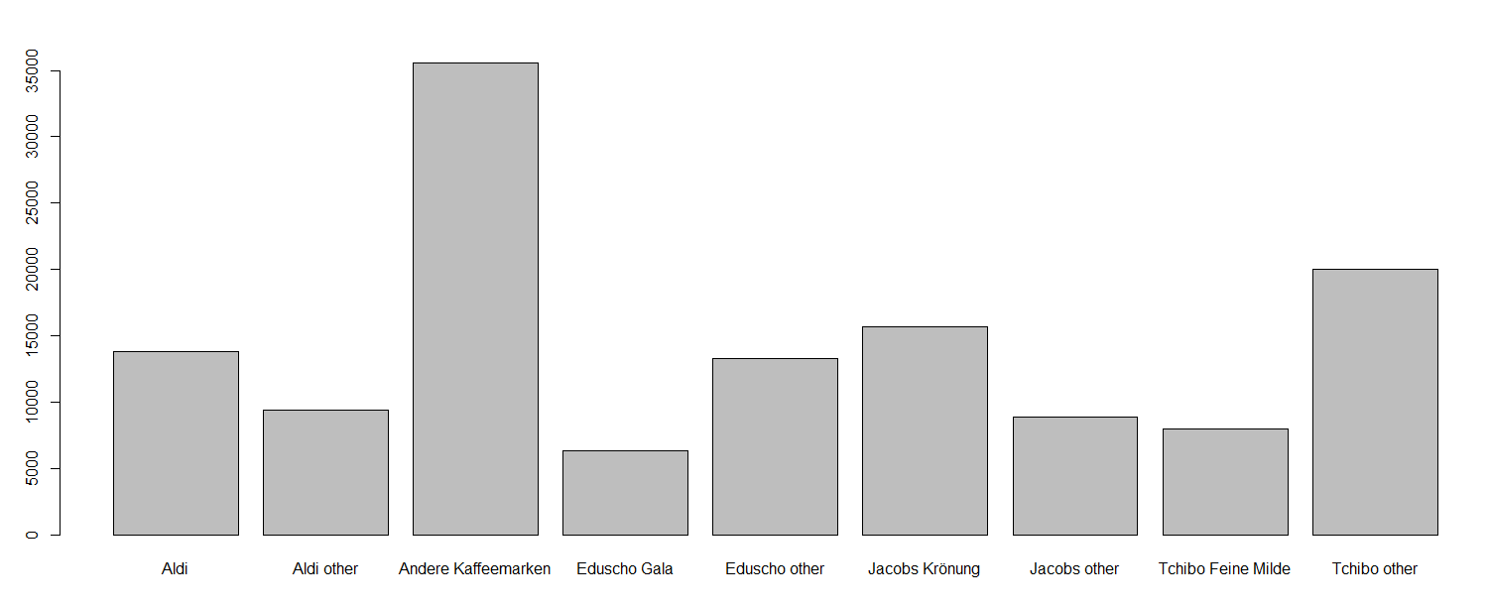

• Which brands of coffee are more popular? Given a brand, are all variants equally preferred?

ANSWER:

By seeing the summary data, brad Andere Kaffeemarken is most popular with 35548 out of 130986

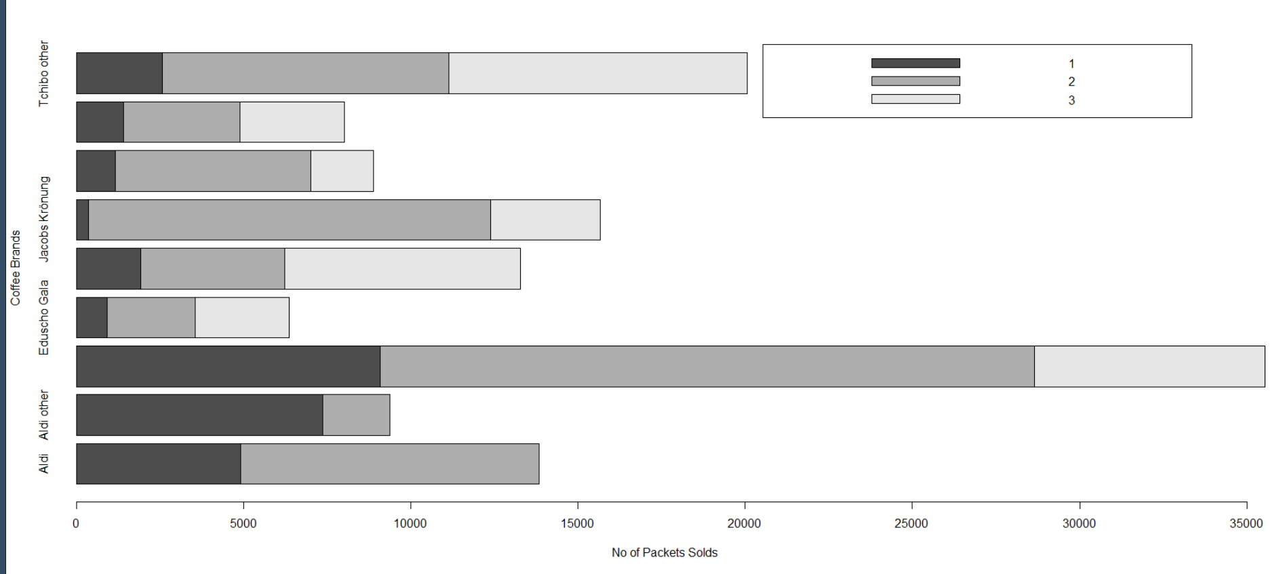

Above shows Coffee Brands, with prices and now of them sold in each brand..