**[0/1 Knapsack Problem | Dynamic Programming | Example](https://www.gatevidyalay.com/0-1-knapsack-problem-using-dynamic-programming-approach/)**

**Knapsack Problem-**

You are given the following-

* A knapsack (kind of shoulder bag) with limited weight capacity.
* Few items each having some weight and value.

**The problem states-**

Which items should be placed into the knapsack such that-

* The value or profit obtained by putting the items into the knapsack is maximum.
* And the weight limit of the knapsack does not exceed.

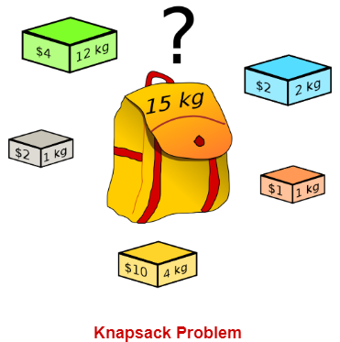

**Knapsack Problem Variants-**

Knapsack problem has the following two variants-

1. Fractional Knapsack Problem
2. 0/1 Knapsack Problem

**0/1 Knapsack Problem-**

In 0/1 Knapsack Problem,

* As the name suggests, items are indivisible here.
* We can not take the fraction of any item.
* We have to either take an item completely or leave it completely.
* It is solved using dynamic programming approach.

**0/1 Knapsack Problem Using Dynamic Programming-**

Consider-

* Knapsack weight capacity = w
* Number of items each having some weight and value = n

0/1 knapsack problem is solved using dynamic programming in the following steps-

**Step-01:**

* Draw a table say ‘T’ with (n+1) number of rows and (w+1) number of columns.
* Fill all the boxes of 0th row and 0th column with zeroes as shown-

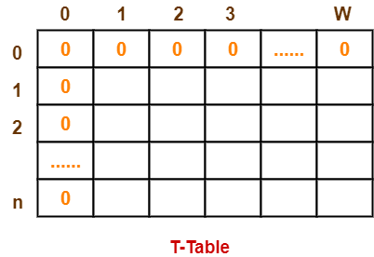

**Step-02:**

Start filling the table row wise top to bottom from left to right.

Use the following formula-

**T (i , j) = max { T ( i-1 , j ) , valuei + T( i-1 , j – weighti) }**

Here, T(i , j) = maximum value of the selected items if we can take items 1 to i and have weight restrictions of j.

* This step leads to completely filling the table.
* Then, value of the last box represents the maximum possible value that can be put into the knapsack.

**Step-03:**

To identify the items that must be put into the knapsack to obtain that maximum profit,

* Consider the last column of the table.
* Start scanning the entries from bottom to top.
* On encountering an entry whose value is not same as the value stored in the entry immediately above it, mark the row label of that entry.
* After all the entries are scanned, the marked labels represent the items that must be put into the knapsack.

**Time Complexity-**

* Each entry of the table requires constant time θ(1) for its computation.
* It takes θ(nw) time to fill (n+1)(w+1) table entries.
* It takes θ(n) time for tracing the solution since tracing process traces the n rows.
* Thus, overall θ(nw) time is taken to solve 0/1 knapsack problem using dynamic programming.

**PRACTICE PROBLEM BASED ON 0/1 KNAPSACK PROBLEM-**

**Problem-**

For the given set of items and knapsack capacity = 5 kg, find the optimal solution for the 0/1 knapsack problem making use of dynamic programming approach.

|  |  |  |
| --- | --- | --- |
| **Item** | **Weight** | **Value** |
| 1 | 2 | 3 |
| 2 | 3 | 4 |
| 3 | 4 | 5 |
| 4 | 5 | 6 |

**OR**

Find the optimal solution for the 0/1 knapsack problem making use of dynamic programming approach. Consider-

n = 4

w = 5 kg

(w1, w2, w3, w4) = (2, 3, 4, 5)

(b1, b2, b3, b4) = (3, 4, 5, 6)

**OR**

A thief enters a house for robbing it. He can carry a maximal weight of 5 kg into his bag. There are 4 items in the house with the following weights and values. What items should thief take if he either takes the item completely or leaves it completely?

|  |  |  |
| --- | --- | --- |
| **Item** | **Weight (kg)** | **Value ($)** |
| Mirror | 2 | 3 |
| Silver nugget | 3 | 4 |
| Painting | 4 | 5 |
| Vase | 5 | 6 |

**Solution-**

**Given-**

* Knapsack capacity (w) = 5 kg
* Number of items (n) = 4

**Step-01:**

* Draw a table say ‘T’ with (n+1) = 4 + 1 = 5 number of rows and (w+1) = 5 + 1 = 6 number of columns.
* Fill all the boxes of 0th row and 0th column with 0.

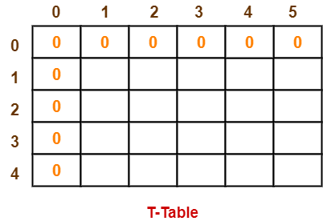

**Step-02:**

Start filling the table row wise top to bottom from left to right using the formula-

**T (i , j) = max { T ( i-1 , j ) , valuei + T( i-1 , j – weighti) }**

**Finding T(1,1)-**

We have,

* i = 1
* j = 1
* (value)i = (value)1 = 3
* (weight)i = (weight)1 = 2

Substituting the values, we get-

T(1,1) = max { T(1-1 , 1) , 3 + T(1-1 , 1-2) }

T(1,1) = max { T(0,1) , 3 + T(0,-1) }

T(1,1) = T(0,1) { Ignore T(0,-1) }

T(1,1) = 0

**Finding T(1,2)-**

We have,

* i = 1
* j = 2
* (value)i = (value)1 = 3
* (weight)i = (weight)1 = 2

Substituting the values, we get-

T(1,2) = max { T(1-1 , 2) , 3 + T(1-1 , 2-2) }

T(1,2) = max { T(0,2) , 3 + T(0,0) }

T(1,2) = max {0 , 3+0}

T(1,2) = 3

**Finding T(1,3)-**

We have,

* i = 1
* j = 3
* (value)i = (value)1 = 3
* (weight)i = (weight)1 = 2

Substituting the values, we get-

T(1,3) = max { T(1-1 , 3) , 3 + T(1-1 , 3-2) }

T(1,3) = max { T(0,3) , 3 + T(0,1) }

T(1,3) = max {0 , 3+0}

T(1,3) = 3

**Finding T(1,4)-**

We have,

* i = 1
* j = 4
* (value)i = (value)1 = 3
* (weight)i = (weight)1 = 2

Substituting the values, we get-

T(1,4) = max { T(1-1 , 4) , 3 + T(1-1 , 4-2) }

T(1,4) = max { T(0,4) , 3 + T(0,2) }

T(1,4) = max {0 , 3+0}

T(1,4) = 3

**Finding T(1,5)-**

We have,

* i = 1
* j = 5
* (value)i = (value)1 = 3
* (weight)i = (weight)1 = 2

Substituting the values, we get-

T(1,5) = max { T(1-1 , 5) , 3 + T(1-1 , 5-2) }

T(1,5) = max { T(0,5) , 3 + T(0,3) }

T(1,5) = max {0 , 3+0}

T(1,5) = 3

**Finding T(2,1)-**

We have,

* i = 2
* j = 1
* (value)i = (value)2 = 4
* (weight)i = (weight)2 = 3

Substituting the values, we get-

T(2,1) = max { T(2-1 , 1) , 4 + T(2-1 , 1-3) }

T(2,1) = max { T(1,1) , 4 + T(1,-2) }

T(2,1) = T(1,1) { Ignore T(1,-2) }

T(2,1) = 0

**Finding T(2,2)-**

We have,

* i = 2
* j = 2
* (value)i = (value)2 = 4
* (weight)i = (weight)2 = 3

Substituting the values, we get-

T(2,2) = max { T(2-1 , 2) , 4 + T(2-1 , 2-3) }

T(2,2) = max { T(1,2) , 4 + T(1,-1) }

T(2,2) = T(1,2) { Ignore T(1,-1) }

T(2,2) = 3

**Finding T(2,3)-**

We have,

* i = 2
* j = 3
* (value)i = (value)2 = 4
* (weight)i = (weight)2 = 3

Substituting the values, we get-

T(2,3) = max { T(2-1 , 3) , 4 + T(2-1 , 3-3) }

T(2,3) = max { T(1,3) , 4 + T(1,0) }

T(2,3) = max { 3 , 4+0 }

T(2,3) = 4

**Finding T(2,4)-**

We have,

* i = 2
* j = 4
* (value)i = (value)2 = 4
* (weight)i = (weight)2 = 3

Substituting the values, we get-

T(2,4) = max { T(2-1 , 4) , 4 + T(2-1 , 4-3) }

T(2,4) = max { T(1,4) , 4 + T(1,1) }

T(2,4) = max { 3 , 4+0 }

T(2,4) = 4

**Finding T(2,5)-**

We have,

* i = 2
* j = 5
* (value)i = (value)2 = 4
* (weight)i = (weight)2 = 3

Substituting the values, we get-

T(2,5) = max { T(2-1 , 5) , 4 + T(2-1 , 5-3) }

T(2,5) = max { T(1,5) , 4 + T(1,2) }

T(2,5) = max { 3 , 4+3 }

T(2,5) = 7

Similarly, compute all the entries.

After all the entries are computed and filled in the table, we get the following table-

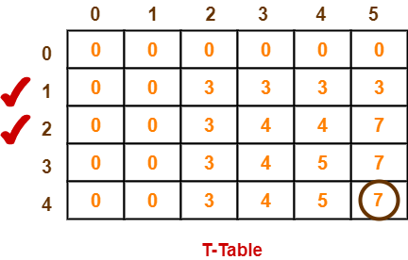

* The last entry represents the maximum possible value that can be put into the knapsack.
* So, maximum possible value that can be put into the knapsack = 7.

**Identifying Items To Be Put Into Knapsack-**

Following Step-04,

* We mark the rows labelled “1” and “2”.
* Thus, items that must be put into the knapsack to obtain the maximum value 7 are-

**Item-1 and Item-2**

To gain better understanding about 0/1 Knapsack Problem,

[**Watch this Video Lecture**](https://www.youtube.com/watch?v=a8ToM6gDigQ)

[**Fractional Knapsack Problem | Greedy Method | Example**](https://www.gatevidyalay.com/fractional-knapsack-problem-using-greedy-approach/)

**Knapsack Problem-**

You are given the following-

* A knapsack (kind of shoulder bag) with limited weight capacity.
* Few items each having some weight and value.

**The problem states-**

Which items should be placed into the knapsack such that-

* The value or profit obtained by putting the items into the knapsack is maximum.
* And the weight limit of the knapsack does not exceed.

**Fractional Knapsack Problem-**

In Fractional Knapsack Problem,

* As the name suggests, items are divisible here.
* We can even put the fraction of any item into the knapsack if taking the complete item is not possible.
* It is solved using Greedy Method.

**Fractional Knapsack Problem Using Greedy Method-**

Fractional knapsack problem is solved using greedy method in the following steps-

**Step-01:**

For each item, compute its value / weight ratio.

**Step-02:**

Arrange all the items in decreasing order of their value / weight ratio.

**Step-03:**

Start putting the items into the knapsack beginning from the item with the highest ratio.

Put as many items as you can into the knapsack.

**Time Complexity-**

* The main time taking step is the sorting of all items in decreasing order of their value / weight ratio.
* If the items are already arranged in the required order, then while loop takes O(n) time.
* Therefore, total time taken including the sort is O(nlogn).

**PRACTICE PROBLEM BASED ON FRACTIONAL KNAPSACK PROBLEM-**

**Problem-**

For the given set of items and knapsack capacity = 60 kg, find the optimal solution for the fractional knapsack problem making use of greedy approach.

|  |  |  |
| --- | --- | --- |
| **Item** | **Weight** | **Value** |
| 1 | 5 | 30 |
| 2 | 10 | 40 |
| 3 | 15 | 45 |
| 4 | 22 | 77 |
| 5 | 25 | 90 |

**OR**

Find the optimal solution for the fractional knapsack problem making use of greedy approach. Consider-

n = 5

w = 60 kg

(w1, w2, w3, w4, w5) = (5, 10, 15, 22, 25)

(b1, b2, b3, b4, b5) = (30, 40, 45, 77, 90)

**OR**

A thief enters a house for robbing it. He can carry a maximal weight of 60 kg into his bag. There are 5 items in the house with the following weights and values. What items should thief take if he can even take the fraction of any item with him?

|  |  |  |
| --- | --- | --- |
| **Item** | **Weight** | **Value** |
| 1 | 5 | 30 |
| 2 | 10 | 40 |
| 3 | 15 | 45 |
| 4 | 22 | 77 |
| 5 | 25 | 90 |

**Solution-**

**Step-01:**

Compute the value / weight ratio for each item-

|  |  |  |  |
| --- | --- | --- | --- |
| **Items** | **Weight** | **Value** | **Ratio** |
| 1 | 5 | 30 | 6 |
| 2 | 10 | 40 | 4 |
| 3 | 15 | 45 | 3 |
| 4 | 22 | 77 | 3.5 |
| 5 | 25 | 90 | 3.6 |

**Step-02:**

Sort all the items in decreasing order of their value / weight ratio-

**I1 I2 I5 I4 I3**

(6) (4) (3.6) (3.5) (3)

**Step-03:**

Start filling the knapsack by putting the items into it one by one.

|  |  |  |
| --- | --- | --- |
| **Knapsack Weight** | **Items in Knapsack** | **Cost** |
| 60 | Ø | 0 |
| 55 | I1 | 30 |
| 45 | I1, I2 | 70 |
| 20 | I1, I2, I5 | 160 |

Now,

* Knapsack weight left to be filled is 20 kg but item-4 has a weight of 22 kg.
* Since in fractional knapsack problem, even the fraction of any item can be taken.
* So, knapsack will contain the following items-

**< I1 , I2 , I5 , (20/22) I4 >**

Total cost of the knapsack

= 160 + (20/27) x 77

= 160 + 70

= 230 units