**Configuration Management using Ansible (Roles)**

Mkdir Ansible(role)project

Cd Ansible(role)project

Mkdir roles

Cd roles

mkdir -p tomcat/{ defaults,handlers, tasks ,vars,test}

nano ~/ansible_role_demo/roles/tomcat/tasks/main.yml

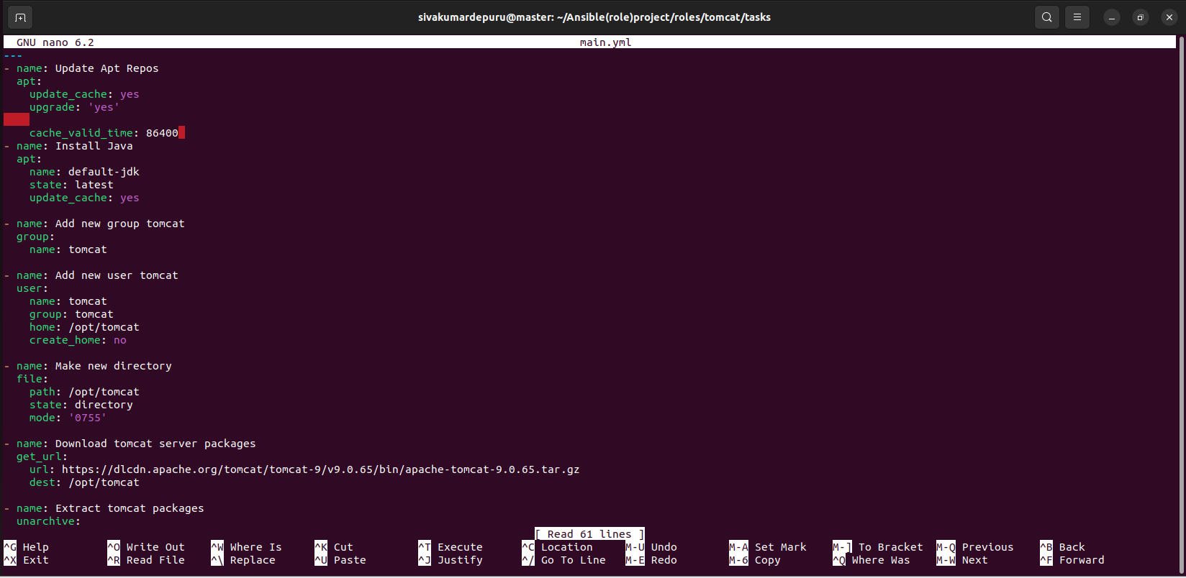

nano ~/ansible_role_demo/roles/tomcat/test/inventory

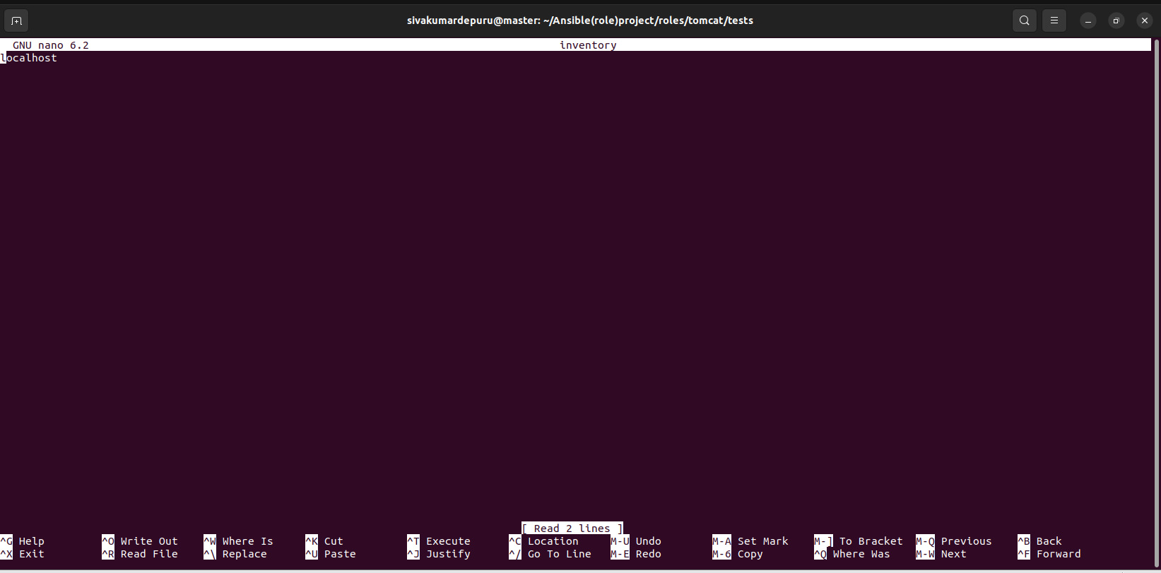

nano ~/ansible_role_demo/roles/tomcat/tests/test.yml

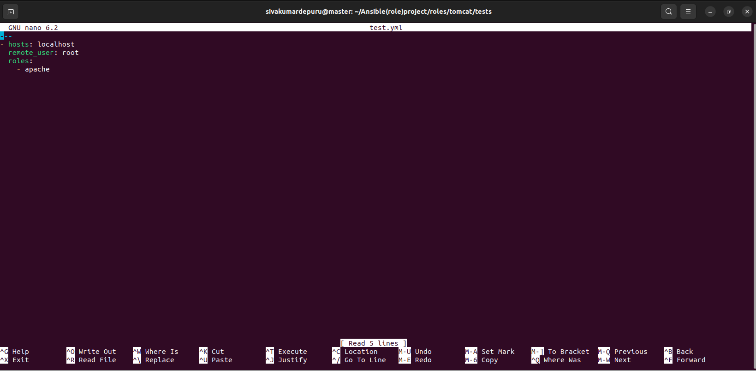

Nano tomcatsetup.yml

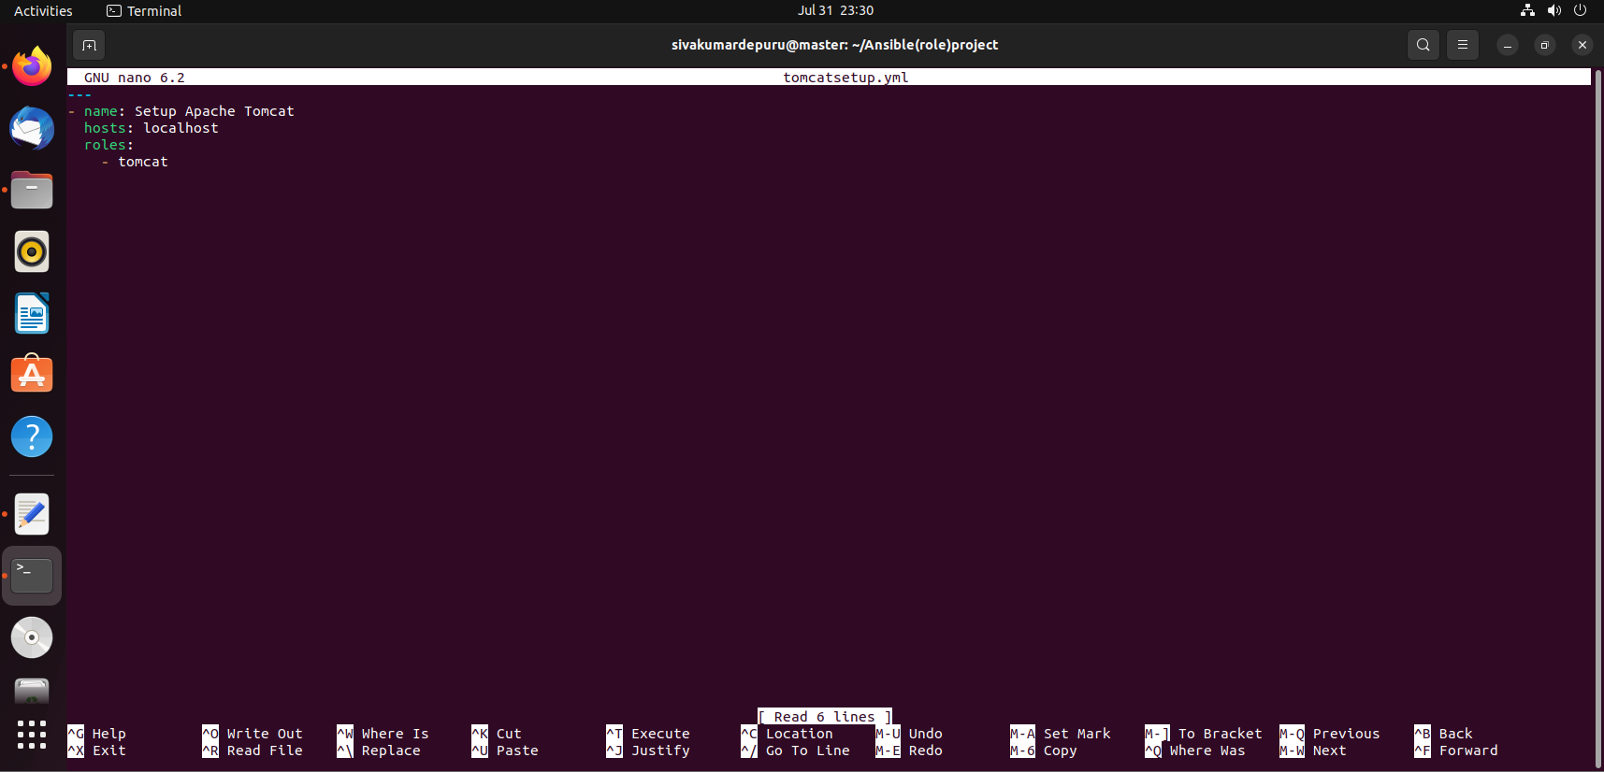

Sudo apt-get install tree

tree

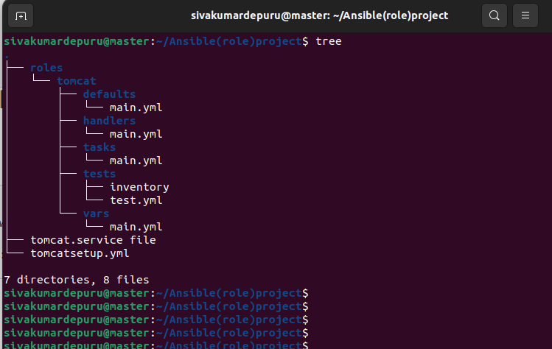

Sudo ansible-playbook tomcatsetup.yml

