School of Computer Science and Engineering

# ASP.Net PROJECT SYNOPSIS

(Project Term February-April, 2020)

# Agro Products selling Website

# Web address: AgrOnline.com

Submitted by:

**Vikas Kumar Singh**

**Roll no. B43**

**Registration Number: 11603404**

**Project Number: 09**

**Course Code: INT 402**

Under the Guidance of

**Ms. Ankita Wadhawan**

**Assistant Professor**

Agro Products selling Website

In today’s day to day life purchasing of products by visiting stores has become a tough job. As a standing in a queue for making the payment of the product has become difficult for customers. To overcome these difficulties, we are coming up with Agro Products selling Website.

Agro Products selling Website is a Online Shopping website which helps to choose a wide range of products through your desktop or smartphone rather than visiting the outlets. It is developed using word press which is an open source blogging platform and content management, the basic Agro products functionality in word press can be achieved through Magento. It is been developed to handle accurate stock and also to overcome a payment gateway problem. Egro Online Shopping website ensures that it accepts a review from our genuine buyers with their genuine identity.

**The Modules used in the project are**

1. Seller as admin  
2. Customer as user

**Admin:**

Admin will login into the application with the default username and password. Admin can add and edit the products and product details. He can also view the orders placed by customers and reviews by customers. Admin can also view the abandoned cart products and featured products. Admin can also view the payments.

**Customer:**

The customer can view the application by registering or without registering as a guest user. But the guest user has limited functionalities compared to the registered user. Registered customer must log in with the username and password after logging in he can select the products and add them to the cart.

***Existing System:***

In the Existing system, we are experiencing high crowd in the stores which make for us select the products and making the payments also takes a lot of time in some reputed stores.

***Proposed System:***

In Proposed System the admin will maintain a wide range of products at affordable prices for customers and it makes easier for those who buy in the application. If a customer leaves the product in the cart without buying and exits the application then the customer will get the mail after particular threshold time.

**UML Diagrams:**

Use case Diagram for Admin:

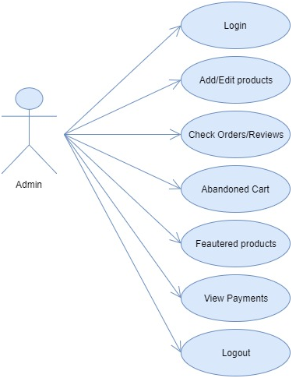

Use case Diagram for Customer:

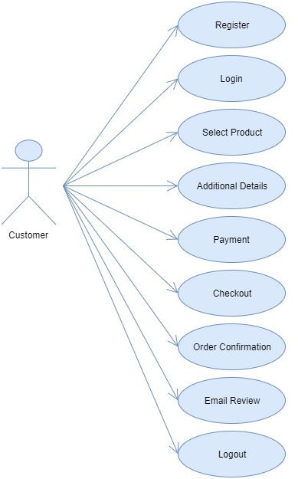

Sequence Diagram for Admin:

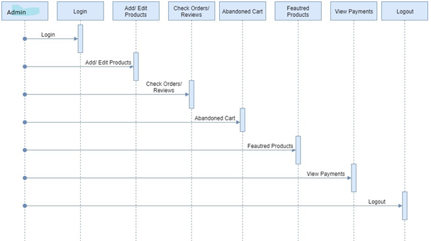

Sequence Diagram for Customer:

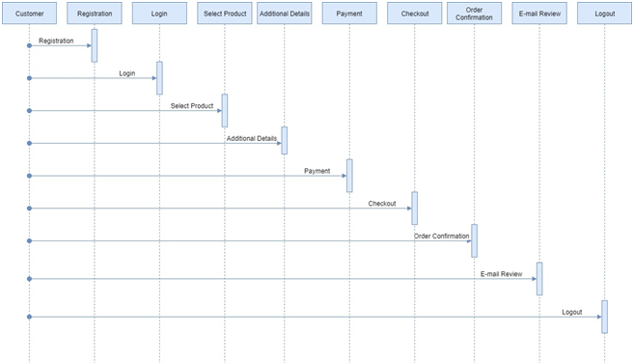

Activity Diagram: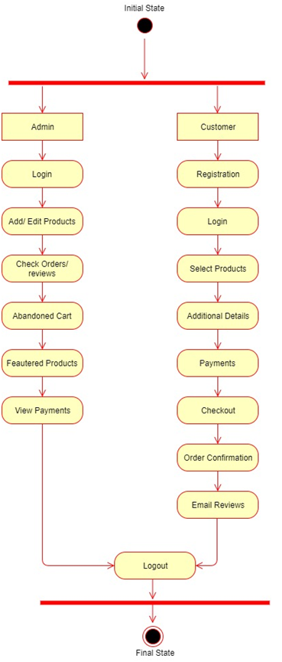

Class Diagram:

