**LEARN ENGLISH | LET’S TALK – FREE ENGLISH LESSON**

**13/10/2024**

**🡪**

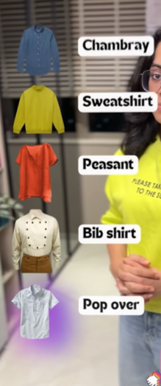 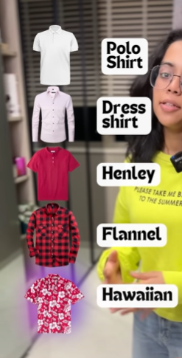

**🡪WIND UP**

**🡪UNWIND**

**🡪SCROLL UP**

**🡪SCROLL DOWN**

**🡪ZOOM IN**

**🡪ZOOM OUT**

**🡪FLIP OPEN**

**🡪FOLD UP**

**🡪PLUG IN**

**🡪UNPLUG**

**🡺14/10/2024**

**🡪excuse me do you know our arrival time**

**🡪can I get on the bus here?**

**🡪can you help me? I can’t find the subway station.**

**🡪I can't walk much farther.**

**1)**

**\*hey Anaya I need to tell you something❌**

**\*I need to bring up something.**

**\*I have something to share with you.**

**\*hey I have got some news for you.**

**\*I need to chat with you.**

**\*can I speak to you privately?**

**\*can I borrow you for a minute?**

**\*There is something I would like to discuss.**

**2)**

**\* I saw ❌**

**\*I sighted – I sighted a rare bird in the garden.**

**\*Spotted – I spotted my friend in the crowd at the mall.**

**\*Glanced at – He glanced at this watch and realized he saw late.**

**\*Glimpsed at – she glimpsed at her own reflection in the darkroom**

**\*stared at – He started at the night sky for a house.**

**🡺15/10/2024**

1. **I spaced out**

**\*Not to be fully present, lost in thoughts**

**-ah sorry I spaced out for movement.**

1. **\*Doom Scrolling**

**-The act of consuming a large amount of negative news.**

**\*Truthiness**

**-A situation where something feels true, even if it's not.**

**\*Nepo Baby**

**-A child of a wealthy famous or a celebrity who benefits from their parent's success**

**\*Coffee nap**

**-A short nap taken after having coffee to boost energy.**

**\*Infodemic**

**-Large speed of accurate and inaccurate news.**

1. **I need – necessity**

**I want – desire**