**✅DAY 01.**

**01.Installing VS Code & How Websites Work | Sigma Web Development Course - Tutorial #1**

**→**installing vs code.

→create the first HTML file.

→client -> browser -> server

→fast(internet speed).

**02.Your First HTML Website | Sigma Web Development Course - Tutorial #2**

**→**github desktop and push

→icons, themes

☑️GitHub Desktop -

☑️vscode-icons(extension )- for icons in vs code

☑️jellyfish theme (extension)- vs code theme changer.

☑️GitHub Theme(extension) - theme .

☑️Material Them (extension) -theme.

☑️prettier (extension)- indentation.

☑️Live preview - run code in the vs browser.

→create files in HTML, CSS, and js.

→earnings: fiver (freelancing ).

**03. Basic Structure of an HTML Website | Sigma Web Development Course - Tutorial #3**

→tags

→ introduction html, ccs, js.

→copy, paste.

→ in cmd type- $ipconfig → copy ip adress

============================================================

**✅DAY 02.**

**04. Heading, paragraphs, and Links | Sigma Web Development Course - Tutorial #4**

→ Select alt = and write multiple lines at once.

→alt + shift + |down arrow = write a multiple copy

→introduction html( heading , paragraph , links)

→create a another bookmark file (inside h1 and h2 add paragraph and links ).

**05. Image, Lists, and Tables in HTML | sigma web development course -Tutorial #5**

→images

→Tables

→lists

==============================================================

**✅DAY 03.**

**06. SEO and Web vitals in HTML | Sigma Web Development Course - Tutorial #6**

→LSP -largest contentful paint

→FID - First input Dealy

→console - > lighthouse

→Responsive

→SEO -> Search Engine Optimization

**07. Forms and Input tags in HTML | Sigma Web Development Course - Tutorial #7**

→forms

→Input types

→name

→radio button

→text area

→select

→div

→autofocus

==============================================================

**✅DAY 04.**

**08. INLINE AND BLOCK ELEMENT IN HTML | SIGMA WEB DEVELOPMENT COURSE - TUTORIAL #8**

→Elements, notes.

→ All tag notes.

→quiz

**============================================================== ✅DAY 04.**

**09. ID & CLASS IN HTML | SIGMA WEB DEVELOPMENT COURSE - TUTORIAL #9**

→ # = id

→. = class.

→basic program.

==============================================================

**✅DAY 05.**

**10. VIDEO, AUDIO, AND MEDIA IN HTML | SIGMA WEB DEVELOPMENT COURSE -TUTORIAL #10**

→video

→Audio

→svg

→iframe

→quick quiz

**==============================================================**

**✅DAY 05.**

**11. SEMANTIC TAGS IN HTML | SIGMA WEB DEVELOPMENT COURSE - TUTORIAL #11**

→Sematic tags. 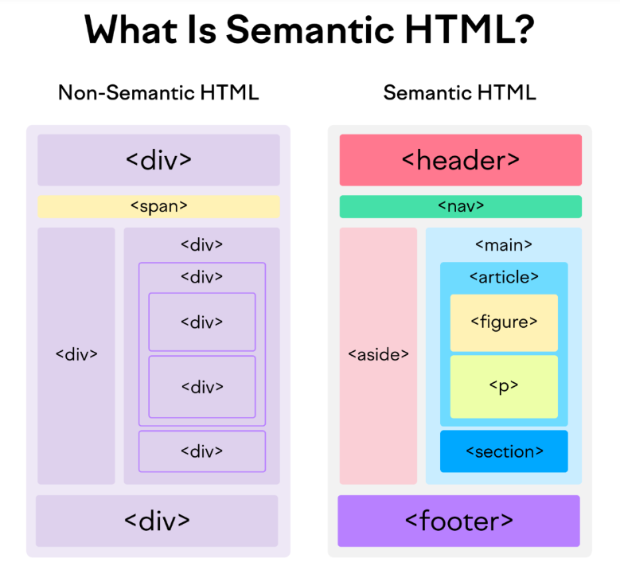

**=========================================================**

**12. Exercise-1 pure HTML | MEDIA PLAYER |SIGMA WEB DEVELOPMENT**

**COURSE -TUTORIAL #12**

→Exercise -1

**==========================================================**

**13. ENTITIES, CODE TAG, AND MORE ON HTML | SIGMA WEB DEVELOPMENT COURSE -TUTORIAL #13**

→&lt;

→&gt;

→&copy;

→&nbsp;

**==========================================================**

**14.INTRODUCTION TO CSS | SIGMA WEB DEVELOPMENT DEVELOPMENT-COURSE-TUTORIAL #14**

→Html notes download;

→CSS notes download.

**==========================================================**

**15.INLINE , INTERNAL | & EXTERNAL CSS | SIGMA WEB DEVELOPMENT COURSE -TUTORIAL #15**

→internal css.

→inline css .

→external css.

**==========================================================**

**16. EXERCISE -1 SOLUTION | SIGMA WEB DEVELOPMENT COURSE -TUTORIAL #16**

→Exercise solutions.

**==========================================================**

**01/10/2024✅**

**17.CSS SELECTORS MASTER CLASS | SIGMA WEB DEVELOPMENT COURSE - TUTORIAL #17**

→ID selectors = # {}

→CLASS selectors = .{}

→Element selectors.= div {}

→ child seletors = div > p{}

→decendant selectors = div

→Universal selectors = *{}

→pseudo selectors = a:visited{},a:link{} ,a:active{},p:firstchild{}

⇒WEB.dev

**===========================================================**

**18. CSS- BOX MODEL , MARGIN , PADDING AND BORDERS - SIGMA WEB DEVELOPMENT COURSE - TUTORIALS #18**

→Box model

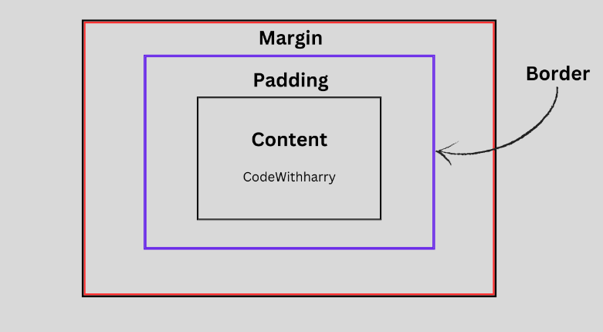

**===========================================================**

**02/10/2024✅**

**19.CSS FONTS, TEXTS AND COLOR PROPERTIES | SIGMA WEB DEVELOPMENT COURSE -TUTORIAL #19**

→fonts properties

→color properties.

→google fonts

→HSL

→HEX color code

**===========================================================**

**20.EXERCISE -2 CSS CHALLENGE | SIGMA WEB DEVELOPMENT COURSE-TUTORIAL #20**

**===========================================================**