ASSIGNMENT 1
1. Explain the difference between frontend, backend, and full-stack development with suitable real-world examples.
Web development is mainly divided into three types, based on which part of a website or app a developer works on.
Frontend Development
This is the part of the website that we can see and interact with directly in our browser, like buttons, menus, colours, and layout. It is also called the client side. It is made using HTML, CSS, and JavaScript, and common tools include React, Angular, and Vue. For example, the homepage design of Flipkart, with its images, product cards, and search bar, is built by a frontend developer.
Backend Development
This is the behind the scenes part that we don't see. It handles the logic, database, and server that make the website actually work. It is also called the server side. It is made using languages like Python, Java, PHP, and Node.js, and involves databases, servers, APIs, and authentication. For example, when we log in to Instagram, the backend checks our username and password from the database and lets us in.
Full-Stack Development
A full-stack developer knows both frontend and backend. They can build a complete website from start to finish on their own. For example, a developer who builds both the login page (frontend) and the code that checks the password (backend) of a college website is a full-stack developer.
2. Create a simple diagram showing how the client-server model works in web architecture.
The client-server model is the basic structure of how websites work on the internet. The client (our browser) asks for information, and the server (a powerful computer) sends the information back, sometimes taking help from a database.
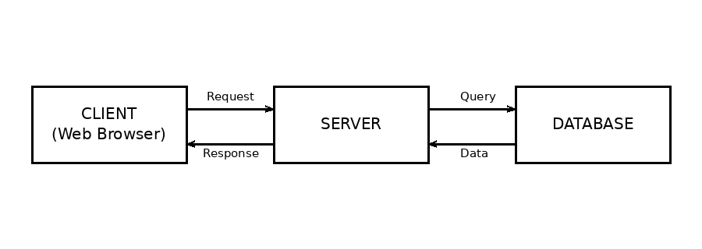
Working, step by step: The client sends a request to the server asking for a webpage. The server processes the request, sometimes talking to a database. Finally, the server sends back a response, which the browser displays as a webpage.
3. Describe how a browser requests and displays a web page from a web server.
When we type a website address (URL) in the browser and press Enter, several steps happen very quickly:
- The browser first finds the IP address of the website using DNS (Domain Name System), which works like a phone book for websites.
- The browser sends an HTTP or HTTPS request to the web server, asking for the page.
- The server receives the request, prepares the required HTML, CSS, and JavaScript files, and sends them back as a response.
- The browser receives these files and renders (draws) them on the screen. This is the webpage we finally see.
- If the page needs extra data, like images or live information, the browser may send more requests to APIs or the server.
This whole process usually takes only a few seconds, or even less.
4. Identify and list the tools required to set up a web development environment. Explain the purpose of each.
- Code Editor (example: VS Code) - used to write and organise code easily, with features like colour coding and auto-complete.
- Web Browser (example: Google Chrome, Firefox) - used to run and test the website, and to check errors using developer tools.
- Version Control System (example: Git) - keeps track of changes made to code and allows teamwork without overwriting each other's work.
- Hosting Platform (example: GitHub Pages, Netlify) - used to upload the finished website so others can access it online.
- Web Server Software (example: Apache, XAMPP) - runs the backend code and serves webpages to browsers.
- Package Manager (example: npm, pip) - helps install and manage extra code libraries needed for the project.
- Terminal or Command Line - used to run commands, install tools, and manage the project directly through text commands.
5. Explain what a web server is and give examples of commonly used servers.
A web server is a computer program, or the computer itself, that stores website files and sends them to a user's browser whenever they are requested. It serves webpages, which is why it is called a web server. In simple words, when we visit a website, our request goes to a web server, and the server replies by sending back the webpage.
Commonly used web servers include:
- Apache HTTP Server - one of the oldest and most widely used, free and open-source.
- Nginx - known for being fast and good at handling many users at once.
- Microsoft IIS - used mainly with Windows-based websites.
- LiteSpeed - known for speed, and often used with WordPress websites.
6. Define the roles of a frontend developer, backend developer, and database administrator in a project.
Frontend Developer
Designs and builds the part of the website users see and interact with, such as the layout, buttons, colours, and animations. Makes sure the website looks good and works well on all screen sizes.
Backend Developer
Writes the logic that runs on the server, handles user login, processes data, and connects the website to the database. Makes sure the website functions correctly and securely behind the scenes.
Database Administrator (DBA)
Manages and organises the data stored in the database, such as user details, orders, and messages. Makes sure the data is safe, backed up, and can be accessed quickly whenever needed.
7. Install VS Code and configure it for HTML, CSS, and JavaScript development. Take a screenshot of the setup.
Steps to install and set up VS Code for web development:
- Go to the official website code.visualstudio.com and download VS Code for your operating system.
- Install it by running the downloaded setup file and following the on-screen instructions.
- Open VS Code and click on the Extensions icon on the left sidebar.
- Install useful extensions such as Live Server (to preview HTML pages instantly), Prettier (to auto-format code), and HTML CSS Support.
- Create a new folder for the project, open it in VS Code, and create files like index.html, style.css, and script.js.
- Right-click on index.html and select Open with Live Server to see the webpage running in the browser.
(Note: A screenshot of the actual VS Code setup with extensions installed should be attached here separately.)
8. Explain the difference between static and dynamic websites. Provide an example of each.
Static Website
A static website shows the same fixed content to every visitor. The content does not change unless a developer manually edits the code. It is built mainly using HTML and CSS. For example, a simple portfolio website showing a person's resume and projects, which stays the same for every visitor.
Dynamic Website
A dynamic website shows content that can change based on user actions, time, or data from a database. It uses backend languages along with HTML and CSS. For example, Amazon's website is dynamic, as it shows different products, prices, and recommendations depending on the user who is logged in.
9. Research and list five web browsers. Explain how rendering engines differ between them.
A rendering engine is the part of the browser that reads HTML, CSS, and JavaScript code and converts it into the visual webpage we see.
- Google Chrome - uses the Blink rendering engine, known for speed and wide extension support.
- Mozilla Firefox - uses the Gecko rendering engine, known for strong privacy features and being open-source.
- Safari - uses the WebKit rendering engine, built by Apple, mainly used on Mac and iPhone devices.
- Microsoft Edge - also uses the Blink engine (same as Chrome), since it is now built on Chromium.
- Opera - also uses the Blink engine, but adds extra features like a built-in VPN and ad blocker.
Since Chrome, Edge, and Opera all use Blink, they render most webpages very similarly. Firefox (Gecko) and Safari (WebKit) may sometimes display pages slightly differently, which is why developers test their websites on multiple browsers.
10. Draw a labelled diagram showing the basic web architecture flow - client, server, database, and APIs.
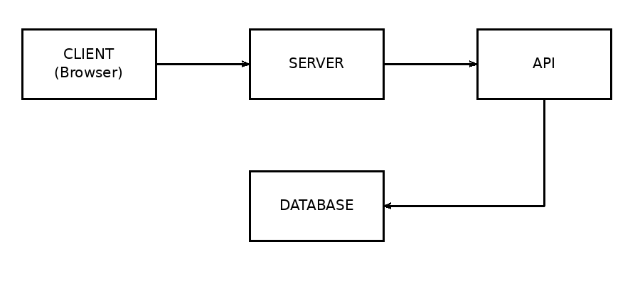
Explanation of the flow:
- Client - the user's browser or app, where the request begins, for example opening a website.
- Server - receives the client's request, processes it, and decides what data is needed.
- API - acts as a bridge that lets the server talk to the database (and sometimes other services) in an organised way.
- Database - stores all the actual data, such as user accounts, products, and messages, and sends the requested data back through the API and server, finally reaching the client.

