**SQL PROJECT**

# Customer Churn Analysis For A Subscription-Based Service

**Dataset Link:** <https://www.kaggle.com/datasets/blastchar/telco-customer-churn/data>

**Content:**

Each row represents a customer, each column contains customer’s attributes described on the column Metadata.

**Objective:**

Identify patterns that lead to customer churn and provide actionable insights to reduce it.

**The data set includes information about:**

* **Customers who left within the last month** – the column is called Churn.
* **Services that each customer has signed up for** – phone, multiple lines, internet, online security, online backup, device protection, tech support, and streaming TV and movies.
* **Customer account information** – how long they’ve been a customer, contract, payment method, paperless billing, monthly charges, and total charges.
* **Demographic info about customers** – gender, age range, and if they have partners and dependents.

**About this file:**

**Telcom Customer Churn**

* Each row represents a customer, each column contains customer’s attributes described on the column Metadata.
* The raw data contains 7043 rows (customers) and 21 columns (features).
* The “Churn” column is our target.

**Steps for Analysing Customer Churn and Designing the Database Schema**

* **Database Analysis:** 
  + Conducted a thorough review of raw database columns and values to understand data structure and relationships.
* **Data Segmentation:**
  + Created separate CSV files to organize data into logical tables:
    - Customer Details
    - Subscriptions
    - Services
    - Billing
* **Key Identification:**
  + Defined primary keys and foreign keys for each table to establish relationships and ensure data integrity.
* **Schema Design:**
  + Utilized MS Excel to visually design and finalize the database schema, ensuring clarity and alignment with project requirements.

**Steps under PostgreSQL**

1. 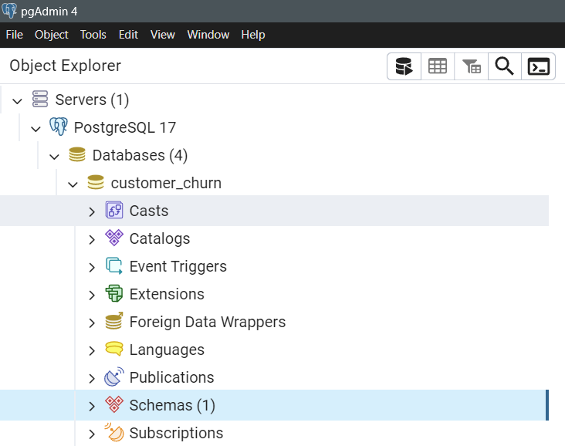**Creating the Database**
2. **Creating tables in the database**
   1. 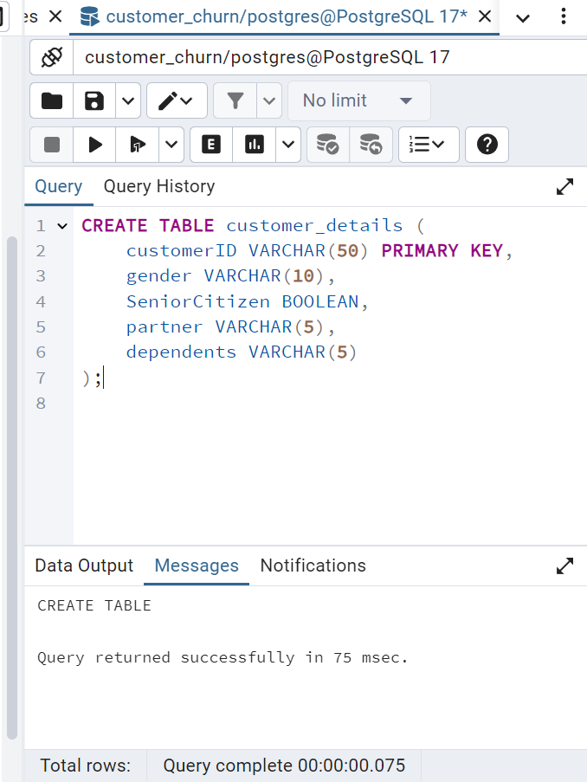**Customer_Details Table**
   2. 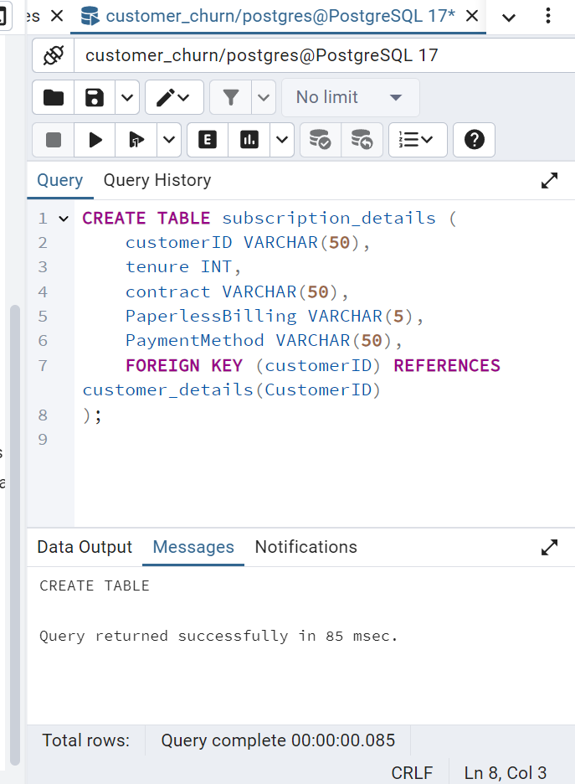**Creating Subscription_Details Table**
   3. 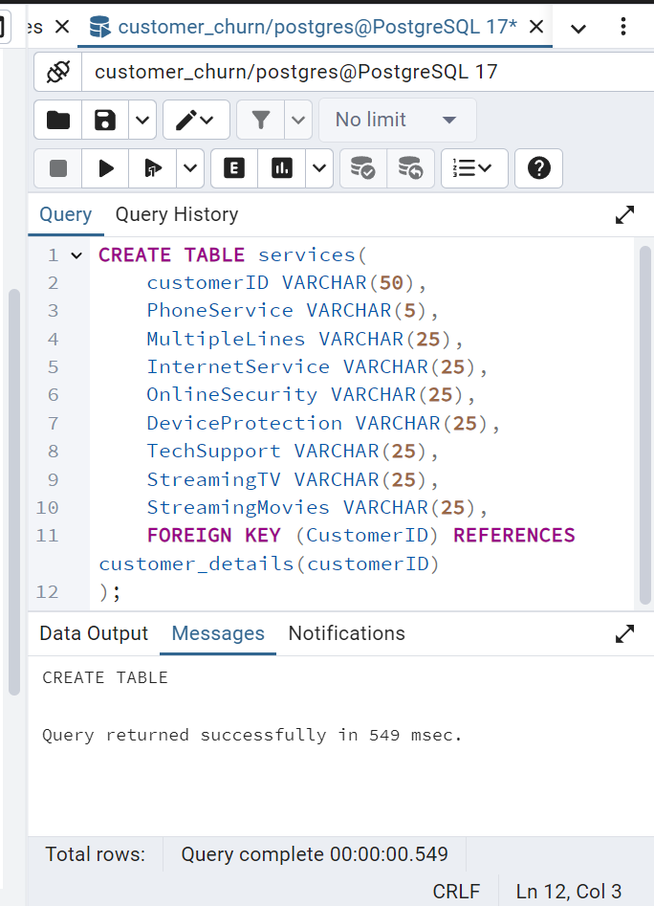**Creating Services Table**
   4. 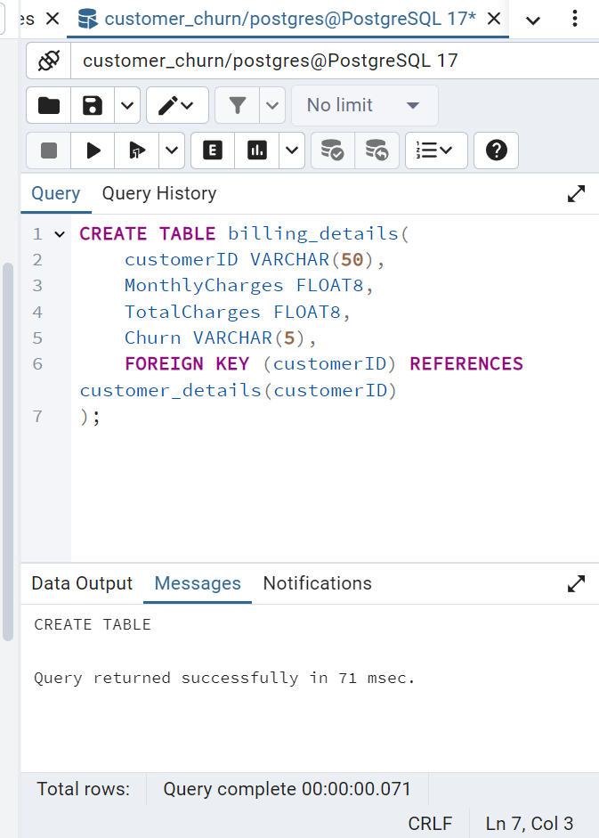**Creating Billing_Details Table**
3. **Importing CSV files to the respective tables:**
   1. 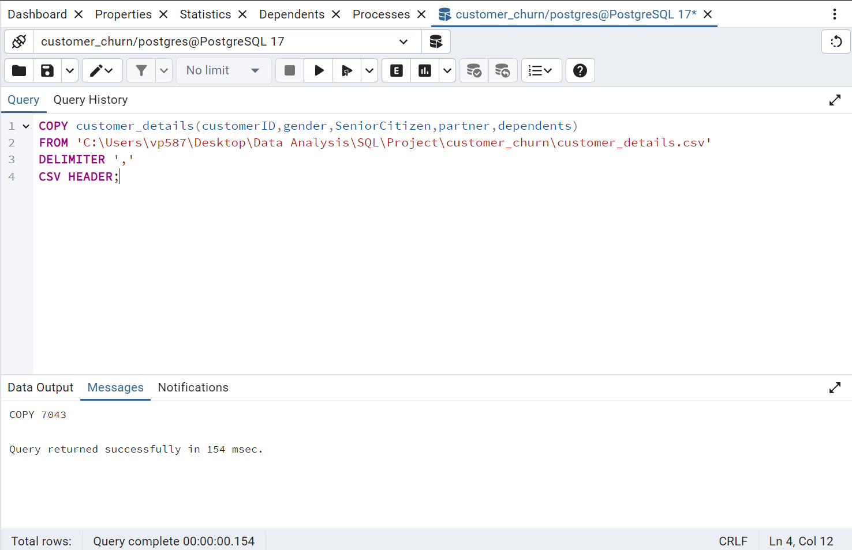**Importing customer_details**
   2. **Importing services**

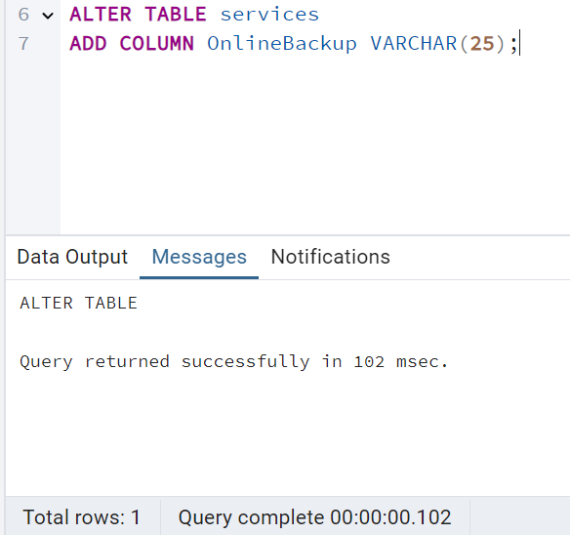I forgot to add OnlineBackup Column

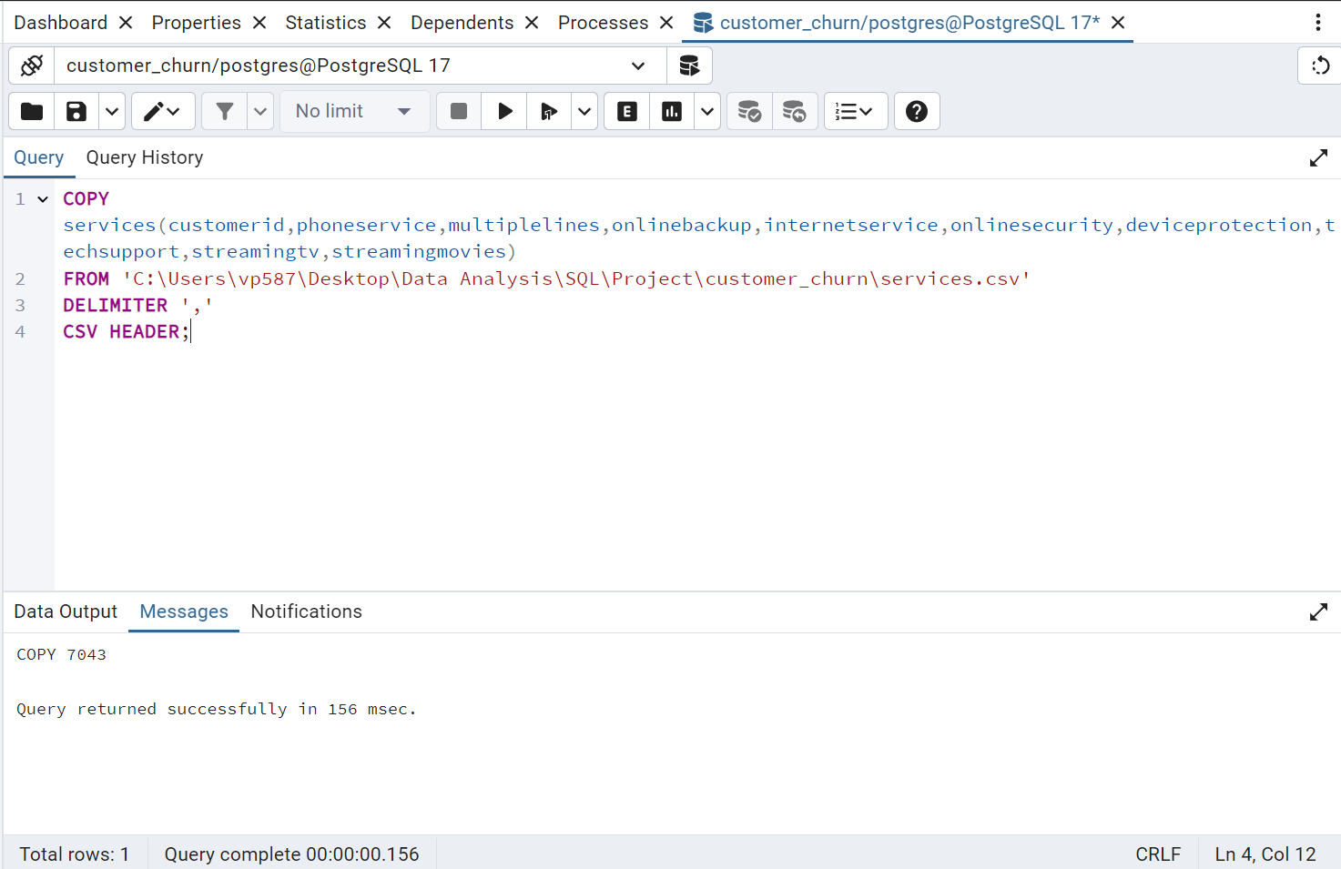

**c) Importing Billing_Details**

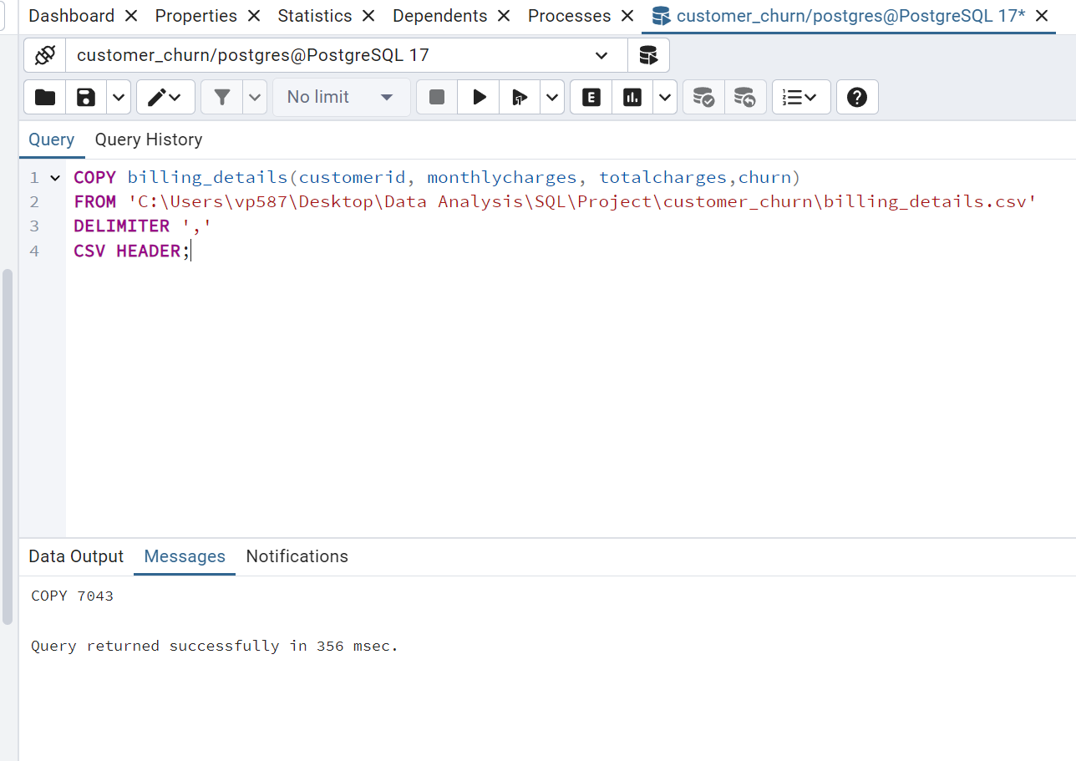

**d) Importing Subscription_Details**

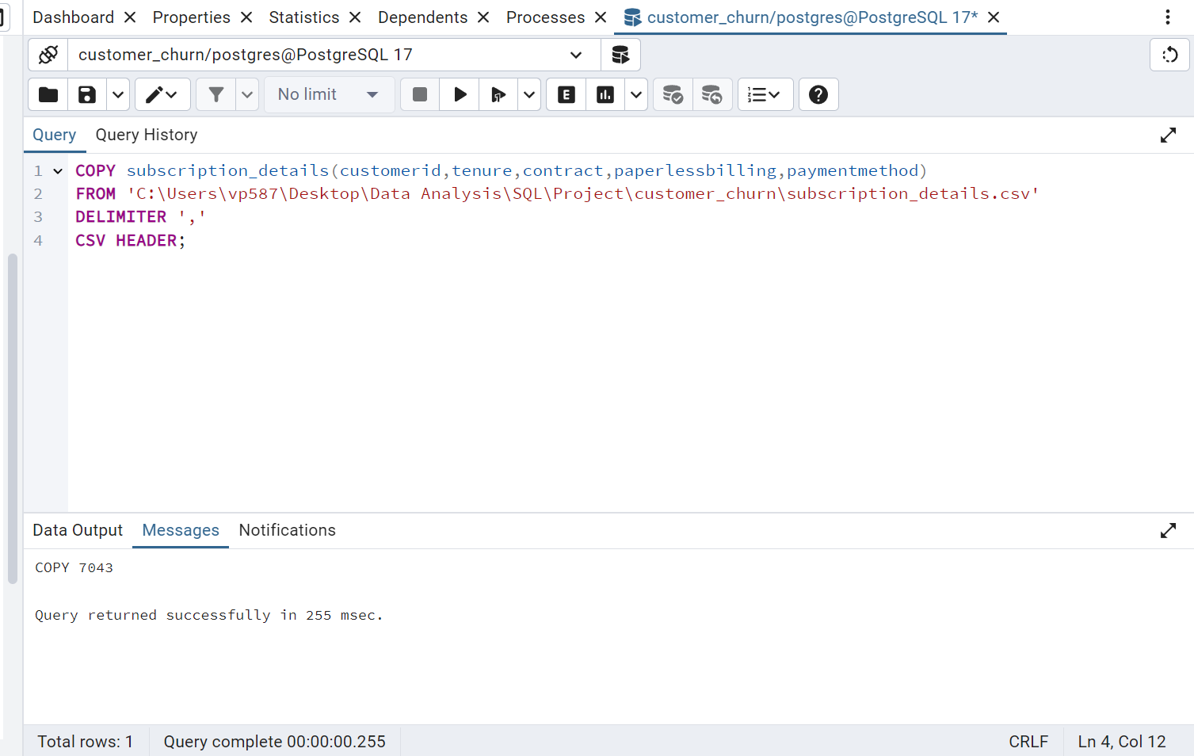

#### Now applying queries to the database

Ques 1: Total number of Churned customers.

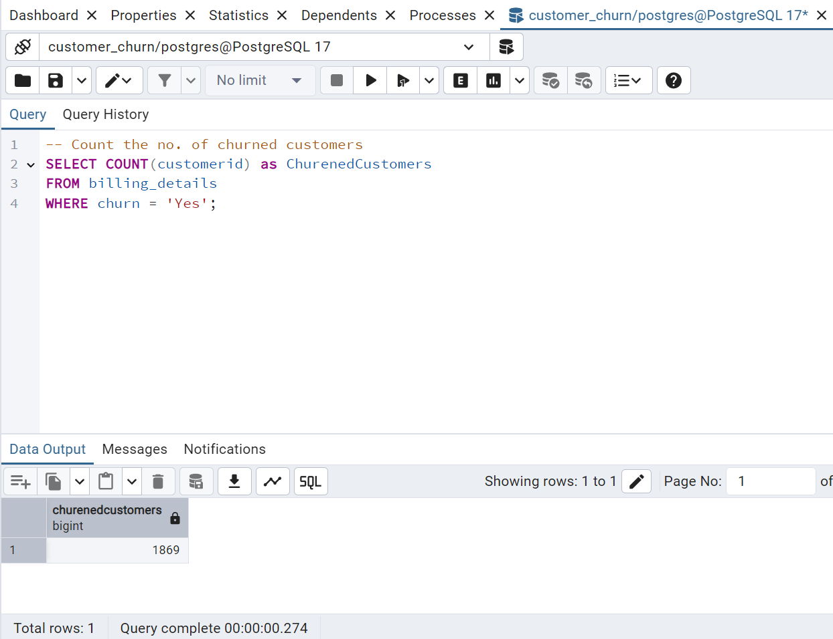

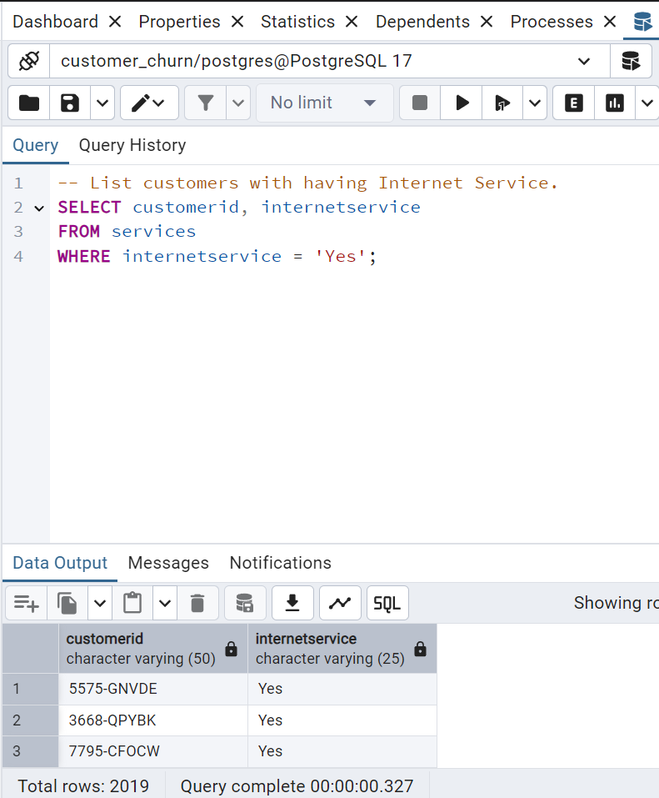Ques 2: List of customers with having Internet Service.

Ques 3: Average monthy charges of all customers.

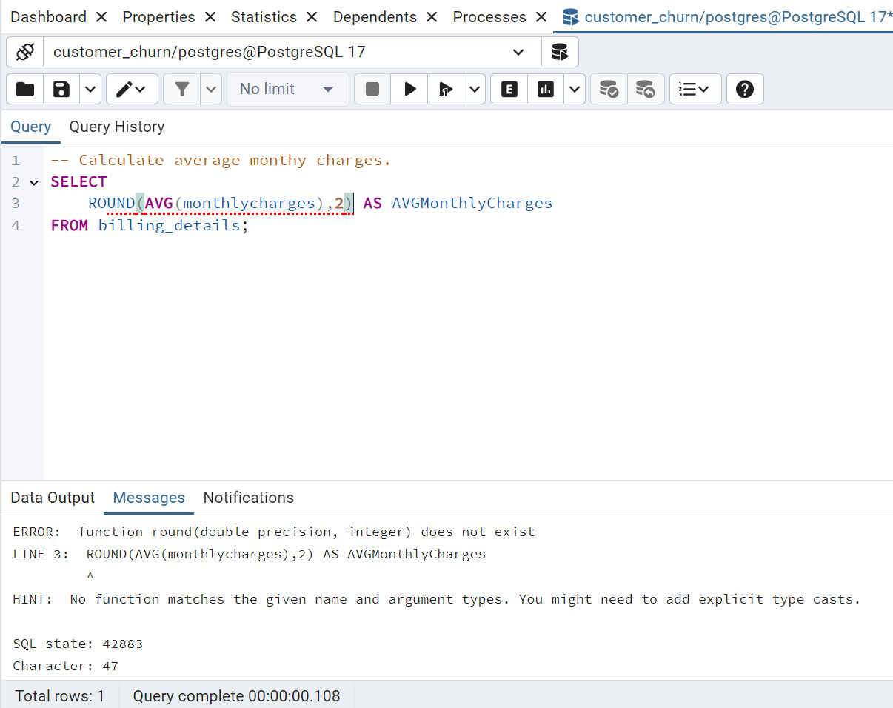

This shows typecast error because monthlycharges have float constraint

Modify the monthlycharges and totalcharges

ALTER TABLE billing_details

ALTER COLUMN MonthlyCharges TYPE INTEGER USING MonthlyCharges::INTEGER;

###### ALTER TABLE billing_details

ALTER COLUMN TotalCharges TYPE INTEGER USING TotalCharges::INTEGER;

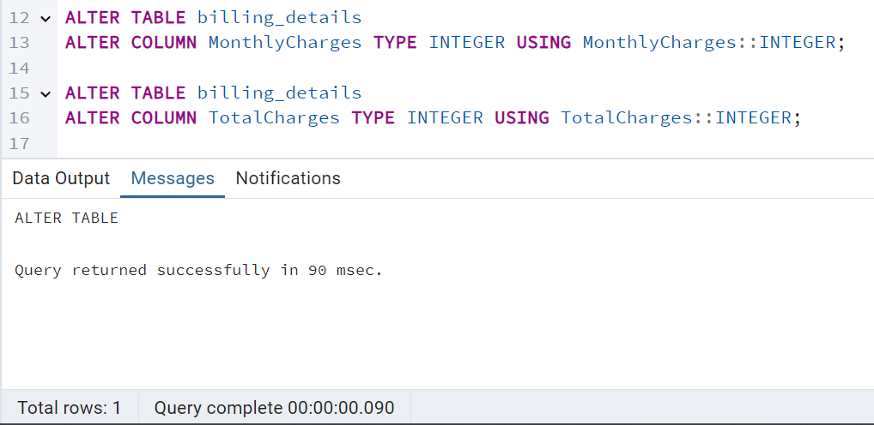

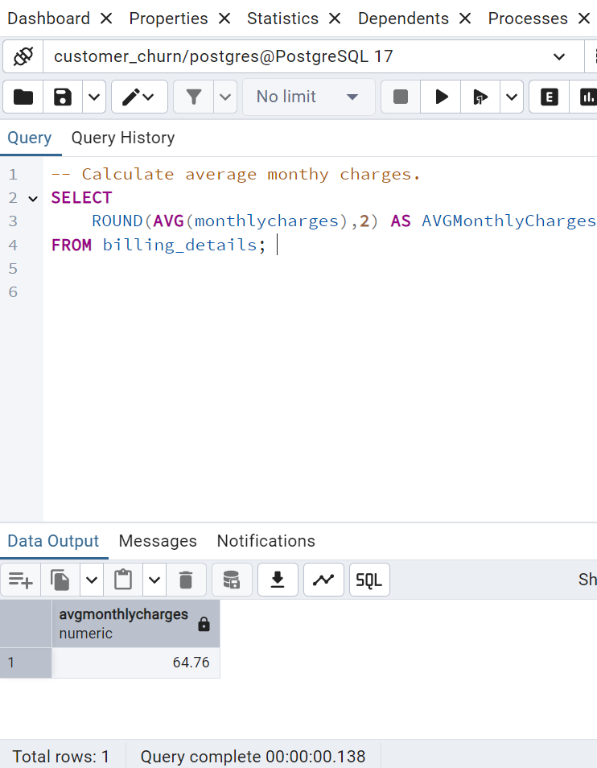

Ques 4: Churn Rate by Contract Type. 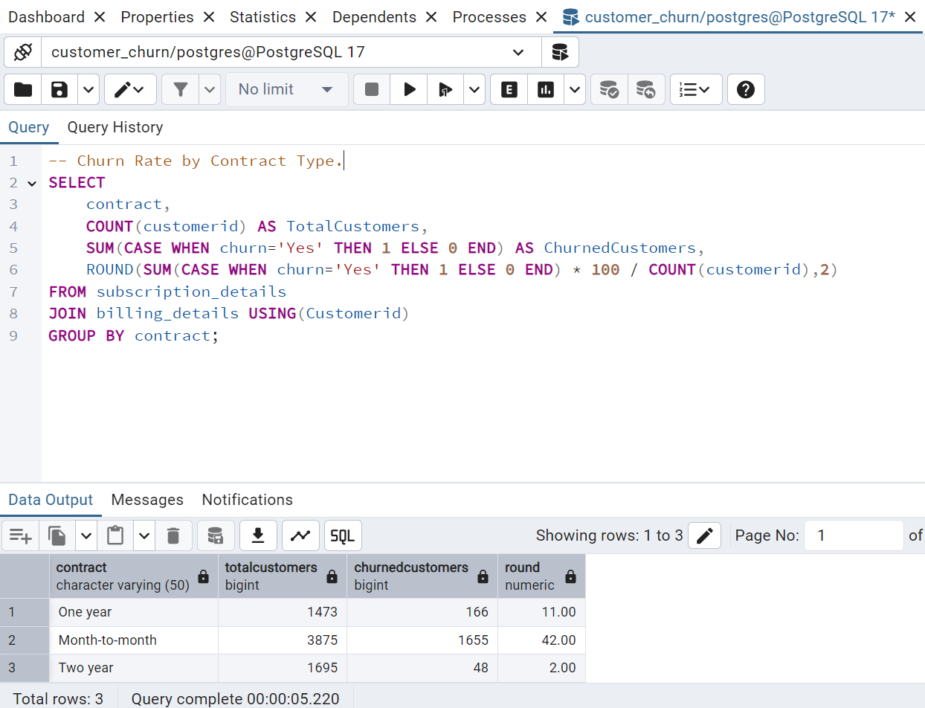

##### Ques 5: Top 3 Customers with the Highest Total Charges

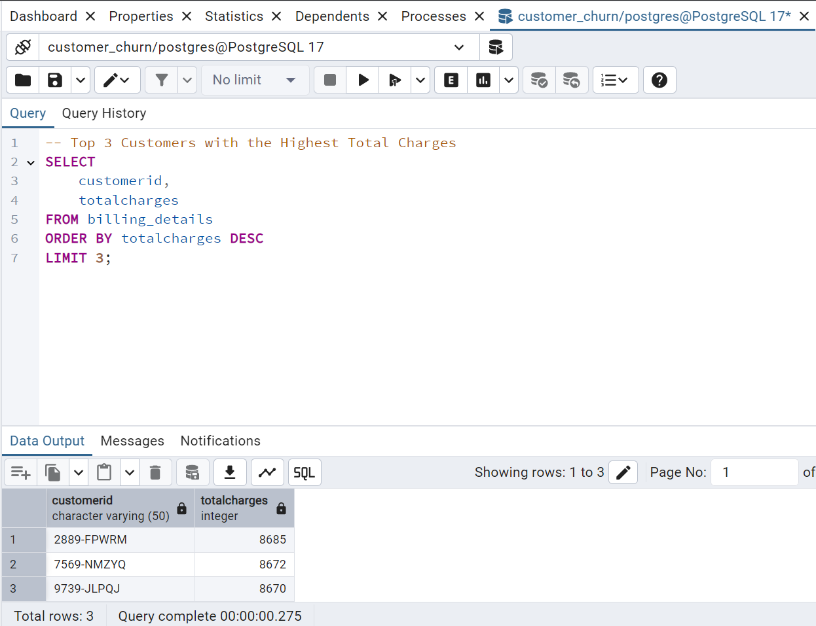

Ques 6: Churn Rate by Internet Service type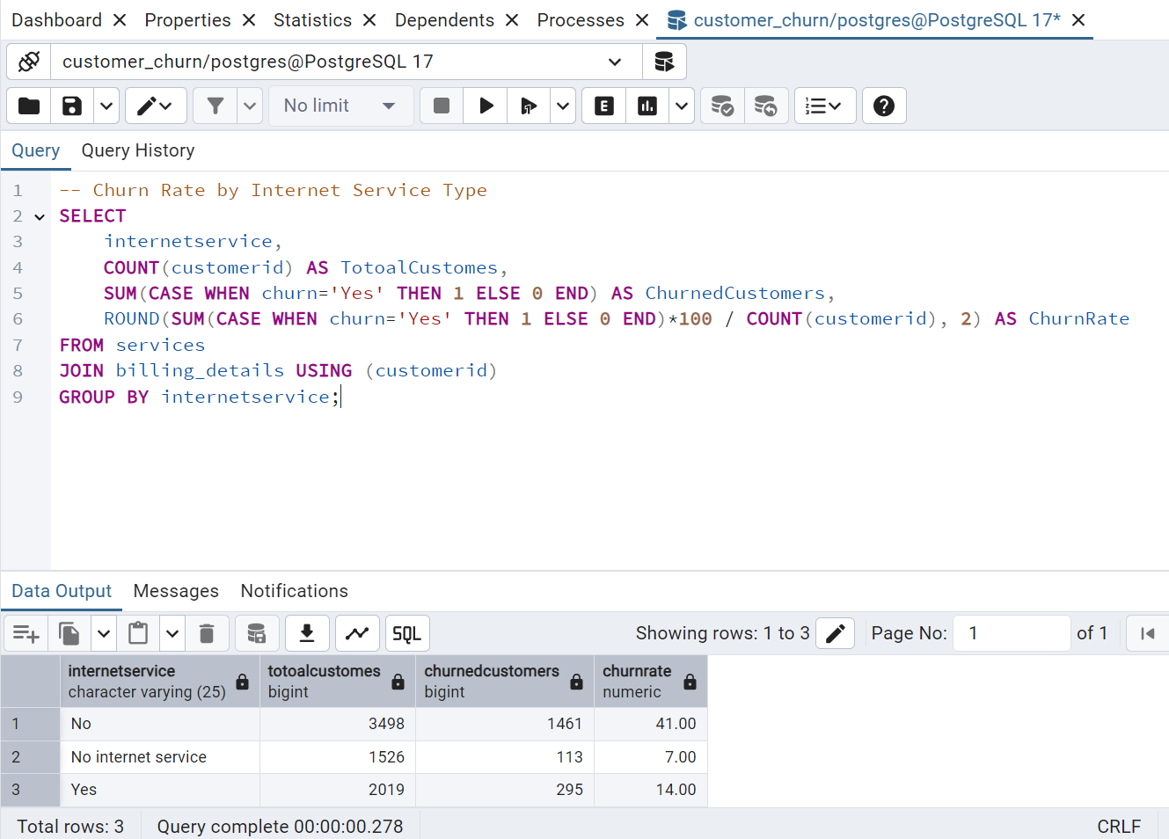

Ques 7: Correlation Between Monthly Charges and Churn  
Analyze if higher monthly charges lead to churn by categorizing customers into charge ranges.

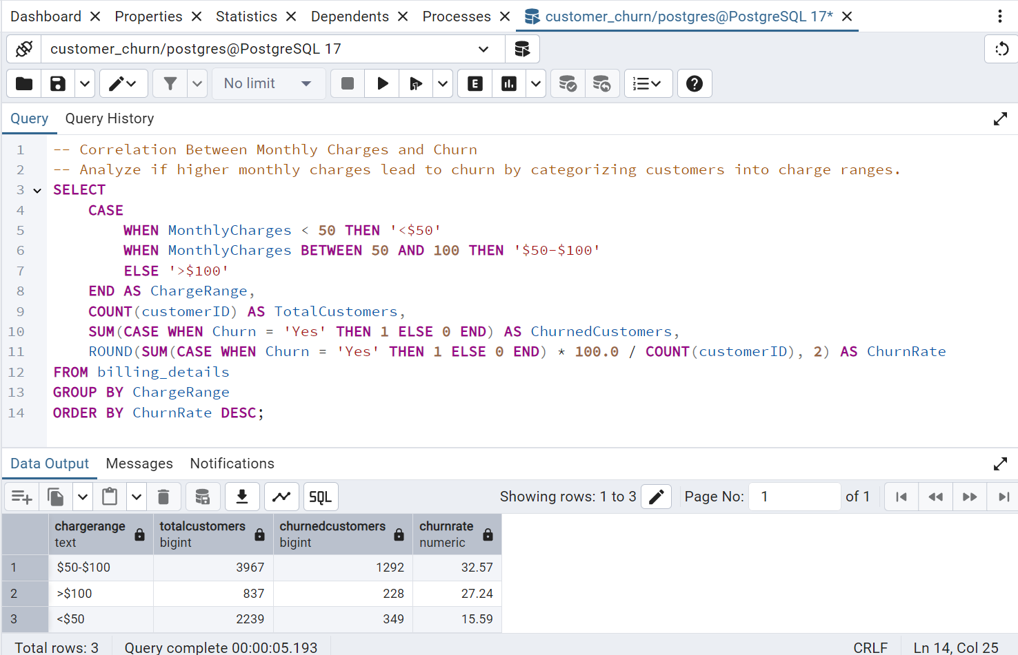

Ques 8: Services Combination Leading to High Churn  
Identify combinations of services (e.g., Phone, Internet) with the highest churn rate.

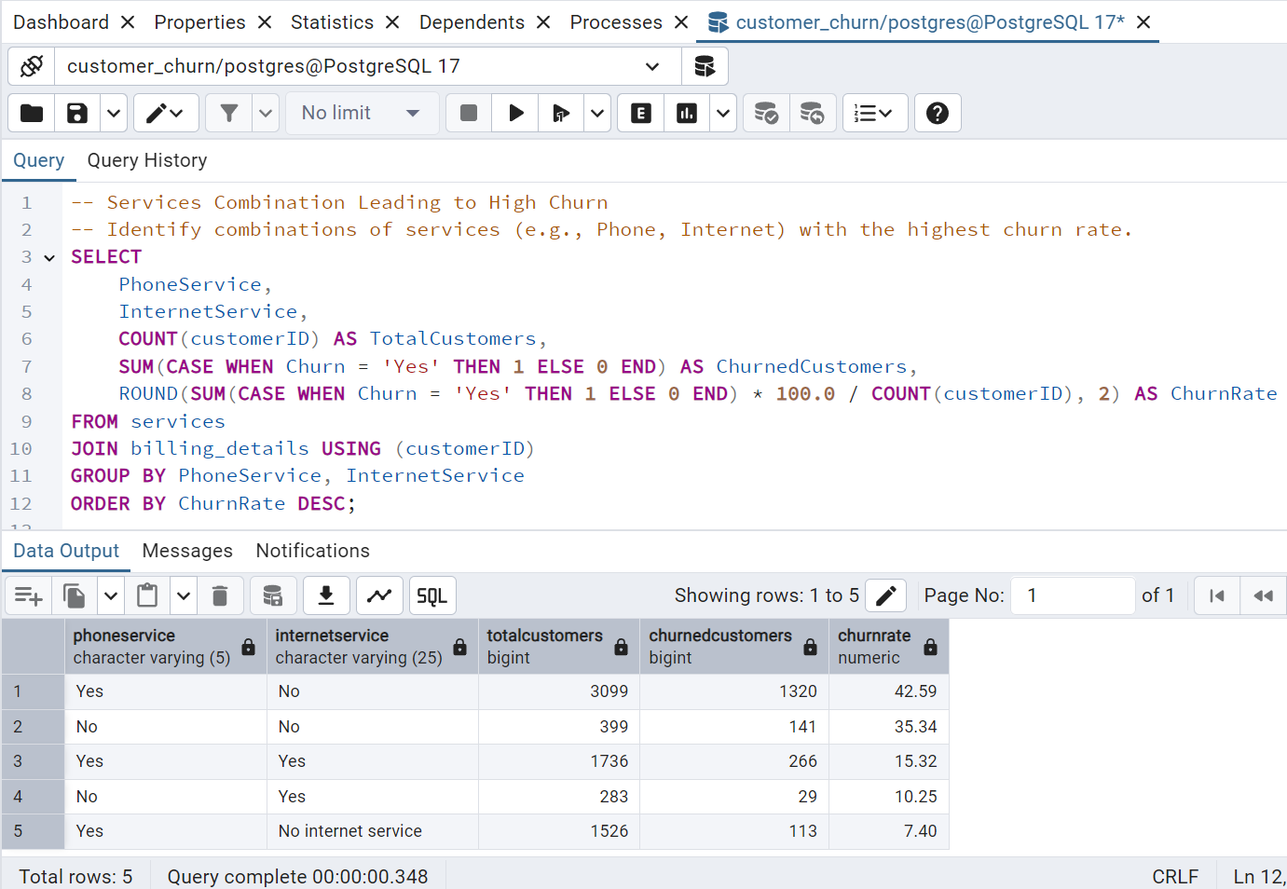

Ques 9: Customer Segmentation by Tenure and Churn

Segment customers into tenure ranges and analyze their churn behavior.

