**Reflection**

My pipeline consisted of below steps.

1. First, I converted the images to grayscale
2. Define a kernel size for Gaussian smoothing / blurring, define our parameters for Canny and run it

3) Region mask - defining a four sided polygon to mask

4) Define the Hough transform parameters

5) Create a "color" binary image to combine with line image

Here are images output in my code -

[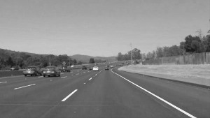](https://github.com/udacity/CarND-LaneLines-P1/blob/master/examples/grayscale.jpg)

Output images

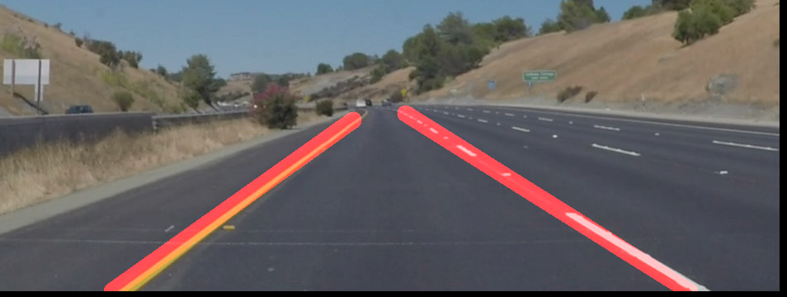

Output video after applying logic-



**2. Identify potential shortcomings with your current pipeline**

I’m facing issues in reading multiple images in pipeline and apply all transformation logic

**3. Suggest possible improvements to your pipeline**

I will apply glob function suggested my mentor to read multiple images.