College Management System

# Application Functionalities:

1.Student Module

2.Admin Module

3.Department Module

# 1.Student Module

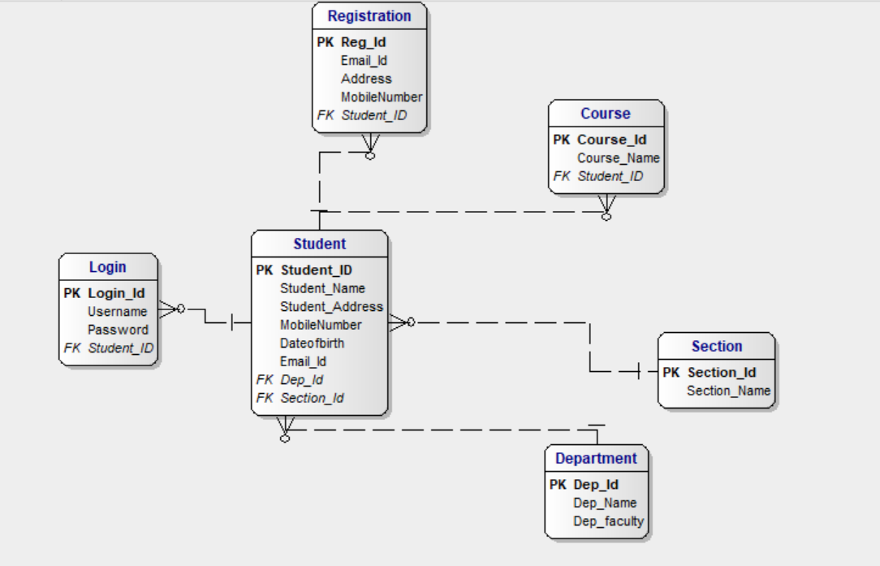

## 2.Admin Module:

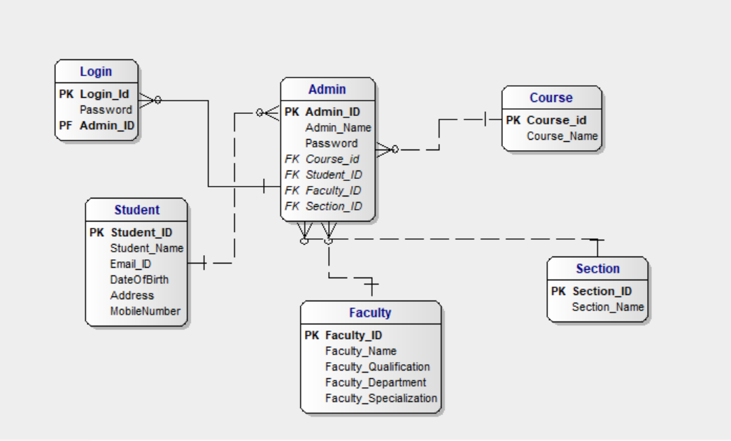

## 3.Department Module:

