# Task 1

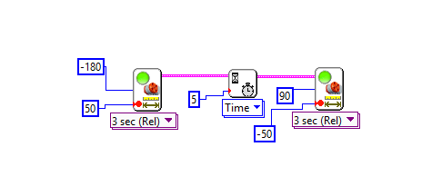

Code for Task 1

The object of task 1 was to understand the basics of motors in LabView. This task was fairly easy, and was mostly following the diagram. The grading TA requested that we switch the direction the motor ran, so it first moved backwards 180°, slept for 5 seconds (as required by the task) and finally moved forward 90°. The robot performed well.

# Task 2

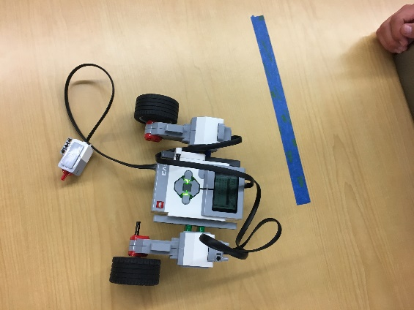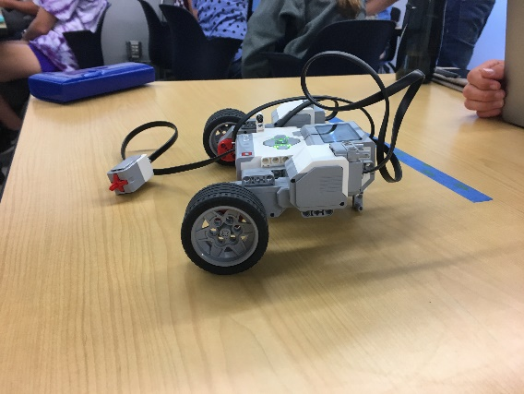

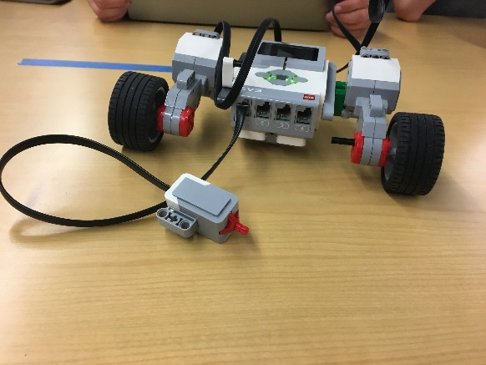

Task 2 was to build a robot. Here’s ours!

# Task 3

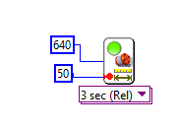

Code for Task 3

Task 3 was to make the robot move 1 foot. This was a process of trial and error. We first estimated the number of rotations the motor would need to travel ~1 foot (which we calculated to be 2 [720°]) and then modified the number based on how far off it was to travelling the required distance. The final distance ended up being turning the motor 640°. In this task, the robot performed flawlessly.

# Task 4

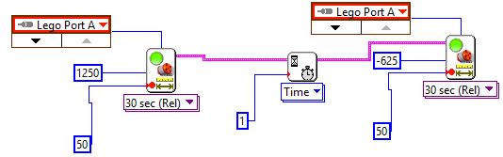

Code for Task 4

Task 4 was to make the robot turn 180° and then 90° in the opposite direction. At first, we attempted to use the steering block, but it was quite a hassle. The biggest problem was the robot never turned consistently when we used it. Sometimes it would turn close to 270° and other times close to 300°. We finally ended up using the move block, but only sent the command to one motor. We determined the degrees required to turn through trial and error, although we could have used the length between wheels as the radius of a circle and determined how many degrees the robot would need to move. Our solution made the robot more consistent. The code shows a move block for 1250° (equivalent to the robot rotating 180°), a sleep timer for one second (as required by the task), and a move block for -625° (equivalent to the robot rotating 90° in the opposite direction). The method we used made the robot perform well.

# Task 5

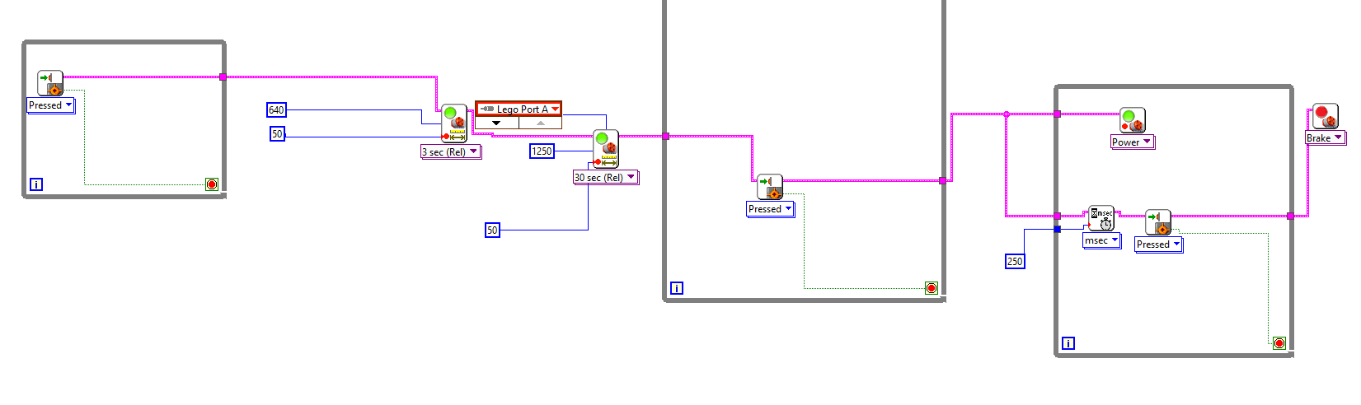

Code for Task 5

The object of task 5 was to mesh everything we learned in the previous tasks. We started the code with a while false loop for the touch sensor – do nothing until the touch sensor is pressed. Once it was pressed, we made it go forward 1 foot and rotate 180° as the task required. Then, it went into another while false loop, as it waited for the touch sensor to be pressed. When it was pressed, it went to another while false, which ran the motor and checked if the touch sensor was pressed (which if it was would cause the motor to brake). The robot worked flawlessly until part 4 and 5 of the task. Since the processing power of the robot is extremely fast, pushing the touch sensor would cause both touch sensor blocks (loop 2 and 3) to be called, which would make the robot barely move and stop. We alleviated this problem by having the touch sensor wait 250ms before checking if it was clicked. In the end the robot worked well.