Load Balancers:

Load Balancers are used when you are having multiple workers and you want to distribute load among them.
A Load Balancer aims to optimize resource usage, provide maximum throughput, minimize response time and avoid overloading of resource.

MuleSoft CloudHub offers two kind of Load Balancer:
- Shared Load Balancers
- Dedicated Load Balancers

Shared Load Balancer:

In Mule, when we deploy our application to CloudHub then shared load balancer will come into role. Like we choose 2 as our worker thread, and deploy our application to cloud, then Mule provide Shared Load Balancer which will do the balancing of traffic and implementing Mule Security. In the shared load balancer you cannot implement your own security, it is provide by the MuleSoft only.
Shared Load Balancer cannot add custom certificates, sub-domains and can’t expose custom vanity domain names.

Below is the snippet:

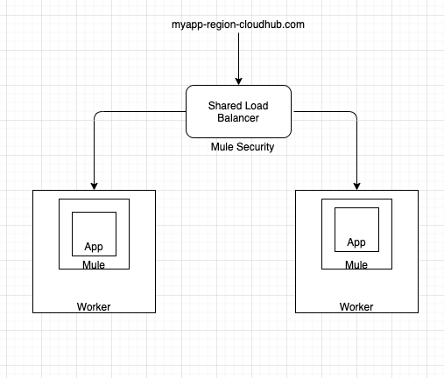

Dedicated Load Balancer:
Dedicated Load Balancer resides inside VPC, user can introduce more than one DLB inside VPC. As this is a part of VPC, so company can introduce customized security certificate, also can do IP whitelisting/blacklisting, configure sub-domains and can write url mapping rules.

Below is the snippet:

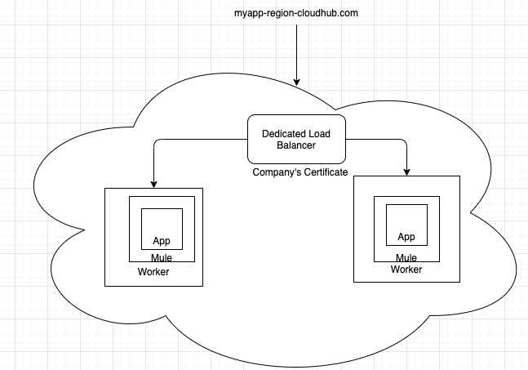

Below is the snippet of overall differences:
