MultiCuisine Ordering System

1.1 Scope :

Multicuisine ordering system provides delicacies from various restraunts at one place. The uniqueness of this project is customers can order fooditems from different restraunts at one place.
Customers can look at the various food items provided by a restraunt and also the pricing of the item. Only customers who have accounts can place order.

1.2 Functionalites:

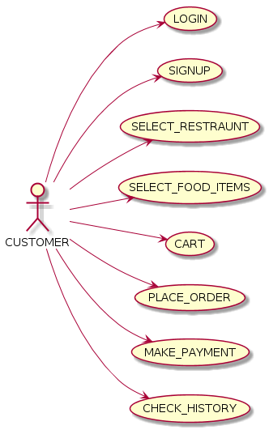

fig. Customer Functionalities

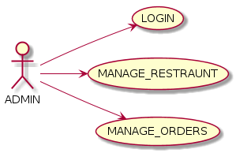

fig. Admin Functionalities

1) Login / Signup :

A) Customer :
a) Customer Signup :

- Customer will have to enter the following fields (mandatory):
i. First name
ii. Last name
iii. Email
iv. Contact number
v.Home address- street, area, city, pincode.
vi. Password ( min 8 characters )
vii. Accept terms and conditions.
-when clicked on signup system will add the above fields into the customer table.

b) Customer Login:

- Customer should enter his email and password to login in to the system.
- System will verify the email and password.
-On successful login customer is directed to restraunt page.
- If failed display message “Incorrect email or password”.

B) Admin :
a) Admin login :

-When admin enters his email and password.
-System will verify the email and password and if correct then the admin will get access to next page.

2) Restraunt List Page :

A) Customer :
- System will only show the list of all the available restraunts in the database.
- Customer can select any restraunt of his liking for ordering the items.
- On selecting a restraunt system will direct him to the food item list page.

B) Admin :
- System will show the list of all the available restraunts in the database.
- he can insert restraunts into the list.
- he can update restraunt details like food items ,restraunt information,etc.
- he can delete the restraunt.
- system will insert, update or delete according to admins command.

3) Food item list :

A) Customer :
- he can see the restraunt details and the food items available in the restraunt.
- on selecting a food item he can add it to cart.

B) Admin :
- he can insert, update or delete food items from the list.

4) Cart :

A) Customer:
- he can see the items available in his cart.
- on selecting place order he will be directed to the Delivery details page.
- he can remove items from his cart.
- he can also see his previous history on selecting history (if any).

5) Orders :

A) Admin :
- only admin will have access to this page.
- he will be able to see all the orders made by all the customers.

6) Delivery details page :

A) Customer :
- he can select payment mode if payment is online then he will be directed to payment portal.
- if cash on delivery is selected then order will be placed.

7) Payment Portal :
- customer will be required to fill card details and on selecting make payment order will be placed.

8) History :
- on successful order placement system will add the order details into this page.

