Scenario 1 - Create three Accounts with initial amount:

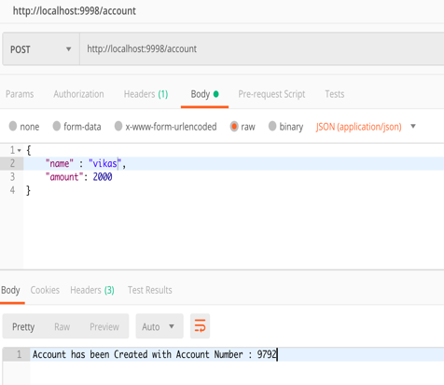 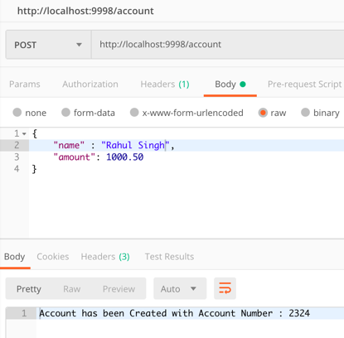 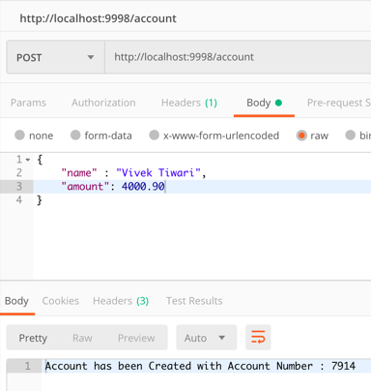

Scenario 2 – Get all the created account to verify the data:

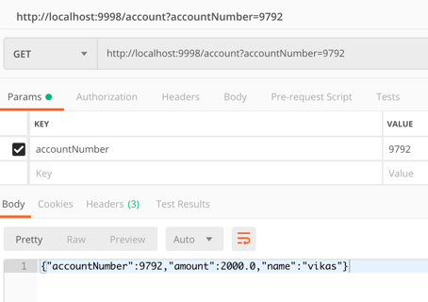 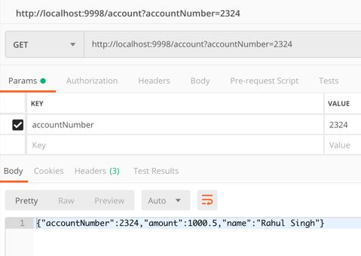 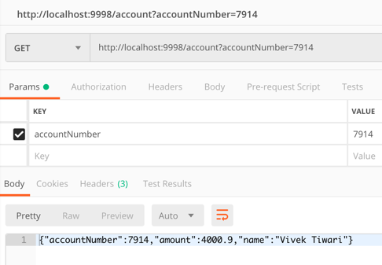

Scenario 3 – Vikas(accountNumber-9792) transfer 200$ to Rahul(accountNumber-2324) and Same time Vivek(accountNumber-7914) transfer 100$ to Rahul(accountNumber-2324).

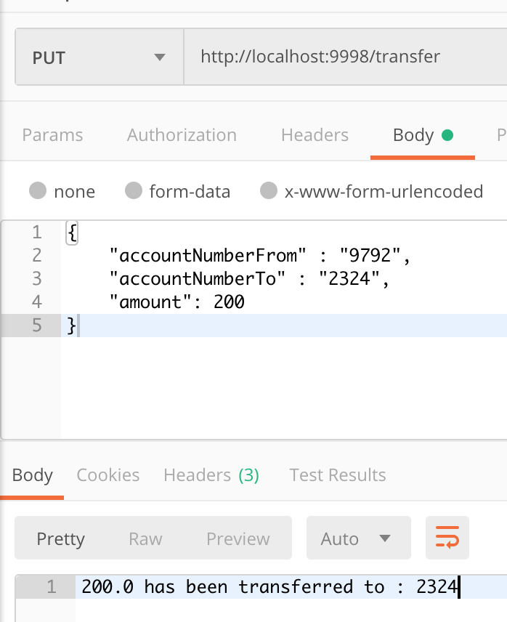 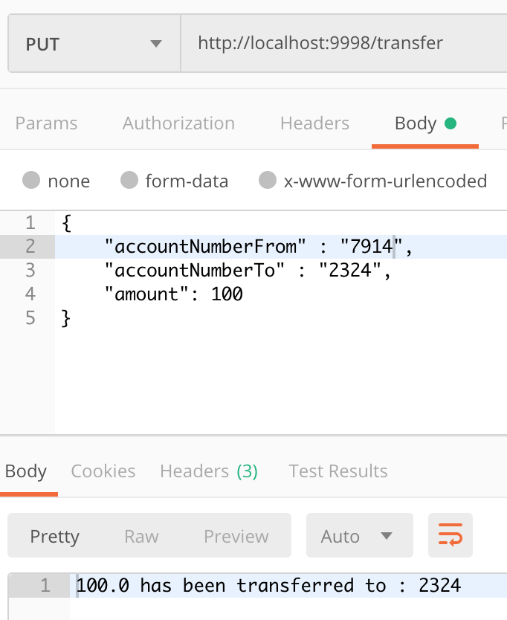

Fetch All three Account to check balance Amount:

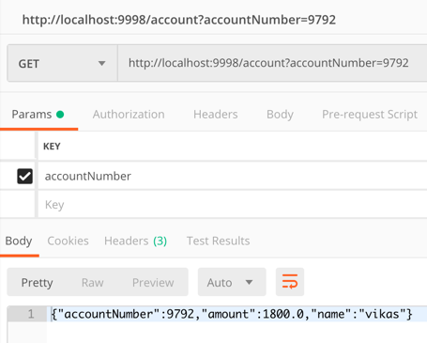 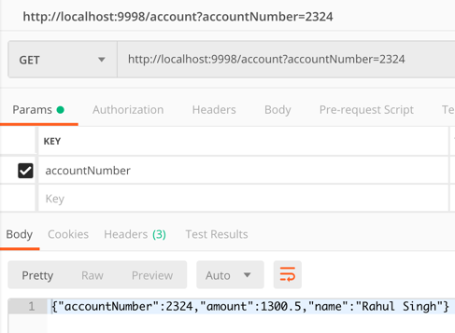 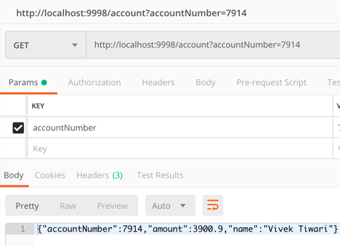

Scenario 4 – When try to send amount to same person from two different account at same time the one got pass and other got fail due to lock on same row update.

1. Success

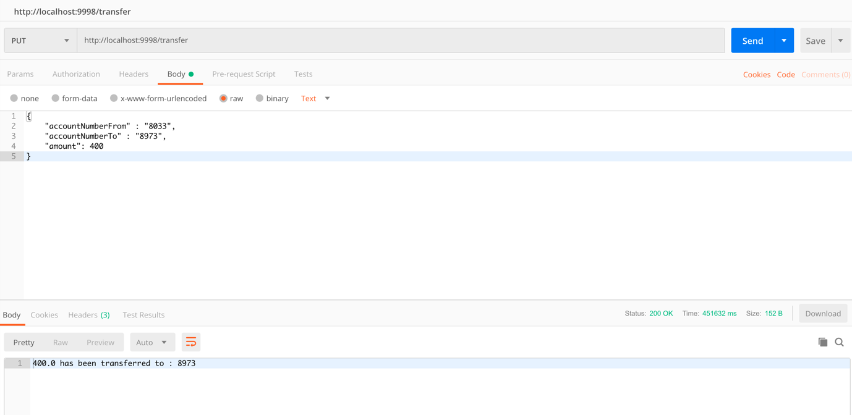

1. Failure

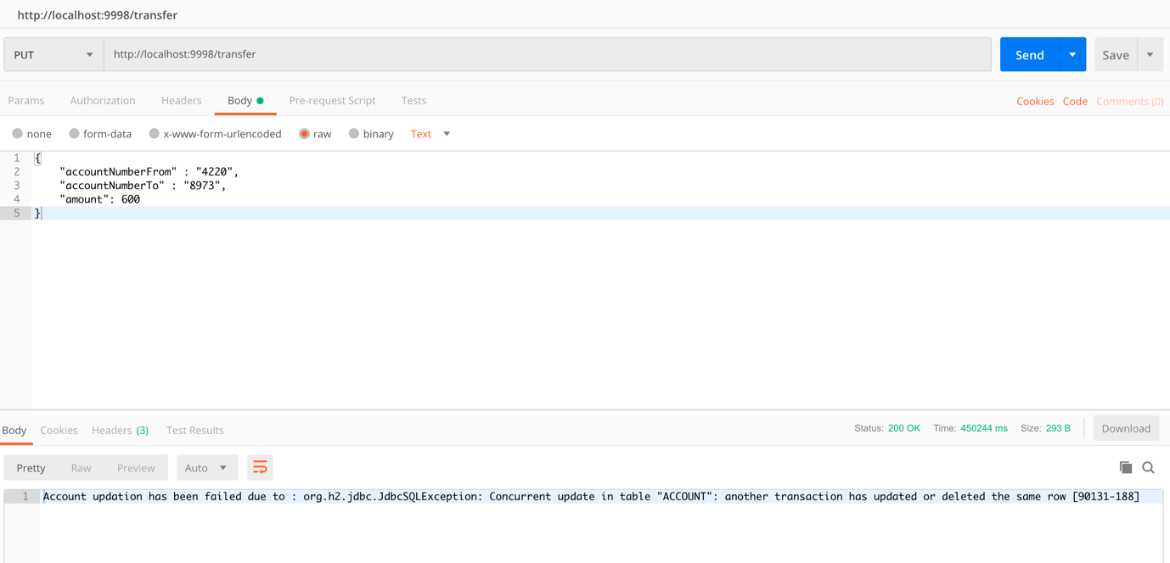

Scenario 5 – Vikas(accountNumber-9792) tries to transfer -200$(negative Amount) to Rahul(accountNumber-2324) will get below Exception:

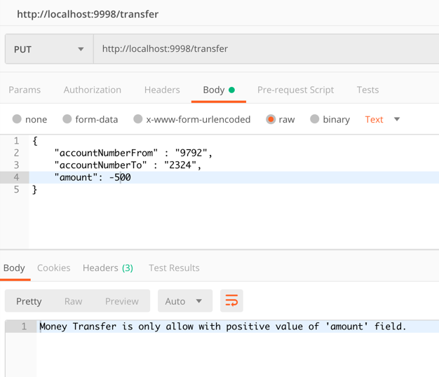

Scenario 6 – Vikas(accountNumber-9792) tries to transfer 10000$(more than its current balance amount) to Rahul(accountNumber-2324) will get below Exception:

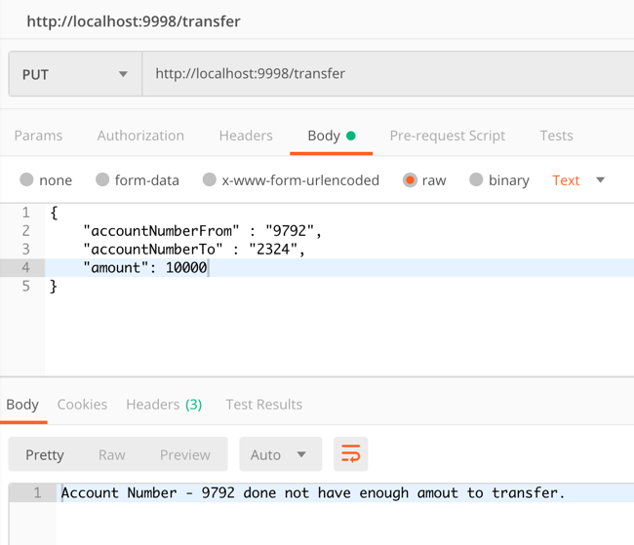

Scenario 7 – Vikas(accountNumber-9792) tries to transfer 100$ with giving wrong Account number to Rahul(accountNumber-2324) will get below Exception:

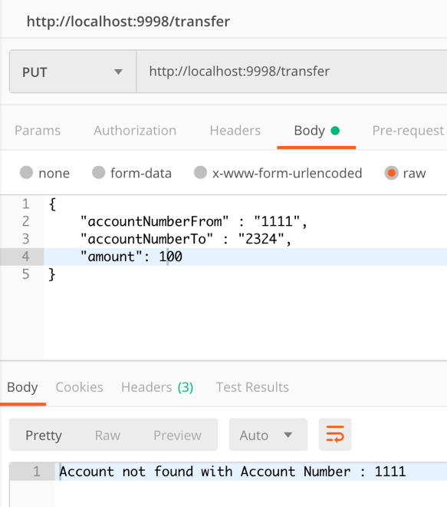 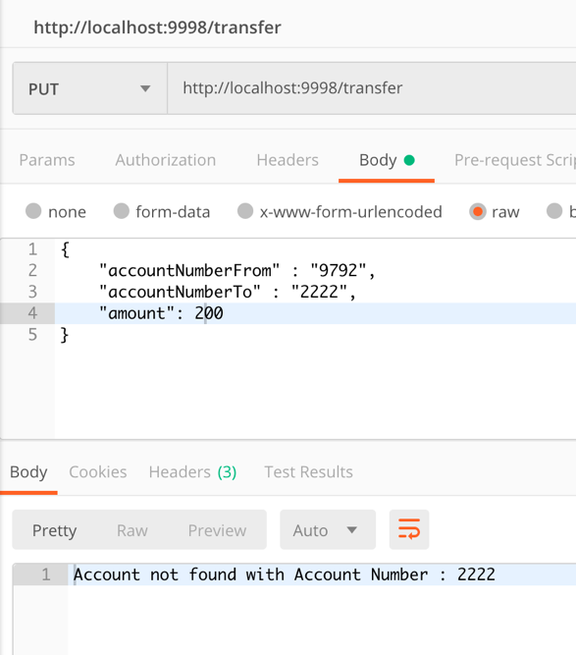

Scenario 8 – Vikas(accountNumber-9792) tries to transfer 100$ with giving wrong Account number as String to Rahul(accountNumber-2324) will get below Exception:

