Configure 3 vms, 2 GB RAM, 1 processor 2 core , 60 GB Storage and 1 NAT ,1 HostOnly adapter.

STEP-1 => Disable firewall , selinux , /etc/hosts hostonly ips entries, mount /home using nfs

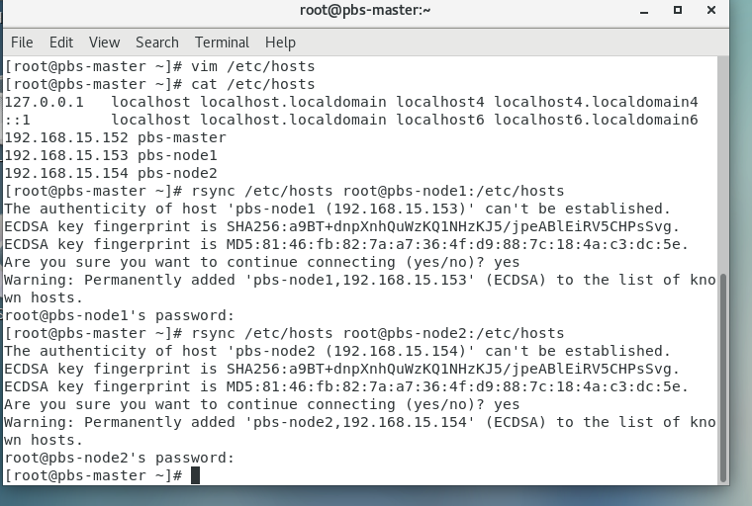

STEP-2

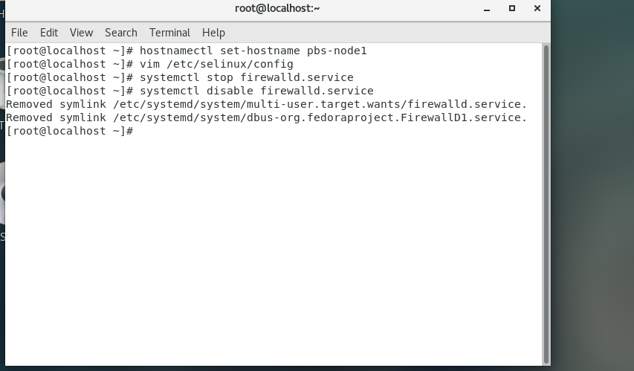

STEP-3

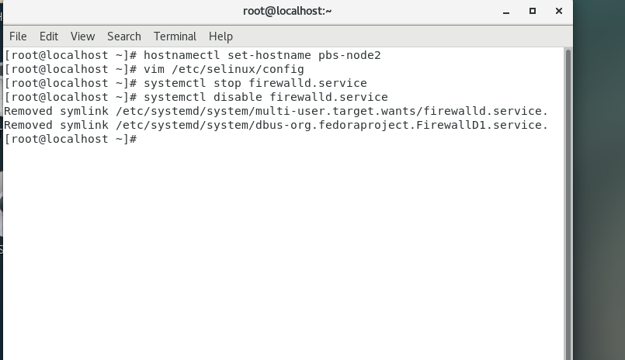

STEP-4 => yum install git –y

git clone <https://github.com/openpbs/openpbs.git>

yum group list

yum groupinstall “Development Tools”

tar -cvf /root/rpmbuild/SOURCES/openpbs-23.06.06.tar.gz openpbs-23.06.06/

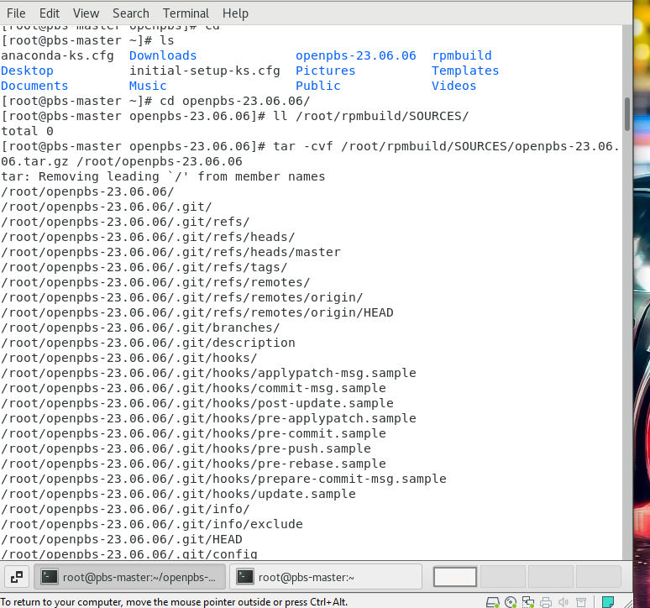

STEP-5 => rpmbuild -ba openpbs.spec

if still shows error

#yum install gcc hawloc-devel -y

yum install libtool-ltdl-devel hwloc-devel libXt-devel libedit-devel libical-devel ncurses-devel postgresql-devel postgresql-contrib python3-devel tcl-devel tk-devel zlib-devel expat-devel openssl-devel –y

again run rpmbuild –ba openpbs.spec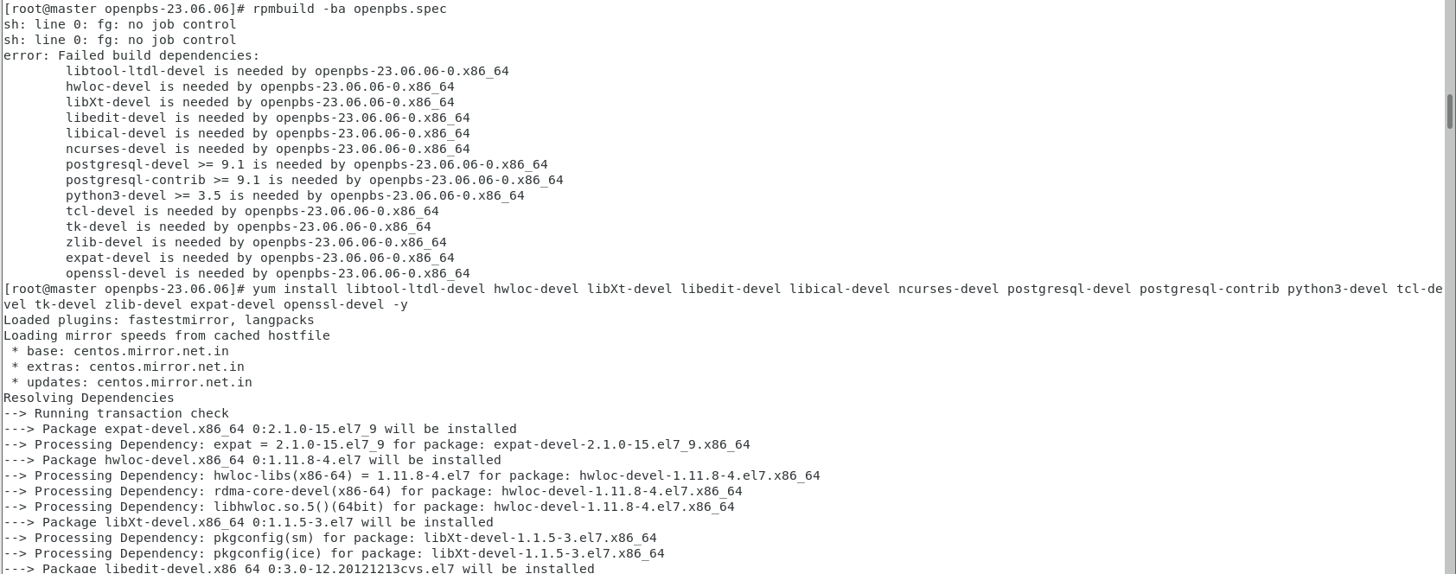

STEP-6 🡺

#cd

#cd rpmbuild/RPMS/x86_64

#ll

# yum install openpbs-server-23.06.06-0.x86_64.rpm -y

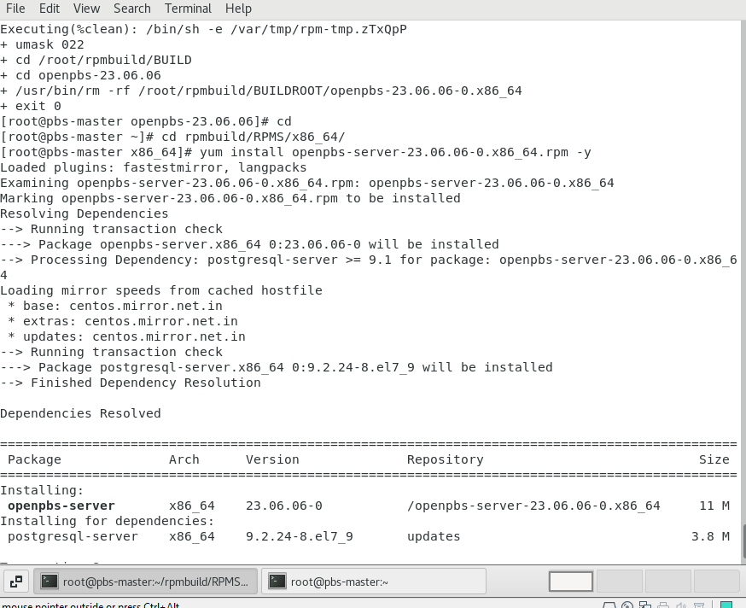

STEP-7 🡺 systemctl status pbs.service

chmod 4755 /opt/pbs/sbin/pbs_iff /opt/pbs/sbin/pbs_rcp

systemctl restart pbs

systemctl status pbs

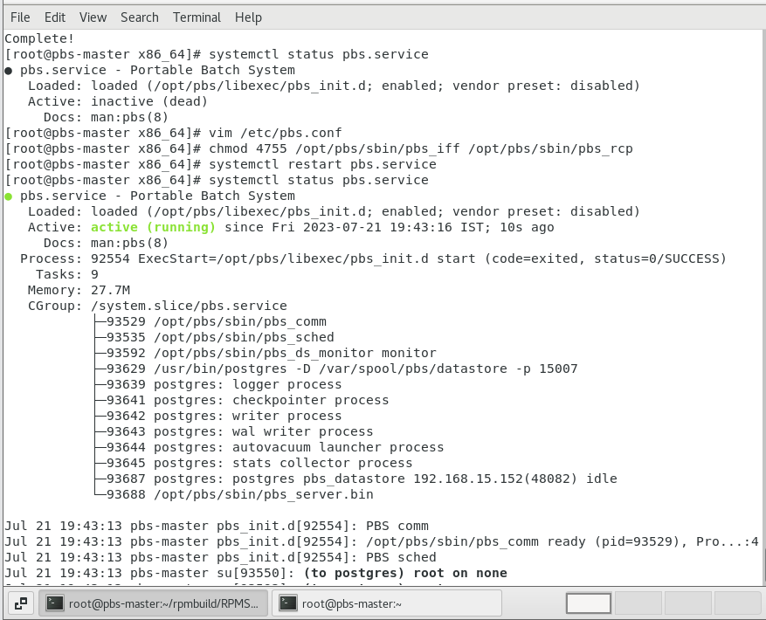

STEP-8 🡺 vi /etc/pbs.conf

Check for the PBS_START_MOM=0 this means MOM service is disabled for the

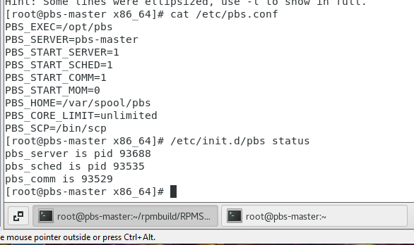

STEP-9 🡺 cat /etc/pbs.conf

/etc/init.d/pbs status

. /etc/profile.d/pbs.sh

which qstat

qstat -B

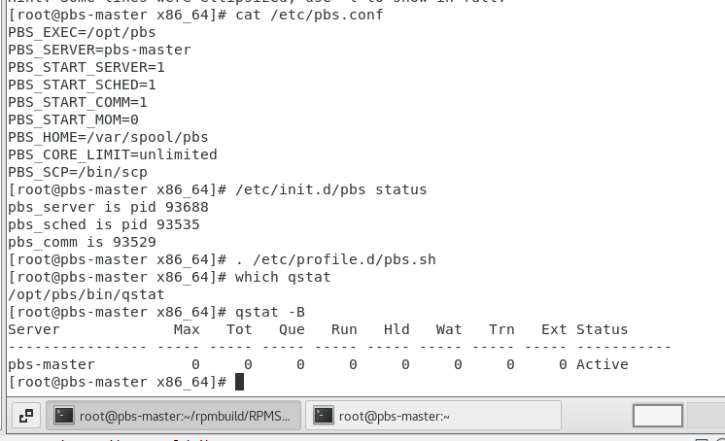

**GO TO PBS-NODE1**

STEP-10 🡺 yum install git -y

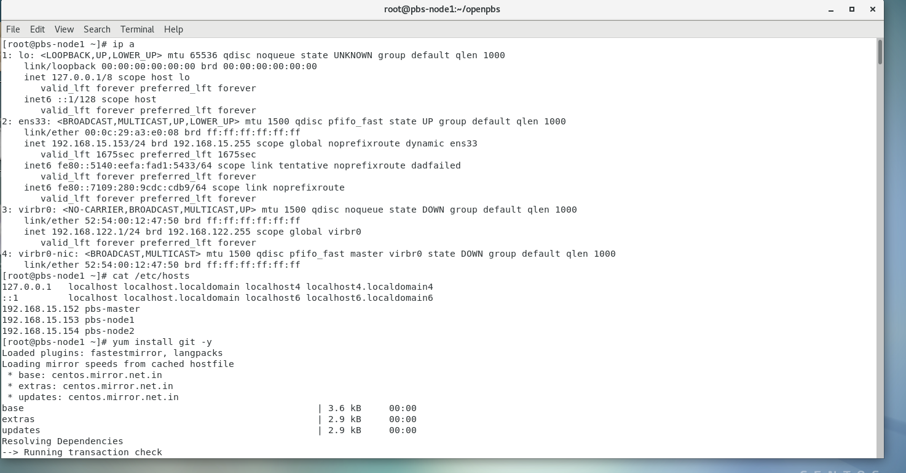

STEP-11 🡺 git clone <https://github.com/openpbs/openpbs.git>

cd openpbs/

ls

./autogen.sh

If you not get this file

#yum provides */autoconf

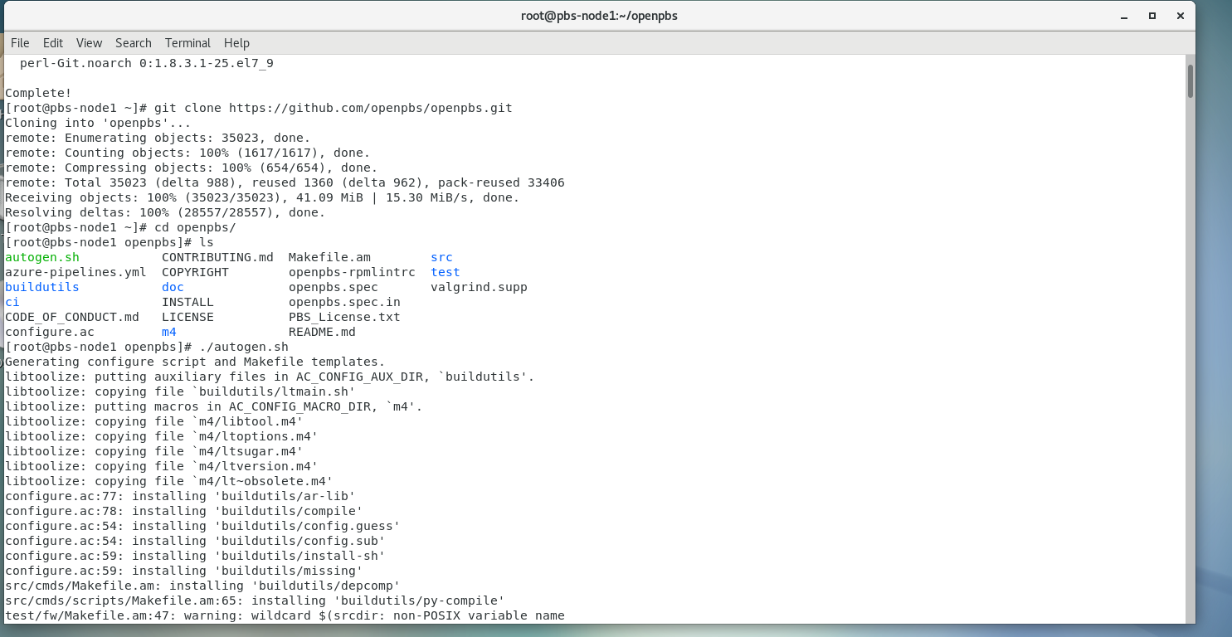

STEP-12 => yum install autoconf automake libtool

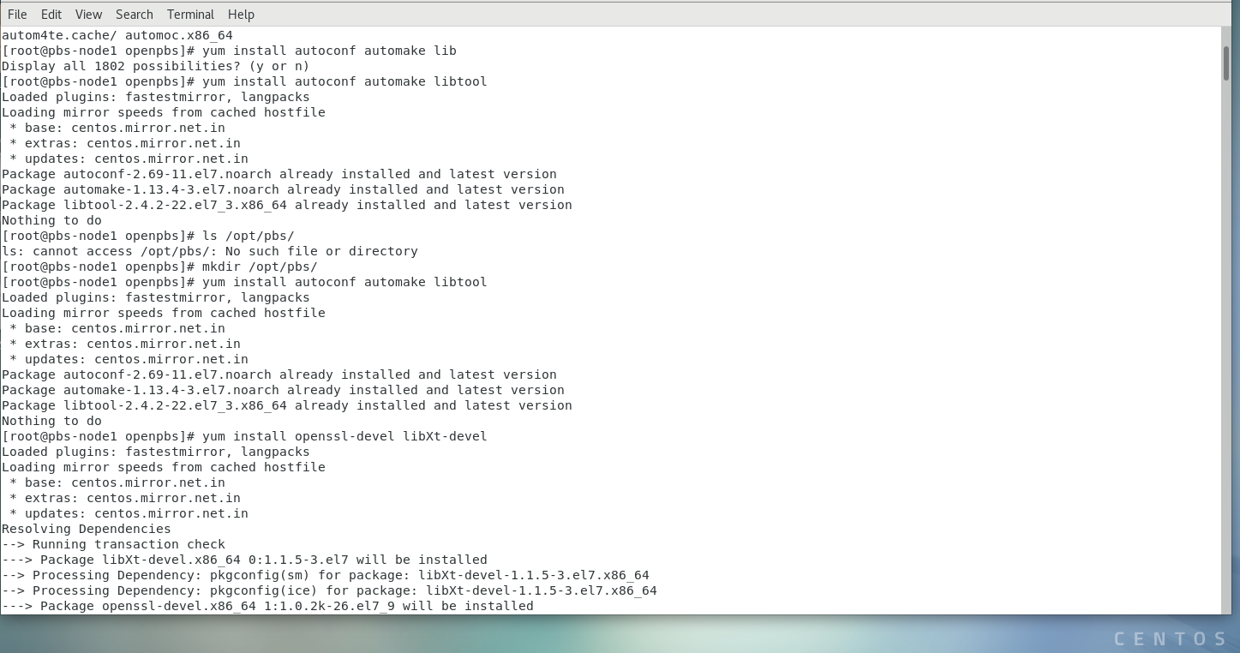

STEP-13 🡺 mkdir /opt/pbs/

yum install openssl-devel libXt-devel

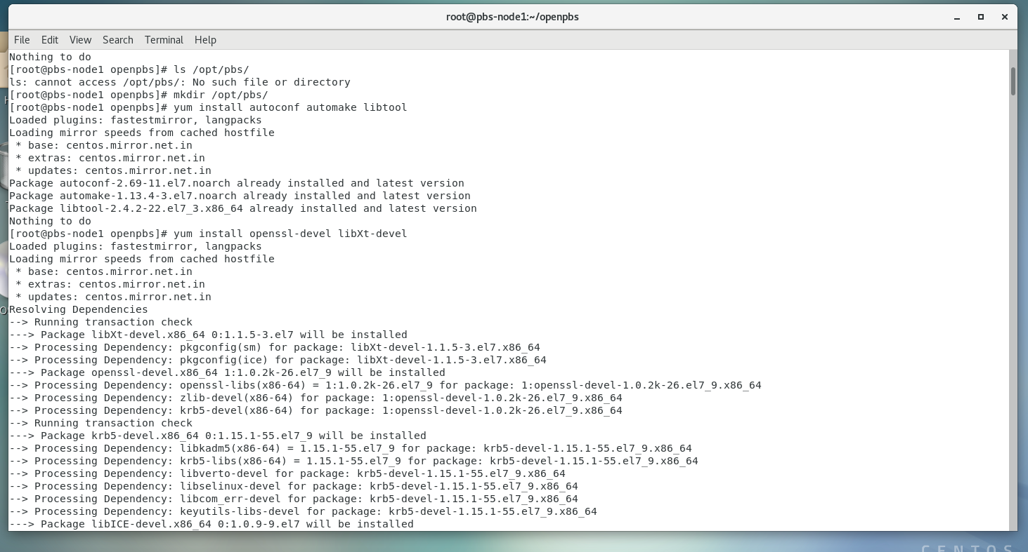

STEP-14 => ./configure –prefix=/opt/pbs

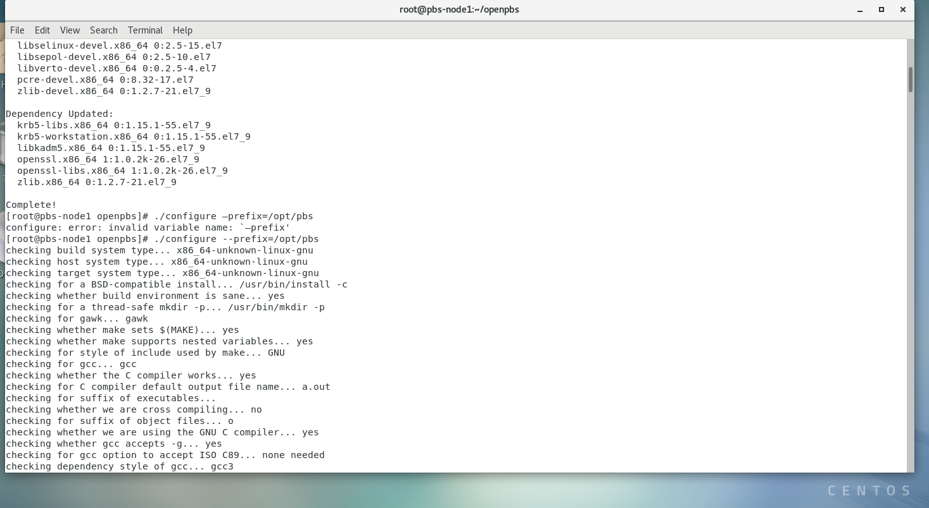

STEP-15 🡺 #you will get error data base is missing.

yum install libtool-ltdl-devel hwloc-devel libXt-devel libedit-devel libical-devel ncurses-devel postgresql-devel postgresql-contrib python3-devel tcl-devel tk-devel zlib-devel expat-devel openssl-devel –y

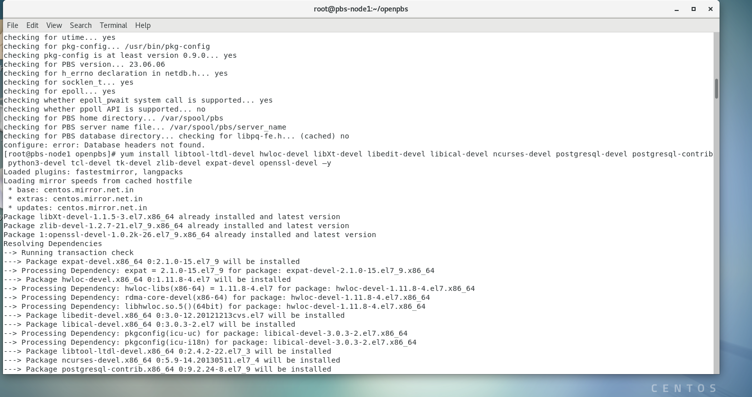

STEP-16 🡺 ./configure –prefix=/opt/pbs

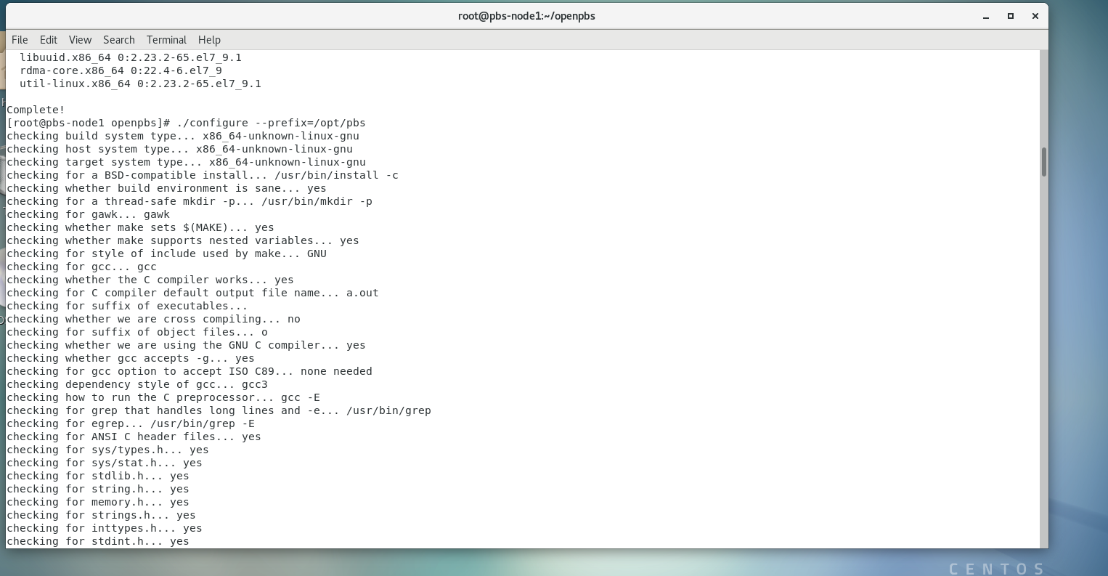

STEP-17 🡺 make

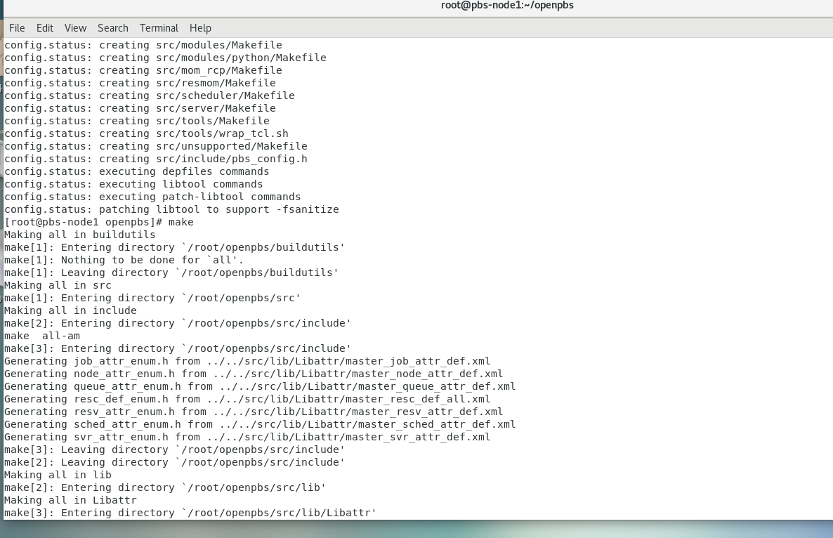

STEP-18 🡺 ls /opt/pbs

ll

make install

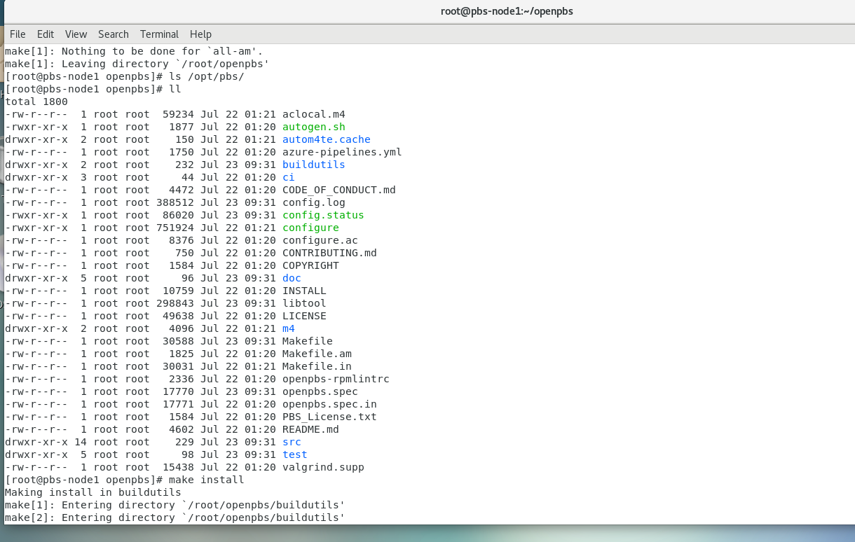

STEP-19 🡺 ll /opt/pbs

#ll /opt/pbs/etc

#run qstat or qstat –B --🡪error

#chmod +x /opt/pbs/etc/pbs.sh

#bash /opt/pbs /etc/pbs.sh

#export PATH=${PATH}:/opt/pbs/bin

**Go pbs-master**

scp /etc/pbs.conf pbs-node1:/etc/pbs.conf

**Again come to pbs-node1**

vim /etc/pbs.conf

systemctl start pbs

systemctl enable pbs

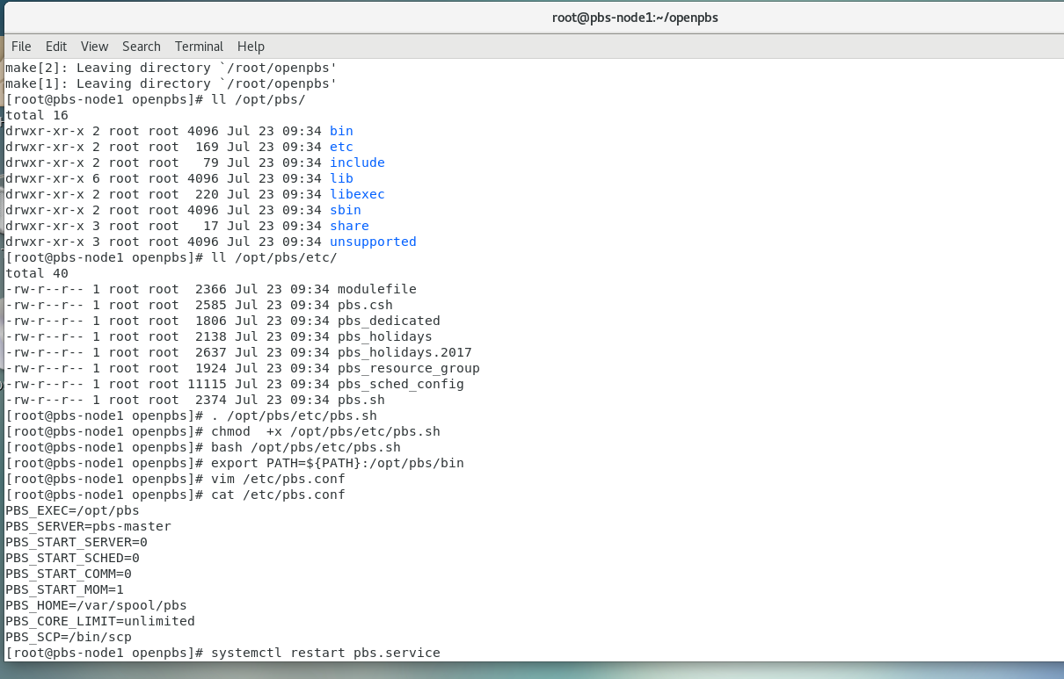

**STEP-20 => GO TO MASTER AND DO SCP**



**STEP-21 🡺 pbs-node1**

systemctl status pbs

qstat -B

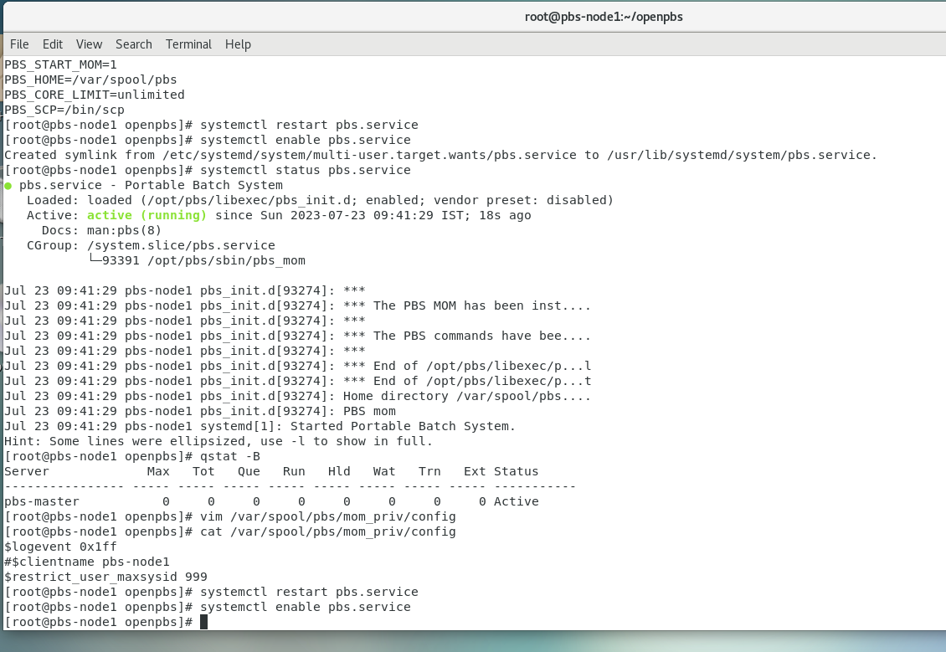

**STEP-22 GO TO MASTER AND RUN THE FOLLOWING CMD**

cd

cd /root/rpmbuild/RPMS/x86_64/

ls

systemctl restart nfs-server.service

systemctl enable nfs-server.service

chmod 777 /home/

vim /etc/exports

/home/ 192.168.15.154 (rw,sync,no_root_squash) 🡪 node2 ip

exportfs –avr

mkdir /home/rpms

cp * /home/rpms/

ll * /home/rpms/

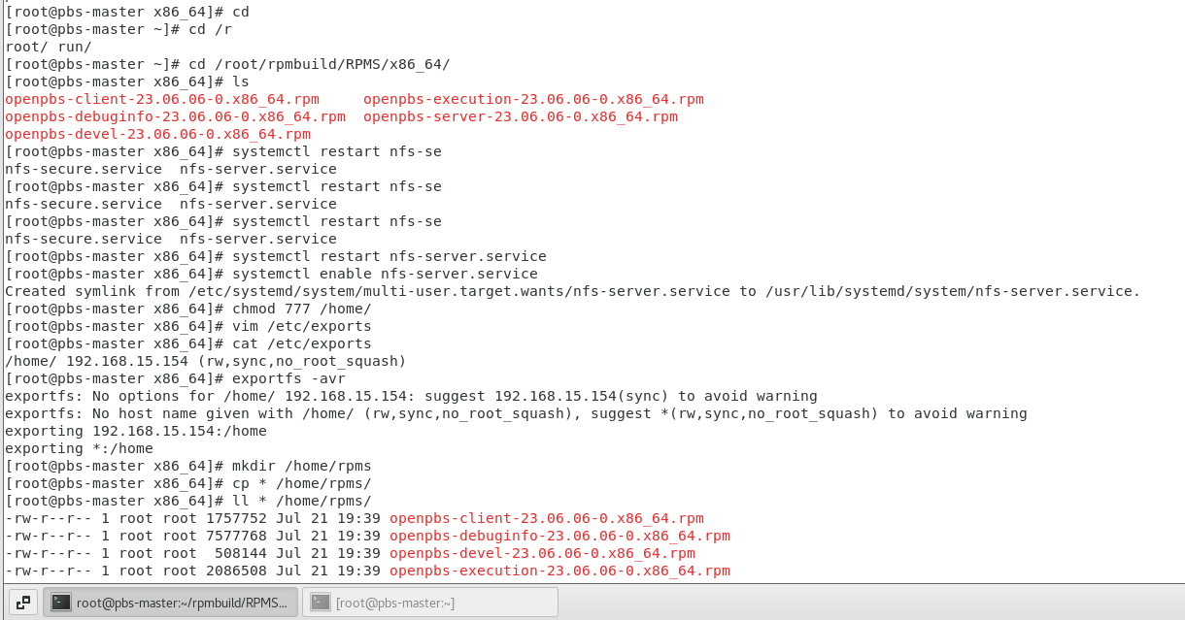

**GO TP PBS-NODE2**

STEP-23 🡺 yum install –y nfs-utils

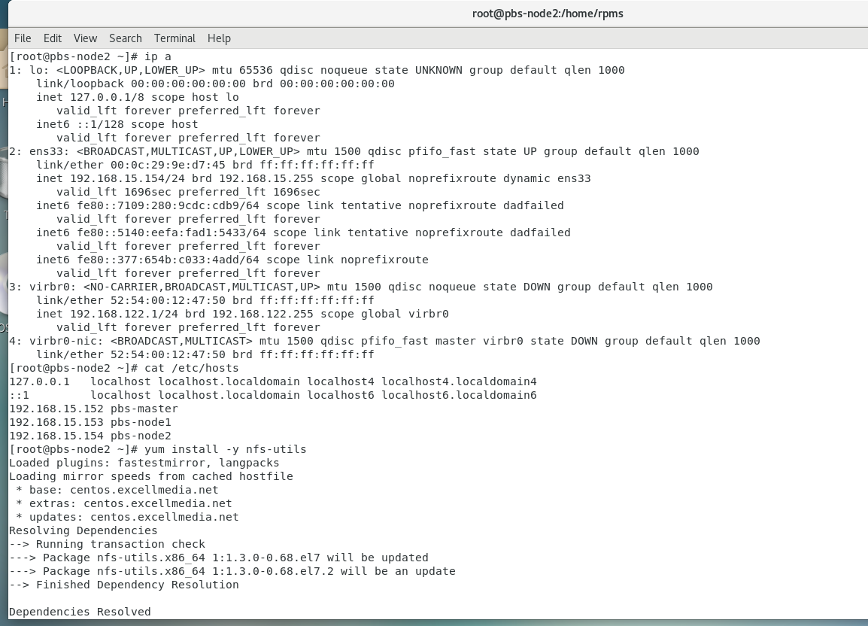

STEP-24

systemctl start nfs

systemctl enable nfs

Mount –t nfs 192..168.15.152:/home/ /home/ 🡪 master ip

df –Th

ll /home/rpms/

cd /home/rpms/

yum install openpbs-execution-23.06.06-0.x86_64.rpm

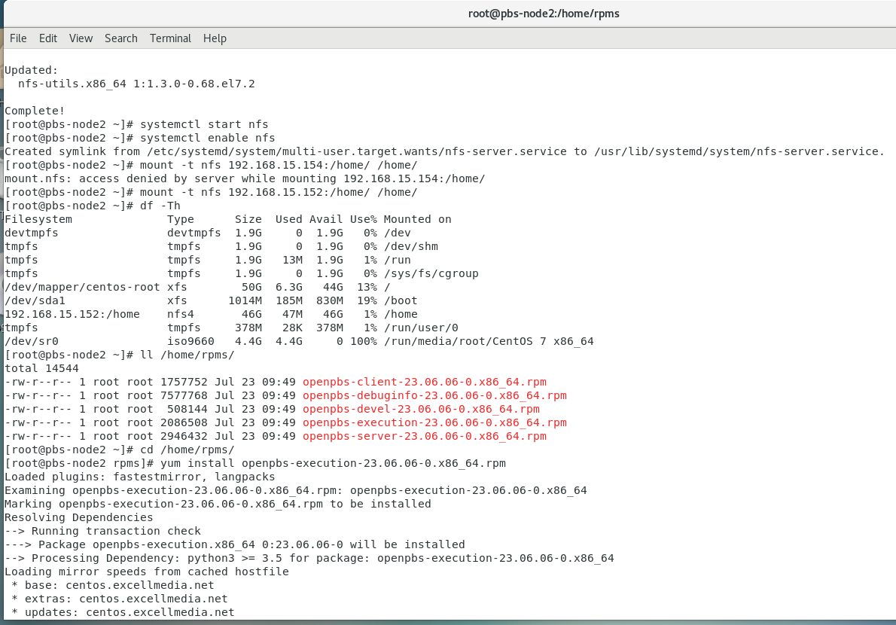

STEP-25 🡺

vim /etc/pbs.conf

systemctl restart pbs

systemctl enable pbs

systemctl status pbs

vim /var/spool/pbs/mom_priv/config this should be done in node1 also

$logevent 0x1ff

#$clientname pbs-node2

$restrict_user_maxsysid 999

