### ASSIGNMENTS OF Setting up MariaDB database:-

**STEP-1🡪**Install MariaDB🡪yum install mariadb-server mariadb-devel -y

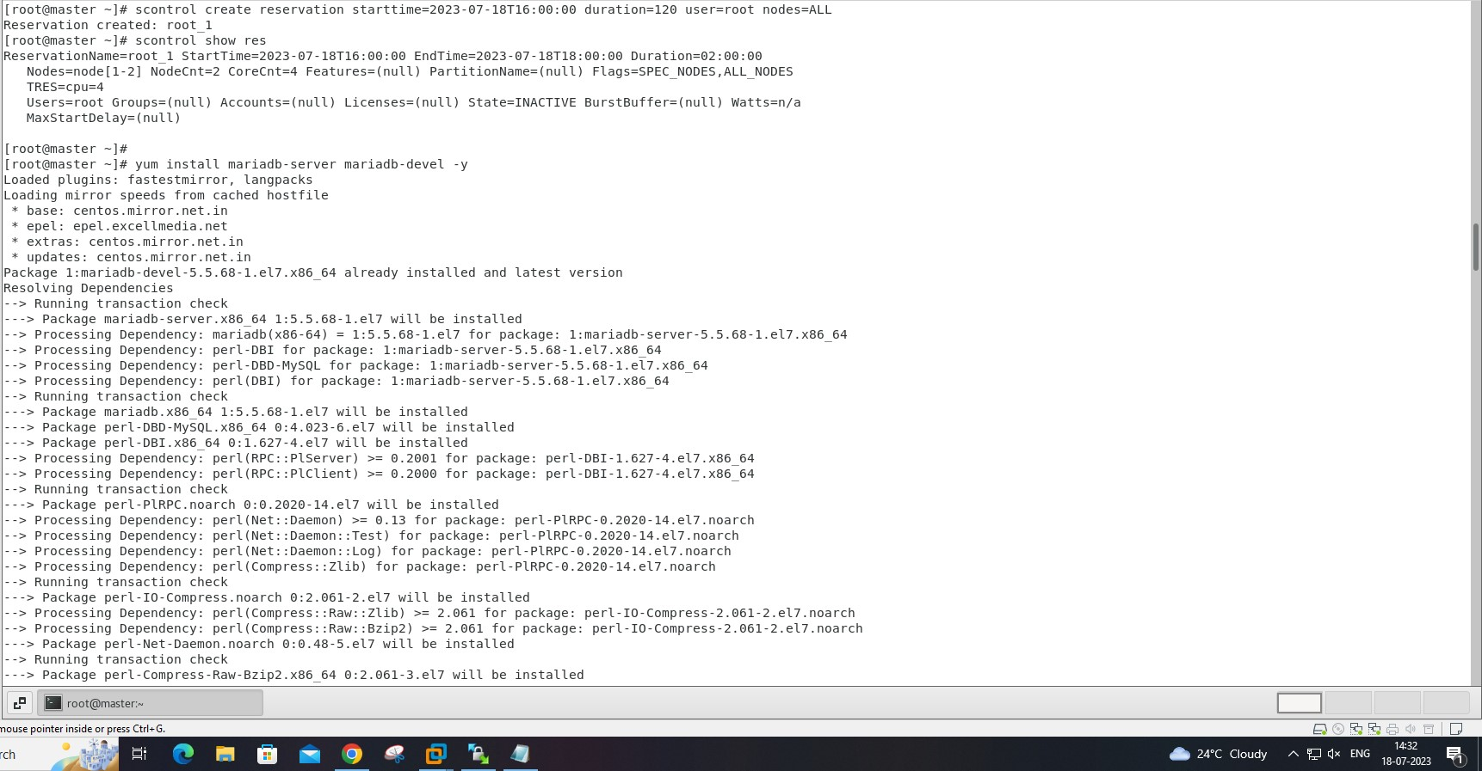

**STEP-2🡪**installing under process…

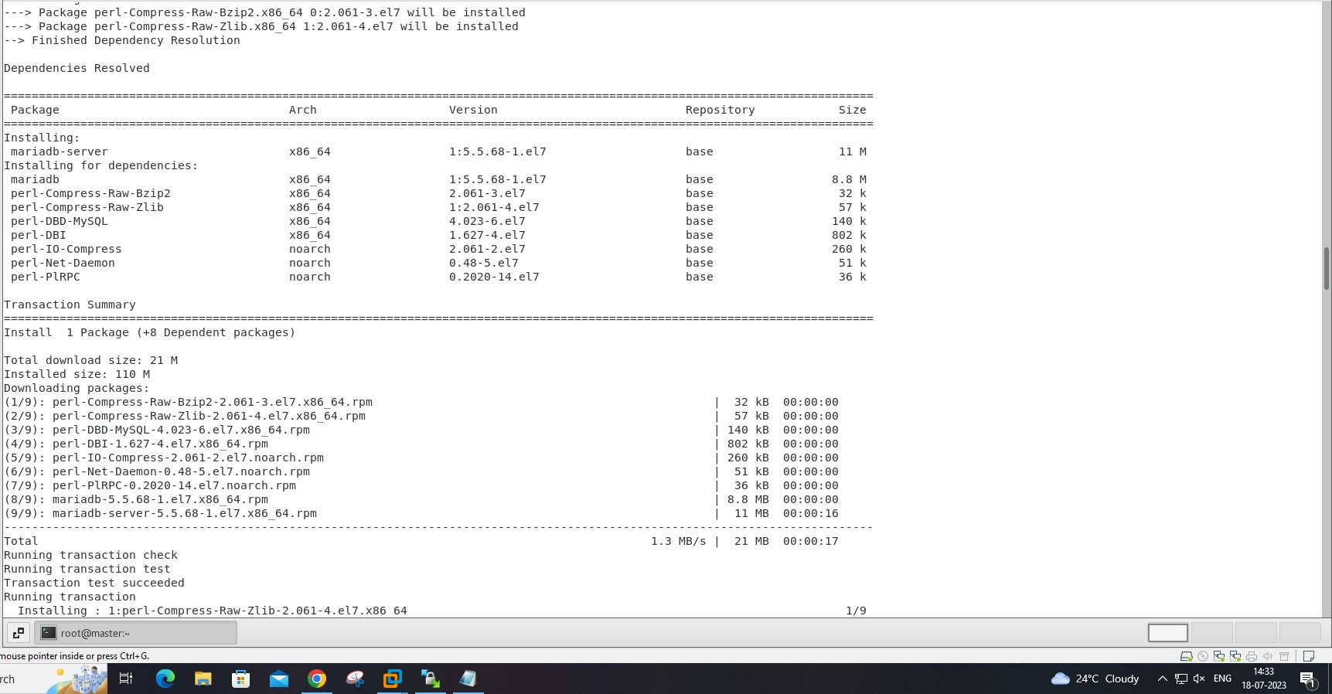

**STEP-3🡪**Start the MariaDB service:-

🡪systemctl enable mariadb

🡪systemctl start mariadb

🡪systemctl status mariadb

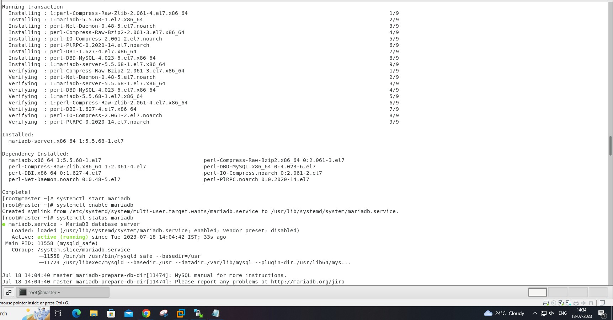

**STEP-4🡪**Create the Slurm database user🡪mysql

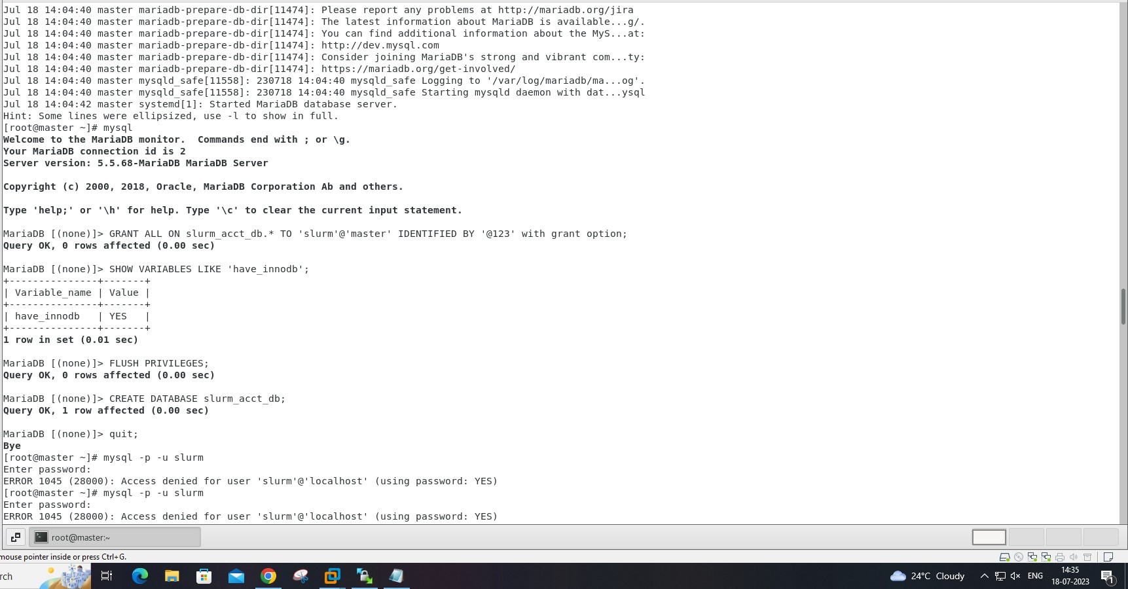

**STEP-5🡪**In mariaDB🡪

*MariaDB[(none)]> GRANT ALL ON slurm_acct_db.* TO 'slurm'@'localhost' IDENTIFIED BY '1234' with grant option;*

*MariaDB[(none)]> SHOW VARIABLES LIKE 'have_innodb';*

*MariaDB[(none)]> FLUSH PRIVILEGES;*

*MariaDB[(none)]> CREATE DATABASE slurm_acct_db;*

*MariaDB[(none)]> quit;*

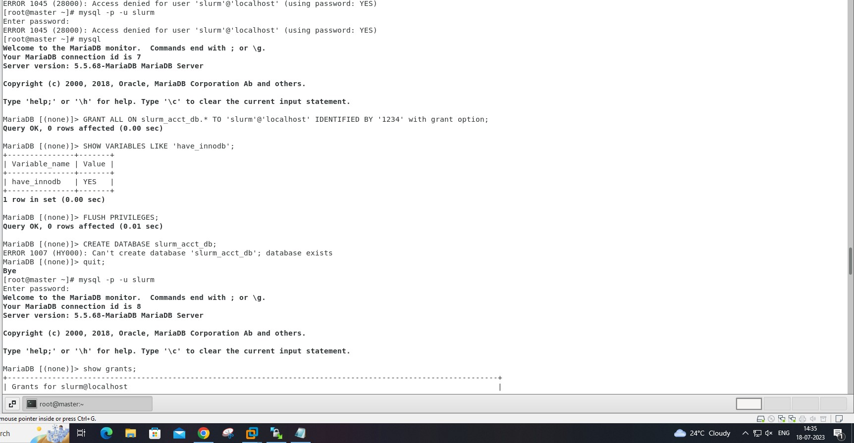

**STEP-6🡪**Verify the databases grants for the slurm user

🡪mysql -p -u slurm

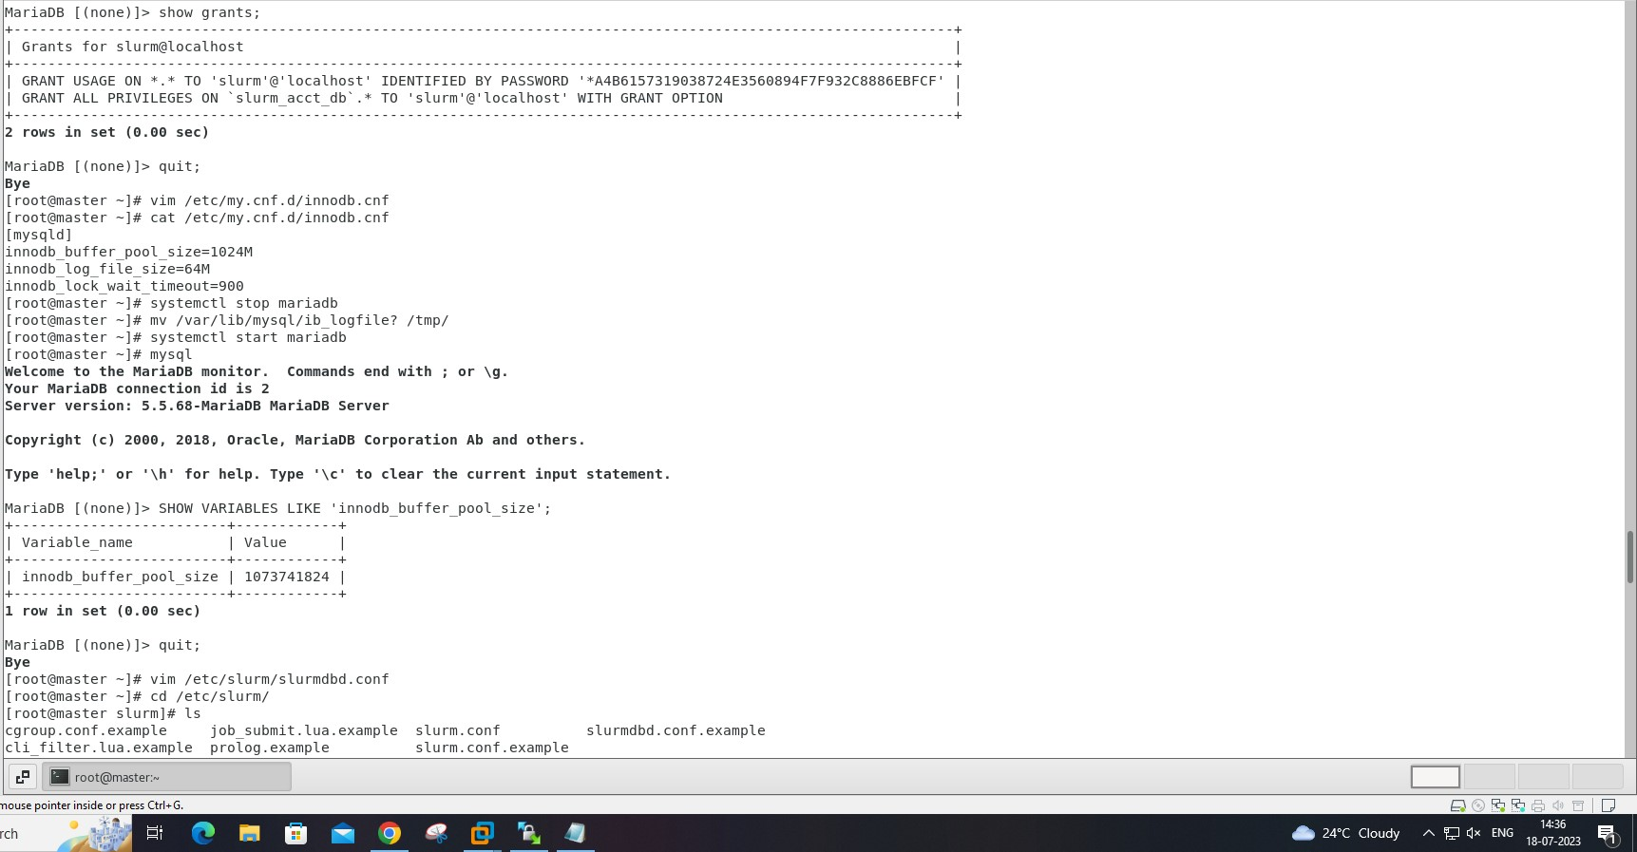

**STEP-7🡪**Tpye password for slurm: 1234. In mariaDB:

MariaDB[(none)]> show grants;

MariaDB[(none)]> quit;

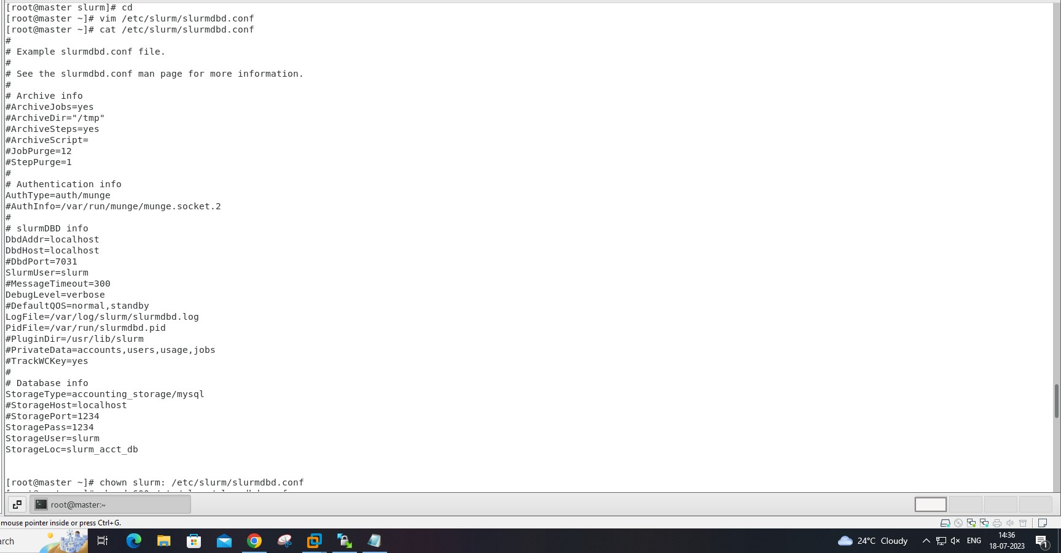

**STEP-8🡪**Create a new file /etc/my.cnf.d/innodb.cnf containing:

[mysqld]

innodb_buffer_pool_size=1024M

innodb_log_file_size=64M

innodb_lock_wait_timeout=900

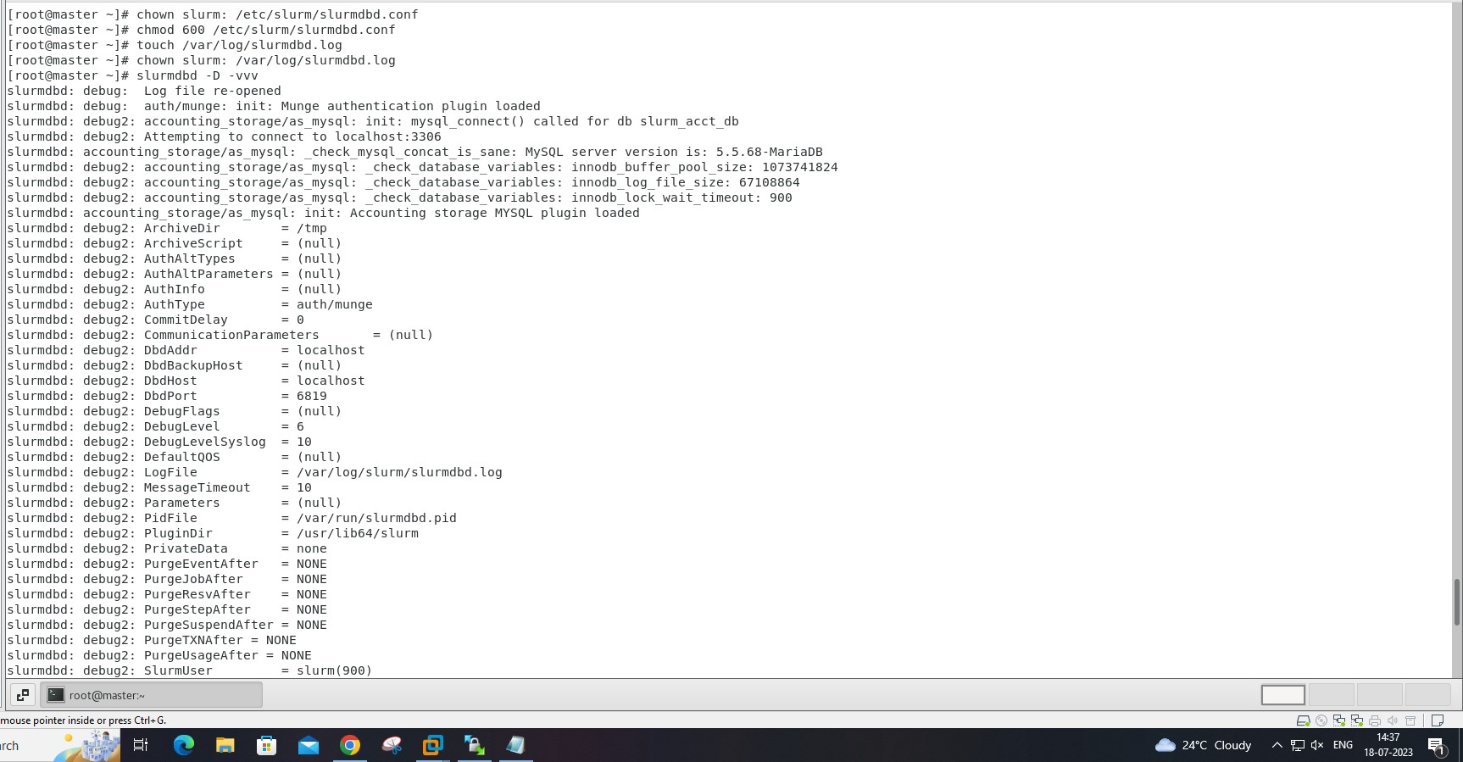

**STEP-9🡪**To implement this change you have to shut down the database and move/remove logfiles:

systemctl stop mariadb

mv /var/lib/mysql/ib_logfile? /tmp/

systemctl start mariadb

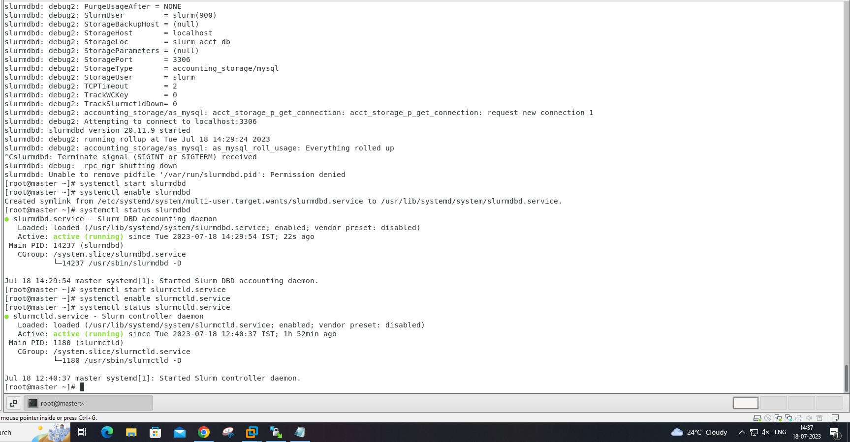

**STEP-10🡪**Start the slurmdbd service:

systemctl enable slurmdbd

systemctl start slurmdbd

systemctl status slurmdbd

On the **master** node:

systemctl enable slurmctld.service

systemctl start slurmctld.service

systemctl status slurmctld.service

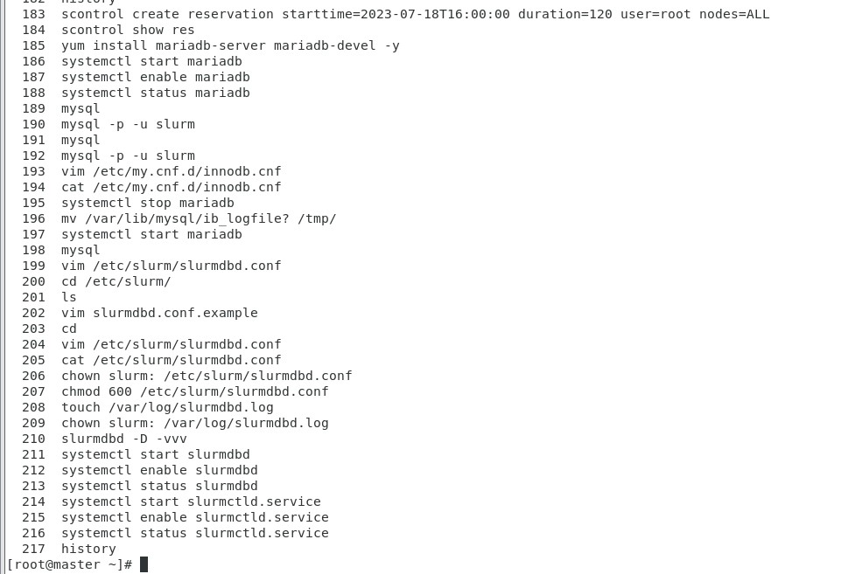

----------------------------------------------------------------------------------------------------------------------------------------

[root@master ~]# scontrol create reservation starttime=2023-07-18T16:00:00 duration=120 user=root nodes=ALL

Reservation created: root_1

[root@master ~]# scontrol show res

ReservationName=root_1 StartTime=2023-07-18T16:00:00 EndTime=2023-07-18T18:00:00 Duration=02:00:00

Nodes=node[1-2] NodeCnt=2 CoreCnt=4 Features=(null) PartitionName=(null) Flags=SPEC_NODES,ALL_NODES

TRES=cpu=4

Users=root Groups=(null) Accounts=(null) Licenses=(null) State=INACTIVE BurstBuffer=(null) Watts=n/a

MaxStartDelay=(null)

[root@master ~]# yum install mariadb-server mariadb-devel -y

Loaded plugins: fastestmirror, langpacks

Loading mirror speeds from cached hostfile

* base: centos.mirror.net.in

* epel: epel.excellmedia.net

* extras: centos.mirror.net.in

* updates: centos.mirror.net.in

Package 1:mariadb-devel-5.5.68-1.el7.x86_64 already installed and latest version

Resolving Dependencies

--> Running transaction check

---> Package mariadb-server.x86_64 1:5.5.68-1.el7 will be installed

--> Processing Dependency: mariadb(x86-64) = 1:5.5.68-1.el7 for package: 1:mariadb-server-5.5.68-1.el7.x86_64

--> Processing Dependency: perl-DBI for package: 1:mariadb-server-5.5.68-1.el7.x86_64

--> Processing Dependency: perl-DBD-MySQL for package: 1:mariadb-server-5.5.68-1.el7.x86_64

--> Processing Dependency: perl(DBI) for package: 1:mariadb-server-5.5.68-1.el7.x86_64

--> Running transaction check

---> Package mariadb.x86_64 1:5.5.68-1.el7 will be installed

---> Package perl-DBD-MySQL.x86_64 0:4.023-6.el7 will be installed

---> Package perl-DBI.x86_64 0:1.627-4.el7 will be installed

--> Processing Dependency: perl(RPC::PlServer) >= 0.2001 for package: perl-DBI-1.627-4.el7.x86_64

--> Processing Dependency: perl(RPC::PlClient) >= 0.2000 for package: perl-DBI-1.627-4.el7.x86_64

--> Running transaction check

---> Package perl-PlRPC.noarch 0:0.2020-14.el7 will be installed

--> Processing Dependency: perl(Net::Daemon) >= 0.13 for package: perl-PlRPC-0.2020-14.el7.noarch

--> Processing Dependency: perl(Net::Daemon::Test) for package: perl-PlRPC-0.2020-14.el7.noarch

--> Processing Dependency: perl(Net::Daemon::Log) for package: perl-PlRPC-0.2020-14.el7.noarch

--> Processing Dependency: perl(Compress::Zlib) for package: perl-PlRPC-0.2020-14.el7.noarch

--> Running transaction check

---> Package perl-IO-Compress.noarch 0:2.061-2.el7 will be installed

--> Processing Dependency: perl(Compress::Raw::Zlib) >= 2.061 for package: perl-IO-Compress-2.061-2.el7.noarch

--> Processing Dependency: perl(Compress::Raw::Bzip2) >= 2.061 for package: perl-IO-Compress-2.061-2.el7.noarch

---> Package perl-Net-Daemon.noarch 0:0.48-5.el7 will be installed

--> Running transaction check

---> Package perl-Compress-Raw-Bzip2.x86_64 0:2.061-3.el7 will be installed

---> Package perl-Compress-Raw-Zlib.x86_64 1:2.061-4.el7 will be installed

--> Finished Dependency Resolution

Dependencies Resolved

=============================================================================================================================

Package Arch Version Repository Size

=============================================================================================================================

Installing:

mariadb-server x86_64 1:5.5.68-1.el7 base 11 M

Installing for dependencies:

mariadb x86_64 1:5.5.68-1.el7 base 8.8 M

perl-Compress-Raw-Bzip2 x86_64 2.061-3.el7 base 32 k

perl-Compress-Raw-Zlib x86_64 1:2.061-4.el7 base 57 k

perl-DBD-MySQL x86_64 4.023-6.el7 base 140 k

perl-DBI x86_64 1.627-4.el7 base 802 k

perl-IO-Compress noarch 2.061-2.el7 base 260 k

perl-Net-Daemon noarch 0.48-5.el7 base 51 k

perl-PlRPC noarch 0.2020-14.el7 base 36 k

Transaction Summary

=============================================================================================================================

Install 1 Package (+8 Dependent packages)

Total download size: 21 M

Installed size: 110 M

Downloading packages:

(1/9): perl-Compress-Raw-Bzip2-2.061-3.el7.x86_64.rpm | 32 kB 00:00:00

(2/9): perl-Compress-Raw-Zlib-2.061-4.el7.x86_64.rpm | 57 kB 00:00:00

(3/9): perl-DBD-MySQL-4.023-6.el7.x86_64.rpm | 140 kB 00:00:00

(4/9): perl-DBI-1.627-4.el7.x86_64.rpm | 802 kB 00:00:00

(5/9): perl-IO-Compress-2.061-2.el7.noarch.rpm | 260 kB 00:00:00

(6/9): perl-Net-Daemon-0.48-5.el7.noarch.rpm | 51 kB 00:00:00

(7/9): perl-PlRPC-0.2020-14.el7.noarch.rpm | 36 kB 00:00:00

(8/9): mariadb-5.5.68-1.el7.x86_64.rpm | 8.8 MB 00:00:00

(9/9): mariadb-server-5.5.68-1.el7.x86_64.rpm | 11 MB 00:00:16

-----------------------------------------------------------------------------------------------------------------------------

Total 1.3 MB/s | 21 MB 00:00:17

Running transaction check

Running transaction test

Transaction test succeeded

Running transaction

Installing : 1:perl-Compress-Raw-Zlib-2.061-4.el7.x86_64 1/9

Installing : 1:mariadb-5.5.68-1.el7.x86_64 2/9

Installing : perl-Net-Daemon-0.48-5.el7.noarch 3/9

Installing : perl-Compress-Raw-Bzip2-2.061-3.el7.x86_64 4/9

Installing : perl-IO-Compress-2.061-2.el7.noarch 5/9

Installing : perl-PlRPC-0.2020-14.el7.noarch 6/9

Installing : perl-DBI-1.627-4.el7.x86_64 7/9

Installing : perl-DBD-MySQL-4.023-6.el7.x86_64 8/9

Installing : 1:mariadb-server-5.5.68-1.el7.x86_64 9/9

Verifying : perl-Compress-Raw-Bzip2-2.061-3.el7.x86_64 1/9

Verifying : perl-Net-Daemon-0.48-5.el7.noarch 2/9

Verifying : 1:mariadb-server-5.5.68-1.el7.x86_64 3/9

Verifying : perl-DBD-MySQL-4.023-6.el7.x86_64 4/9

Verifying : 1:mariadb-5.5.68-1.el7.x86_64 5/9

Verifying : 1:perl-Compress-Raw-Zlib-2.061-4.el7.x86_64 6/9

Verifying : perl-DBI-1.627-4.el7.x86_64 7/9

Verifying : perl-IO-Compress-2.061-2.el7.noarch 8/9

Verifying : perl-PlRPC-0.2020-14.el7.noarch 9/9

Installed:

mariadb-server.x86_64 1:5.5.68-1.el7

Dependency Installed:

mariadb.x86_64 1:5.5.68-1.el7 perl-Compress-Raw-Bzip2.x86_64 0:2.061-3.el7

perl-Compress-Raw-Zlib.x86_64 1:2.061-4.el7 perl-DBD-MySQL.x86_64 0:4.023-6.el7

perl-DBI.x86_64 0:1.627-4.el7 perl-IO-Compress.noarch 0:2.061-2.el7

perl-Net-Daemon.noarch 0:0.48-5.el7 perl-PlRPC.noarch 0:0.2020-14.el7

Complete!

[root@master ~]# systemctl start mariadb

[root@master ~]# systemctl enable mariadb

Created symlink from /etc/systemd/system/multi-user.target.wants/mariadb.service to /usr/lib/systemd/system/mariadb.service.

[root@master ~]# systemctl status mariadb

● mariadb.service - MariaDB database server

Loaded: loaded (/usr/lib/systemd/system/mariadb.service; enabled; vendor preset: disabled)

Active: active (running) since Tue 2023-07-18 14:04:42 IST; 33s ago

Main PID: 11558 (mysqld_safe)

CGroup: /system.slice/mariadb.service

├─11558 /bin/sh /usr/bin/mysqld_safe --basedir=/usr

└─11724 /usr/libexec/mysqld --basedir=/usr --datadir=/var/lib/mysql --plugin-dir=/usr/lib64/mys...

Jul 18 14:04:40 master mariadb-prepare-db-dir[11474]: MySQL manual for more instructions.

Jul 18 14:04:40 master mariadb-prepare-db-dir[11474]: Please report any problems at http://mariadb.org/jira

Jul 18 14:04:40 master mariadb-prepare-db-dir[11474]: The latest information about MariaDB is available...g/.

Jul 18 14:04:40 master mariadb-prepare-db-dir[11474]: You can find additional information about the MyS...at:

Jul 18 14:04:40 master mariadb-prepare-db-dir[11474]: http://dev.mysql.com

Jul 18 14:04:40 master mariadb-prepare-db-dir[11474]: Consider joining MariaDB's strong and vibrant com...ty:

Jul 18 14:04:40 master mariadb-prepare-db-dir[11474]: https://mariadb.org/get-involved/

Jul 18 14:04:40 master mysqld_safe[11558]: 230718 14:04:40 mysqld_safe Logging to '/var/log/mariadb/ma...og'.

Jul 18 14:04:40 master mysqld_safe[11558]: 230718 14:04:40 mysqld_safe Starting mysqld daemon with dat...ysql

Jul 18 14:04:42 master systemd[1]: Started MariaDB database server.

Hint: Some lines were ellipsized, use -l to show in full.

[root@master ~]# mysql

Welcome to the MariaDB monitor. Commands end with ; or \g.

Your MariaDB connection id is 2

Server version: 5.5.68-MariaDB MariaDB Server

Copyright (c) 2000, 2018, Oracle, MariaDB Corporation Ab and others.

Type 'help;' or '\h' for help. Type '\c' to clear the current input statement.

MariaDB [(none)]> GRANT ALL ON slurm_acct_db.* TO 'slurm'@'master' IDENTIFIED BY '@123' with grant option;

Query OK, 0 rows affected (0.00 sec)

MariaDB [(none)]> SHOW VARIABLES LIKE 'have_innodb';

+---------------+-------+

| Variable_name | Value |

+---------------+-------+

| have_innodb | YES |

+---------------+-------+

1 row in set (0.01 sec)

MariaDB [(none)]> FLUSH PRIVILEGES;

Query OK, 0 rows affected (0.00 sec)

MariaDB [(none)]> CREATE DATABASE slurm_acct_db;

Query OK, 1 row affected (0.00 sec)

MariaDB [(none)]> quit;

Bye

[root@master ~]# mysql

Welcome to the MariaDB monitor. Commands end with ; or \g.

Your MariaDB connection id is 7

Server version: 5.5.68-MariaDB MariaDB Server

Copyright (c) 2000, 2018, Oracle, MariaDB Corporation Ab and others.

Type 'help;' or '\h' for help. Type '\c' to clear the current input statement.

MariaDB [(none)]> GRANT ALL ON slurm_acct_db.* TO 'slurm'@'localhost' IDENTIFIED BY '1234' with grant option;

Query OK, 0 rows affected (0.00 sec)

MariaDB [(none)]> SHOW VARIABLES LIKE 'have_innodb';

+---------------+-------+

| Variable_name | Value |

+---------------+-------+

| have_innodb | YES |

+---------------+-------+

1 row in set (0.00 sec)

MariaDB [(none)]> FLUSH PRIVILEGES;

Query OK, 0 rows affected (0.01 sec)

MariaDB [(none)]> CREATE DATABASE slurm_acct_db;

ERROR 1007 (HY000): Can't create database 'slurm_acct_db'; database exists

MariaDB [(none)]> quit;

Bye

[root@master ~]# mysql -p -u slurm

Enter password: 1234

Welcome to the MariaDB monitor. Commands end with ; or \g.

Your MariaDB connection id is 8

Server version: 5.5.68-MariaDB MariaDB Server

Copyright (c) 2000, 2018, Oracle, MariaDB Corporation Ab and others.

Type 'help;' or '\h' for help. Type '\c' to clear the current input statement.

MariaDB [(none)]> show grants;

+--------------------------------------------------------------------------------------------------------------+

| Grants for slurm@localhost |

+--------------------------------------------------------------------------------------------------------------+

| GRANT USAGE ON *.* TO 'slurm'@'localhost' IDENTIFIED BY PASSWORD '*A4B6157319038724E3560894F7F932C8886EBFCF' |

| GRANT ALL PRIVILEGES ON `slurm_acct_db`.* TO 'slurm'@'localhost' WITH GRANT OPTION |

+--------------------------------------------------------------------------------------------------------------+

2 rows in set (0.00 sec)

MariaDB [(none)]> quit;

Bye

[root@master ~]# vim /etc/my.cnf.d/innodb.cnf

[root@master ~]# cat /etc/my.cnf.d/innodb.cnf

[mysqld]

innodb_buffer_pool_size=1024M

innodb_log_file_size=64M

innodb_lock_wait_timeout=900

[root@master ~]# systemctl stop mariadb

[root@master ~]# mv /var/lib/mysql/ib_logfile? /tmp/

[root@master ~]# systemctl start mariadb

[root@master ~]# mysql

Welcome to the MariaDB monitor. Commands end with ; or \g.

Your MariaDB connection id is 2

Server version: 5.5.68-MariaDB MariaDB Server

Copyright (c) 2000, 2018, Oracle, MariaDB Corporation Ab and others.

Type 'help;' or '\h' for help. Type '\c' to clear the current input statement.

MariaDB [(none)]> SHOW VARIABLES LIKE 'innodb_buffer_pool_size';

+-------------------------+------------+

| Variable_name | Value |

+-------------------------+------------+

| innodb_buffer_pool_size | 1073741824 |

+-------------------------+------------+

1 row in set (0.00 sec)

MariaDB [(none)]> quit;

Bye

[root@master ~]# vim /etc/slurm/slurmdbd.conf

[root@master ~]# cd /etc/slurm/

[root@master slurm]# ls

cgroup.conf.example job_submit.lua.example slurm.conf slurmdbd.conf.example

cli_filter.lua.example prolog.example slurm.conf.example

[root@master slurm]# vim slurmdbd.conf.example

[root@master slurm]# cd

[root@master ~]# vim /etc/slurm/slurmdbd.conf

[root@master ~]# cat /etc/slurm/slurmdbd.conf

#

# Example slurmdbd.conf file.

#

# See the slurmdbd.conf man page for more information.

#

# Archive info

#ArchiveJobs=yes

#ArchiveDir="/tmp"

#ArchiveSteps=yes

#ArchiveScript=

#JobPurge=12

#StepPurge=1

#

# Authentication info

AuthType=auth/munge

#AuthInfo=/var/run/munge/munge.socket.2

#

# slurmDBD info

DbdAddr=localhost

DbdHost=localhost

#DbdPort=7031

SlurmUser=slurm

#MessageTimeout=300

DebugLevel=verbose

#DefaultQOS=normal,standby

LogFile=/var/log/slurm/slurmdbd.log

PidFile=/var/run/slurmdbd.pid

#PluginDir=/usr/lib/slurm

#PrivateData=accounts,users,usage,jobs

#TrackWCKey=yes

#

# Database info

StorageType=accounting_storage/mysql

#StorageHost=localhost

#StoragePort=1234

StoragePass=1234

StorageUser=slurm

StorageLoc=slurm_acct_db

[root@master ~]# chown slurm: /etc/slurm/slurmdbd.conf

[root@master ~]# chmod 600 /etc/slurm/slurmdbd.conf

[root@master ~]# touch /var/log/slurmdbd.log

[root@master ~]# chown slurm: /var/log/slurmdbd.log

[root@master ~]# slurmdbd -D -vvv

slurmdbd: debug: Log file re-opened

slurmdbd: debug: auth/munge: init: Munge authentication plugin loaded

slurmdbd: debug2: accounting_storage/as_mysql: init: mysql_connect() called for db slurm_acct_db

slurmdbd: debug2: Attempting to connect to localhost:3306

slurmdbd: accounting_storage/as_mysql: _check_mysql_concat_is_sane: MySQL server version is: 5.5.68-MariaDB

slurmdbd: debug2: accounting_storage/as_mysql: _check_database_variables: innodb_buffer_pool_size: 1073741824

slurmdbd: debug2: accounting_storage/as_mysql: _check_database_variables: innodb_log_file_size: 67108864

slurmdbd: debug2: accounting_storage/as_mysql: _check_database_variables: innodb_lock_wait_timeout: 900

slurmdbd: accounting_storage/as_mysql: init: Accounting storage MYSQL plugin loaded

slurmdbd: debug2: ArchiveDir = /tmp

slurmdbd: debug2: ArchiveScript = (null)

slurmdbd: debug2: AuthAltTypes = (null)

slurmdbd: debug2: AuthAltParameters = (null)

slurmdbd: debug2: AuthInfo = (null)

slurmdbd: debug2: AuthType = auth/munge

slurmdbd: debug2: CommitDelay = 0

slurmdbd: debug2: CommunicationParameters = (null)

slurmdbd: debug2: DbdAddr = localhost

slurmdbd: debug2: DbdBackupHost = (null)

slurmdbd: debug2: DbdHost = localhost

slurmdbd: debug2: DbdPort = 6819

slurmdbd: debug2: DebugFlags = (null)

slurmdbd: debug2: DebugLevel = 6

slurmdbd: debug2: DebugLevelSyslog = 10

slurmdbd: debug2: DefaultQOS = (null)

slurmdbd: debug2: LogFile = /var/log/slurm/slurmdbd.log

slurmdbd: debug2: MessageTimeout = 10

slurmdbd: debug2: Parameters = (null)

slurmdbd: debug2: PidFile = /var/run/slurmdbd.pid

slurmdbd: debug2: PluginDir = /usr/lib64/slurm

slurmdbd: debug2: PrivateData = none

slurmdbd: debug2: PurgeEventAfter = NONE

slurmdbd: debug2: PurgeJobAfter = NONE

slurmdbd: debug2: PurgeResvAfter = NONE

slurmdbd: debug2: PurgeStepAfter = NONE

slurmdbd: debug2: PurgeSuspendAfter = NONE

slurmdbd: debug2: PurgeTXNAfter = NONE

slurmdbd: debug2: PurgeUsageAfter = NONE

slurmdbd: debug2: SlurmUser = slurm(900)

slurmdbd: debug2: StorageBackupHost = (null)

slurmdbd: debug2: StorageHost = localhost

slurmdbd: debug2: StorageLoc = slurm_acct_db

slurmdbd: debug2: StorageParameters = (null)

slurmdbd: debug2: StoragePort = 3306

slurmdbd: debug2: StorageType = accounting_storage/mysql

slurmdbd: debug2: StorageUser = slurm

slurmdbd: debug2: TCPTimeout = 2

slurmdbd: debug2: TrackWCKey = 0

slurmdbd: debug2: TrackSlurmctldDown= 0

slurmdbd: debug2: accounting_storage/as_mysql: acct_storage_p_get_connection: acct_storage_p_get_connection: request new connection 1

slurmdbd: debug2: Attempting to connect to localhost:3306

slurmdbd: slurmdbd version 20.11.9 started

slurmdbd: debug2: running rollup at Tue Jul 18 14:29:24 2023

slurmdbd: debug2: accounting_storage/as_mysql: as_mysql_roll_usage: Everything rolled up

^Cslurmdbd: Terminate signal (SIGINT or SIGTERM) received

slurmdbd: debug: rpc_mgr shutting down

slurmdbd: Unable to remove pidfile '/var/run/slurmdbd.pid': Permission denied

[root@master ~]# systemctl start slurmdbd

[root@master ~]# systemctl enable slurmdbd

Created symlink from /etc/systemd/system/multi-user.target.wants/slurmdbd.service to /usr/lib/systemd/system/slurmdbd.service.

[root@master ~]# systemctl status slurmdbd

● slurmdbd.service - Slurm DBD accounting daemon

Loaded: loaded (/usr/lib/systemd/system/slurmdbd.service; enabled; vendor preset: disabled)

Active: active (running) since Tue 2023-07-18 14:29:54 IST; 22s ago

Main PID: 14237 (slurmdbd)

CGroup: /system.slice/slurmdbd.service

└─14237 /usr/sbin/slurmdbd -D

Jul 18 14:29:54 master systemd[1]: Started Slurm DBD accounting daemon.

[root@master ~]# systemctl start slurmctld.service

[root@master ~]# systemctl enable slurmctld.service

[root@master ~]# systemctl status slurmctld.service

● slurmctld.service - Slurm controller daemon

Loaded: loaded (/usr/lib/systemd/system/slurmctld.service; enabled; vendor preset: disabled)

Active: active (running) since Tue 2023-07-18 12:40:37 IST; 1h 52min ago

Main PID: 1180 (slurmctld)

CGroup: /system.slice/slurmctld.service

└─1180 /usr/sbin/slurmctld -D

Jul 18 12:40:37 master systemd[1]: Started Slurm controller daemon.

[root@master ~]# history

183 scontrol create reservation starttime=2023-07-18T16:00:00 duration=120 user=root nodes=ALL

184 scontrol show res

185 yum install mariadb-server mariadb-devel -y

186 systemctl start mariadb

187 systemctl enable mariadb

188 systemctl status mariadb

189 mysql

190 mysql -p -u slurm

191 mysql

192 mysql -p -u slurm

193 vim /etc/my.cnf.d/innodb.cnf

194 cat /etc/my.cnf.d/innodb.cnf

195 systemctl stop mariadb

196 mv /var/lib/mysql/ib_logfile? /tmp/

197 systemctl start mariadb

198 mysql

199 vim /etc/slurm/slurmdbd.conf

200 cd /etc/slurm/

201 ls

202 vim slurmdbd.conf.example

203 cd

204 vim /etc/slurm/slurmdbd.conf

205 cat /etc/slurm/slurmdbd.conf

206 chown slurm: /etc/slurm/slurmdbd.conf

207 chmod 600 /etc/slurm/slurmdbd.conf

208 touch /var/log/slurmdbd.log

209 chown slurm: /var/log/slurmdbd.log

210 slurmdbd -D -vvv

211 systemctl start slurmdbd

212 systemctl enable slurmdbd

213 systemctl status slurmdbd

214 systemctl start slurmctld.service

215 systemctl enable slurmctld.service

216 systemctl status slurmctld.service

217 history

**RESERVATION COMMANDS**

[root@master ~]# scontrol create reservation starttime=2023-07-18T16:00:00 duration=120 user=root nodes=ALL

Reservation created: root_1

[root@master ~]# scontrol show res

ReservationName=root_1 StartTime=2023-07-18T16:00:00 EndTime=2023-07-18T18:00:00 Duration=02:00:00

Nodes=node[1-2] NodeCnt=2 CoreCnt=4 Features=(null) PartitionName=(null) Flags=SPEC_NODES,ALL_NODES

TRES=cpu=4

Users=root Groups=(null) Accounts=(null) Licenses=(null) State=INACTIVE BurstBuffer=(null) Watts=n/a

MaxStartDelay=(null)

