5251, Prestige Gulmohar,
Kalkere Main Road, Jayanti Nagar, Horamavu, Bangalore – 560043
vikas.rajan@microsoft.com
(+91) 9663581144
http://vikasresume.azurewebsites.net/
Vikas Rajan
Dynamics CRM & Web Developer

Objective | Senior Web Developer with specialization in D365 CE PowerApps and having around 17 years of experience in web-based technologies like ASP.NET, C#, SQL Server, JavaScript, Microsoft Dynamics CRM, SSIS, D3.js, Azure. Looking forward to exploring opportunities which are a blend of Dynamics CRM and data analytics.
Qualifications Summary | - Presently working as a Senior Software Engineer for Commerce Financial Services (CFS) Team in Microsoft IDC.  - Leading the feature team for the Digital transformation of Incentive Claims Management, an application used by distributors & resellers worldwide for claiming incentives on Surface Deals  - Have been involved in complete SDLC for design, development and deployment of Dynamics CRM projects for several clients like Lenovo, Adobe, Texas WIC (Women Infant children), BAT (British American Tobacco), WIPRO, etc.  - Pior to CFS, was working as a Senior CRM Consultant and Delivery Lead for Microsoft Global Services Ltd.  - Have participated in several hackathon events internally within Microsoft. One of the notable contributions being the development of a seamless integration between Dynamics CRM and Lync.  - Have a keen interest in data analytics and have been exploring data visualization technologies like d3.js  - Conversant with .NET Architecture/Technology with specific emphasis on development using C#
Skills | PRIMARY SKILLS  PowerApps  Canvas Apps  Microsoft D365 CE  WEB TECHNOLOGIES  JavaScript/jQuery  ASP.NET/Web Services  Azure  VISUALIZATION  D3.js  DEVELOPMENT LANGUAGE  C#  VB.NET  DATABASE  SQL Server  SQL Server Integration Services (SSIS)
Work History | MICROSOFT IDC – Bengaluru, India 2020 – Present  Sr. Software Engineer  - Leading the development for Dynamics 365 CE and all PowerApps related components for Incentive Claim Management.  - Created a marketplace extension for common CICD steps that was not available in the PowerApps Build Tools. The extension is available for download here and the source code for the same is available in the Git Repository github.com/vikasrajan82/D365ADOReleaseAutomation  - As a senior software engineer, was responsible for  - Formalized the development guideline document for D365 components and ensured adherence to the same.  - Preparation of detailed technical design document  - Requirement Gathering and functional design anlaysis  - Mentoring of new members within the team.  - Have been maintaining a GitHub profile (https://github.com/vikasrajan82) to collaborate on projects outside the scope of regular work.  MICROSOFT Global SERVICES – Bengaluru, India 2013 – 2020  Sr. CRM Consultant  - Designed, developed and managed the delivery of CE projects for clients like Lenovo, Adobe, Texas WIC, Wipro, etc.  - Designed the plugin/activity code framework that provided a 3-layer architecture for development. The architecture helped in code reuse and reducing the size of the assembiles. The main objective of the framewok was to reduce duplicacy, improve readability and reduce class coupling.  - Have mentored development teams with more than 25-30 team members with focus on quality and timely delivery.  - Engaged the team to setup automated build and deployment using Azure DevOps, quality checks for StyleCop, Code Analysis, Code coverage, etc.  - Contributed to the development of utilities that helped automating deployments of solutions to upstream environments.  - As a dev lead, was responsible for  - Preparation of detailed technical design document, ensure adherence of development team to quality standards like code coverage, code metrics, etc.  - Requirement Gathering and functional design anlaysis  - Conducted several deisgn workshops with Customer and other internal stakeholders  - Effort Estimations as per the One Services Estimator  - Define branching and release strategy for continuous integration and deployment  - As part of an earlier hackathon event, developed a seamless integration between Lync and Dynamics CRM. The presentation video is available here.  - Designed and develpoed an integration middleware using Azure components like Logic Apps, Functions, etc. As per the recommended practice, the middlewares were integrated with Azure KeyVault for storage of sensitive information and Application Insights for error logging.  - Was involved in prior integration projects that required custom middleware to be developed between Dynamics CRM & other Microsoft products like Yammer, SharePoint, etc.  - Apart from the regular proejct work, have been exploring different technologies in data anlaytics and visualization. The below interactive resume is an attempt to learn the capabilities of the open source library D3.js. http://vikasresume.azurewebsites.net/  ORACLE FINANCIAL SERVICES (OFSS) – Mumbai, India 2007 – 2013  Associate Consultant (.NET)  - Worked in the position of a senior developer for projects in the financial domain for clients like CITIBANK, etc  - Developed ASP.NET applications for projects like Catalyst, SAR, etc. These applications had integrations with several external websites and hence required multiple web services to be developed and maintained.  - As an onsite coordinator, worked closely with the customer for requiremnet gathering and functional specification preparation.  - Was responsible for framework design and its implementation.  - Effort estimation and adherence to schedule timeline.  - Report develpoment with back-end as SQL Server  infosys technologies ltd – Mysore, India 2004 – 2007  Sr. Software Engineer (.NET)  - Was involved in the development of ASP.NET Projects.  - Designed and created DTS packages as part of data migration projects.  - Worked on the integration of Fusion Charts within the ASP.NET web pages.  - Created a multi-level nested grid using JavaScript for easy navigation. This have been used as a custom control in several of the html pages within the application.
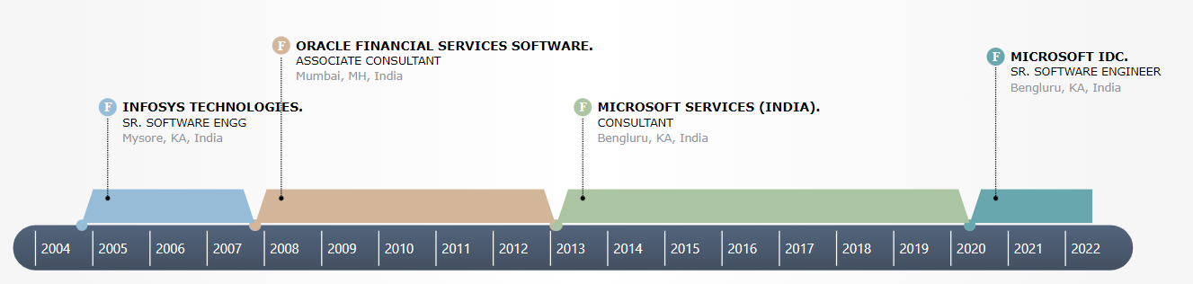
Education | Fr. C.r.i.t – Vashi, Mumbai, India 2004  Bachelor of Engineering in Electronics and Telecommunication
Certifications | MB2-710: Microsoft Dynamics CRM 2016 Online Deployment 2017  532: Developing Microsoft Azure Solutions 2015  MB2-866: Microsoft Dynamics CRM 2011 Customization and Configuration 2014
Personal Profile | Date of Birth 27th October 1982  Marital Status Married

