Phishing Detection & Awareness Report
Analysis of Simulated Phishing Emails Targeting Contoso Corp Employees
Prepared as part of a Cyber Security Internship Project
Date of Analysis: 15 July 2026
Tools Used: Manual Header & Content Inspection, Domain Verification

Purpose of This Report
Phishing emails are fake messages designed to trick people into clicking dangerous links, giving away passwords, or handing over company information. This report looks at two example phishing emails, explains exactly how you can tell they are fake, and gives simple rules everyone at the company can follow to stay safe.
No technical background is needed to understand this report. Each email is broken down in plain language, with the suspicious parts pointed out directly on the evidence.

Risk Classification Key
Every email reviewed is placed into one of three categories:
Category | What It Means
Safe | From a verified, trusted sender. No suspicious links or requests. Safe to act on normally.
Suspicious | Has one or more warning signs. Should not be trusted until verified with the sender through a separate, known channel.
Phishing | Confirmed fake. Designed to steal information or install malware. Do not click, reply, or open attachments — report and delete.

Scope
Two email samples, both sent to a fictional employee ("John Doe") at a fictional company ("Contoso Corp"), were reviewed as part of internal phishing-awareness testing:
- Email 1 — impersonating a physical security vendor ("Vanguard Security")
- Email 2 — impersonating internal Human Resources / audit staff

Executive Summary
Both emails reviewed are confirmed phishing attempts. Both were sent from the same fake domain pretending to be two different organizations, both pressure the reader to act quickly, and both rely on a link to do the damage. The table below summarizes the findings.
No. | Email | Main Trick Used | Risk Level
1 | "Vanguard Security" — fake camera footage alert | Curiosity + fake urgency, link and attachment | Phishing
2 | "HR Compliance" — fake expense fraud alert | Fear of punishment, urgent link | Phishing

Email Analysis 1 — "Vanguard Security" Impersonation
From (shown) | Vanguard Security <alex.lee@alerting-services.com>
To | john.doe@mybusiness.com
Subject theme | Unusual camera activity at your desk
Risk Level | PHISHING
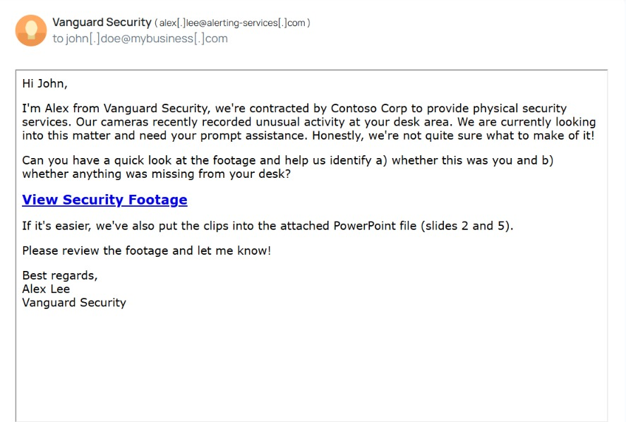
Evidence: Email claiming to be from Vanguard Security, requesting review of "footage"

Why This Is Fake
- Sender domain doesn't match: The email claims to be "Vanguard Security" working for "Contoso Corp," but it was actually sent from alerting-services.com — a domain with no connection to either name. A real vendor would email from its own company domain.
- Fake urgency dressed up as confusion: The line "we're not quite sure what to make of it" is designed to make the reader curious and drop their guard, while still pushing them to act fast.
- Asks you to confirm personal details: The email asks the reader to say whether the activity was "you" and what was on their desk — a way of getting someone to engage without thinking twice.
- Two ways to get you to click: The email offers both a direct link ("View Security Footage") and an attached PowerPoint file. Offering a backup option is a common trick in case one path is blocked by security software.
- Generic greeting: "Hi John" with no further personal or account-specific detail — real vendors usually reference an account number or specific site.

What Could Happen If Someone Clicked
The link or attachment would most likely lead to a fake login page designed to steal the employee's username and password, or silently install malicious software on their computer.

Risk Classification
PHISHING

Email Analysis 2 — "HR Compliance" Impersonation
From (shown) | Human Resources <human.resources@alerting-services.com>
To | john.doe@mybusiness.com
Subject theme | Flagged expenses / possible fraud
Risk Level | PHISHING
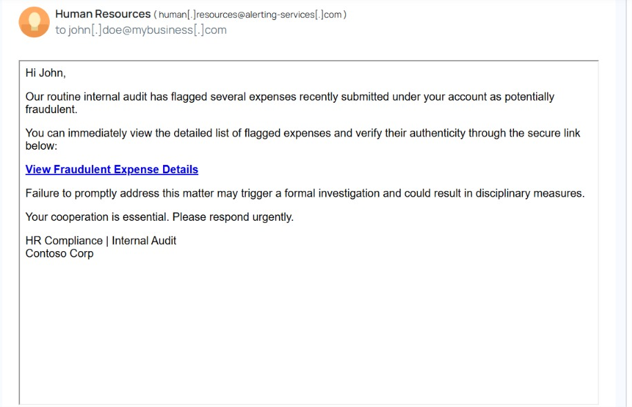
Evidence: Email impersonating HR/Compliance, threatening disciplinary action

Why This Is Fake
- Same fake domain as Email 1: It was sent from alerting-services.com again, this time pretending to be internal HR at "Contoso Corp." The real company's HR team would send email from the company's own domain, not an outside one.
- Fear-based pressure: Words like "potentially fraudulent," "disciplinary measures," and "respond urgently" are designed to scare the reader into clicking before they stop to think.
- No real details given: A genuine audit would name the specific expense, date, or amount in question. This email gives nothing concrete — just a vague accusation and a link.
- Single link is the entire call to action: "View Fraudulent Expense Details" is the only way offered to "resolve" the issue, pushing the reader straight to a link instead of a phone call or in-person conversation.
- Impersonal, transactional tone: Short, generic, and signed only with a department name — no real person's name or contact details.

What Could Happen If Someone Clicked
The link likely leads to a fake company login page built to capture the employee's credentials, which attackers could then use to access real company systems and email.

Risk Classification
PHISHING

Common Pattern Across Both Emails
Both emails, despite pretending to be from completely different organizations, share the same fingerprint — a strong sign they came from the same attacker:
- Both were sent from the same lookalike domain, alerting-services.com, reused to impersonate two unrelated identities.
- Both create pressure to act immediately, just through different emotions — curiosity/concern in Email 1, fear of punishment in Email 2.
- Both center the entire request around a single link (with Email 1 adding a backup attachment).
- Neither email includes specific, verifiable details that a genuine internal message would normally contain.

Prevention & Awareness Guidelines

Do's
- Check the sender's actual email address, not just the display name, before trusting a message.
- Hover over links to preview the real destination before clicking.
- Verify unexpected or urgent requests by contacting the person or department directly, using a phone number or email you already know is correct — not one provided in the suspicious email.
- Report suspicious emails to IT/Security immediately using the official reporting process.
- Slow down when a message pressures you to act "right now."

Don'ts
- Don't click links or open attachments in unexpected emails, even if they look official.
- Don't enter your username or password after clicking a link from an email.
- Don't reply to a suspicious email to "ask if it's real" — this confirms your address is active.
- Don't assume a professional-looking email is automatically genuine — attackers copy real branding and tone closely.
- Don't forward suspicious emails to coworkers without warning them it may be a phishing test or attack.

Summary
Both emails reviewed in this report are phishing attempts, built to pressure an employee into clicking a link through either curiosity or fear. Neither came from a legitimate company domain. Recognizing mismatched sender domains, urgency, vague details, and pressure tactics are the fastest ways any employee — technical or not — can catch a phishing attempt before it causes harm.

