API Security Risk Analysis
A simple look at how safe two test APIs are with people's data
Prepared by Vikas • July 2026

1. What This Report Is About
Think of an API as a waiter in a restaurant. You (the app) ask the waiter for something — say, a customer's profile — and the waiter goes to the kitchen (the server) and brings it back. This report checks whether that "waiter" is being too generous: is it handing out food to people who never even ordered, or bringing out way more than what was asked for?
We looked at two practice APIs that are made specifically for learning and testing — JSONPlaceholder and ReqRes — the same way a security professional would check a real company's app before it goes live. We only looked and asked questions; we never tried to break anything, overload it, or sneak past any locks.

2. What We Did
- Sent simple, safe requests (like asking "show me user #1") using a tool called Postman.
- Checked whether we needed a username/password or key to see the data — and we didn't, for JSONPlaceholder.
- Looked closely at what came back in the response — was it just a name, or someone's whole address and phone number too?
- Checked the technical "headers" that come with every response, which quietly reveal things like whether there's a limit on how many requests you can make.
- Compared this to how a real, well-protected SaaS product should behave.

3. The Short Version
The good news: this is a practice API, so no real person's data was ever actually at risk. The important part is that we found the exact same mistakes here that show up in real data breaches — meaning if a real company built their API the same way, it would be a genuine problem worth fixing before launch.
# | Issue | Where | Risk Level
1 | Personal details visible to anyone, no login needed | JSONPlaceholder | High
2 | API gives back more personal info than an app would ever need | JSONPlaceholder | High
3 | You can guess your way through every user's data just by changing a number | JSONPlaceholder | Medium
4 | Write requests accept junk data without complaint | JSONPlaceholder | Low
5 | One shared key for the whole app, not tied to a single person | ReqRes | Medium
6 | Good practice already in place: request limits are enforced | JSONPlaceholder | Good ✅

4. What We Found — Explained Simply

1. Anyone Can See People's Personal Details — No Login Needed
Risk level: High
What we found: We asked for "user #1" and, without proving who we were in any way, we instantly got back their full name, email, home address, GPS coordinates, and phone number.
Why it matters: Imagine a filing cabinet in a company lobby that anyone can open — no key, no ID check. In a real product, this would let anyone collect people's contact details for spam, scams, or worse, just by typing in a web address.
What should happen instead: The app should ask "who are you?" (a login or access token) before handing back anyone's personal information — every single time, no exceptions.

2. It Hands Over More Information Than Necessary
Risk level: High
What we found: Even simple requests came back stuffed with extra detail — GPS coordinates, employer info, full addresses — far more than a typical app screen would ever display.
Why it matters: It's like asking someone's name and being handed their entire personal file instead. The more data that gets sent around, the more there is to leak if something ever goes wrong — a lost laptop, a buggy app, or a hacked server all become bigger disasters.
What should happen instead: Only send back the specific pieces of information a screen actually needs to show — nothing more.

3. You Can "Walk Through" Everyone's Data Just by Counting
Risk level: Medium
What we found: User records are numbered 1, 2, 3, and so on in order. Anyone can simply change the number in the address bar and page through every single record in the system.
Why it matters: This is like a hotel where room numbers are in order and there's no keycard check — you could simply walk down the hallway and open every door. In a real app, this lets one person quietly collect every other user's data.
What should happen instead: Use random, unguessable IDs instead of simple counting numbers, and double-check that whoever is asking is actually allowed to see that specific record.

4. It Accepts Messy or Made-Up Data Without Complaint
Risk level: Low
What we found: When we sent made-up or oddly-formatted information to create or update a record, the API accepted it without pushing back or flagging anything wrong.
Why it matters: It's like a form that never checks if you filled it in properly — it just says "OK, got it!" even if you wrote nonsense. In a real system, this can let bad or harmful data sneak in and cause errors down the line.
What should happen instead: The system should check that submitted information makes sense and looks right, and politely reject anything that doesn't, with a clear explanation.

5. One Shared "Password" for the Whole App, Not Per Person
Risk level: Medium
What we found: ReqRes now requires a key to be sent with every request — good — but that key identifies the app as a whole, not the individual person using it.
Why it matters: It's a bit like an office building that has one master key shared by every employee, rather than individual keycards. If that one key is ever leaked — say, accidentally left inside an app's code — everyone using that key is affected, and it's hard to know who actually did what.
What should happen instead: Pair that shared key with a short-lived, personal login token for anything involving a real person's account, so access can be tracked and switched off per-person if needed.

6. Good News: Request Limits Are Already in Place
Risk level: Good ✅
What we found: Looking at the response details, we could see the API keeps count of how many requests are allowed (1000) and how many are left (999), and it resets after a set time — see the screenshot below.
Why it matters: This is a genuinely good safety habit. It stops any one person from overwhelming the system with too many requests at once, which protects the service for everyone else.
What should happen instead: No action needed here — this is a good practice worth keeping and even copying elsewhere in the system.

5. Overall, How Risky Is This?
Taken together, we'd call this Medium-to-High risk if it were a real product. Nothing here is exotic or hard to find — these are the everyday mistakes that show up again and again in real-world data leaks. The encouraging part is that every single one of them has a well-known, straightforward fix.

6. What Should Happen Next
- Always check who's asking before handing back personal information.
- Only share the exact pieces of data a screen actually needs — not the whole record.
- Make user IDs hard to guess, and double-check permission on every request.
- Check that submitted data actually makes sense before accepting it.
- Keep using request limits — and consider personal login tokens alongside any shared app key.

7. Screenshots From Our Testing
Below are the actual Postman screenshots taken while testing, showing exactly what was found.

Screenshot 1 — Requesting user #1 (no login required)
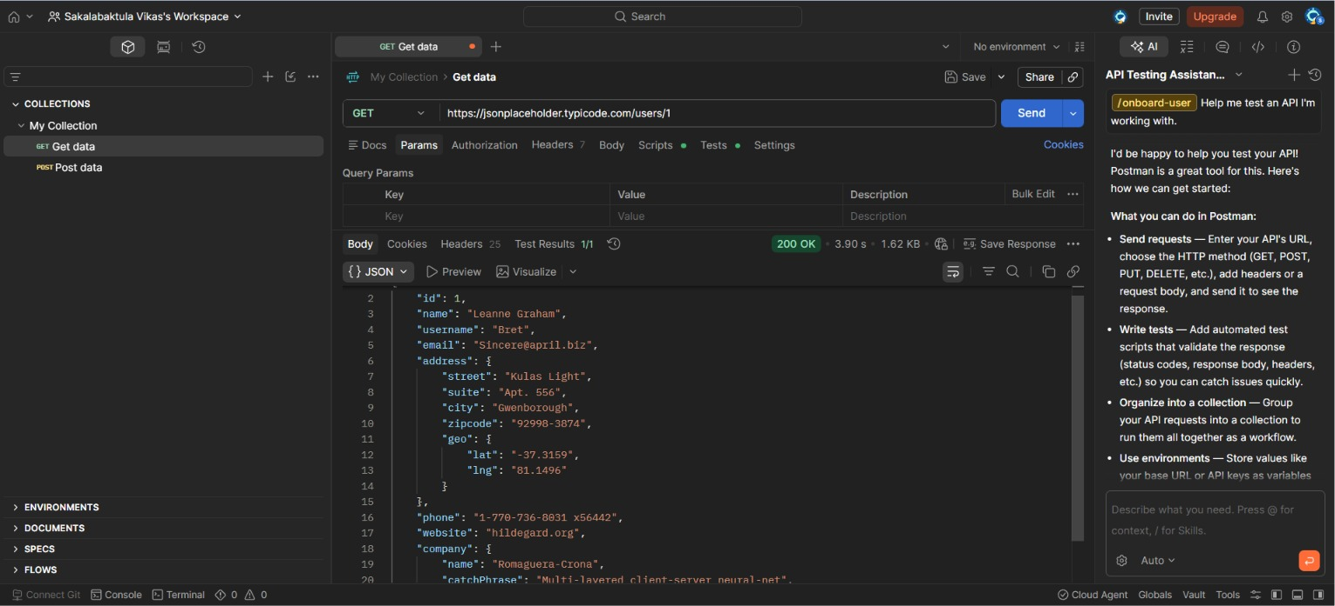
GET /users/1 — full personal details returned instantly, with no authentication of any kind.

Screenshot 2 — Requesting user #2 (simply changing the number)
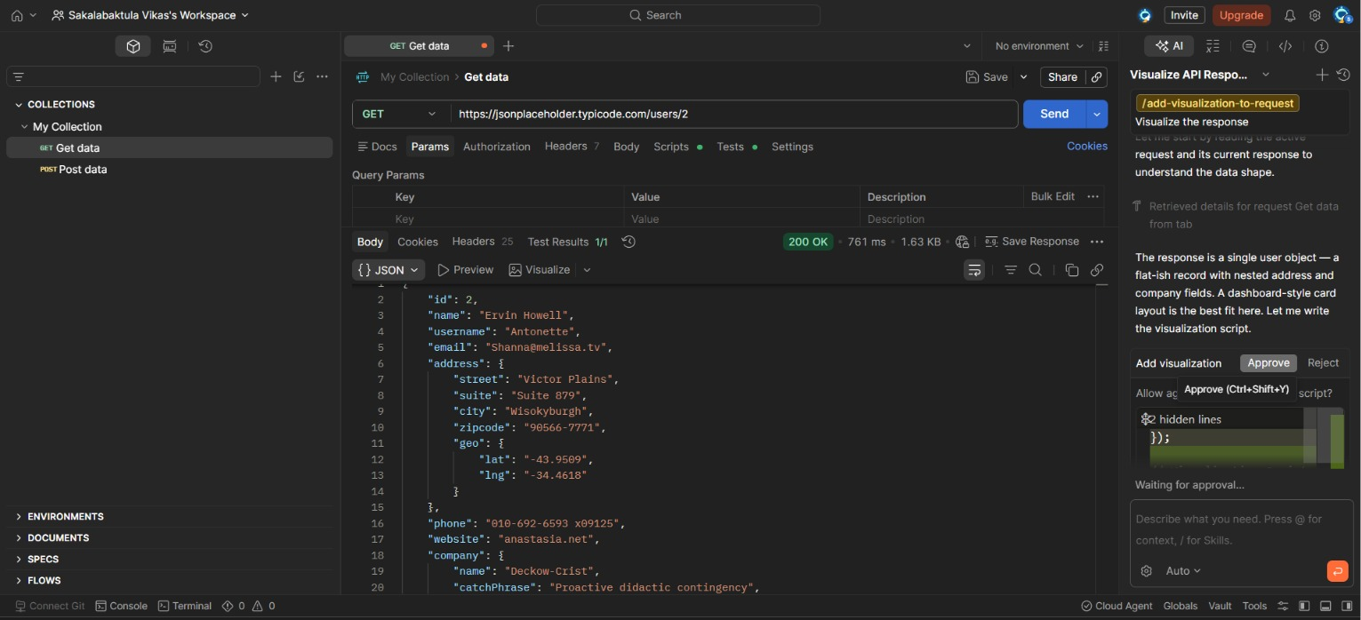
GET /users/2 — a different person's full record, just by counting up from user #1.

Screenshot 3 — Checking the response headers (the good news)
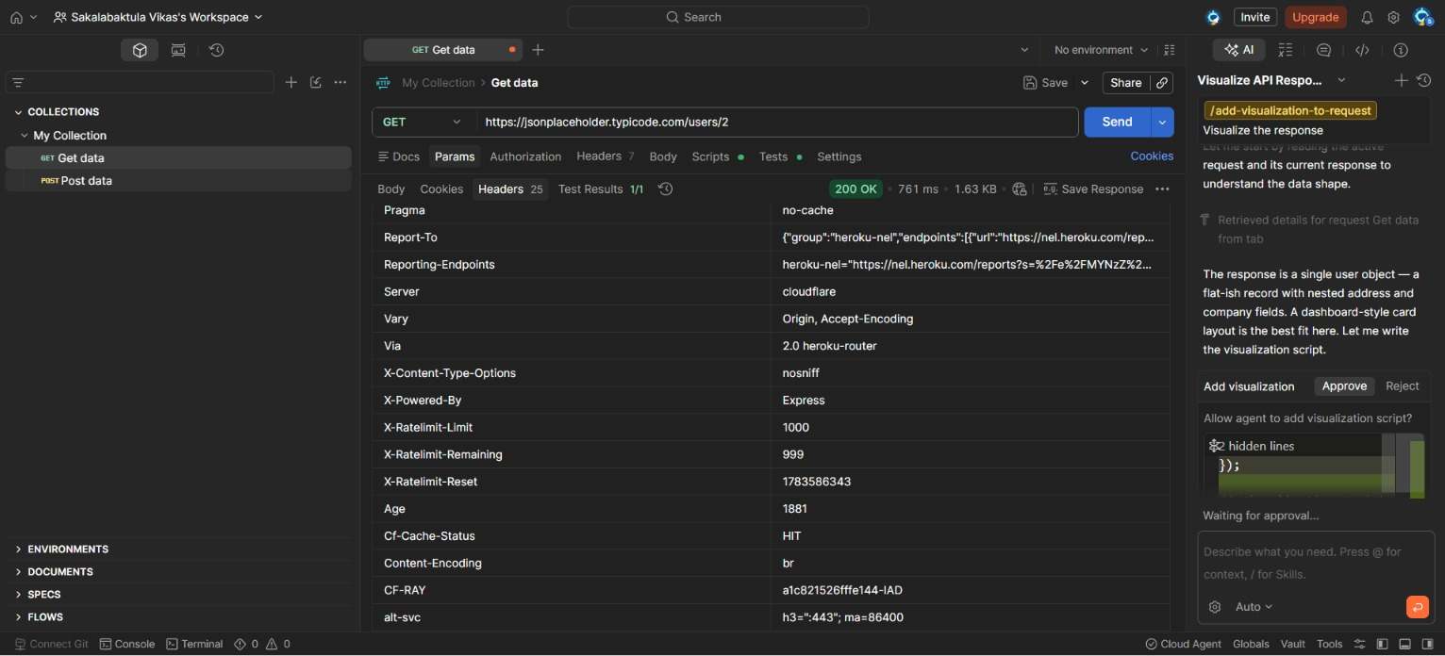
Response headers showing X-Ratelimit-Limit, -Remaining, and -Reset — proof that request limits are properly enforced.

8. Remediation Plan
A simple action plan, ordered by what to fix first.
Issue | Fix | Priority | Suggested Timeline
No login required for personal data | Require authentication (OAuth2/JWT) on every endpoint returning personal or business data. | Critical | Immediate (before launch)
Too much data returned | Return only the fields the client actually needs — field-level filtering. | High | 1–2 weeks
Guessable IDs / no ownership check | Use unguessable IDs (UUIDs) and check the requester is allowed to see that record. | High | 1–2 weeks
Messy data accepted on write | Add strict schema validation; reject unexpected fields with a clear error. | Medium | 2–4 weeks
Shared API key, not per-person | Keep keys secret and rotate them; add short-lived personal tokens for sensitive actions. | Medium | 2–4 weeks
Rate limiting | Already working well — keep it consistent across all endpoints. | Low (maintain) | Ongoing

9. A Quick Note on Ethics
Everything in this report came from public practice APIs that are specifically built for people to learn and test on — JSONPlaceholder and ReqRes. At no point did we try to break in, overload the system, or access anything private or real. We only looked, asked simple questions, and wrote down what we saw.

