1. Grade Checker
Take a score as input and print the grade based on the following:
90+ : "A"
80-89 : "B"
70-79 : "C"
60-69 : "D"
Below 60 : "F"
here we used a basic if else statement to carry out marks and all.
Answer:
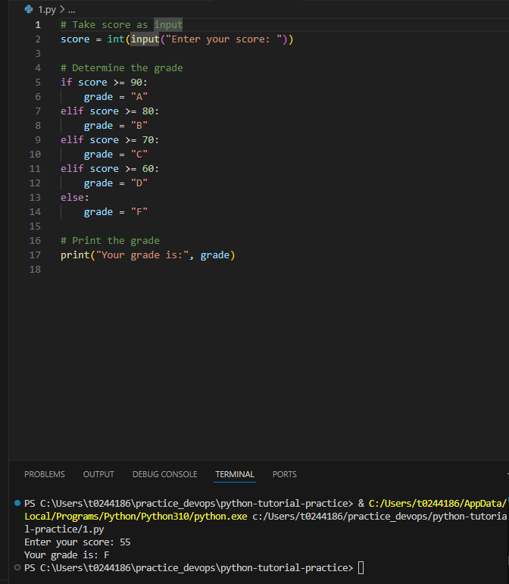

2 Student Grades
Create a dictionary where the keys are student names and the values are their grades. Allow the user to:
Add a new student and grade.
Update an existing student’s grade.
Print all student grades
Execution output:
PS C:\Users\t0244186\practice_devops\python-tutorial-practice> & C:/Users/t0244186/AppData/Local/Programs/Python/Python310/python.exe c:/Users/t0244186/practice_devops/python-tutorial-practice/1.py
Enter your score: 55
Your grade is: F
PS C:\Users\t0244186\practice_devops\python-tutorial-practice> & C:/Users/t0244186/AppData/Local/Programs/Python/Python310/python.exe c:/Users/t0244186/practice_devops/python-tutorial-practice/2.py

--- Student Grades Menu ---
1. Add a new student and grade
2. Update an existing student's grade
3. Print all student grades
4. Exit
Enter your choice (1-4): 1
Enter student's name: vikas
Enter student's grade: A
vikas's grade added successfully!

--- Student Grades Menu ---
1. Add a new student and grade
2. Update an existing student's grade
3. Print all student grades
4. Exit
Enter your choice (1-4): 3

--- All Student Grades ---
vikas: A

--- Student Grades Menu ---
1. Add a new student and grade
2. Update an existing student's grade
3. Print all student grades
4. Exit
Enter your choice (1-4): 2
Enter the student's name to update: vikas
Enter the new grade: B
vikas's grade updated successfully!

--- Student Grades Menu ---
1. Add a new student and grade
2. Update an existing student's grade
3. Print all student grades
4. Exit
Enter your choice (1-4): 3

--- All Student Grades ---
vikas: B

--- Student Grades Menu ---
1. Add a new student and grade
2. Update an existing student's grade
3. Print all student grades
4. Exit
Enter your choice (1-4): 4
Exiting the program. Goodbye!
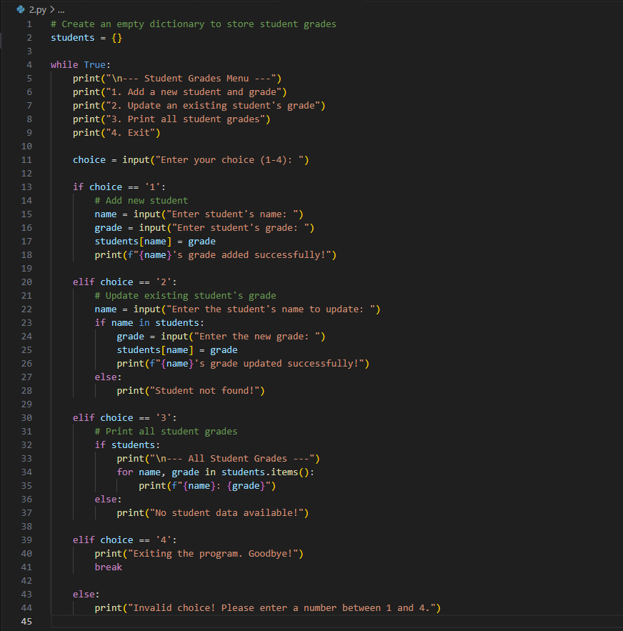

3.Write to a File
Write a program to create a text file and write some content to it.

Using file functions like write and open.
Execution : PS C:\Users\t0244186\practice_devops\python-tutorial-practice> & C:/Users/t0244186/AppData/Local/Programs/Python/Python310/python.exe c:/Users/t0244186/practice_devops/python-tutorial-practice/3.py
File 'myfile.txt' created and content written successfully!
PS C:\Users\t0244186\practice_devops\python-tutorial-practice>
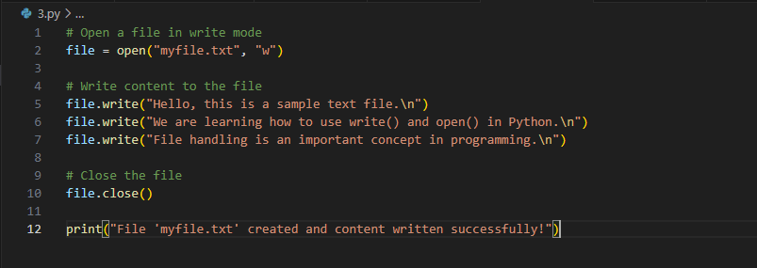
New file created and content updated:
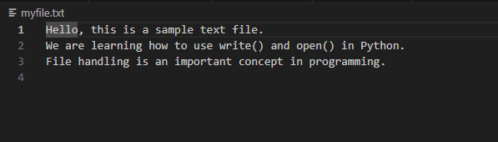
4. Read from a File
We used open in read mode and file.read to read and print to display.
