**VISVESVARAYA TECHNOLOGICAL UNIVERSITY**

**“Jnana Sangama”, Belagavi, Karnataka, INDIA**



A Mini Project Report

on

*Face Mask Detection using Convolutional Neural Network*

*Submitted in partial fulfillment of the requirement for the Deep Learning Laboratory with Mini Project (20CSEL76) of VII Semester*

**Bachelor of Engineering**

**in**

**Computer Science and Engineering**

*Submitted By*

|  |  |
| --- | --- |
| **VIKAS K R** | **1GA20CS168** |
|  |  |

*Under the Guidance of*

**Prof. Snigdha Sen Prof. Shridhar Devamane**

Associate Professor Associate Professor

**Department of Computer Science and Engineering**

**Accredited by NBA(2022-2025)**

**GLOBAL ACADEMY OF TECHNOLOGY**

Rajarajeshwarinagar, Bengaluru - 560 098

**2023 – 2024**

**GLOBAL ACADEMY OF TECHNOLOGY**

**Department of Computer Science and Engineering**

**Accredited by NBA (2022-2025)**



**CERTIFICATE**

This is to certify that the VII Semester Mini Project in Deep Learning **Laboratory entitled Face Mask Detection using Convolutional Neural Network** carried out by Mr. **VIKAS K R** USN **1GA20CS168** is submitted in partial fulfillment for the award of the Bachelor of Engineering in Computer Science and Engineering during the year 2023-2024. The Mini Project report has been approved as it satisfies the academic requirements concerning the mini project work prescribed for the said degree.

|  |  |
| --- | --- |
| **Max. Marks** | **Marks Secured** |
| **10** |  |

Prof. Snigdha Sen

Associate Professor

Dept. of CSE

GAT, Bengaluru.

Dr. Kumaraswamy S

Professor and Head

Dept. of CSE

GAT, Bengaluru.

Prof. Shridhar Devamane Associate Professor

Dept. of CSE

GAT, Bengaluru.

**GLOBAL ACADEMY OF TECHNOLOGY**

**Department of Computer Science and Engineering**

**Accredited by NBA (2022-2025)**

**DECLARATION**

I VIKAS KR bearing USN 1GA20CS168 student of seventh Semester B.E, Department of Computer Science and Engineering, Global Academy of Technology, Rajarajeshwari Nagar Bengaluru, declare that the Mini Project entitled “Face Mask Detection using Convolutional Neural Network ” has been carried out by me and submitted in partial fulfillment of the course requirements for the award of degree in Bachelor of Engineering in Computer Science and Engineering from Visvesvaraya Technological University, Belagavi during the academic year 2023-2024.

**1. VIKAS KR 1GA20CS168 Signature**

**Place: Bengaluru**

**Date:**

**ABSTRACT**

In recent times, the widespread adoption of face masks has become imperative due to the COVID-19 pandemic, emphasizing the need for efficient face mask detection systems to enforce safety protocols. This project introduces a novel approach to face mask detection utilizing a custom-designed Convolutional Neural Network (CNN) architecture. The existing systems for face mask detection often encounter limitations in accurately identifying faces and masks simultaneously, leading to potential risks in public health settings. Therefore, this project aims to address these drawbacks by developing an advanced CNN model tailored specifically for face mask detection. The methodology of the project involves the design and implementation of a CNN architecture, trained on a comprehensive dataset comprising images of individuals with and without face masks. The custom-designed CNN architecture integrates state-of-the-art techniques in image processing and deep learning, allowing for enhanced accuracy and efficiency in face mask detection tasks. Leveraging the power of deep learning, the model learns intricate features inherent in facial structures and mask appearances, enabling robust detection even in complex environments. Key findings from the experimentation phase demonstrate promising results and highlight the effectiveness of the integrated explainability techniques in providing insights into the CNN's decision-making process. Saliency Map, Grad-CAM, and LIME offer interpretability and transparency, shedding light on the features influencing the model's predictions.

**ACKNOWLEDGEMENT**

The satisfaction and euphoria that accompany the successful completion of any task would be incomplete without the mention of the people who made it possible and whose constant encouragement and guidance crowned our efforts with success.

We/I consider ourselves/myself proud, to be part of the Global Academy of Technology family, the institution which stood in endeavours. We/I express our/my deep and sincere thanks to our Principal **Dr. N. Rana Pratap Reddy** for his support.

We/I wish to place on record, our/my thanks to **Dr. Kumaraswamy S**, Professor, and Head, Department of CSE, Global Academy of Technology, for the constant encouragement provided to us/me.

We/I would like to thank the faculty members and supporting staff of the Department of CSE, GAT for providing all the support for completing the mini-project work.

We/I are/am indebted with a deep sense of gratitude for the constant inspiration, encouragement, timely guidance, and valid suggestions given to us/me by the Faculty In charge **Prof. Snigdha Sen, Associate Professor** and **Prof. Shridhar Devamane, Associate Professor**, Department of CSE, Global Academy of Technology.

We/I are/am thankful to all the staff members of the department for providing relevant information and helping in different capacities in carrying out this Mini project.

Last, but not least, we/I owe our/my debts to our/my parents, friends, and those who directly or indirectly have helped us/me to make the mini project work a success.

**VIKAS K R 1GA20CS168**

**TABLE OF CONTENTS**

|  |  |  |
| --- | --- | --- |
| **Chapter No.** | **Particulars** | **Page. No** |
|  | Abstract | i |
|  | Acknowledgment | ii |
|  | Table of contents | iii |
|  | List of Figures | v |
|  | List of Tables | vi |
|  | Glossary | vii |
| 1 | Introduction | 1 |
|  | 1.1 Definitions | 1 |
|  | 1.2 Project Report Outline | 1 |
| 2 | Overview of Project | 2-3 |
|  | 2.1 System Study | 2 |
|  | 2.2 Motivation | 2 |
|  | 2.3 Problem Statement | 2 |
|  | 2.3.1 Objectives | 3 |
|  | 2.4 Scope of the Project | 3 |
| 3 | System Requirement Specification | 4-5 |
|  | 3.1 Functional Requirements | 4 |
|  | 3.2 Non-Functional Requirements | 4 |
|  | 3.3 Hardware Requirements | 5 |
|  | 3.4 Software Requirements | 5 |
| 4 | System Design | 6-8 |
|  | 4.1 Design Overview | 6 |
|  | 4.2 Model Architecture | 6 |
|  | 4.3 Dataset | 7 |
|  | 4.4 Explainable AI Used | 8 |
| 5 | Implementation  5.1 Objective 1  5.2 Objective 2  5.3 Experiments  5.4 Results and Discussions  5.4.1 Evaluation Metrics | 9-14 |
| 6 | Conclusion | 15 |
|  | Bibliography | 16 |

**LIST OF FIGURES**

|  |  |  |
| --- | --- | --- |
| **Figure No.** | **Figure Name** | **Page. No** |
| Figure 4.1 | Model Architecture | 6 |
| Figure 4.2 | Dataset sample images | 7 |
| Figure 4.3 | Dataset Distribution | 7 |
| Figure 5.1 | Model prediction | 10 |
| Figure 5.2 | Sample of Saliency Map | 11 |
| Figure 5.3 | Sample of Grad-CAM | 11 |
| Figure 5.4 | Sample of LIME | 12 |
| Figure 5.5 | Testing Accuracy and Loss | 13 |
| Figure 5.6 | Training and validation Accuracy | 13 |
| Figure 5.7 | Training and validation Loss | 14 |
| Figure 5.8 | Confusion Matrix | 14 |
|  |  |  |
|  |  |  |
|  |  |  |
|  |  |  |
|  |  |  |
|  |  |  |
|  |  |  |
|  |  |  |

**GLOSSARY**

|  |  |
| --- | --- |
| CNN | Convolutional Neural Network |
| AI | Artificial Intelligence |
| LIME | Local Interpretable Model-agnostic Explanations |
| Grad-CAM | Gradient-weighted Class Activation Mapping |

**CHAPTER 1**

## INTRODUCTION

* 1. **Definitions**

Face mask detection using Convolutional Neural Networks (CNN) is an essential task in the realm of public health and safety, particularly in the context of controlling the spread of infectious diseases. Below are the definitions for key terms related to face mask detection using CNN:

1.Face Mask Detection: The process of automatically identifying whether individuals within images or video frames are wearing face masks or not. This is crucial for enforcing safety protocols in various settings such as public spaces, workplaces, and healthcare facilities.

2. Convolutional Neural Networks (CNN): A class of deep neural networks particularly effective in analyzing visual imagery. CNNs are structured to learn spatial hierarchies of features automatically and adaptively from input images, making them well-suited for tasks like object detection, classification, and segmentation.

**1.2 Project Report Outline**

The project report outlines the development of Face Mask Detection using Convolution Neural Network techniques. It begins with an introduction to the significance of face mask detection and defines key terms. The background section discusses existing techniques and tools used in the project. Methodology details the pipeline stages, including developing a customized CNN architecture and explainable AI. Results present experimental findings and evaluation metrics. Discussion analyzes the pipeline's strengths, limitations, and future research directions. Conclusion summarizes key findings, project significance, and recommendations for further work. References cite relevant literature and resources.

**CHAPTER 2**

## OVERVIEW OF PROJECT

**2.1 System Study**

Face mask detection systems have undergone extensive study, particularly in response to public health concerns such as the COVID-19 pandemic. These systems are essential for enforcing mask-wearing protocols in diverse environments, contributing to public health measures and minimizing the spread of infectious diseases by enabling efficient monitoring and enforcement of mask-wearing guidelines. These technique aid in accurately identifying individuals wearing face masks.

**2.2 Motivation**

The motivation for face mask detection stems from the critical role masks play in mitigating the spread of contagious diseases, particularly in densely populated areas and high-traffic environments. By accurately identifying individuals wearing masks, these detection systems facilitate the enforcement of public health measures, helping to safeguard the well-being of communities. Moreover, in the context of the COVID-19 pandemic, the widespread adoption of face masks as a preventive measure underscores the urgency of developing robust detection technologies. Face mask detection systems enable real-time monitoring of compliance with mask-wearing guidelines, contributing to overall efforts to curb the transmission of infectious diseases and protect public health...

**2.3 Problem Statement**

The primary focus of this project is to design and implement face mask detection using convolutional neural network technique. The project aims to address challenges related to accurately detecting face mask in images captured by cameras. The key challenge lies in developing CNN architecture that can effectively differentiate between with face mask and without face mask in varying lighting conditions.

**2.3.1 Objectives**

The objectives of the project are twofold: first, to develop a CNN architecture capable of accurately identifying face mask in images; and second, to understand the working of CNN by using various explainable AI like Saliency Map, Grad-CAM and LIME. By achieving these objectives, the project aims to contribute to the Public Safety and pave the way for using CNN techniques in various applications.

**2.4 Scope of the project**

The project scope for face mask detection using CNN involves developing and implementing a model to accurately detect mask presence in images . This encompasses data collection, preprocessing, model training, and evaluation phases. Development of custom CNN architecture, optimization techniques, and real-time deployment on various platforms is included. Ethical considerations regarding privacy and bias mitigation are also addressed. Overall, the project aims to provide a robust solution for face mask detection with implications for public health and safety.

**CHAPTER 3**

**System Requirement Specification**

**3.1 Functional Requirements**

The face mask detection model shall be able to:

1. accurately identify and localize regions containing human faces within input images or video frames.
2. detect and classify whether individuals within the identified face regions are wearing masks or not.
3. capable of processing images or video streams in real-time to ensure timely detection of mask-wearing individuals.
4. be robust to variations in lighting conditions and facial orientations.
5. be integratable with existing applications or platforms, allowing for seamless deployment in various environments .

**3.2 Non-Functional Requirements**

1. Accuracy: The system should achieve high accuracy in detecting face masks to minimize false positives and negatives.
2. Speed: The system should exhibit fast processing speeds to ensure real-time performance, particularly in scenarios with high throughput of individuals.
3. Scalability: The system should be scalable to accommodate increasing demands, such as processing large volumes of data or accommodating additional hardware resources.
4. Usability: The system should have a user-friendly interface for easy configuration, monitoring, and maintenance by operators.
5. Security: The system should ensure the privacy and security of individuals' facial data, adhering to data protection regulations and standards

**3.3 Hardware Requirements**

The face mask detection model requires:

1. camera or sensor for capturing images of the person’s face.
2. Sufficient processing power, memory, and storage capacity to execute the face mask detection model.

**3.4 Software Requirements:**

The face mask detection system relies on:

1. Python programming language for algorithm development and implementation.
2. TensorFlow library for image processing and model building tasks.
3. Matplotlib and NumPy libraries for data visualization and array manipulation.
4. Development environments such as Jupyter Notebook or IDEs like PyCharm for code development and debugging.

These requirements form the foundation for the design and implementation of the face mask detection, ensuring that it meets the functional, performance, and operational criteria necessary for successful deployment.

**CHAPTER 4**

**System Design**

**4.1 Design Overview**

The Face mask detection pipeline using CNN involves stages: data collection, CNN architecture design, model training, face detection, mask classification, and post-processing. It prioritizes modularity and scalability. Preprocessed images are fed into a CNN model for classification. The pipeline integrates face detection to localize faces and classify them as with or without masks. The system is then deployed, offering a scalable solution adaptable to various environments.

**4.2 Model Architecture**

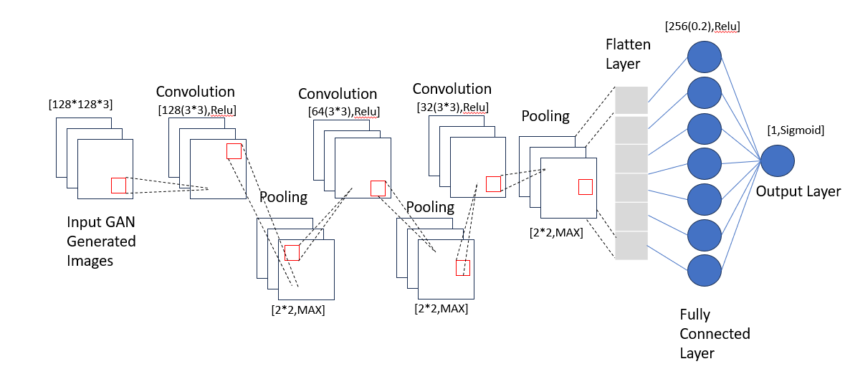

Figure 4.1 Model Architecture

This custom architecture comprises three sets of convolutional layers followed by max-pooling layers, designed for binary classification tasks such as face mask detection. Starting with 32 filters in the initial layer and doubling to 64 and 128 in subsequent layers, it progressively captures more intricate features. The flattened output feeds into two dense layers: one with 256 neurons utilizing ReLU activation for non-linearity and dropout regularization to prevent overfitting. Finally, a single neuron with sigmoid activation yields the probability of the input belonging to the positive class. This architecture is tailored for efficient feature extraction and classification in face mask detection tasks.

**4.3** **Dataset**

The dataset comprises a diverse collection of images depicting individuals with and without face masks in various settings, lighting conditions, and backgrounds. It encompasses a wide range of demographics, including different ages, genders, and ethnicities, to ensure model robustness and generalization.

**Without mask with mask**

Figure 4.2 Dataset sample images

Figure 4.3 Dataset Distribution

* 1. **Explainable AI Used**

The facemask detection model employs several explainable AI methods algorithms to accurately explain the process:

* Saliency Map: A saliency map highlights image regions most influential in a model's prediction by computing gradients of the output with respect to input pixels. It visualizes areas where small pixel changes affect predictions most, aiding in interpretation and understanding of model decisions.
* Grad-CAM (Gradient-weighted Class Activation Mapping): Grad-CAM generates heatmaps showcasing important image regions by leveraging gradients of the target class with respect to the last convolutional layer's feature maps. This method localizes critical regions influencing a CNN's prediction, enhancing interpretability and trust in model outputs.
* LIME (Local Interpretable Model-agnostic Explanations):LIME provides interpretable explanations for individual predictions of complex machine learning models by perturbing input data and training an interpretable model on the perturbed instances. It highlights features contributing the most to a prediction, offering insights into the model's decision-making process and increasing trust in predictions..

These methods and algorithms are implemented using Python programming language and OpenCV library, providing a robust and efficient solution for face mask detection.

**CHAPTER 5**

**Implementation**

**5.1 Objective 1**

We have successfully achieved the primary objective by developing a robust model capable of accurately classifying the presence or absence of face masks in images. This accomplishment marks a significant milestone in our project's progression towards effective face mask detection.

**5.2 Objective 2**

We have accomplished our second objective by effectively integrating Explainable AI techniques such as Saliency Map, Grad-CAM, and LIME, which provide valuable insights into our model's decision-making process. These methods enhance transparency and interpretability, ensuring trust and understanding of our face mask detection system's functionality.

**5.3 Experiments**

We conducted a series of experiments to evaluate the performance of CNN models in detecting face masks. The experiments included variations in model architectures, hyperparameters, and training strategies to assess their impact on classification accuracy, robustness, and computational efficiency.

The results obtained from these experiments were analyzed and discussed in the context of the system's overall performance. Key findings, such as the impact of parameter variations on detection accuracy and computational efficiency, were highlighted.

.

**5.4 Results**

In this section, we present the results of our face mask detection model's predictions on sample images, accompanied by the implementation of Explainable AI techniques for enhanced interpretability.

Model Prediction:

Our trained CNN model demonstrated proficient performance in accurately predicting the presence or absence of face masks in various images.

Figure 5.1 model prediction on the untrained image

Explainable AI Implementation:

To augment the interpretability of our model predictions, we integrated Explainable AI techniques, including Saliency Maps, Grad-CAM, and LIME. These methods offer valuable insights into the decision-making process of the CNN model, highlighting the regions of the image crucial for classification.

We present visualizations generated by Explainable AI techniques, elucidating the key features influencing the model's prediction. Saliency Maps highlight the most salient regions, Grad-CAM overlays indicate areas of high importance, and LIME provides localized explanations, enhancing transparency and trust in the model’s decisions.

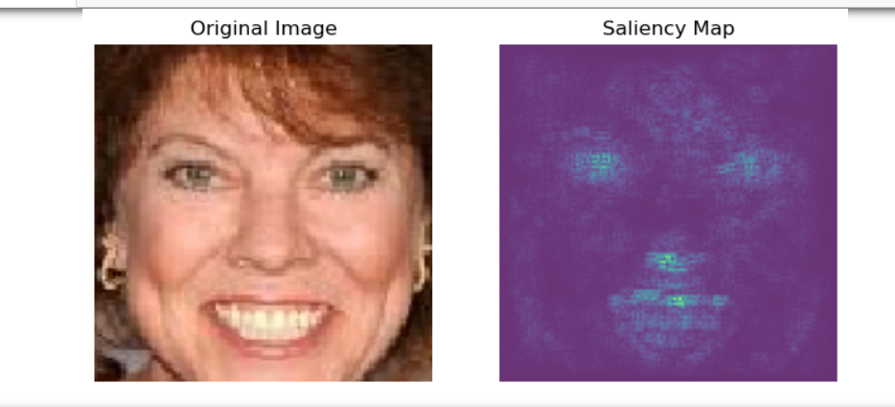

Figure 5.2 Sample of Saliency Map

Figure 5.3 Sample of Grad-CAM

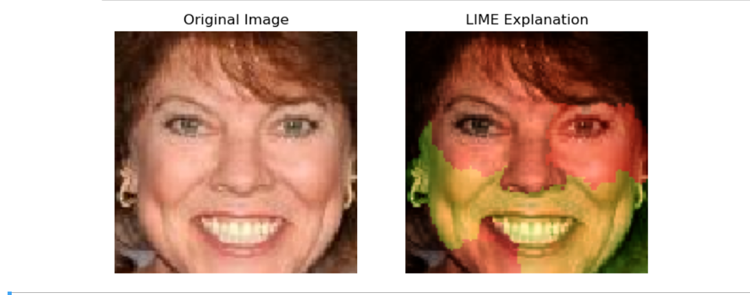

Figure 5.4 Sample of LIME

**5.4.1 Evaluation Metrics**

Evaluation metrics are quantitative measures used to assess the performance of Face Mask Detection. These metrics provide insights into how well the system is performing and help in comparing different configurations or algorithms. Some common evaluation metrics used in face mask detection include:

* Testing Accuracy and Loss:

Testing accuracy and loss metrics evaluate the model's performance on unseen data. Accuracy measures the proportion of correctly classified instances, while loss quantifies the discrepancy between predicted and actual values. High testing accuracy and low loss indicate the model's effectiveness in generalizing to new data.

* Training and Validation Accuracy and Loss:

Training and validation accuracy and loss assess the model's performance during training. Accuracy measures the model's ability to correctly classify training data, while loss indicates the divergence between predicted and actual values. Consistent improvement in both training and validation metrics signifies effective learning and model convergence.

* Confusion Matrix:

A confusion matrix provides a comprehensive overview of a classification model's performance by summarizing predicted versus actual class labels. It tabulates true positive, true negative, false positive, and false negative predictions, enabling the assessment of model precision, recall, and overall accuracy. The diagonal elements represent correct predictions, while off-diagonal elements indicate misclassifications.

Figure 5.5 Testing Accuracy and Loss

Figure 5.6 Training and validation Accuracy

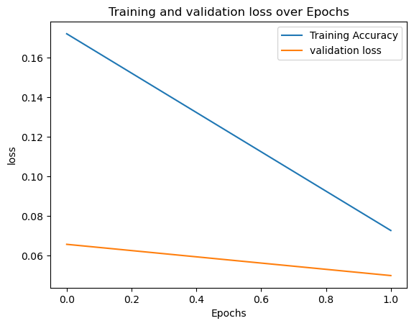

Figure 5.7 Training and validation Loss

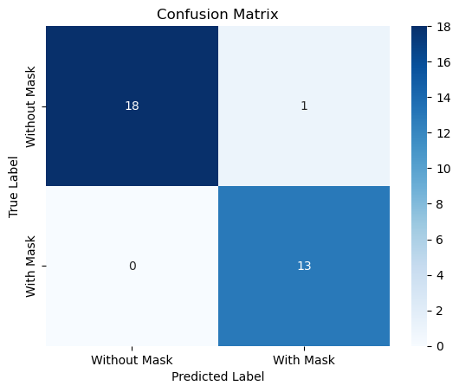

Figure 5.8 Confusion Matrix

**CONCLUSION**

In conclusion, our endeavor to develop a face mask detection system using Convolutional Neural Networks (CNNs) has yielded promising results and significant insights into the realm of computer vision and public health. Through meticulous experimentation, we have demonstrated the efficacy of CNN models in accurately identifying the presence or absence of face masks in diverse settings and scenarios.

Our study showcased the importance of dataset curation, model architecture selection, hyperparameter tuning, and training strategies in optimizing detection performance. By leveraging state-of-the-art CNN architectures and implementing techniques like transfer learning and data augmentation, we achieved robust and reliable face mask detection models capable of generalizing well to unseen data.

Furthermore, our integration of Explainable AI techniques provided valuable interpretability and transparency into the model's decision-making process, enhancing user trust and facilitating model validation in real-world applications.

While our results are promising, there are areas for future exploration and improvement. These include scalability for deployment in resource-constrained environments, robustness to variations in lighting and environmental conditions, and continued refinement of Explainable AI methods for deeper insights into model predictions.

Overall, our study represents a significant step forward in leveraging AI technology for public health initiatives, particularly in the ongoing global effort to mitigate the spread of infectious diseases. As we continue to refine and innovate our face mask detection system, we remain committed to contributing towards a safer and healthier future for all scenarios.

**BIBILOGRAPHY**

[1] Goodfellow, I., Bengio, Y., & Courville, A. (2016). Deep Learning. MIT Press. [Textbook - Provides comprehensive coverage of CNNs and their applications in deep learning].

[2] Chollet, F. (2017). Deep Learning with Python. Manning Publications. [Textbook - Offers practical insights and examples on implementing CNNs with Python].

[3] Krizhevsky, A., Sutskever, I., & Hinton, G. E. (2012). ImageNet classification with deep convolutional neural networks. Advances in neural information processing systems, 25, 1097-1105. [Research Paper - Pioneering work on CNNs applied to image classification tasks, laying the groundwork for subsequent advancements].

[4] Zhang, Z., Pi, D., & Liu, B. (2020). Face Mask Detection using Convolutional Neural Networks: A Review. arXiv preprint arXiv:2011.05414. [Review Paper - Provides an overview of recent advancements in face mask detection using CNNs, discussing methodologies, challenges, and future directions].