## Deliverables

1. ***All the required normalized tables with their data types, constraints, indexes, etc.***

**USERS**

|  |  |  |
| --- | --- | --- |
| **Column Name** | **Type** | **Constraint** |
| Id | Bigint(20) | Primary key, Auto increment |
| Name | varchar(255) |  |
| Phone | Bigint(20) |  |
| Email | varchar(255) | Unique key UK_USERS_EMAIL |
| password | varchar(255) |  |

**USER_ROLES**

|  |  |  |
| --- | --- | --- |
| **Column Name** | **Type** | **Constraint** |
| Id | Bigint(20) | Primary key, Auto increment |
| Role_id | INT(11) | Reference role table as fk |
| user_id | Bigint(20) | Reference user table as fk |

**ROLES**

|  |  |  |
| --- | --- | --- |
| **Column Name** | **Type** | **Constraint** |
| Id | Bigint(20) | Primary key, Auto increment |
| name | VARCHAR(255) | Unique key UK_ROLES_NAME |

**STAFF**

|  |  |  |
| --- | --- | --- |
| **Column Name** | **Type** | **Constraint** |
| Id | Bigint(20) | Primary key, Auto increment |
| User_id | Bigint(20) | Reference user table as fk |
| sponsor_id | Bigint(20) | Reference sponsor table as fk |
| created_by | Bigint(20) | Self reference to id column since staff can create another staff |
| updated_by | Bigint(20) | Self reference to id column since staff can update another staff |
| created_at | TIMESTAMP | CURRENT_TIMESTAMP |
| updated_at | TIMESTAMP | CURRENT_TIMESTAMP ON UPDATE CURRENT_TIMESTAMP |

**SPONSORS**

|  |  |  |
| --- | --- | --- |
| **Column Name** | **Type** | **Constraint** |
| Id | Bigint(20) | Primary key, Auto increment |
| organization_name | VARCHAR(255) |  |
| country_code | VARCHAR(45) |  |
| phone_number | Bigint(20) |  |
| address | VARCHAR(255) |  |
| category | VARCHAR(255) |  |

**CASE_STATUS**

|  |  |  |
| --- | --- | --- |
| **Column Name** | **Type** | **Constraint** |
| Id | SMALLINT(5) | Primary key, Auto increment |
| status | VARCHAR(100) |  |

**CANDIDATES**

|  |  |  |
| --- | --- | --- |
| **Column Name** | **Type** | **Constraint** |
| Id | Bigint(20) | Primary key, Auto increment |
| user_id | BIGINT(20) | Reference to user table as fk |
| sponsored_by | BIGINT(20) | Reference to sponsors table fk |
| internal_reference | VARCHAR(255) |  |
| assigned_veeting_officer | BIGINT(20) | Reference to staff table fk |
| Comments | VARCHAR(255) |  |
| case_status_id | SMALLINT(5) | Reference to case status table fk |
| activation_code | VARCHAR(255) | UNIQUE Key |
| activations_code_expiration | TIMESTAMP | Created date + 14 days |
| interview_audio | VARCHAR(255) | Keep document url |
| interview_transcript | VARCHAR(255) | Keep document url |
| interview_sar | VARCHAR(255) | Keep document url |
| created_at | TIMESTAMP | CURRENT_TIMESTAMP |
| updated_at | TIMESTAMP | CURRENT_TIMESTAMP ON UPDATE CURRENT_TIMESTAMP |
| created_by | BIGINT(20) | Reference to staff table as fk |
| updated_by | BIGINT(20) | Reference to staff table as fk |

**Triggers on candidate Table**

* **case_status_change_log_after_update**
  + When case status changes, then update the last record with end date null and set the end date for that record for the given candidate
  + Add new record in this table with new status
* handle_expiration_date
  + Set activations_code_expiration = 14 days from now when a case is created
* Case_status_log_after_insert
  + Insert the first record for the candidate in log table, when the case is created

**CANDIDATE_STATUS_CHANGE_LOG**

|  |  |  |
| --- | --- | --- |
| **Column Name** | **Type** | **Constraint** |
| Id | BIGINT(20) | Primary key, Auto increment |
| start_time | TIMESTAMP |  |
| end_time | TIMESTAMP |  |
| case_status_id | SMALLINT(5) | Reference to case status table as fk |
| candidate_id | BIGINT(20) | Reference to candidate table as fk |

1. ***Entity-relationship diagram showing the relationships among the tables***

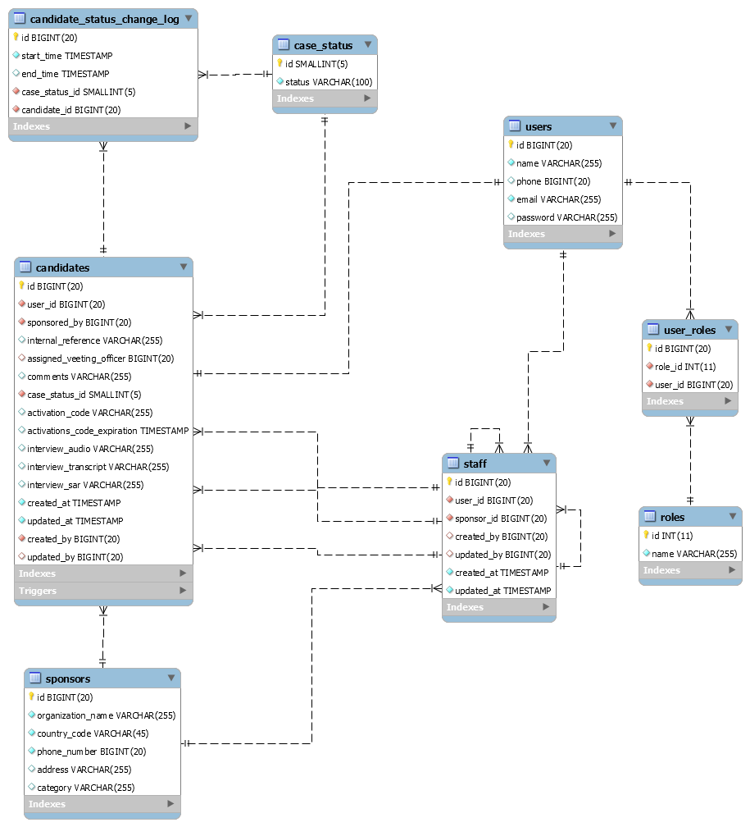

**Notation Symbols**

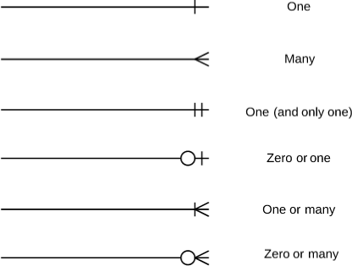

1. ***API specifications for each of the designed RESTful API***

***Login API***

**User Controller**

Method: POST

END POINT: /u/login (User Login)

Parameters:

|  |  |
| --- | --- |
| **Name** | **Description** |
| loginDto *  (body) | loginDto  Example Value :  {  "password": "string",  "rememberme": false,  "email": "string"  }  **Parameter Content Type :** application/json |

Responses

|  |  |
| --- | --- |
| **Code** | **Description** |
| 200 | Successfully token create |
| 409 | Username password do not matches |
| 404 | No matching user found. |
| 403 | Forbidden |

***Sponsors API [*** *Create an API to list all sponsor managers, officers and recipient belong to a specific sponsor. ]*

**Sponsors controller**

Method: GET

END POINT: /api/sponsor /{id}/staff

Description: This will return all the staff related to specific sponsor id

Parameters:

|  |  |
| --- | --- |
| **Name** | **Description** |
| id *  integer  (path) | Id  This is the sponsors id  **Parameter Content Type :** application/json |

Responses

|  |  |
| --- | --- |
| **Code** | **Description** |
| 200 | Array of staff  Example Value  [  {  "name": "string",  "phoneNumber": “number”,  "email": "string ",  "role": "string ",  "organizationName": "string "  }  ] |
| 404 | No matching sponsors found |
| 403 | Forbidden |

**Sponsors controller**

Method: GET

END POINT: /api/sponsor/searchByName/{search}/stafff

Description: This will return all the staff related to specific sponsor organization name search

Parameters:

|  |  |
| --- | --- |
| **Name** | **Description** |
| id *  search  (path) | search  This is search term  **Parameter Content Type :** application/json |

Responses

|  |  |
| --- | --- |
| **Code** | **Description** |
| 200 | Array of staff  Example Value  [  {  "name": "string",  "phoneNumber": “number”,  "email": "string ",  "role": "string ",  "organizationName": "string "  }  ] |
| 404 | No matching sponsors found |
| 403 | Forbidden |

***Sponsors API*** *[ Create an API which should return all candidates belong to a specific sponsor]*

**Sponsors controller**

Method: GET

END POINT: /api/sponsor /{id}/ candidate

Description: This will return all the candidates related to specific sponsor id

Parameters:

|  |  |
| --- | --- |
| **Name** | **Description** |
| id *  integer  (path) | Id  This is the sponsors id  **Parameter Content Type :** application/json |

Responses

|  |  |
| --- | --- |
| **Code** | **Description** |
| 200 | Array of Candidates  Example Value  [  {  "name": "string",  "phoneNumber": number,  "email": " string ",  "comments": "string",  "caseStatus": "string ",  "assignedOfficer": “string”,  "expirationDate": "datetime",  "sponsoredBy": "string ",  "sponsoredContact": “number”  }  ] |
| 404 | No matching sponsors found |
| 403 | Forbidden |

**Sponsors controller**

Method: GET

END POINT: /api/sponsor/searchByName/{search}/candidate

Description: This will return all the candidates related to specific sponsor organization name search

Parameters:

|  |  |
| --- | --- |
| **Name** | **Description** |
| id *  search  (path) | search  This is search term  **Parameter Content Type :** application/json |

Responses

|  |  |
| --- | --- |
| **Code** | **Description** |
| 200 | Array of Candidates  Example Value  [  {  "name": "string",  "phoneNumber": number,  "email": " string ",  "comments": "string",  "caseStatus": "string ",  "assignedOfficer": “string”,  "expirationDate": "datetime",  "sponsoredBy": "string ",  "sponsoredContact": “number”  }  ] |
| 404 | No matching sponsors found |
| 403 | Forbidden |

***Candidates API*** *[*Create an API to list candidates based on their case status.

**Candidate controller**

Method: GET

END POINT: /api/ candidates/ status/{id}

Description: This will return all the candidates related matching with specific status id

Parameters:

|  |  |
| --- | --- |
| **Name** | **Description** |
| id *  integer  (path) | Id  This is the case status id  **Parameter Content Type :** application/json |

Responses

|  |  |
| --- | --- |
| **Code** | **Description** |
| 200 | Array of Candidates  Example Value  [  {  "name": "string",  "phoneNumber": number,  "email": " string ",  "comments": "string",  "caseStatus": "string ",  "assignedOfficer": “string”,  "expirationDate": "datetime",  "sponsoredBy": "string ",  "sponsoredContact": “number”  }  ] |
| 403 | Forbidden |

**Candidate controller**

Method: GET

END POINT: {candidateId}/newStatus/{newStatusId}

Description: This will update the status of candidate to new status

Parameters:

|  |  |
| --- | --- |
| **Name** | **Description** |
| candidateId *  integer  (path)  newStatusId *  integer  (path) | candidateId  This is the case candidate id  newStatusId  This is status id of the case  **Parameter Content Type :** application/json |

Responses

|  |  |
| --- | --- |
| **Code** | **Description** |
| 200 | Success |
| 4040002 | No matching candidate found. |
| 4040004 | Case status not found. |
| 403 | Forbidden |

***Reports API*** *[*Create an API which returns a report of a case, informing us which stage of an interview took longest time to finish.]

**Report controller**

Method: GET

END POINT: /api/reports /candidate/{id}

Description: This will return report for the case for the given candidate id

Parameters:

|  |  |
| --- | --- |
| **Name** | **Description** |
| id *  integer  (path) | Id  This is the candidate id  **Parameter Content Type :** application/json |

Responses

|  |  |
| --- | --- |
| **Code** | **Description** |
| 200 | Candidate Report  Example Value  {  "candidateId": “number”  "timeTaken": “number”,  "status": "string",  "candidateDto": {  "name": " string ",  "phoneNumber": “number”,  "email": " string ",  "comments": " string ",  "caseStatus": " string ",  "assignedOfficer": “string”,  "expirationDate": "date",  "sponsoredBy": " string ",  "sponsoredContact": “number”  }  } |
| 4040002 | No matching candidate found. |
| 403 | Forbidden |

**Report controller**

Method: GET

END POINT: /api/reports /candidate

Description: This will return report for the all the canidates

Parameters:

|  |  |
| --- | --- |
| **Name** | **Description** |
|  | **Parameter Content Type :** application/json |

Responses

|  |  |
| --- | --- |
| **Code** | **Description** |
| 200 | Array of Candidate Report  Example Value  [  {  "candidateId": “number”  "timeTaken": “number”,  "status": "string",  "candidateDto": {  "name": " string ",  "phoneNumber": “number”,  "email": " string ",  "comments": " string ",  "caseStatus": " string ",  "assignedOfficer": “string”,  "expirationDate": "date",  "sponsoredBy": " string ",  "sponsoredContact": “number”  }  }  ] |
| 4040002 | No matching candidate found. |
| 403 | Forbidden |

1. **Authentication mechanism to authenticate them for usage**

