**Introduction to Database Systems (CSD317)**

**Practice Lab#7**

**Date: 02/11/22**

|  |  |
| --- | --- |
| **You have to upload the screen shot (black screen) of output with the queries one by one, in a word** | |
| **doc & file name must be->Roll No _PracticeLab#7.** |  |

**Stored Procedure: -**

1. Create a new database and use it,

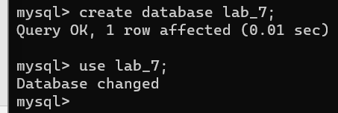

1. Create a Stored Procedure “**CreateTable”** to create a dynamic table (means you will pass table name at the time of procedure call) as per given below declaration.

|  |  |  |  |  |  |
| --- | --- | --- | --- | --- | --- |
|  | **Attribute(Field/Column) Name** |  |  | **Data Declaration** |  |
| S_ID | |  | Int, auto_increment start value =1001 | | |
| Name | |  | Varchar(30), not null | | |
| Department | |  | Varchar(30), default “CSE” | | |
| DBMS_Marks | |  | Decimal(5,2) | | |

➢ For now, pass table name **student**



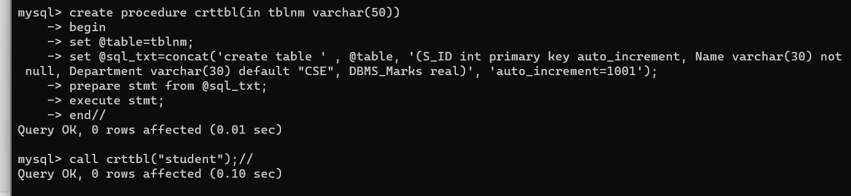

1. Create a procedure **Insert_record** to insert below mention data tocc the table.

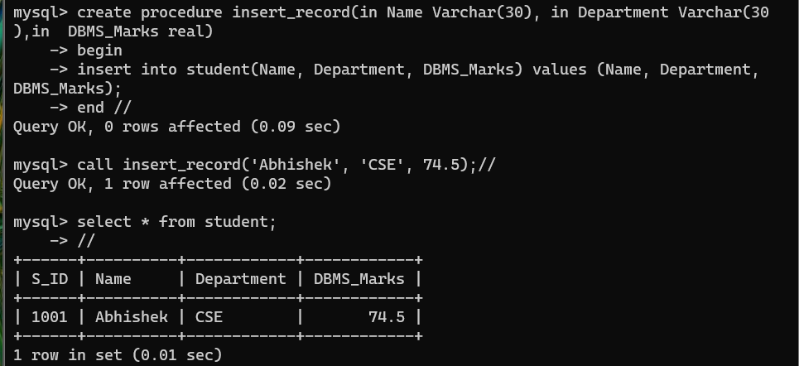

|  |  |  |  |  |  |  |  |  |  |  |  |
| --- | --- | --- | --- | --- | --- | --- | --- | --- | --- | --- | --- |
|  | S_ID |  |  | Name |  |  | Department |  |  | DBMS_Marks |  |
| 1001 | |  | Abhishek | |  | CSE | |  | 74.5 | | |
| 1002 | |  | Adhyan | |  | Mechinical | |  | 82.0 | | |
| 1003 | |  | Aravindan | |  | Civil | |  | 94.5 | | |
| 1004 | |  | Arihant | |  | CSE | |  | 48.5 | | |
| 1005 | |  | Bhaven | |  | Electrical | |  | 70.5 | | |
| 1006 | |  | Jashan | |  | Mechinical | |  | 68.0 | | |
| 1007 | |  | Manan | |  | Civil | |  | 95.0 | | |
| 1008 | |  | Mayank | |  | CSE | |  | 56.0 | | |
| 1009 | |  | Prateek | |  | Electrical | |  | 65.5 | | |
| 1010 | |  | Riya | |  | Mechinical | |  | 35.0 | | |

1. Discribe table student.

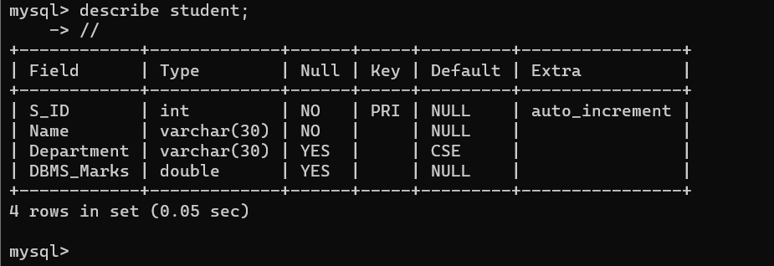

1. Create & Call a Stored Procedure “**display_table”** to display the data of any table (you just need to pass the table name) at the time of procedure call.

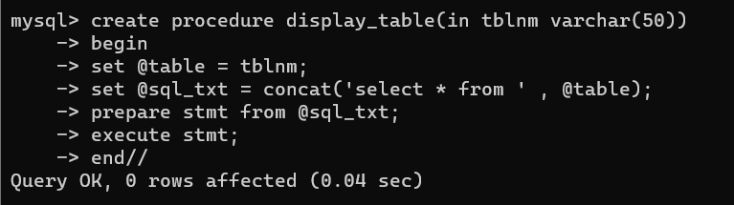

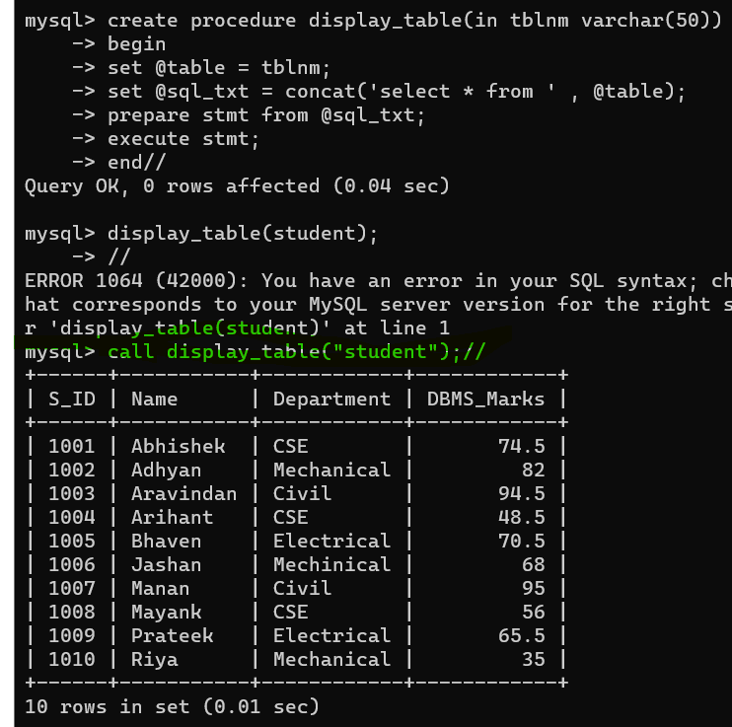

1. Create a procedure **count_rcrd** to count the number of records of any table of selected database (for example student).

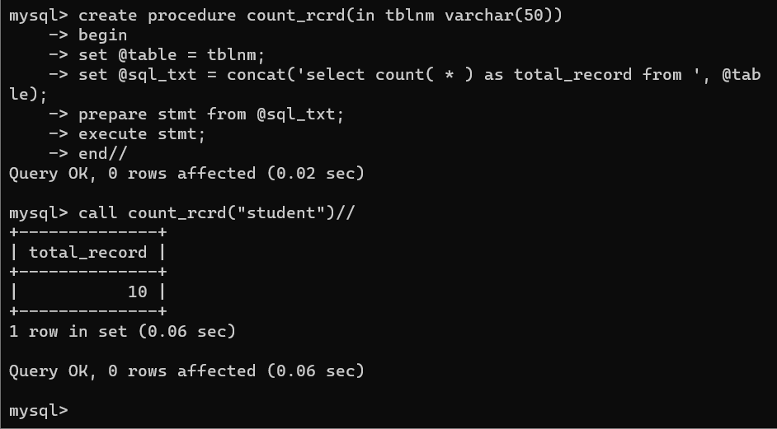

o *Create & Call a Stored Procedure “****Update_Record”*** *to update name of a student for example, set the student name “Ram” whose S_ID is 1006 at the time of procedure call (do it in free time).*

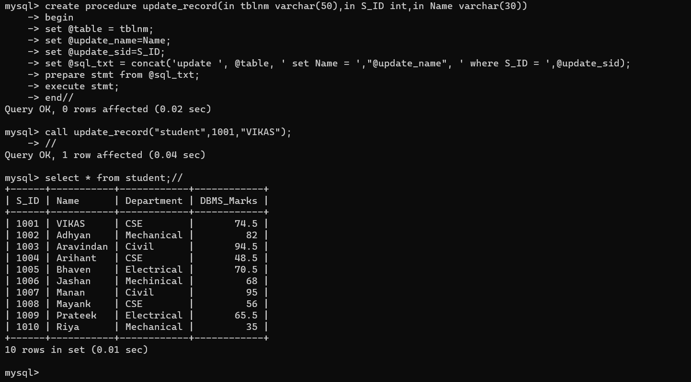

**Stored Function (user defined or stored function):**

1. Create a stored function **cal_avg** to calculate the average of 5 numbers. You have to give the numbers in function call (in select command). For example, calculate the average of 10,20,30,40,50. //

**Accessing tables in stored functions**

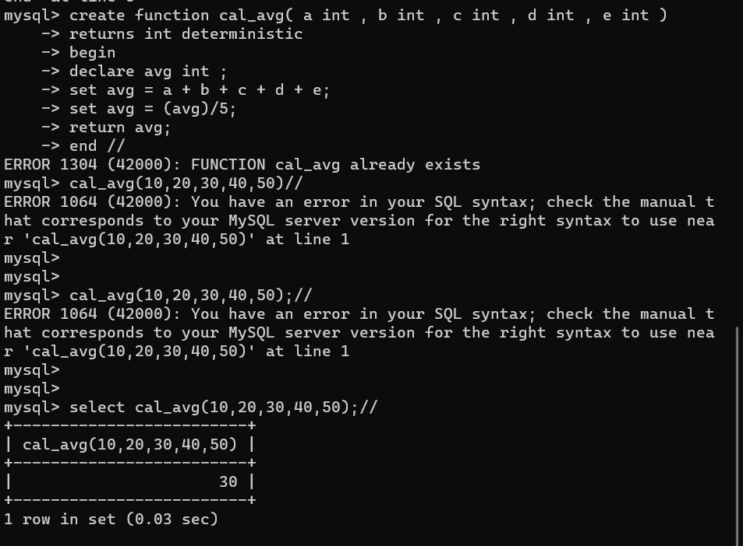

1. Create a function **Grade** to check the grades of the students as per given below conditions:

* + If marks>= 90 then Grade is “A”
  + If marks >=80 and marks <90 then Grade is “B” ➢ If marks >=60 and marks <80 then Grade is “C”
  + marks >=40 and marks <60 then Grade is “D”
  + If marks< 40 then Grade is “F”

Call this function in student table & your output should be like (*your output may differ because now I have a single record in my table)*:

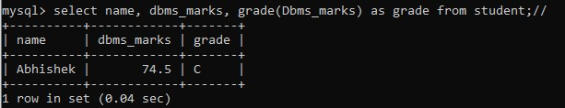

* **You can call this function for any table where you have the similar scenario/requirements.**
* **Try to implement more function examples in different ways**.

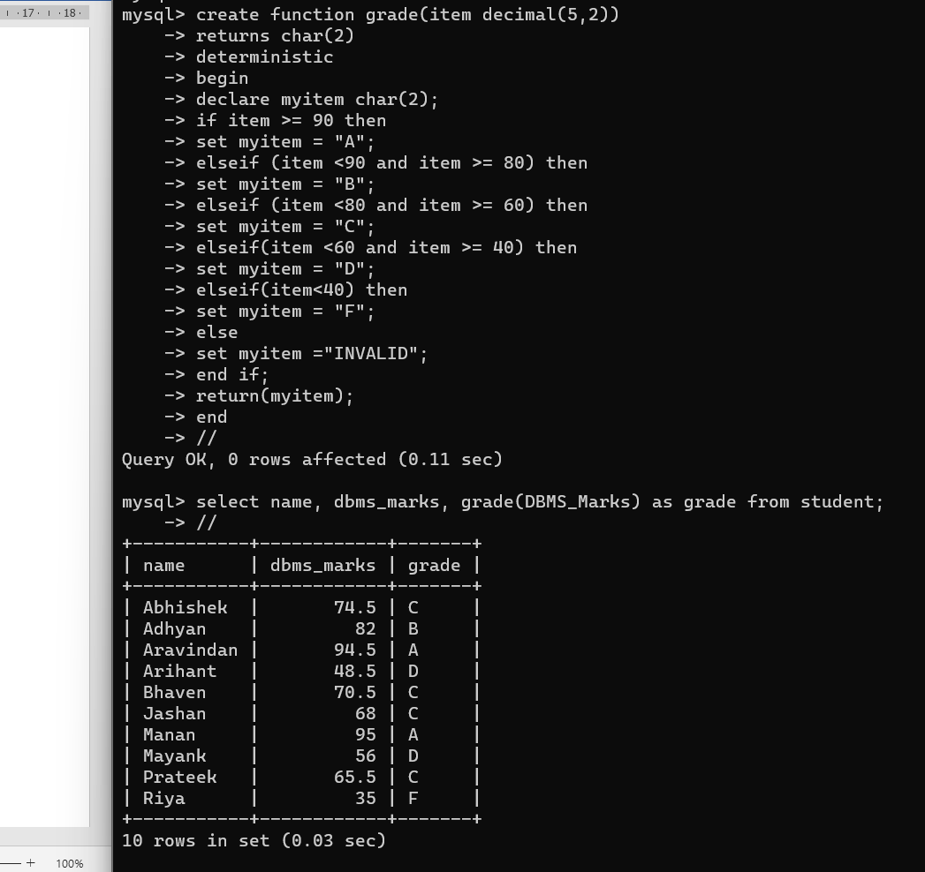

1. Drop all the procedures & functions, you have created recently.