**Project Report Template**

**Title of Project:** Smart High-Beam Safety Assistant

**Name of the Innovator:** Vikas Vardhan SP  
**Start Date:** 1-10-2025

**End Date: 31-10-2025**

***Day 1: Empathise & Define***

*Step 1: Understanding the Need*

* Which problem am I trying to solve?

I’m solving the problem of road accidents and driver discomfort caused by the improper use of high-beam headlights at night. Many drivers unintentionally keep their high beams on, creating visibility issues and leading to accidents. My app helps detect high-beam usage, alert drivers, and promote safer night driving through technology.

* Who is affected by this problem?
* How did I find out about this? [Select whichever is applicable]
* Interviews
* Observation
* Online Research
* AI Tools

*Step 2: What is the problem?*

*The problem is that many drivers use high beams irresponsibly at night, causing glare and temporary blindness for oncoming drivers. This leads to discomfort, slower reaction times, and an increased risk of accidents — especially on highways and poorly lit rural roads.*

Why is this problem important to solve?

This problem is important to solve because it directly impacts road safety and driver well-being. Reducing high-beam misuse can significantly decrease night-time accidents, improve visibility, and create more awareness among drivers. By leveraging AI-based detection and educational features, this app empowers drivers to be more responsible and ensures safer roads for everyone.

**Take-home task**

Ask 2-3 people what they think about the project:

* **• 1. Driver (Frequent Night Driver):**“I think this app will be really helpful because high-beam lights often blind me while driving at night. If the app can detect and alert drivers to dim their lights, it will make night driving much safer for everyone.”
* **• 2. Traffic Police Officer:**  
  “This kind of app can promote road safety awareness and help reduce accidents. Many drivers don’t realize how dangerous high-beam misuse can be. If this app provides automatic alerts and data analytics, it could even support traffic safety programs.”
* **• 3. Resident (Lives Near a Highway):**  
  “I like this idea because we often see accidents at night due to blinding headlights. If drivers use an app like this, it can prevent glare, reduce accidents, and make roads safer for both drivers and pedestrians.”

*AI Tools you can use for Step 1 and 2:*

**AI Tools Used:**

1. **Meta MGX**

**• Used as a no-code development tool to design and deploy the *SmartBeam* road safety app.**• Helps create interactive dashboards for alerts, camera-based detection systems, and driver interface screens without coding.  
• Ideal for building features such as high-beam detection alerts, night vision assist mode, and driver analytics modules.

**2. ChatGPT**

• Used for idea generation, app concept validation, and feature planning.  
• Helped design AI-driven alert messages, safety tips, and user interface text for the app.  
• Useful for generating driver awareness content, accident prevention guidelines, and real-time response messages for in-app notifications..

**3. AI Vision and Detection References (Structure Design):  
To design the AI-based detection and warning system, references can be taken from:**• Google MediaPipe / TensorFlow Lite – for real-time camera-based detection of high beams using mobile devices.  
• IBM Watson Visual Recognition – for understanding object and light-intensity detection through trained AI models.  
• Microsoft Azure Computer Vision – for integrating image analysis and brightness detection for improving night vision assist mode.

***Day 2: Ideate***

*Step 3: Brainstorming solutions*

* List **at least 5 different solutions** (wild or realistic):
* • **AI-Based High-Beam Detection App** – A mobile application that uses the smartphone camera or sensor to detect oncoming high beams and alerts the driver in real time to dim their lights or take safety measures.
* • **Smart Vehicle Lighting System** – An AI-enabled module integrated into vehicles that automatically switches between high and low beams depending on road and traffic conditions.
* • **Night Vision Assist Display** – A screen-based mode in the app that adjusts brightness and contrast using AI to improve visibility during night drives and reduce glare from oncoming vehicles.
* • **Driver Awareness & Safety Analytics Dashboard** – A companion feature or web dashboard that tracks how often high beams are misused, provides safety scores, and suggests ways to improve driving habits.
* • **Road Safety Awareness Campaign App** – A digital awareness tool that educates users on responsible driving, proper headlight use, and night-time safety through interactive tips, quizzes, and AI-generated reminders.
* • **SmartBeam Platform** – A complete AI-powered platform combining high-beam detection, night vision assist, and awareness analytics built using **Meta MGX**, designed to promote responsible night driving and reduce road accidents.

*Step 4: My favourite solution:*

*My* ***favourite solution*** *is* ***SmartBeam****, an AI-powered mobile application designed to improve night driving safety and reduce accidents caused by high-beam headlights. It combines* ***real-time light detection****,* ***automatic dimming alerts****, and* ***AI-based night vision assist*** *to enhance visibility and ensure responsible driving. Built using* ***Meta MGX****, the app allows seamless design of detection workflows, driver alerts, and safety dashboards without coding.  
SmartBeam is an* ***innovative, practical, and impactful solution*** *for promoting safe and responsible night driving among vehicle users.*

***Step 5: Why am I choosing this solution?***

*I am choosing* ***SmartBeam*** *because it provides a* ***complete solution*** *to one of the most common causes of night-time accidents — improper use of high-beam lights. It’s simple to use, AI-powered, and designed to* ***increase driver awareness, reduce glare-related accidents, and save lives****. The app also supports long-term road safety education through data insights and awareness campaigns, making it both useful and sustainable.*

*AI Tools you can use for Step 3-5:*

**AI Tools for Step 3–5**

**1. Meta MGX**• Used to design and build the SmartBeam app without any coding.  
• Helps create modules for real-time detection, driver alert systems, and safety analytics dashboards.

**2. ChatGPT**• Helps brainstorm and structure app features, such as alert logic and user messages.  
• Can generate driver safety tips, awareness content, and night-driving recommendations.  
• Assists in writing user interface text, FAQs, and AI-based driving education modules for the app.

**3. AI Vision & Detection References (for design and flow)**

* Google MediaPipe / TensorFlow Lite – Helps in detecting high-beam intensity using the smartphone camera and provides real-time analysis for glare reduction.
* IBM Watson Visual Recognition – Assists in image and brightness analysis to understand when a high beam is causing visibility problems.
* Microsoft Azure Computer Vision – Enables object detection and environment understanding for smarter road visibility features.

**4. AI Research Tools**

*AI Tools you can use for the take-home task:*

***Google Scholar / Research AI –*** Used to explore research papers and innovations related to road safety, glare detection, and driver-assist systems.

***AI Text & Summarization Tools –*** Helps summarize findings from AI-based safety studies and present the best solutions clearly for project documentation.

***Day 3: Prototype & Test***

*Step 6: Prototype – Building my first version*

What will my solution look like?

* **Home Screen:** Welcomes the driver and provides quick access to safety options like “Start Detection,” “Night Vision Assist,” and “Safety Tips.”
* **AI-Powered Detection System:** Uses the phone camera to identify high-beam glare from oncoming vehicles and gives real-time alerts (audio + visual) to dim lights.
* **Night Vision Assist Mode:** Enhances visibility on the screen using AI-based brightness and contrast adjustment to help drivers see clearly in dark conditions.
* **Driver Analytics Dashboard:** Displays data such as how often high beams were misused, average driving safety score, and areas with frequent glare issues.
* **Safety Awareness Section:** Provides AI-generated tips, do’s and don’ts for night driving, and educational campaigns to promote responsible road behavior.

**Design Style:**

* Simple, intuitive, and driver-friendly interface to ensure safe and distraction-free use while driving.
* Dark-themed visuals for better night visibility and reduced glare during use.
* Real-time interactive alerts and voice notifications to assist drivers without manual operation.
* Mobile-compatible and responsive layout for both Android and IoT-based systems in vehicles.

**Prototype Tools:**

* Built using **Meta MGX**, no coding required, with all features **interactive and testable**.

What AI tools will I need to build this?

**AI Tools Needed to Build CareerPath**

**Meta MGX**

* No-code platform to **design and deploy** the app prototype.
* Allows creating **interactive dashboards, camera-based detection UIs, and driver alert screens** without coding.

**Google TensorFlow Lite**

* Enables **real-time high-beam detection** using AI vision models optimized for mobile devices.
* Supports **image classification and light-intensity recognition** from live video feed.

**ChatGPT (or similar LLMs)**

Used for **AI-driven driver tips, awareness messages, and in-app chatbot support.**

Helps in generating **contextual road safety advice** based on detection data and driver behavior.

**IBM Watson Visual Recognition**

* Assists in **training models** to distinguish between **high-beam, low-beam, and ambient light** conditions.
* Provides **data labeling and image analysis** support for more accurate glare detection.

**Canva AI / Figma AI**

* Used to **design app screens, awareness posters, and road-safety campaign visuals** for user testing and presentations.

What AI tools I finally selected to build this solution?

1. **Chat GPT**
2. **Metamgx**

**Smart High-Beam Safety Assistant**

**Tool Link:** **https://mgx-4cr404mqtbi.mgx.world/**

Internal Working of tool:

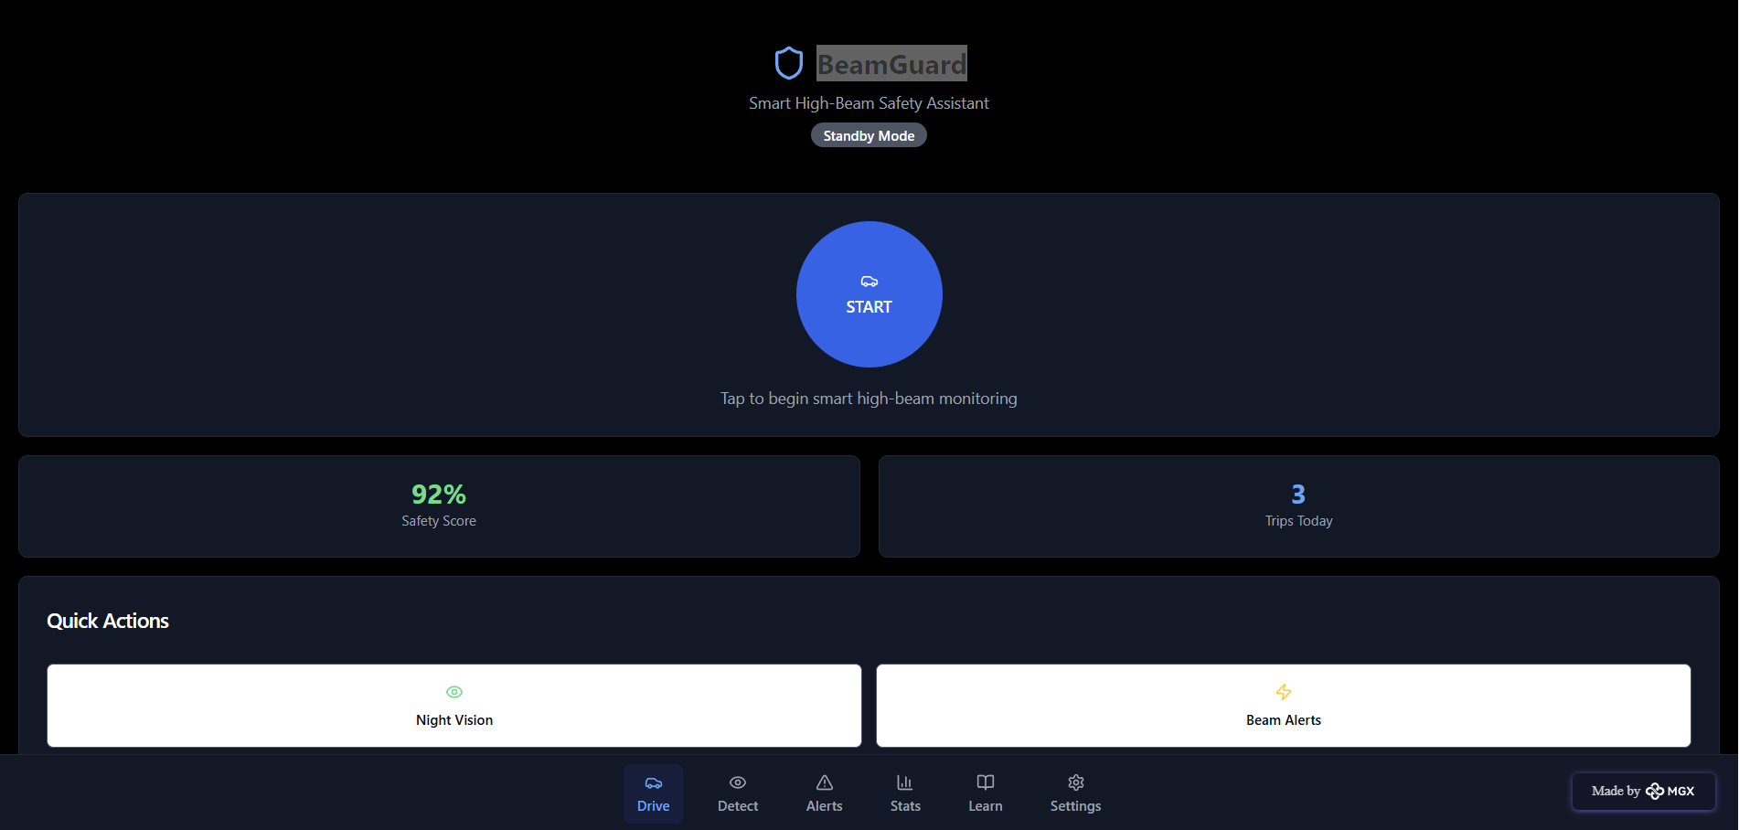

Vehicle detection system:

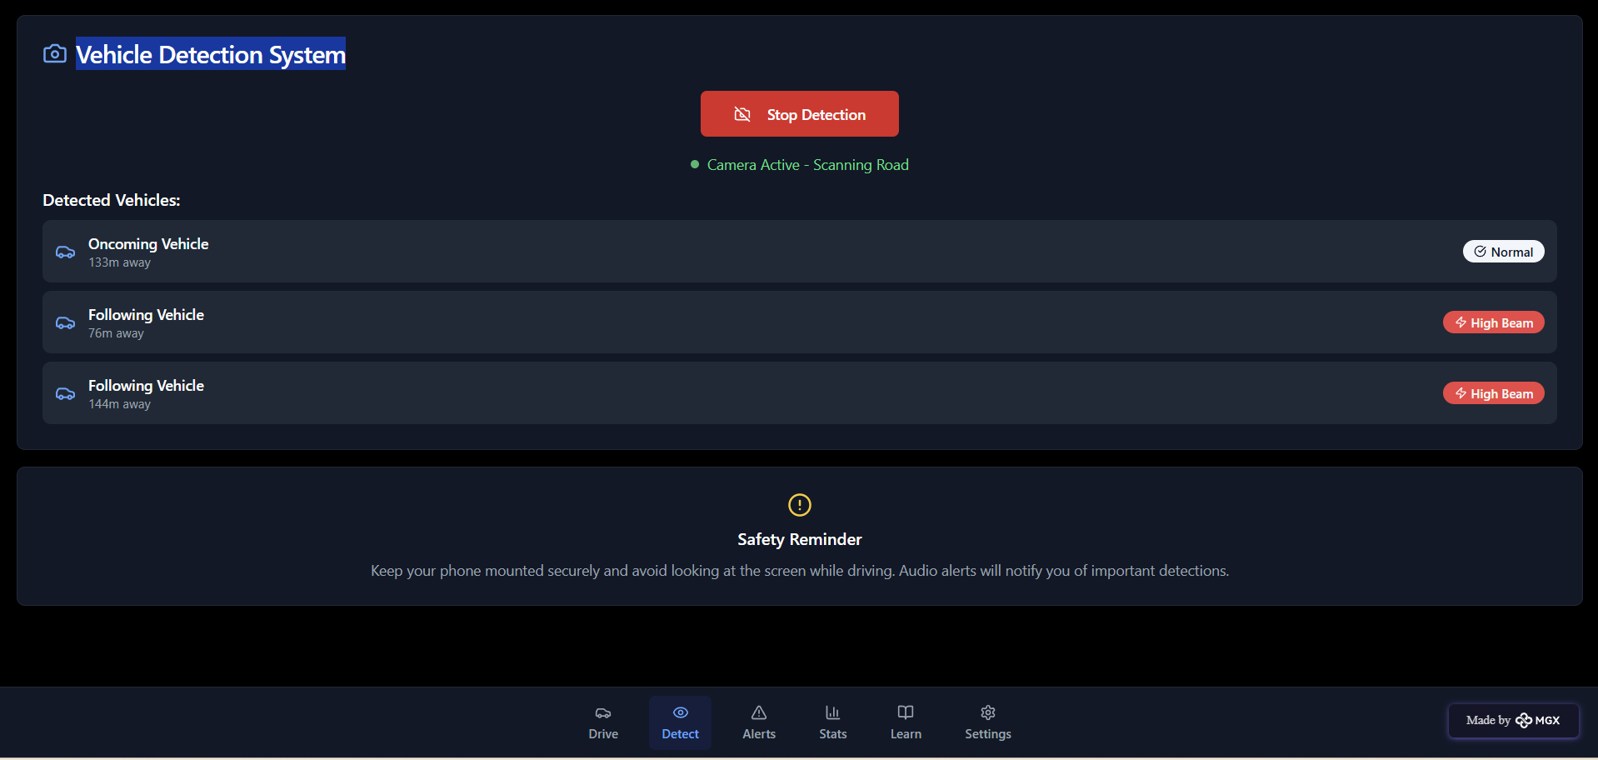

Driving analytics:

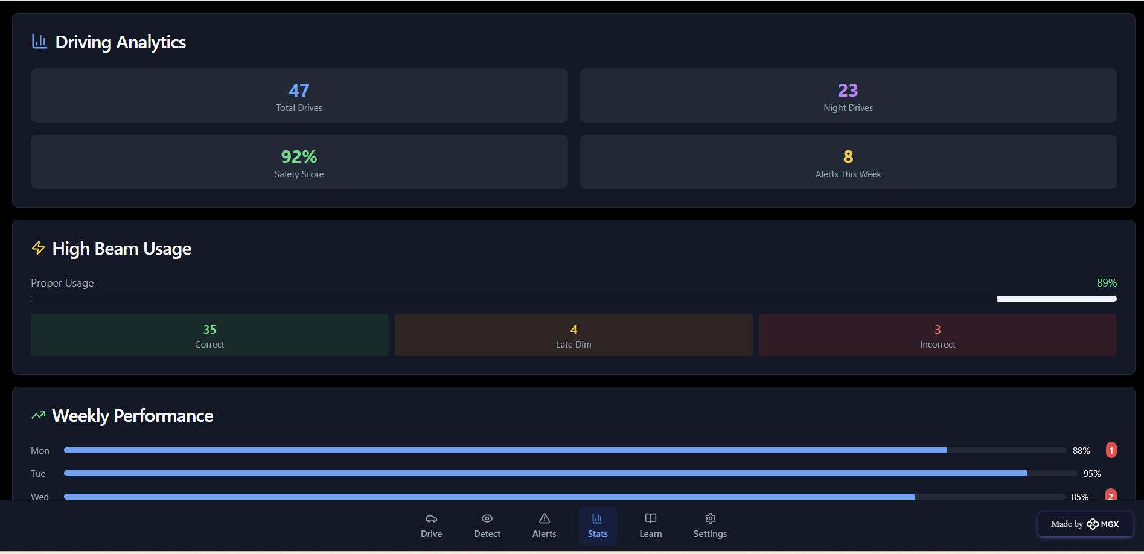

Alert system setting:

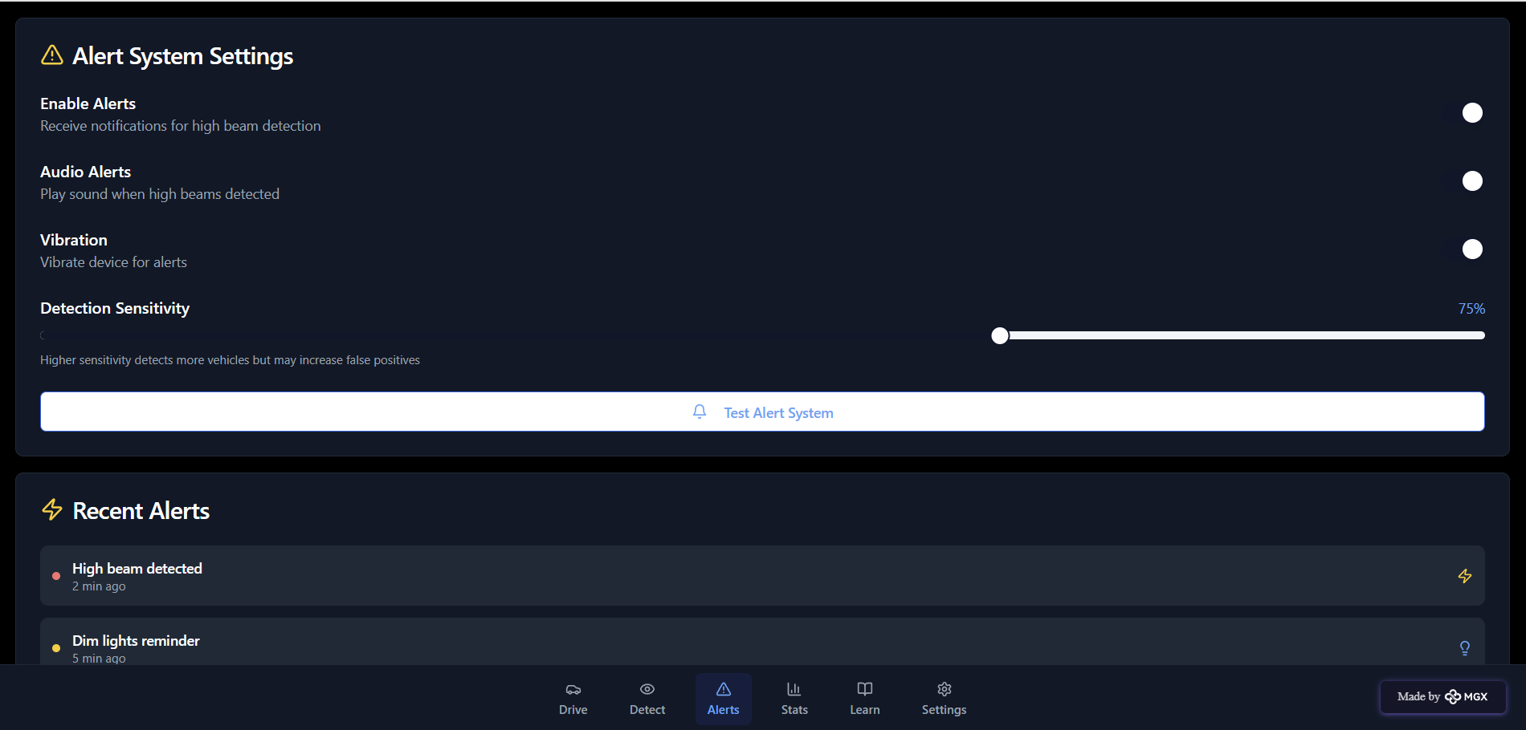

Learning progress:

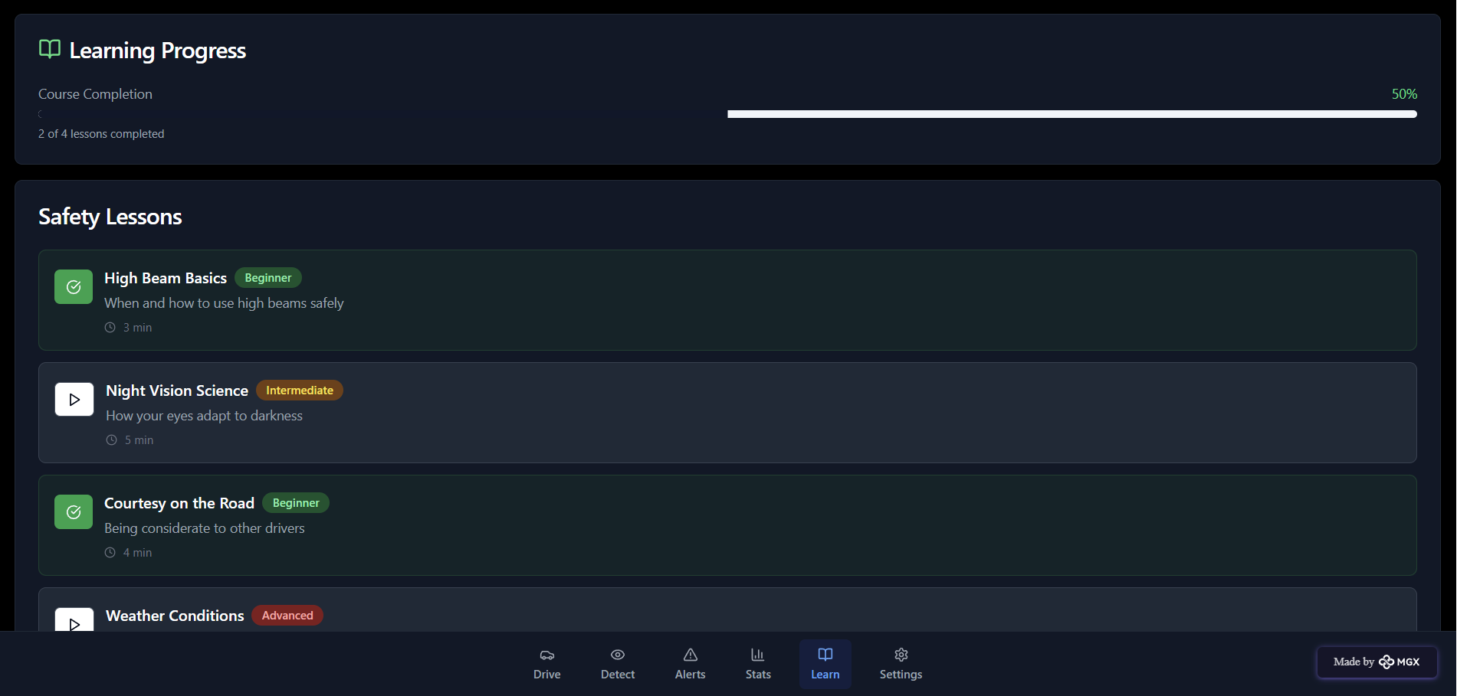

*Step 7: Test – Getting Feedback*

I shared my **SmartBeam** solution with:

* **Local drivers and daily commuters** – to get feedback on how effectively the system detects high beams and improves night driving comfort.
* **Traffic police officers** – to understand how useful it could be in improving road safety and reducing glare-related accidents.
* **Automobile engineers and IoT enthusiasts** – to evaluate the accuracy and performance of the detection system.
* **Peers and mentors** – for suggestions on improving AI accuracy, app usability, and user interface design.

**Feedback: Pros and Cons**

**Pros (Positive Insights from Feedback):**

* Users found the AI-based detection system very accurate in identifying high-beam lights in real time.
* The voice alert and visual warning feature were appreciated as they helped drivers stay focused without distractions.
* The idea of promoting road safety using AI was considered innovative and socially impactful.
* The integration with ESP32 and camera module impressed users for being cost-effective and suitable for rural road conditions.

**Cons (Areas to Improve Noted in Feedback):**

* The system occasionally misdetects streetlights or reflections as high-beams under certain conditions.
* Some users felt the alert volume and timing could be better optimized to avoid unnecessary notifications.
* The prototype lacks a data-logging feature, which could help analyze repeated high-beam zones.
* The mobile interface design could be made more user-friendly for quick setup and calibration.

**My Response for The Feedback:**  
SmartBeam is an innovative solution developed using AI and IoT components like the ESP32 and camera module. Since this is an initial prototype, some limitations exist in terms of detection accuracy and hardware integration. To fully implement all advanced features—such as data logging, adaptive light control, and cloud-based analysis—we would need further collaboration with automobile industries, traffic management departments, and IoT research labs.

The current prototype successfully demonstrates the **concept, usability, and real-world potential** of using AI to enhance **road safety and reduce glare-related accidents**. With improved hardware, better datasets, and expanded testing in different lighting conditions, SmartBeam can evolve into a reliable and scalable solution for safer night driving.

👍 What works well:

**What Works Well**

🚗 **Accurate Glare Detection:** The AI-based camera system effectively detects incoming high-beam headlights and adjusts accordingly to prevent glare.

⚙️ **IoT Integration:** SmartBeam uses the **ESP32 microcontroller** for real-time data processing and sensor control, ensuring quick response and stable performance.

💡 **Automatic Dimming Feature:** The system automatically lowers the vehicle’s headlight intensity, improving night-time visibility and reducing accidents.

🔋 **Energy Efficient:** Designed to optimize power consumption, making it suitable for continuous use in vehicles.

📱 **Scalable and Upgradeable:** The prototype allows easy integration with other vehicle systems, making it adaptable for future updates and smart road technologies.

🌍 **Affordable and Accessible:** Built using cost-effective hardware components, making it a **practical and scalable** solution for both rural and urban drivers.

🔧 What needs improvement:

🔁 **Detection Consistency:** The AI model sometimes misidentifies low beams or reflective lights as high beams; accuracy can be improved with more dataset training.

📶 **Connectivity Limitations:** The prototype currently works offline; adding cloud-based monitoring or remote diagnostics could enhance functionality.

🔧 **Hardware Optimization:** Needs improved sensor calibration and waterproofing for better outdoor performance and reliability.

🤝 **Collaboration Required:** To scale the solution, partnerships with **automobile industries, traffic management authorities, and research institutes** are needed.

🎨 **User Interface Enhancements:** Adding a mobile app dashboard to show detection logs, alerts, and performance data can improve usability and engagement

*AI Tools you can use for Step 6-7:*

**ChatGPT/Perplexity AI/Claude AI/Canva AI/Chatling AI/Figma AI/Metamgx/Gamma AI**: You can use these tools to build solutions/models or mock-up dummy prototypes

***Day 4: Showcase***

*Step 8: Presenting my Innovation:*I am presenting **SmartBeam**, an **AI-based high beam detection and road safety system** designed to reduce accidents caused by glare from oncoming headlights. It uses **AI and IoT** to create a safer and more comfortable night driving experience for everyone.

**It features:**

* **AI-Powered Glare Detection:** Uses an intelligent camera system to detect incoming high-beam headlights and automatically adjust light intensity to prevent glare.
* **IoT-Based Control System:** Built using **ESP32**, which processes sensor data in real time for smooth and quick headlight adjustments.
* **Automatic Dimming Mechanism:** Ensures drivers have clear visibility while preventing temporary blindness for oncoming vehicles.
* **Energy Efficient & Affordable Design:** Developed with cost-effective components to make it accessible and practical for widespread use.
* **Scalable Integration:** Can be integrated into existing vehicle systems or upgraded with smart road safety networks

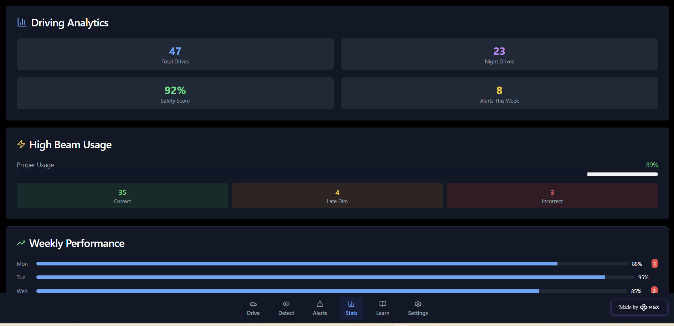

*Step 9: Reflections*

* What did I enjoy the most during this project-based learning activity?

I enjoyed **building SmartBeam using AI and IoT technologies** and watching my idea turn into a **real, working prototype**. It was exciting to **design the glare detection system, automatic dimming mechanism, and ESP32-based control module**, and see how it could **improve night driving safety**.  
Creating a project that uses **artificial intelligence for real-world road safety** made me realize how technology can directly **save lives and make transportation safer**, especially on rural and poorly lit roads.

What was my biggest challenge during this project-based learning activity?

My biggest challenge was **integrating the AI detection model with the ESP32 hardware** to ensure smooth real-time performance. Managing **sensor calibration, light intensity control, and timing accuracy** required careful testing.  
Additionally, **limited resources and environmental variations** (like different vehicle headlight intensities) made fine-tuning the system a complex but rewarding process.

**Take-home task**

<https://github.com/punithhcreator/Careerpath-No-code-application>

*AI Tools you can use for Step 8:*

**Canva AI:** Use this to design your **project poster or presentation slides**, showcasing how SmartBeam detects glare, adjusts headlights, and improves safety. Export your final document as a PDF and upload it to GitHub.