**Bar Chart**

Bar charts are used with discrete data (e.g., number of people) and provide a visual display for comparing quantities in different categories or groups. They help the reader to see relationships quickly.

Misleading Axis: In Figure below, both bar charts show 44% of Older American Act Title III service recipients living alone and 56% not living alone. The bar chart on the left is misleading, however, since the Y axis starts at 40% and ends at 60% and therefore appears to show very large difference between the results, suggesting that most service recipients do not live alone. In reality the difference is much smaller, with only slightly more than half of service recipients not living alone.

The bar chart on the right presents the data accurately and in context of the range of possible values, with the Y axis starting at zero and ending at 100. In addition, the bar chart on the right includes value labels, showing the actual percent for both categories. As a rule, bar charts showing percentages should end at 100%. Value labels should be used when they help the reader to know the individual value for each category or group (vs. the relative size or rank).

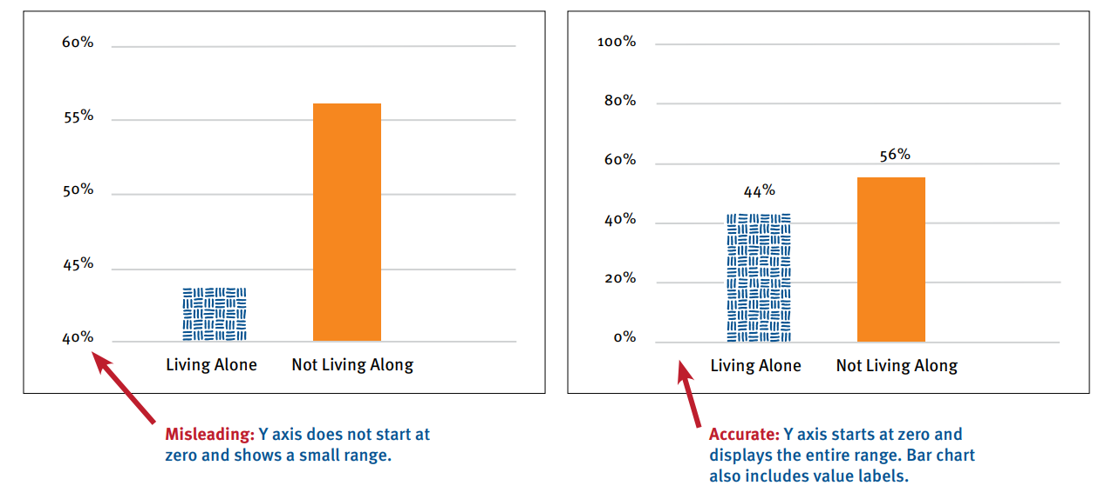

Fig 1. Percent of Older Americans Act (OAA) Title III service recipients living alone.

**Line Graph**

Line graphs (line charts) are used with continuous data, providing a visual display of data or information that changes over time. They help to illustrate overall trends such as an increase or decrease in performance over time.

In Figure below, each line graph shows the total annual number of complaints brought to, or initiated by, the Long-Term Care Ombudsman Program, which is required to investigate and resolve complaints on behalf of residents of long-term care facilities. The first line graph shows the total number of complaints for 2000–2005 and suggests a steady increase in the number of complaints over time. The presentation is misleading, however, as it covers just a small select period of time. The second line graph, which shows the total number of complaints for 2000–2018, provides more context and leads to a very different conclusion, with the number of complaints actually declining after 2005 and then remaining quite steady after 2012. If the start and end values of the data are important to know, the values should be added to the line graph. If the goal is to show just the slope of the line (i.e., the change over time), the values do not need to be shown.

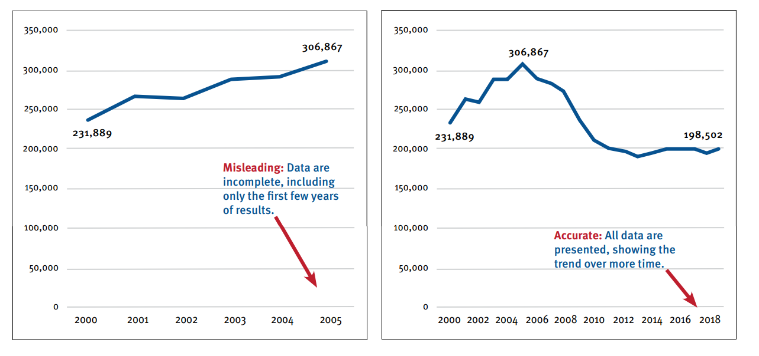

 Fig 2. Total number of complaints of willful mistreatment of long-term care facility residents.