**It is highly recommended that you read through all notes in this document before altering the template.**

Replace the yellow highlighted text on this page with your information, remove the highlighting, and delete this note. If you are not enrolled in a Master of Science program, you may not have a degree program. The Graduate School will provide additional guidance during your review. Throughout this document, helpful notes are in blue highlighting. Note that this document is formatted to print single sided. Please see [the Guide](http://www.mtu.edu/gradschool/policies-procedures/theses-dissertations/pdfs/guide.pdf) for the required formatting changes for a double sided document and additional formatting guidance and description.

# Case Study X/ Project: Title Here

By

Student1, Student2

CHAMPLAIN COLLEGE

Fall 2025

## Introduction

Briefly introduce your project’s context, objectives, and scope. Explain *why* this work matters and what you aim to accomplish. The document

### Heading 3 Subsection

Table example

Table 1 Mapping of headings to bookmarks for PDF conversion.

| Heading Label | Bookmark Level |
| --- | --- |
| Heading 1 | 1 |
| Heading 2 | 2 |
| Heading 3 | 3 |
| Heading 4 | 4 |
| Heading 5 | 5 |
| Heading 6 | 2 |
| Heading 7 | 2 |
| Heading 8 | 3 |
| Heading 9 | 4 |

The final write-up must be submitted as a PDF and follow strict formatting: use Times New Roman throughout, with section titles in 16pt bold, subsection titles in 14pt bold, and body text in 12pt regular. All text must be fully **justified** (select the text and hit ctrl+j), with line spacing set to 1.0, and standard 1-inch margins on all sides. Include page numbers in the footer of every page.

The above paragraph is justified

The main content (excluding title page and references) should be minimum 500 words.

The below paragraph is not justified

All visualizations must be complete (with axes, units, labels, legends as appropriate), be uniform in size, centered, and accompanied by a figure number and descriptive caption. Before submission, verify the file is PDF, styling rules are obeyed, word count is within range (excluding title page/references), and every figure is consistent, readable, numbered, captioned, and centered.

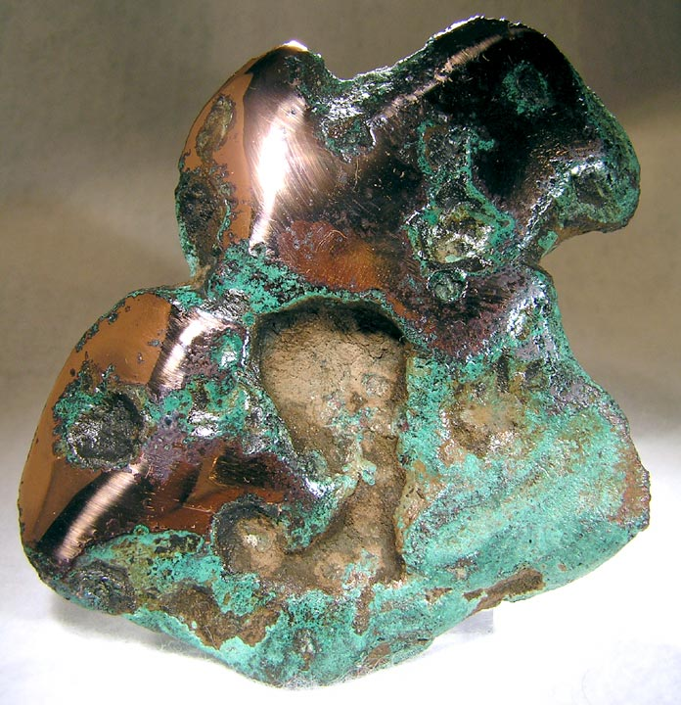

Figure 1. Native copper from Keweenaw County. (Figure caption font: 10pt; Figure must be centered)

## Additional Chapter

Note: Screenshots of R code visualization are not allowed. Save the Plot and the add here.

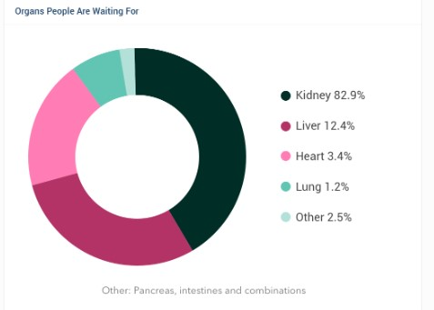

Figure 2. This image is a screenshot

### Heading 2 Subsection

You can additional sections here

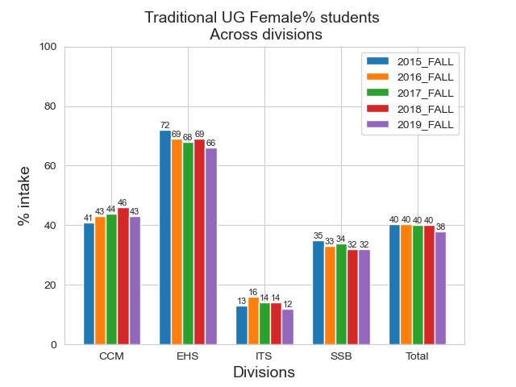

Figure 3. This image is a saved image.

## Final Chapter

Chapter details. Use of AI to generate report is strictly prohibited.

## Chapter X

The main body of the document is included here. The organization of this section is at the discretion of the committee.

Use Heading 2 for chapter headings. A page break will automatically be inserted before each new chapter. Use Headings 3-5 for sections within each chapter. Use “Normal” text for paragraphs in the document. To [edit the appearance of styles](http://blogs.mtu.edu/gradschool/2010/11/23/edit-a-style/) in this document, see our blog for a tutorial.

To insert

### Heading 3 Subsection

Subsection X.1

#### Accessibility Notes

SubSubsection X.1.1

Use can copy paste to create more sections