AI Voice Translator
Developer handbook: architecture, API contract and step-by-step tasks for the frontend and backend
Item | Details
Repository | https://github.com/vikasvardhan7/Ai-translator
Version | 1.0, 18 October 2026
Project owner | Vikas Vardhan: backend developer; reviews and merges all frontend pull requests
Frontend developer | Developer A (teammate): owns everything in frontend/
Current status | Phase 1, Step 1A (project setup) done: commit 0b741e9 on main
Core rule | Any spoken language is detected automatically and translated into the listener's chosen language. Free services only.

How to use this handbook. Sections 1 to 4 explain the product, the team and the final architecture. Sections 5 to 7 cover setup and the Git workflow. Section 8 is the API contract both developers build against. Section 9 lists every Phase 1 step with exact tasks for the frontend and the backend. Sections 10 to 12 cover Phase 2, the target folder structure and a command cheat sheet.

1. What we are building
A web app that lets two people who speak different languages talk naturally. Each person chooses the language they want to read and hear. Whatever language someone speaks is detected automatically, translated into the other person's chosen language, shown as captions on both sides and spoken aloud. Every conversation is saved and can be downloaded as a transcript.

Example conversation
Who | Preferred language | Says | The other person reads and hears
Guest | Telugu | మీరు ఎలా ఉన్నారు? | Vikas: "How are you?" as an English caption and English voice
Vikas | English | "I'm fine, thank you." | Guest: the Telugu translation as a caption and Telugu voice
Guest | Telugu | A sentence in Hindi | Vikas: the English translation. The Hindi is detected automatically.
Vikas | English | A sentence in Telugu | Guest: the original Telugu, unchanged, because it is already the Guest's language

Ground rules
- Any language in, the listener's language out. Telugu and English are only the first test pair. Languages come from a configurable list, never hard-coded.
- Free only. The Gemini API free tier, local models such as Whisper, and browser voices. No paid service without the owner's approval.
- Laptop web app first. Chrome or Edge on Windows. iPhone comes later and only when requested.
- Tap-to-talk first. Each person has their own talk button, so the app always knows who is speaking. Hands-free mode comes in Phase 2.
- API keys never reach the browser. They live only in backend/.env.

2. Team and ownership
Role | Person | Owns | Responsibilities
Developer A  Frontend | Teammate | frontend/ | Consent and language screens, microphone capture, talk buttons, captions, voice playback, history and download screens. Opens a pull request for every step.
Developer B  Backend | Vikas Vardhan | backend/ | Sessions API, WebSocket server, audio ingestion, AI pipeline, database, exports. Reviews and merges all frontend pull requests. Merges own backend work directly after tests pass.
Shared | Both, by agreement | docs/PROTOCOL.md, docs/DECISIONS.md, CLAUDE.md, README.md | Changed only in a pull request that both people agree on.

Each developer may use a coding agent (Claude or Codex). The agent follows the rules in CLAUDE.md and works only inside its developer's folder.

3. Final architecture flow
The browser records and plays audio and shows captions. The backend runs every AI step behind three replaceable interfaces. One WebSocket carries audio to the backend and results back. Normal REST calls handle sessions, the language list, history and exports.
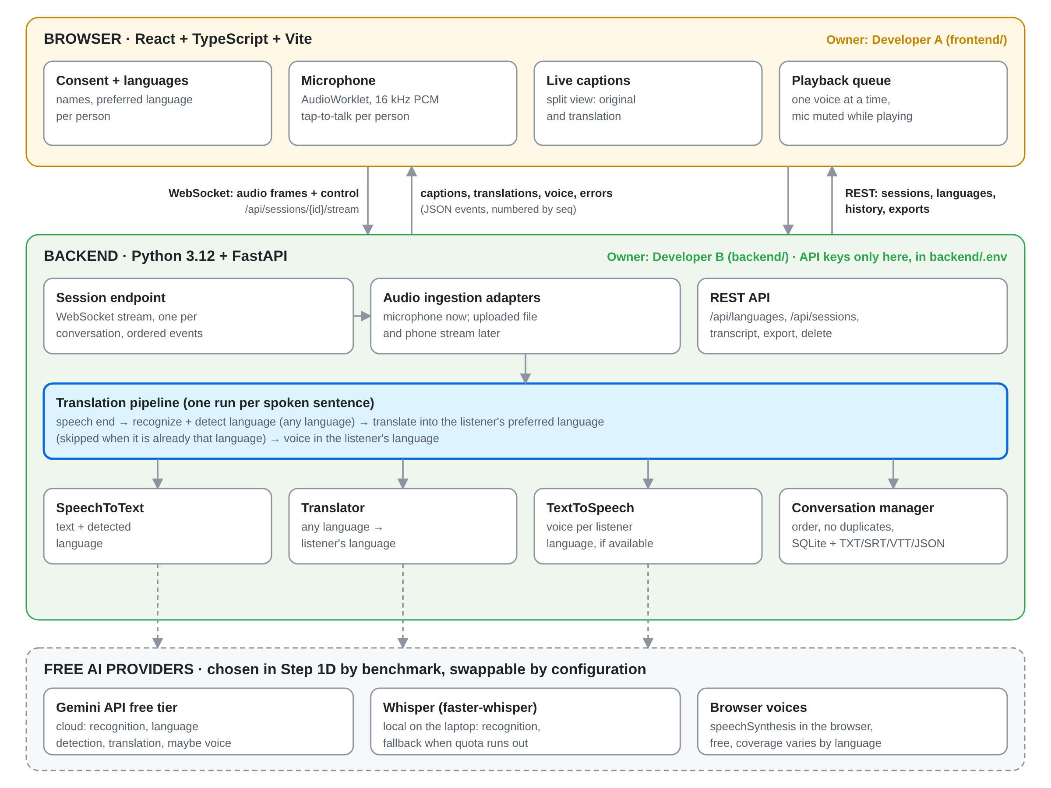
Figure 1. System architecture and ownership

How one sentence travels through the system
Every spoken sentence (an "utterance") follows the same eight steps. The only thing that changes is who is speaking and who is listening.
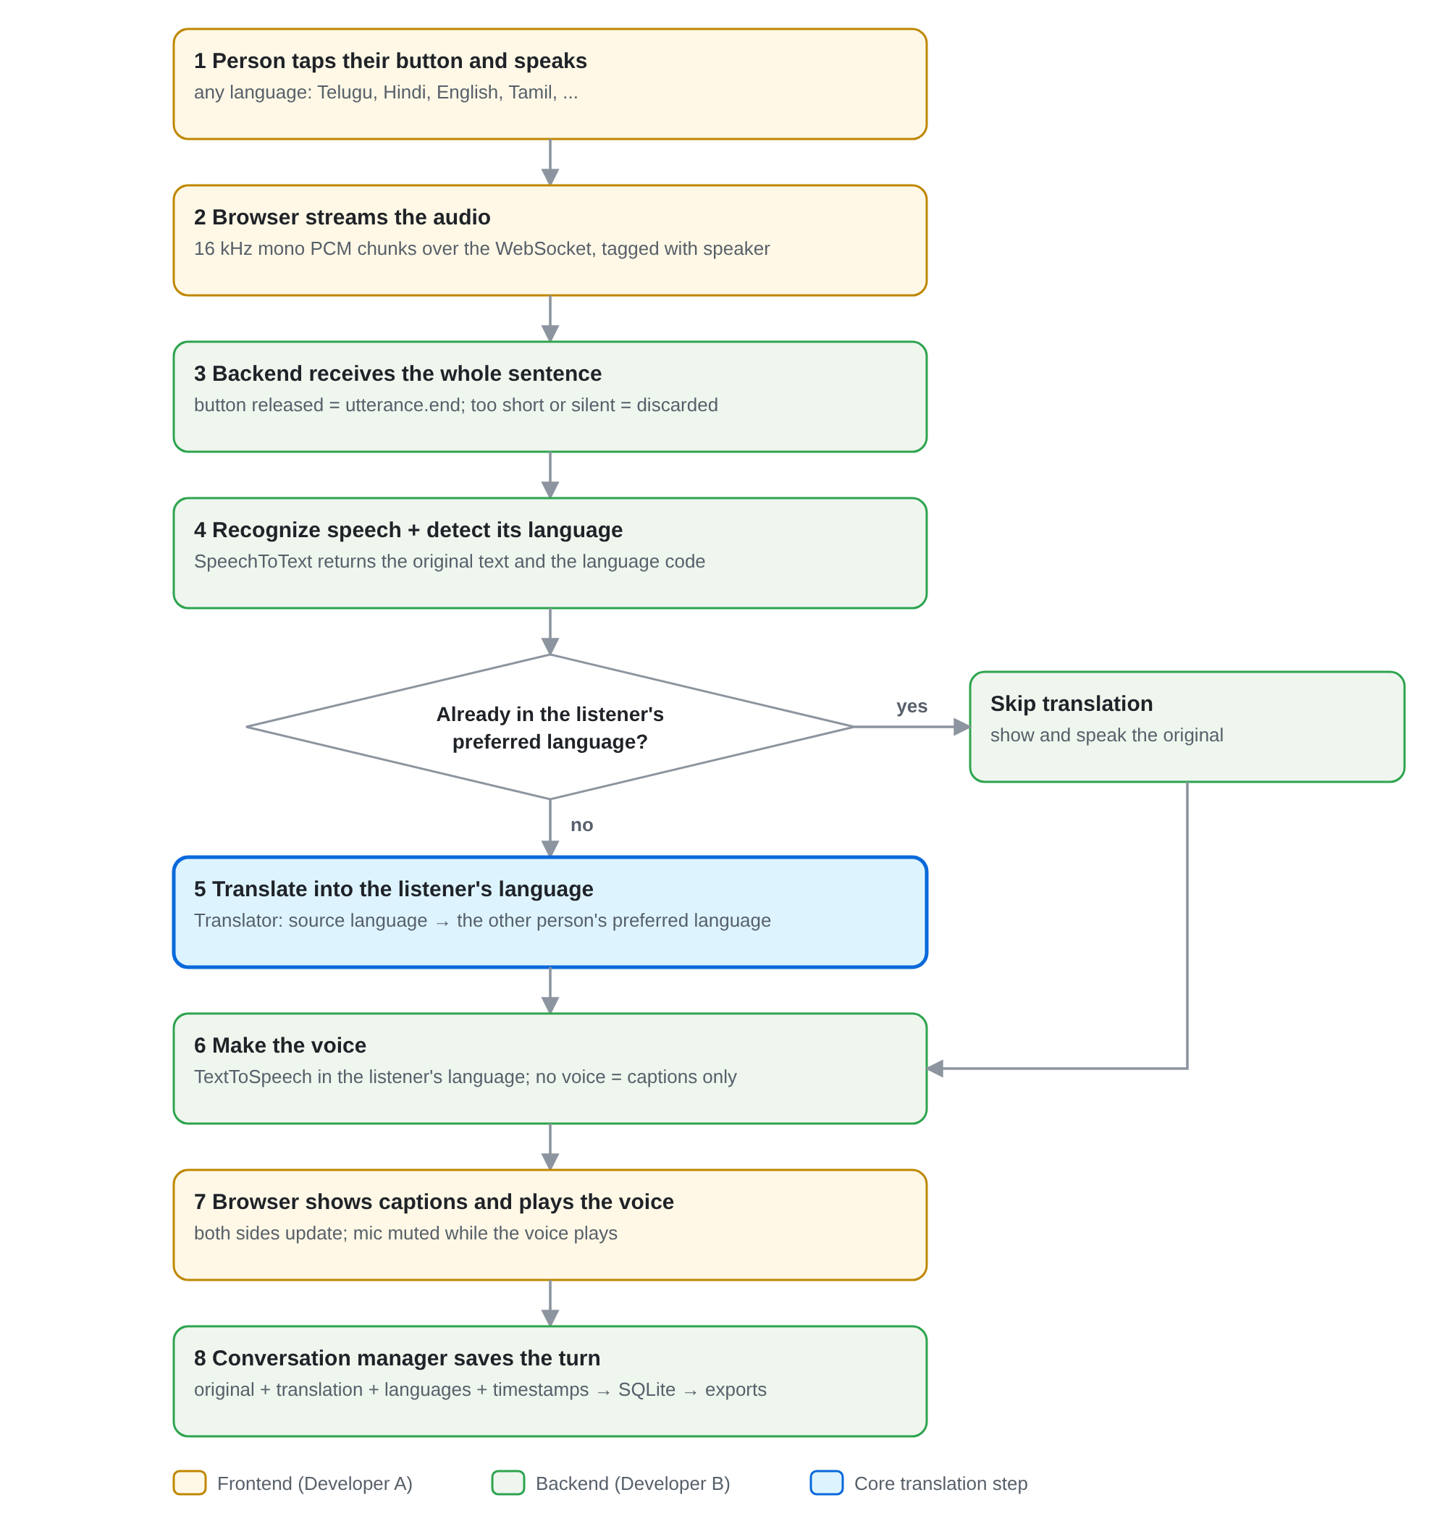
Figure 2. One sentence, end to end

Components
Component | Lives in | Owner | Built in step
Consent screen and language pickers | frontend/src/features/consent/ | Developer A | 1B
REST and WebSocket client | frontend/src/services/ | Developer A | 1B
Microphone capture and talk buttons | frontend/src/features/live-session/audio/ | Developer A | 1C
Captions split view | frontend/src/features/live-session/ | Developer A | 1D
Playback queue | frontend/src/features/live-session/audio/ | Developer A | 1E
History and downloads | frontend/src/features/transcript/ | Developer A | 1F
Languages list and sessions API | backend/app/api/, backend/app/core/languages.py | Developer B | 1B
WebSocket session endpoint | backend/app/api/sessions.py | Developer B | 1B
Audio ingestion adapters | backend/app/services/audio_ingestion/ | Developer B | 1C
SpeechToText and Translator | backend/app/services/ | Developer B | 1D
TextToSpeech | backend/app/services/tts.py | Developer B | 1E
Conversation manager, database, exports | backend/app/services/, backend/app/models/ | Developer B | 1F

4. Rules for everyone
- Work only on the step you are assigned. Do not start the next step on your own.
- Before starting, pull the latest main and create a new branch. Never work directly on main.
- Stay inside your own folder: frontend/ for Developer A, backend/ for Developer B.
- Do not change the API contract (section 8) on your own. Propose the change in a pull request to docs/PROTOCOL.md first.
- Ask before adding a new dependency. Say what it is for and why existing code cannot do it.
- Never commit .env files, API keys, passwords or tokens. Never paste keys into chat, issues or screenshots.
- Run the tests, type check and lint before opening a pull request. Never claim something works without testing it.
- Keep pull requests small: one step, one area.
- Use free services only. Anything that could cost money needs the owner's approval first.

5. Getting started (frontend developer)
Do this once on your own computer. You need the backend running locally too, because the frontend talks to it.

Step 1: install the tools
- Node.js 22.12 or newer (24 recommended) with npm
- Python 3.12 (tick "Add python.exe to PATH" in the installer)
- Git
- VS Code

Step 2: allow npm to run in PowerShell (Windows only, once)
Set-ExecutionPolicy -Scope CurrentUser -ExecutionPolicy RemoteSigned

Step 3: accept the GitHub invitation and clone the repository
git clone https://github.com/vikasvardhan7/Ai-translator.git C:\dev\Ai-translator
cd C:\dev\Ai-translator
git config --global user.name "Your Name"
git config --global user.email "your-github-email@example.com"

Step 4: run the backend (terminal 1)
cd C:\dev\Ai-translator\backend
python -m venv .venv
.\.venv\Scripts\Activate.ps1
pip install -r requirements-dev.txt
Copy-Item .env.example .env
pytest
uvicorn app.main:app --reload --port 8000
Open http://localhost:8000/health. It should show {"status":"ok","version":"0.1.0"}.

Step 5: run the frontend (terminal 2)
cd C:\dev\Ai-translator\frontend
npm install
npm test
npm run typecheck
npm run dev
Open http://localhost:5173. You should see the AI Voice Translator placeholder page. If both work, setup is done.

6. Git workflow for the frontend developer

For every step
- Start from the latest main:
git switch main
git pull
git switch -c 1b-frontend
- Build the step. Commit often with clear messages:
git add frontend
git commit -m "1B frontend: consent screen with language pickers"
- Before opening the pull request, run the checks and bring in any new changes from main:
cd frontend
npm test
npm run typecheck
npm run build
cd ..
git fetch origin
git merge origin/main
- Push the branch and open a pull request on GitHub (base: main, compare: your branch):
git push -u origin 1b-frontend
- Fill in the pull request description using the template below, then wait for Vikas's review. Fix requested changes on the same branch and push again. The pull request updates automatically.

Branch names
Step | Frontend branch | Backend branch
1B Consent and connection | 1b-frontend | 1b-backend
1C Microphone and streaming | 1c-frontend | 1c-backend
1D Recognition and translation | 1d-frontend | 1d-backend
1E Voice playback | 1e-frontend | 1e-backend
1F Transcript and downloads | 1f-frontend | 1f-backend

Pull request description template
## What this does
- (short list of what was built)

## How to test
1. Start the backend and frontend
2. (exact clicks and what you should see)

## Checks
- [ ] npm test passes
- [ ] npm run typecheck passes
- [ ] npm run build passes
- [ ] Only files in frontend/ changed
- [ ] No new dependencies, or they are listed and explained below
- [ ] No secrets or .env files

## Screenshots
(paste screenshots of the new screens)

Never
- Push directly to main.
- Edit files in backend/ (ask Vikas instead).
- Change message shapes in section 8 without a protocol pull request.
- Commit .env, node_modules/ or build output.

7. Reviewing and merging (Vikas)

Checking a frontend pull request
- Read the pull request on GitHub under Files changed.
- Check that only frontend/ changed (and shared docs only if agreed):
git fetch origin
git diff --stat origin/main...origin/1b-frontend
- Run it locally against your backend:
git switch 1b-frontend
cd frontend
npm install
npm test
npm run typecheck
npm run dev
- Follow the "How to test" steps from the pull request and the joint test for that step (section 9).
- Optionally ask Claude: "check 1b-frontend". Claude reads the changed files and reports problems before you merge.
- If everything passes, click Merge pull request on GitHub. Otherwise choose Request changes with clear comments.
- Update your laptop:
git switch main
git pull

Merging your own backend work
cd backend
pytest
ruff check .
cd ..
git switch main
git merge 1b-backend
git push
Do not add a GitHub rule that requires pull requests on main. It would also block your own direct merges. Instead, the teammate agrees never to push to main.

8. API contract (protocol v1)
Both developers build against this contract. During Step 1B it is copied into docs/PROTOCOL.md, which then becomes the single source of truth. Any change after that needs a pull request both people agree on.

8.1 REST endpoints
Base address in development: http://localhost:8000. All bodies are JSON. Errors return {"detail": "readable message"} with a 4xx or 5xx status.
Method and path | Step | Purpose
GET /health | 1A | Backend is running. Returns {"status":"ok","version":"0.1.0"}.
GET /api/languages | 1B | List of supported languages for the pickers.
POST /api/sessions | 1B | Start a conversation with two participants and their preferred languages. Returns the session id.
WS /api/sessions/{session_id}/stream | 1B | Live channel: audio in, captions and events out.
POST /api/sessions/{session_id}/stop | 1F | End the conversation and save the transcript.
GET /api/sessions | 1F | List past conversations, newest first.
GET /api/sessions/{session_id}/transcript | 1F | All saved turns of one conversation.
GET /api/sessions/{session_id}/export?format=txt|srt|vtt|json | 1F | Download the transcript as a file.
DELETE /api/sessions/{session_id} | 1F | Delete a conversation and its transcript.

GET /api/languages: response
{
"languages": [
{ "code": "en", "name": "English", "native_name": "English" },
{ "code": "te", "name": "Telugu", "native_name": "తెలుగు" },
{ "code": "hi", "name": "Hindi", "native_name": "हिन्दी" }
]
}
Language codes are ISO 639-1 (two letters) where one exists. The frontend shows them as "Telugu: తెలుగు" and must not hard-code the list.

POST /api/sessions: request and response
// request
{
"consent": true,
"participants": [
{ "id": "A", "name": "Vikas", "preferred_language": "en" },
{ "id": "B", "name": "Guest", "preferred_language": "te" }
]
}

// response: 201 Created
{
"session_id": "6f1c2a9e-0d4b-4b8e-9a51-2f0e7c3d1a77",
"participants": [ ...same as sent... ],
"created_at": "2026-10-18T09:30:00Z"
}
Validation: exactly two participants with ids A and B, a non-empty name of at most 40 characters, a preferred_language from /api/languages, and consent set to true. Otherwise the response is 422 with a readable message.

8.2 WebSocket connection
- URL: ws://localhost:8000/api/sessions/{session_id}/stream (the frontend builds it from the backend address by swapping http for ws).
- Text frames carry JSON messages. Every message has a type field.
- Binary frames carry microphone audio (section 8.4).
- Every message from the server also has seq, a number that goes up by one per message. The frontend uses it to keep order and ignore duplicates.
- The first message from the server is always session.ready. An unknown session id closes the socket with code 4404.

8.3 Messages from the browser to the server
Type | Step | Fields | Meaning
ping | 1B | none | Keep-alive check. The server answers pong.
utterance.start | 1C | utterance_id (new UUID), speaker_id ("A" or "B"), spoken_language (optional code, or null for auto-detect) | A person pressed their talk button. Audio frames follow.
(binary audio frame) | 1C | raw audio bytes (8.4) | Audio for the utterance that is currently open.
utterance.end | 1C | utterance_id | The person stopped talking. The server processes the sentence.
session.stop | 1B | none | End the conversation. The server closes the socket.

8.4 Audio format
Property | Value
Encoding | PCM, signed 16-bit integers, little-endian
Channels | 1 (mono)
Sample rate | 16,000 Hz (the browser captures at 44.1 or 48 kHz and downsamples)
Frame size | About 100 ms: 1,600 samples = 3,200 bytes per binary message
When | Only between utterance.start and utterance.end. Frames outside an open utterance get an no_active_utterance error.
Limits | Shorter than 0.3 s: discarded with audio_too_short. Longer than 30 s: the browser stops automatically; the server rejects anything longer with audio_too_long.

8.5 Messages from the server to the browser
Type | Step | Fields (plus type and seq) | Meaning
session.ready | 1B | session_id, participants | The live channel is open.
pong | 1B | none | Answer to ping.
utterance.received | 1C | utterance_id, speaker_id, duration_ms | The server received the whole sentence.
transcript.partial | 2A | utterance_id, speaker_id, text | Text so far while the person is still speaking (Phase 2).
transcript.final | 1D | utterance_id, speaker_id, text, language, language_name | What was said and the detected language.
translation.final | 1D | utterance_id, speaker_id, listener_id, target_language, text, translated (true or false) | The text for the listener. translated is false when the original was already in the listener's language.
tts.audio | 1E | utterance_id, listener_id, format ("mp3" or "wav"), audio_base64 | Only sent if the server makes the voice (decided in 1E). Otherwise the browser speaks the text itself.
error | 1B | code, message, retryable, utterance_id (or null) | Something went wrong. Show message to the user.

8.6 Example exchange
-> {"type":"utterance.start","utterance_id":"u-101","speaker_id":"B","spoken_language":null}
-> (binary audio frames, about 100 ms each)
-> {"type":"utterance.end","utterance_id":"u-101"}
<- {"type":"utterance.received","seq":4,"utterance_id":"u-101","speaker_id":"B","duration_ms":2100}
<- {"type":"transcript.final","seq":5,"utterance_id":"u-101","speaker_id":"B",
"text":"మీరు ఎలా ఉన్నారు?","language":"te","language_name":"Telugu"}
<- {"type":"translation.final","seq":6,"utterance_id":"u-101","speaker_id":"B",
"listener_id":"A","target_language":"en","text":"How are you?","translated":true}

8.7 Error codes
Code | Retryable | When
invalid_message | no | The message is not valid JSON or has an unknown type or missing fields.
unknown_session | no | The session id does not exist (also socket close code 4404).
no_active_utterance | no | Audio or utterance.end arrived without an open utterance.
audio_too_short | no | Less than 0.3 s of audio, or only silence.
audio_too_long | no | More than 30 s of audio in one utterance.
unsupported_language | no | The detected or requested language is not in the list.
provider_unavailable | yes | The AI service could not be reached or timed out.
quota_exceeded | yes, later | The free-tier limit was reached. Try again later.
internal_error | yes | Unexpected server error. Details are in the backend log only.

9. Phase 1: step-by-step tasks
Each step has frontend tasks for Developer A, backend tasks for Vikas and a joint test. A step is finished only when both branches are merged and the joint test passes. The next step starts after that.

Step 1B: Consent and connection
Goal: both people agree to the recording, enter their names and preferred languages, a session is created and the live channel opens.

Frontend tasks (Developer A, branch 1b-frontend)
- src/services/protocol.ts: TypeScript types for every message in section 8 (a union type for browser messages and one for server messages), plus parseServerMessage(raw) that returns a typed message or null for anything unknown.
- src/services/api.ts: getHealth(), getLanguages() and createSession(participants), using getBackendUrl() from src/config.ts. Throw an error with the server's detail message on any non-2xx response.
- src/services/sessionSocket.ts: a small class that opens the WebSocket for a session id, exposes a status (connecting, open, closed, error), calls a handler for each parsed server message, and has send(message), sendAudio(bytes) and close().
- src/features/consent/LanguageSelect.tsx: a searchable dropdown filled from /api/languages, showing "English name: native name". Typing "tel" or "తె" finds Telugu.
- src/features/consent/ConsentScreen.tsx: a short explanation (the microphone is used only while a talk button is on; audio is sent to an AI service to be transcribed and translated), two participant cards (name and preferred language, defaults "You"/English and "Guest"/Telugu), a checkbox "Both people agree", and a Start button that stays disabled until everything is valid. Start calls createSession.
- src/features/session/SessionScreen.tsx with a status panel: "Backend connected" (from /health), "Live channel open" (after session.ready), both participants with their languages, and an End button that sends session.stop and returns to the consent screen.
- src/App.tsx: switch between the consent screen and the session screen. No router library needed.
- Show clear messages for: backend not running, language list failed to load, session rejected (the 422 message), and live channel closed unexpectedly.
- Tests: parseServerMessage (valid, unknown type, broken JSON), api.ts with a mocked fetch, and the language search filter. Component tests need @testing-library/react and jsdom. Ask Vikas to approve them in the pull request.

Backend tasks (Vikas, branch 1b-backend)
- Copy section 8 into docs/PROTOCOL.md. Add docs/DECISIONS.md (any language in, listener's language out; free only; tap-to-talk first) and update CLAUDE.md.
- app/core/languages.py: the language list (code, English name, native name). GET /api/languages returns it.
- POST /api/sessions with the validation in 8.1, storing sessions in memory for now.
- WebSocket /api/sessions/{id}/stream: close with 4404 for unknown sessions, send session.ready, answer ping with pong, close on session.stop, send invalid_message errors for bad input. Number every message with seq.
- pytest tests for every rule above.

Joint test
- Start both apps. Fill in the consent screen with English for one person and Telugu for the other, tick the checkbox and press Start.
- The session screen shows "Backend connected" and "Live channel open" with both participants.
- Stop the backend. The frontend shows that the connection was lost. Start it again and begin a new session.
- Try to start without ticking the checkbox. The Start button stays disabled.

Step 1C: Microphone and audio streaming
Goal: a person presses their talk button, speaks, and the backend receives clean 16 kHz audio for that sentence.

Frontend tasks (Developer A, branch 1c-frontend)
- src/features/live-session/audio/pcm.ts: pure functions downsampleTo16k(samples, inputRate), floatTo16BitPCM(samples) (little-endian Int16Array) and rmsLevel(samples). Unit-test all three.
- public/pcm-worklet.js: an AudioWorklet processor that passes the microphone samples to the main thread.
- src/features/live-session/audio/useMicrophone.ts: asks for the microphone with getUserMedia({ audio: { channelCount: 1, echoCancellation: true, noiseSuppression: true, autoGainControl: true } }), starts and stops capture, and exposes a level from 0 to 1.
- Group the 16 kHz samples into frames of 1,600 samples (3,200 bytes) and send each with sendAudio.
- TalkButton, one per person: click to start (send utterance.start with a new crypto.randomUUID()), click again to stop (send utterance.end). Only one button can be active. Stop automatically after 30 s.
- A small level meter next to the active button, so people can see the mic is hearing them.
- Friendly messages: microphone blocked ("Allow the microphone using the lock icon in the address bar"), no microphone found, and microphone in use by another app.
- Show "Received 2.1 s of audio" when utterance.received arrives. This is a temporary debug line for the joint test.

Backend tasks (Vikas, branch 1c-backend)
- app/services/audio_ingestion/base.py (adapter interface) and microphone.py (browser microphone adapter).
- Collect frames per open utterance, enforce the format and the 0.3 s and 30 s limits, and send utterance.received.
- In development mode, save each utterance as backend/data/debug/{utterance_id}.wav (Git ignores this folder).
- Tests with recorded audio fixtures instead of a live microphone.

Joint test
- Each person presses their button and says one sentence.
- Open the saved WAV files. The voice should sound normal. If it sounds too fast, too slow or high-pitched, the sample rate conversion is wrong.
- Block the microphone in the browser and check the message. Allow it again and check that recording works.

Step 1D: Recognition, language detection and translation
Goal: whatever language a person speaks, the other person reads it in their preferred language.

Frontend tasks (Developer A, branch 1d-frontend)
- src/features/live-session/conversationStore.ts: a reducer that builds the list of turns from server messages, keyed by utterance_id, in seq order, ignoring duplicates.
- SplitView: two panels, one per person. Each panel shows every turn in that person's preferred language as the main text, with the original underneath in smaller text when it differs.
- Each turn shows the speaker's name, a language badge such as "Telugu (detected)", and a status: processing (between utterance.end and the result), done, or failed with the error message.
- When translated is false, show the original once with a small note "already in your language".
- Fonts: include "Nirmala UI" (Windows) and "Noto Sans" in the font list so Indian scripts display correctly.
- Before the backend is ready, build against mock events: src/dev/mockEvents.ts with the example exchange from section 8.6, enabled with ?mock=1 in the address.
- Tests for the reducer: ordering, duplicates, errors, and the translated: false case.

Backend tasks (Vikas, branch 1d-backend)
- Benchmark the free options (Gemini API free tier and local Whisper) with about 20 recorded sentences each in Telugu, English and Hindi. Record accuracy and time per sentence, check current free-tier limits, then choose.
- SpeechToText and Translator interfaces and the chosen free provider. Prefer one request per sentence (audio in; text, language and translation out) to save free quota.
- Target language = the other participant's preferred language. Skip translation when it already matches. Respect spoken_language when it is set.
- Send transcript.final and translation.final, or errors such as provider_unavailable and quota_exceeded.
- Tests with a fake provider, so tests never call the real service or use the quota.

Joint test
- Telugu speaker to English listener: the English panel shows the correct translation.
- English speaker to Telugu listener: the Telugu panel shows the correct translation.
- A third language, such as Hindi, is detected and translated.
- Speaking the listener's own language shows the original with "already in your language".

Step 1E: Voice playback
Goal: each translation is spoken aloud in the listener's language, one at a time, without the app hearing itself.

Frontend tasks (Developer A, branch 1e-frontend)
- src/features/live-session/audio/PlaybackQueue.ts: plays items one after another, never overlapping, and can cancel everything when the session ends.
- Browser voices: load speechSynthesis.getVoices() (wait for the voiceschanged event), pick a voice whose language starts with the target code, and speak the translation text.
- If the server sends tts.audio, play that audio instead of the browser voice.
- While a voice is playing, disable both talk buttons and send no audio frames, so the translation is not recorded again.
- If there is no voice for a language on this computer, show "No voice for Telugu on this device, captions only" instead of failing silently.
- A voice on/off switch.
- Tests for the queue: order, no overlap, cancel.

Backend tasks (Vikas, branch 1e-backend)
- Decide per language: browser voice (default, free) or a free server voice when it is better or the browser has none. Make it a setting (VOICE_MODE=browser or server).
- If server voice is used: a TextToSpeech interface, the provider, and tts.audio messages.

Joint test
- Five quick turns in both directions: every translation is spoken, in order, with no overlap.
- The spoken translation never appears as a new turn (no echo loop).
- A language without a voice shows the captions-only message.

Step 1F: Transcript, history and downloads
Goal: every conversation is saved and can be reopened, downloaded and deleted.

Frontend tasks (Developer A, branch 1f-frontend)
- src/features/transcript/HistoryScreen.tsx: list of past conversations from GET /api/sessions (date, names, languages, number of turns), opened from a History button.
- TranscriptView.tsx: all turns of one conversation from GET /api/sessions/{id}/transcript, with times, original and translation.
- DownloadMenu.tsx: TXT, SRT, VTT and JSON downloads using the export endpoint.
- Delete with a confirmation dialog, then remove the item from the list.
- The End button on the session screen calls POST /api/sessions/{id}/stop before returning to the start.

Backend tasks (Vikas, branch 1f-backend)
- SQLite storage for sessions and utterances (the database file lives in the Git-ignored backend/data/).
- Conversation manager: one ordered timeline for both directions, final turns stored once.
- Transcript, list, stop, export (TXT, SRT, VTT, JSON) and delete endpoints, with tests for each export format.

Joint test
- Hold a conversation of at least six turns, then end it.
- Reopen it from History. All turns appear in order.
- Download all four formats and open each. SRT and VTT timings must match the order of the turns.
- Delete it. It disappears from History and its transcript address returns 404.

10. Phase 2: real-time, robust and mobile-ready
Phase 2 starts only after the Phase 1 acceptance checklist (section 12) passes. The same split and workflow apply. Detailed tasks will be added to this handbook when Phase 2 begins.
Step | Frontend (Developer A) | Backend (Vikas) | Done when
2A Streaming | Live partial captions that update while someone speaks | Streaming recognition; faster end-of-speech detection | Captions move as the person talks
2B Hands-free | Hands-free toggle; who-is-speaking indicator | Detected language decides the direction when the two languages differ | A conversation works without tapping
2C Reliability | Automatic reconnect; offline and quota messages | Retries; latency per stage; free-quota tracking | Latency is measured and Wi-Fi drops recover
2D Recordings | Upload screen with progress; transcript editor | File-upload adapter; background jobs; DOCX and PDF export | A saved recording becomes an edited, translated transcript
2E Free fallback | Indicator for cloud or local mode | Local Whisper (and local translation if good enough) after the quota runs out | The app keeps working without the cloud provider
2F Mobile | Responsive layout; Safari on iPhone | Free HTTPS hosting; phone-call integration report | Works in iPhone Safari; iPhone route decided

Ordinary iPhone cellular calls cannot be captured by a web app. Live call translation needs a different design (for example a provider-managed call), which step 2F evaluates.

11. Target folder structure (end of Phase 1)
Ai-translator/
├── frontend/ Developer A
│ ├── public/pcm-worklet.js
│ └── src/
│ ├── App.tsx, main.tsx, config.ts
│ ├── services/ api.ts, protocol.ts, sessionSocket.ts
│ ├── features/
│ │ ├── consent/ ConsentScreen, LanguageSelect
│ │ ├── session/ SessionScreen, StatusPanel
│ │ ├── live-session/ SplitView, TalkButton, conversationStore
│ │ │ └── audio/ pcm.ts, useMicrophone, PlaybackQueue
│ │ └── transcript/ HistoryScreen, TranscriptView, DownloadMenu
│ └── dev/mockEvents.ts
├── backend/ Vikas
│ ├── app/
│ │ ├── main.py
│ │ ├── core/ config.py, languages.py
│ │ ├── api/ sessions.py, exports.py
│ │ ├── services/
│ │ │ ├── audio_ingestion/ base.py, microphone.py
│ │ │ ├── speech_recognition.py, translation.py, tts.py
│ │ │ ├── providers/ the chosen free provider(s)
│ │ │ ├── conversation_manager.py
│ │ │ └── export_service.py
│ │ └── models/ session, utterance
│ ├── tests/
│ └── data/ database and debug audio (Git-ignored)
├── docs/ PROTOCOL.md, DECISIONS.md, blueprint
├── CLAUDE.md
└── README.md

12. Phase 1 acceptance checklist and commands

Phase 1 is complete when
- Both people can give consent, choose any supported language and start and stop a session.
- Speech in any supported language is detected and translated into the listener's chosen language.
- Each caption appears once, in order, with the speaker's name and detected language.
- Translations are spoken in the listener's language where a voice exists, with no echo loop, and the voice can be turned off.
- Conversations are saved, reopen correctly, and download as TXT, SRT, VTT and JSON.
- A missing API key, network errors, an exhausted free quota, unsupported audio and a blocked microphone all show clear messages.
- All tests pass on main.

Command cheat sheet
Task | Command (PowerShell)
Start the backend | cd backend; .\.venv\Scripts\Activate.ps1; uvicorn app.main:app --reload --port 8000
Backend tests and lint | pytest and ruff check .
Start the frontend | cd frontend; npm run dev
Frontend checks | npm test, npm run typecheck, npm run build
New branch from latest main | git switch main; git pull; git switch -c 1c-frontend
Bring main into your branch | git fetch origin; git merge origin/main
See what a branch changes | git diff --stat origin/main...origin/1c-frontend
Push your branch | git push -u origin 1c-frontend

