Creation The EBS-Volume

Defination :- Amazon EBS is simply a virtual hard drive for your EC2 cloud computer. Just like plugging a USB pendrive into your laptop to store files, you attach an EBS volume to an EC2 instance to store data permanently.

Step 1. Navigate to EBS Volumes Console :-
- Screenshot :-
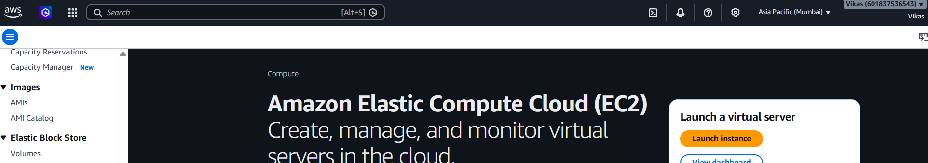

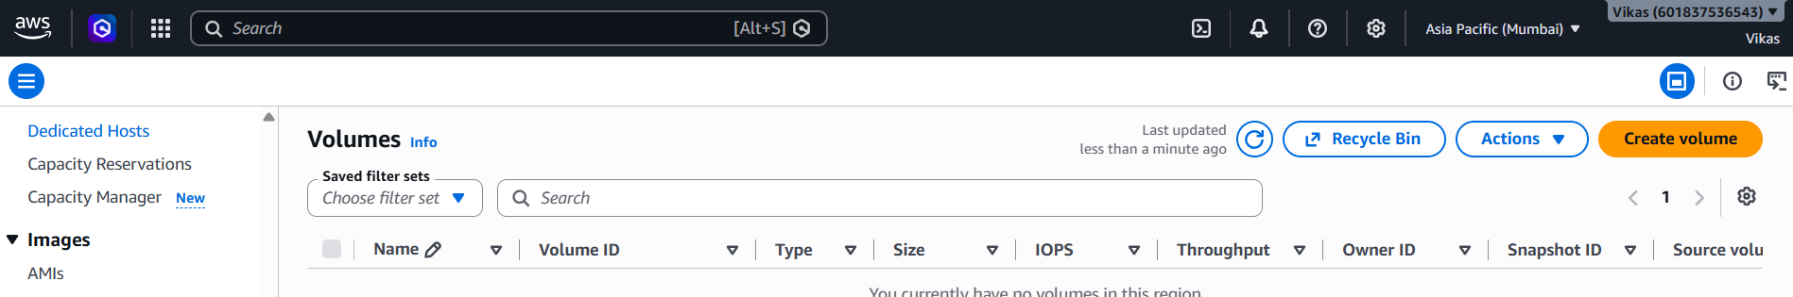

- Explaination :- Logged into the AWS Console and went to the EC2 Dashboard. Clicked on Volumes under Elastic Block Store in the left menu to start creating a new storage volume.

Step 2. Configure Volume Properties :-
- Screenshot :- 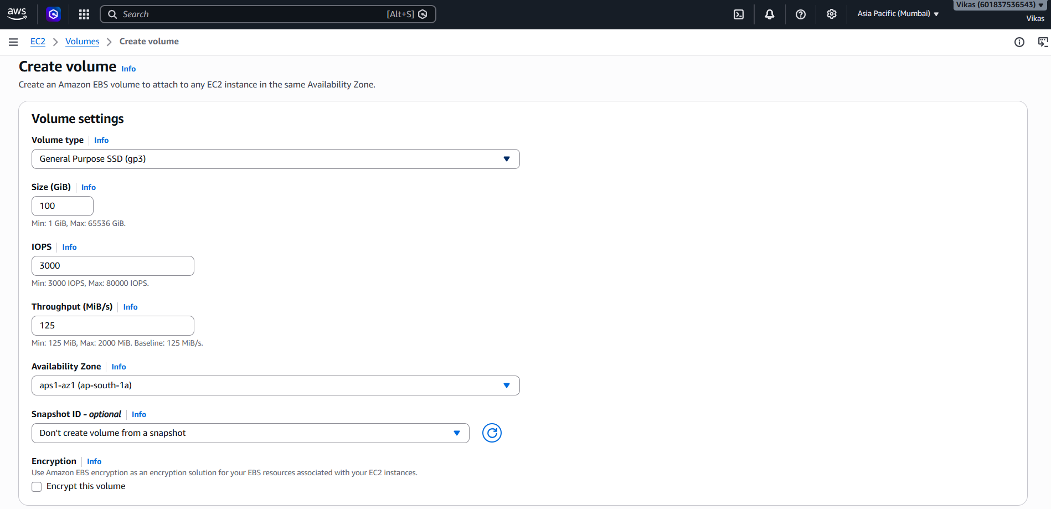

- Explaination :- Chose gp3 as the storage type, set the size to 100GiB, and selected the Availability Zone ap-south-1a so it matches the EC2 instance.

Step 3. Configure Resource Tags :-
- Screenshot :- 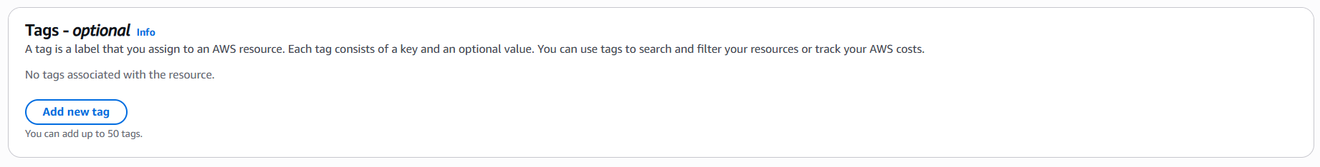

- Explaination :- Checked the option Tags section, which is used to give the volume a name or label to easily identify and track it.

Step 4. Snapshot Summary :-
- Screenshot :- 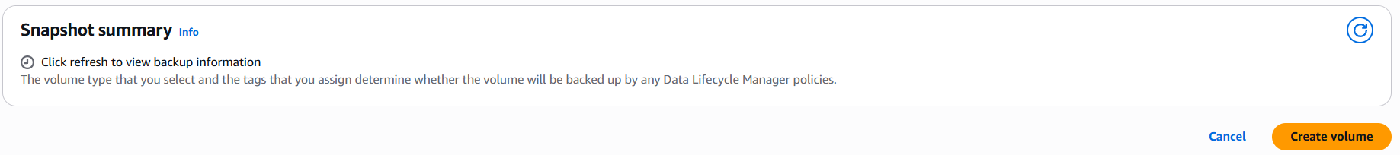
- Explaination :- Reviewed the backup snapshot details and clicked the orange Create volume button to create the storage disk.
Step 5. Verify Volume Status :-
- Screenshot :- 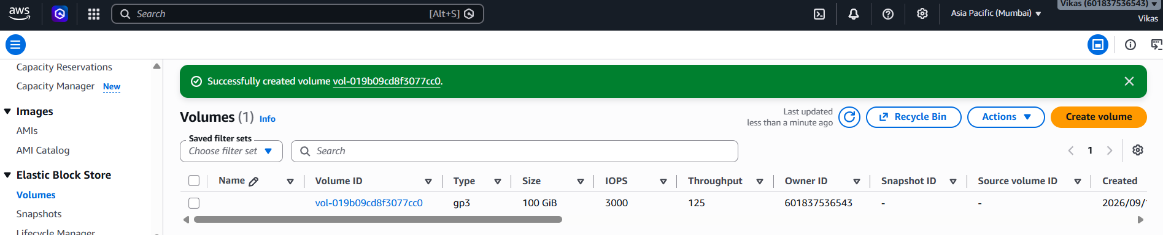

- Explaination :- Confirmed that the volume was created successfully with ID vol-019b09cd8f3077cc0 and is now ready to be attached to the EC2 instance.

