Managing Access with IAM Permissions

Overview :- This walkthrough shows how to create a new user in AWS and give that user access to only one thing — S3. Instead of everyone using the same main account, a separate login is made just for this purpose, with limited permissions.
Below is a simple, step-by-step look at the screenshots:

Step 1 – Specify User Details :-
- Define :- A new IAM user named "vikas_123" is created, with console access enabled and a custom password set, so this user can log in separately from the main account.
- Screenshot :-
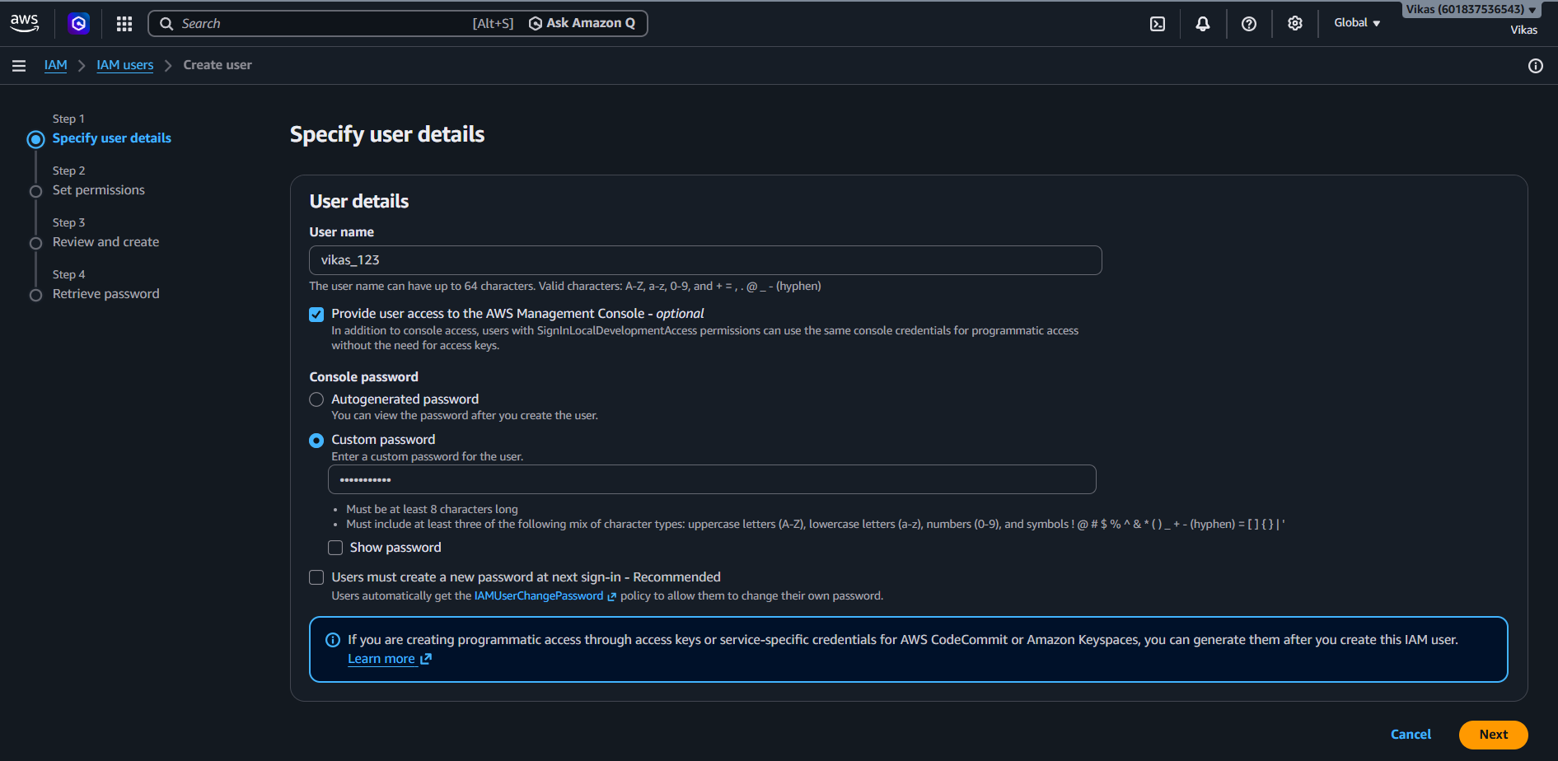

Step 2 – Set Permissions
- Define :- "Attach policies directly" is selected, which lets a permission policy be given straight to this user instead of through a group.
- Screenshot :-
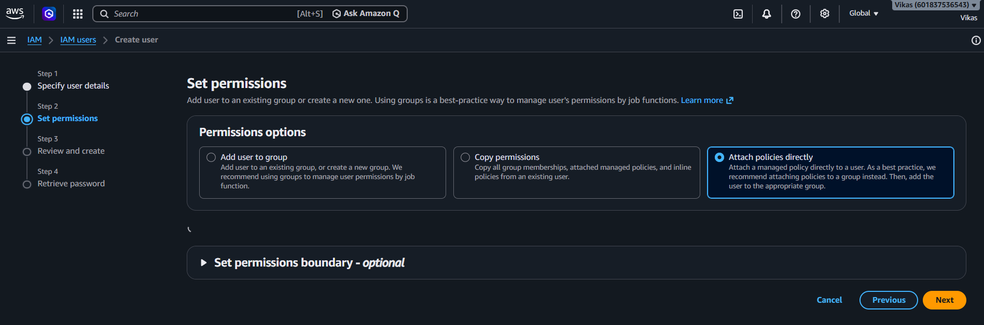
Step 3 – Choose Permissions Policy :-
- Define :- "AmazonS3FullAccess" policy is selected, meaning this user will be allowed to fully use Amazon S3, but nothing else by default.
- Screenshot :-
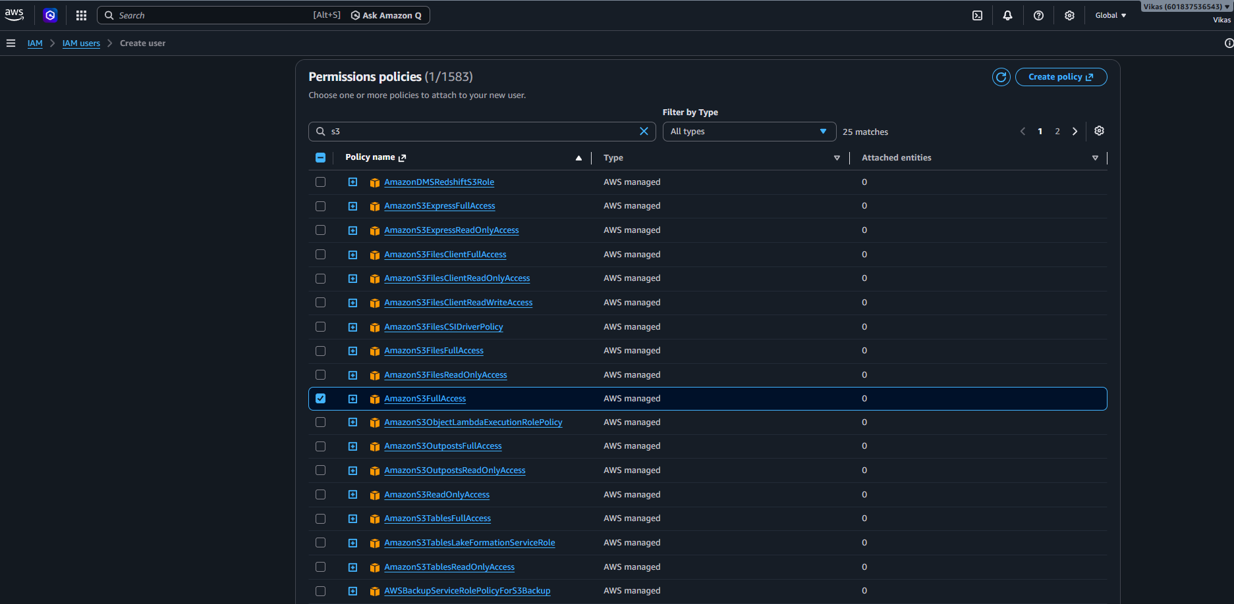

Step 4 – Permissions Boundary (Optional) :-
- Define :- The optional "Set permissions boundary" section is skipped here, since it is not required for this basic setup.
- Screenshot :-

Step 5 – Review and Create
- Define :- A summary shows the user name "vikas_123" and the attached policy "AmazonS3FullAccess", before finally creating the user.
- Screenshot :-
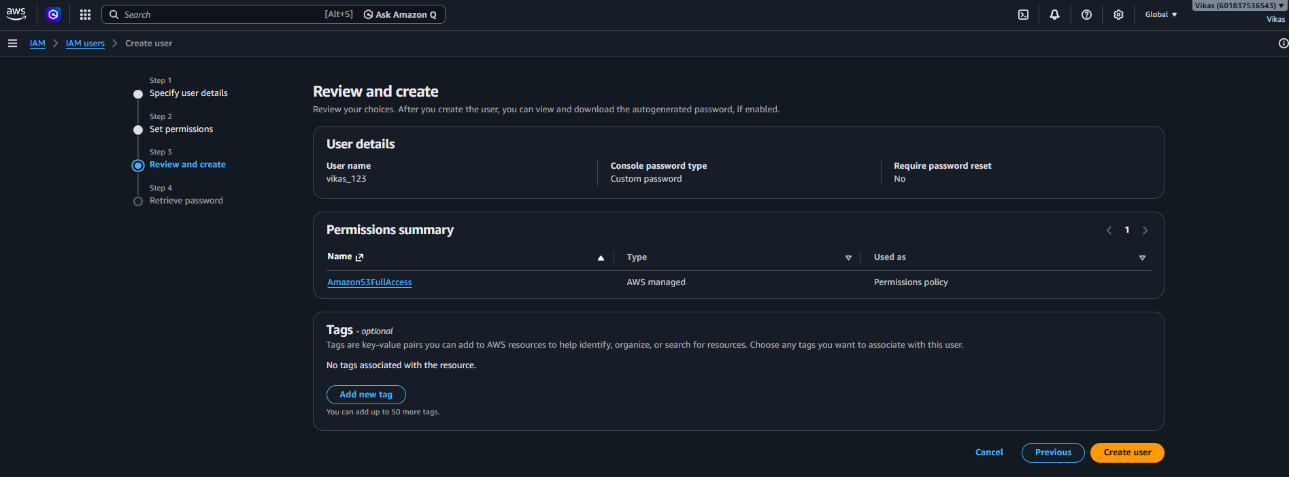

Step 6 – Retrieve Password :-
- Define :- The user is created successfully. This screen shows the console sign-in URL, username, and password, needed for this user to log in.
- Screenshot :-
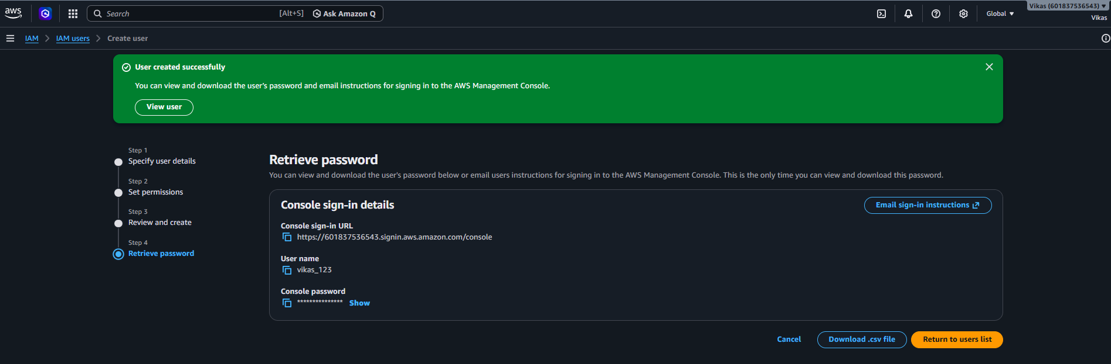

Step 7 – IAM User Sign In :-
- Define :- Using the sign-in URL, account ID, username "vikas_123", and password, the new IAM user logs into the AWS console separately from the root account.
- Screenshot :-
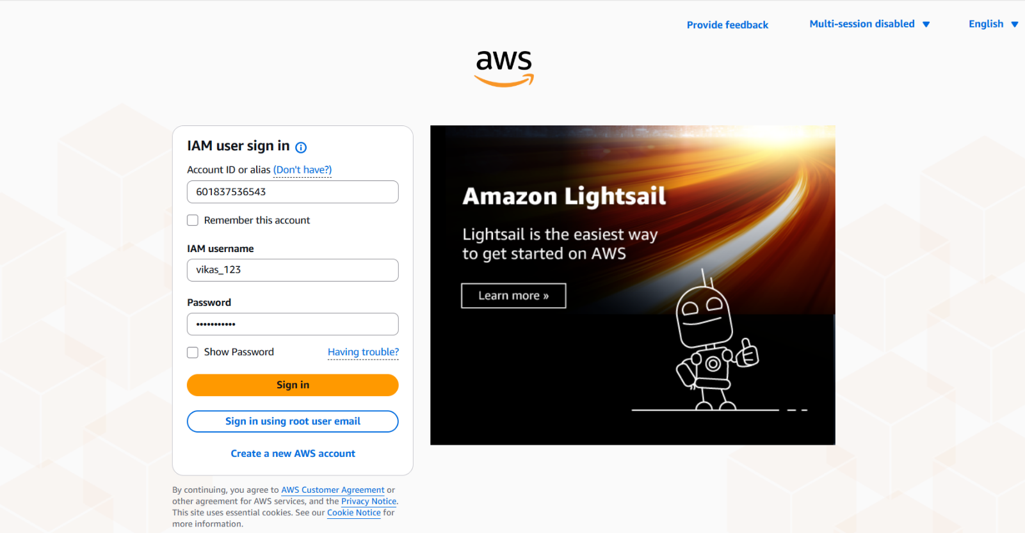

Step 8 – Limited Console Access :-
- Define :- After logging in as "vikas_123", sections like AWS Health and Cost & usage show "Access denied", since this user only has S3 permissions, not full account access.
- Screenshot :-
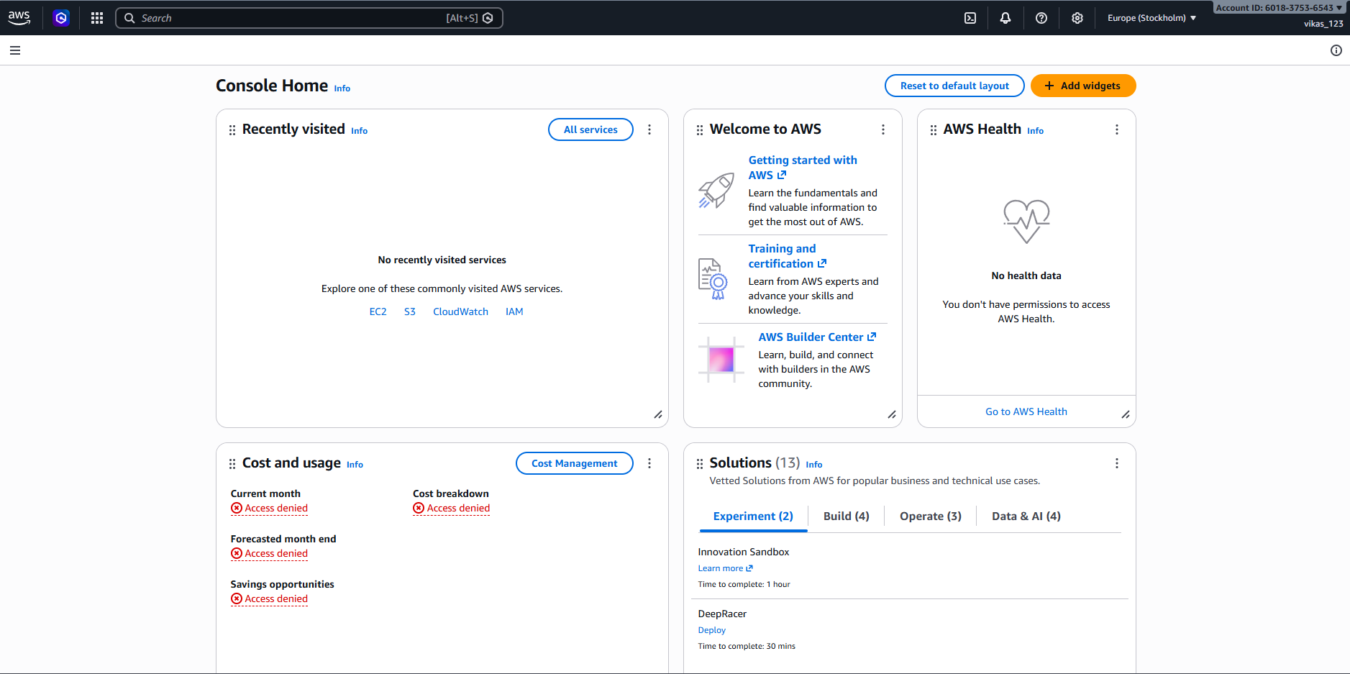

Step 9 – S3 Access Works :-
- Define :- The Amazon S3 page opens normally for this user, confirming that the AmazonS3FullAccess permission is working as expected.
- Screenshot :-
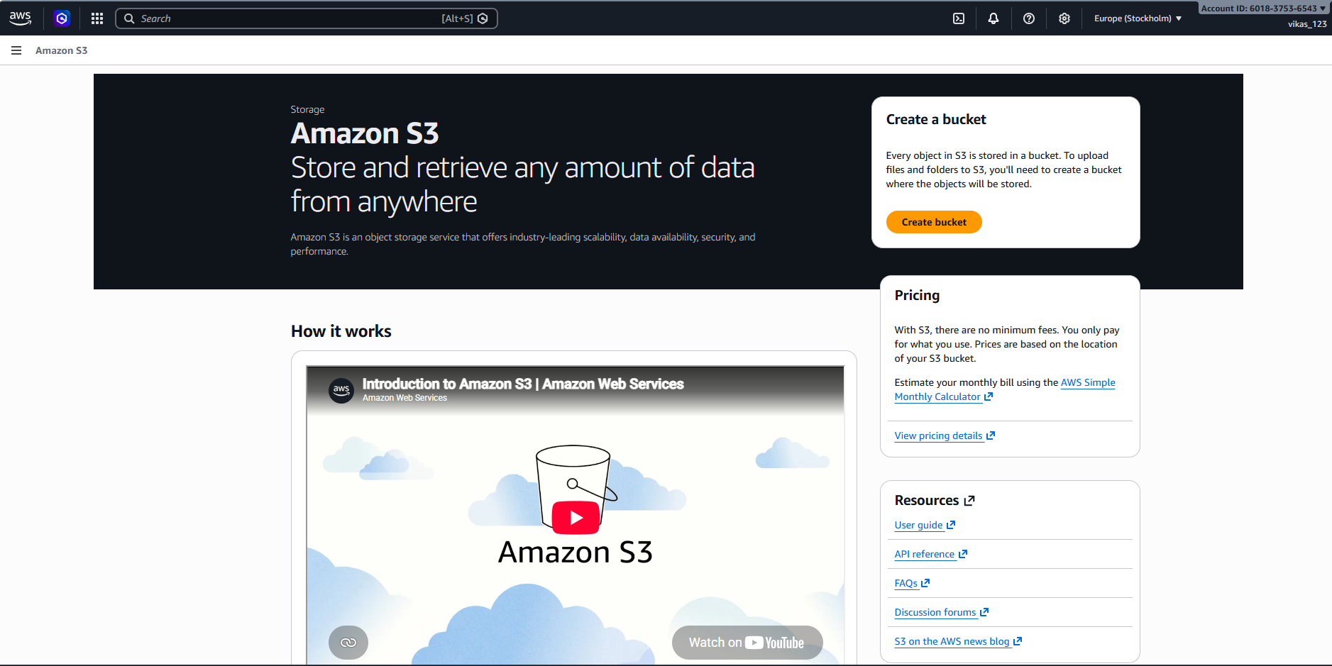

Step 10 – Other Services Blocked :-
- Define :- Opening the EC2 dashboard shows "Access denied" everywhere, proving this user cannot use services outside of what was specifically permitted.
- Screenshot :-
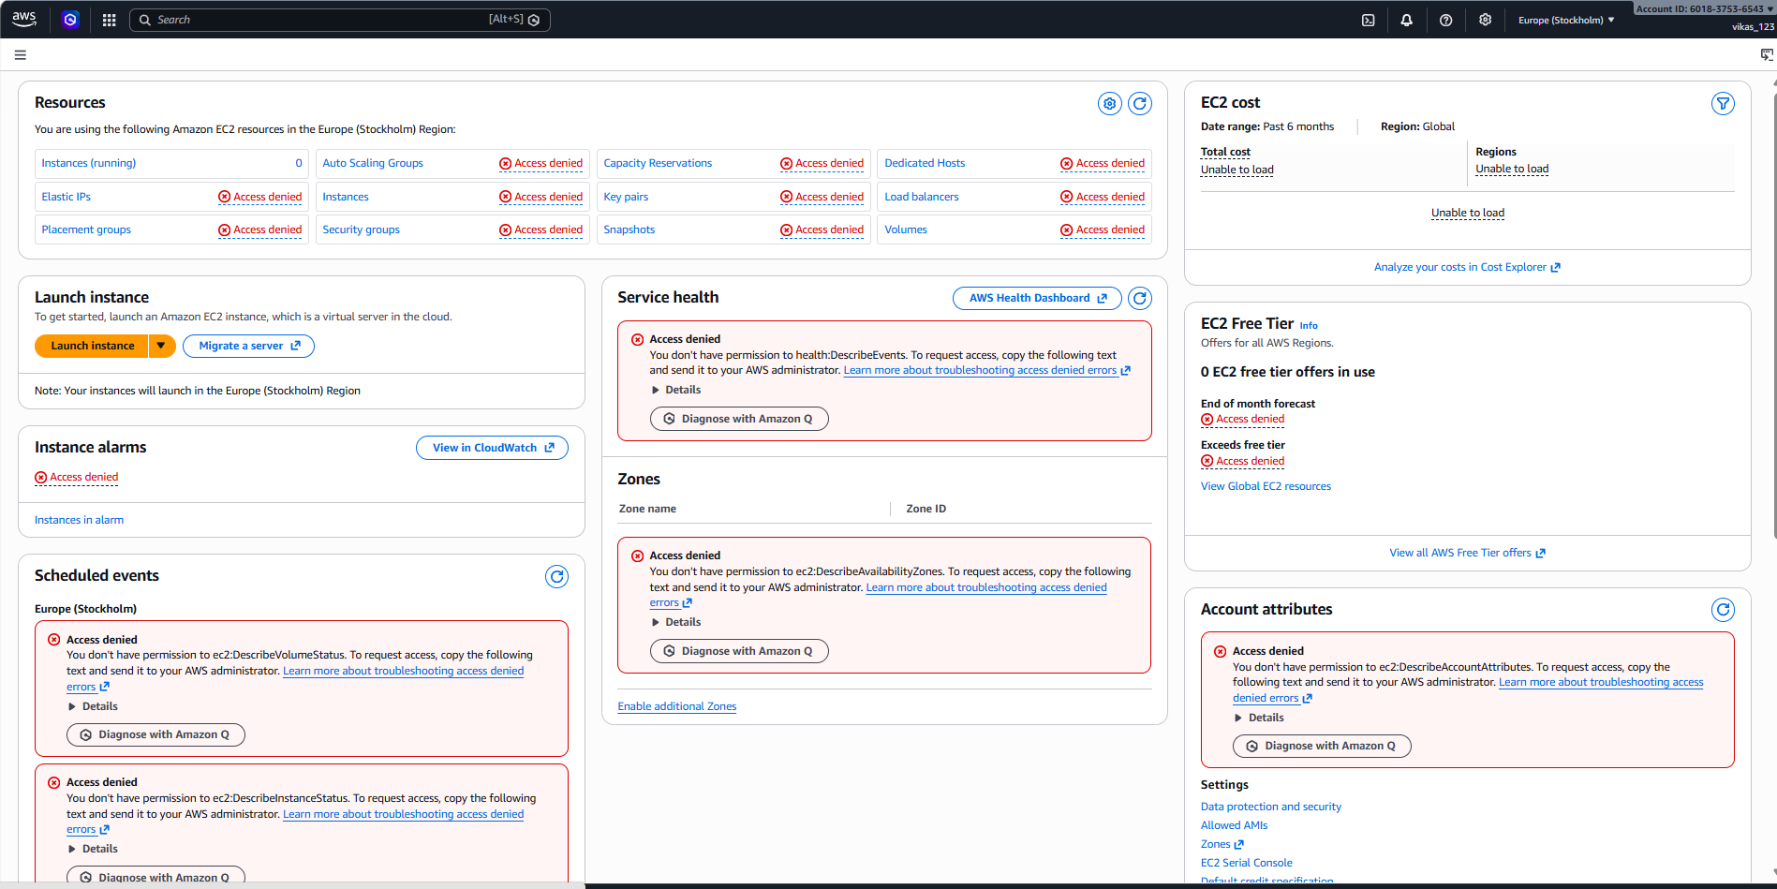
Conclusion :-
This document shows how IAM permissions work in AWS: a separate user is created, given access to only one service (S3) through a policy, and then that limited access is confirmed by logging in as that user — S3 works, while other services like EC2 stay blocked.

