Creating Multiple IAM Users & Groups

Overview
This walkthrough shows how to create several IAM users in AWS and organize them into groups, so permissions can be managed for many users at once instead of one by one.
Below is a simple, step-by-step look at the screenshots:
Step 1 – IAM Users (Empty) :-
- Define :- The IAM users page starts empty, with no users created yet.
- Screenshot :-
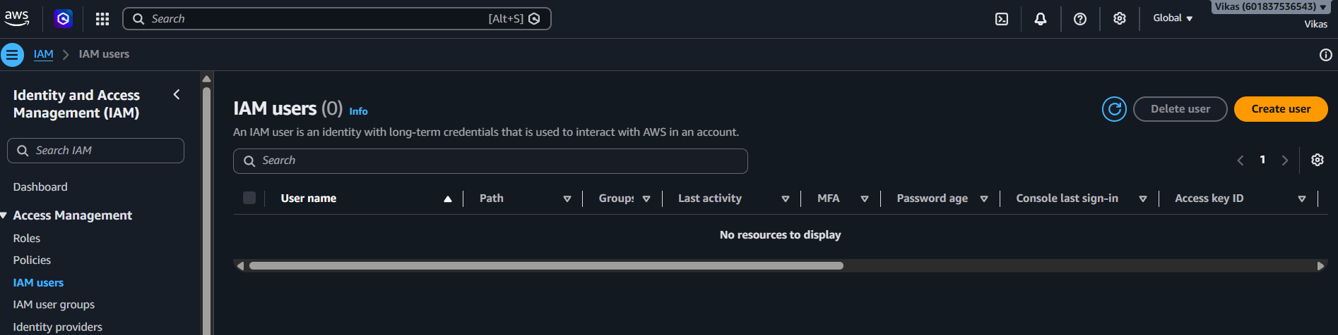

Step 2 – Specify User Details :-
- Define :- A new user named "vk_01" is created, with console access enabled and an autogenerated password.
- Screenshot :-
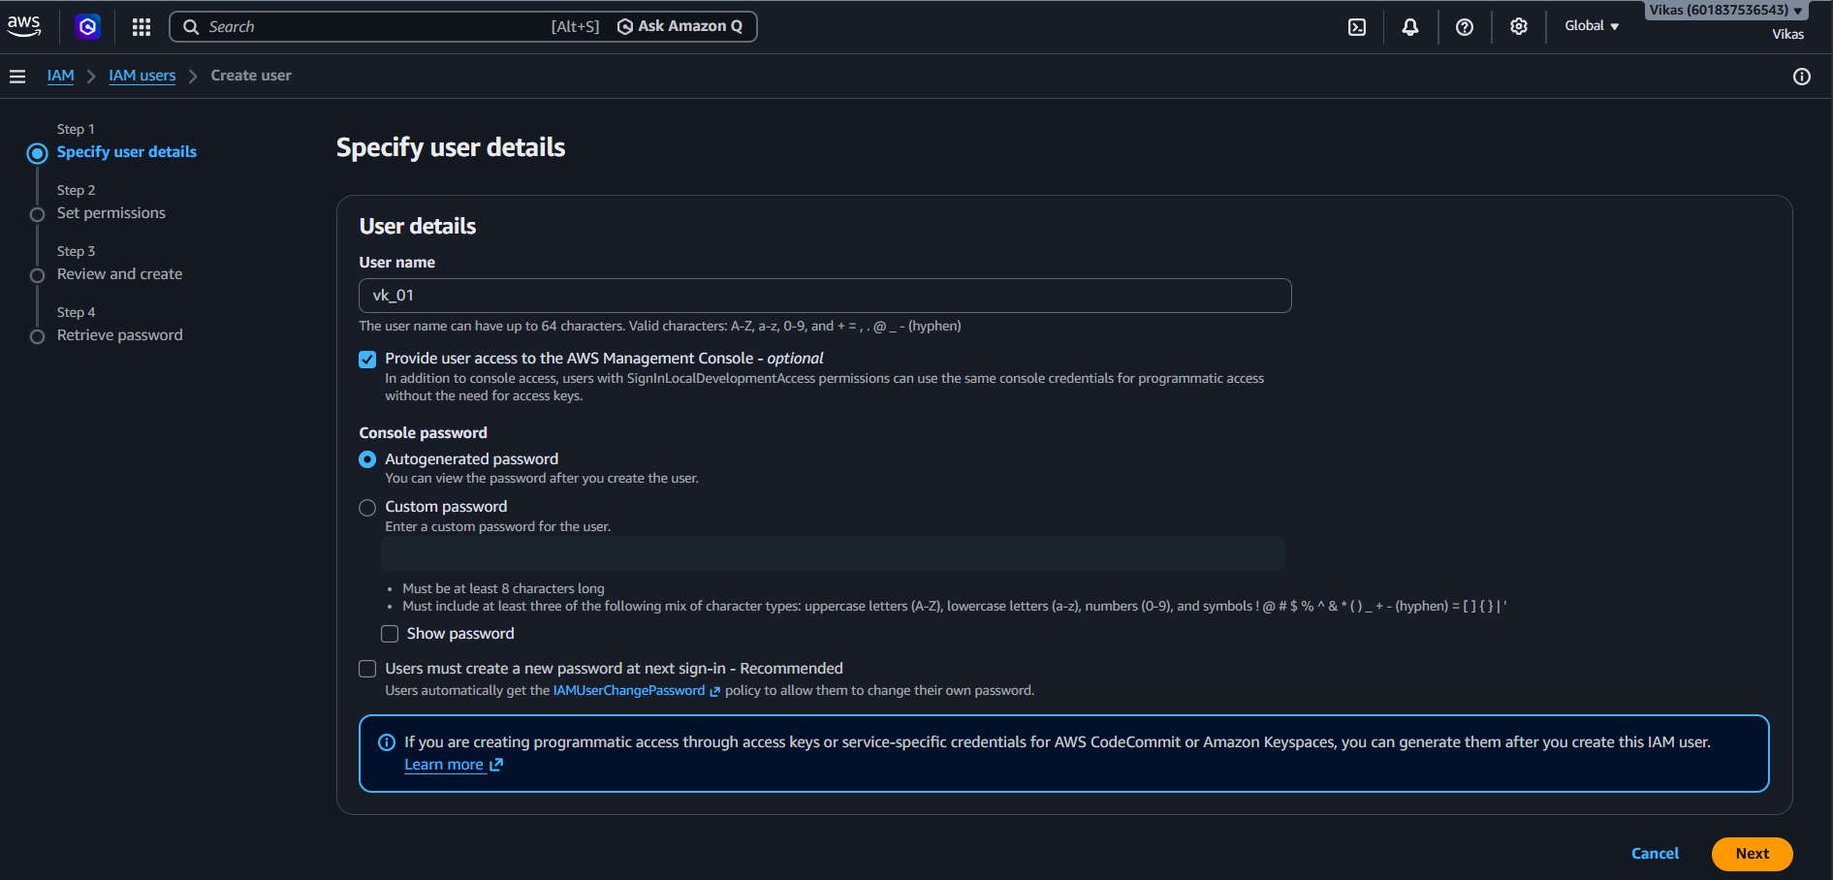
Step 3 – Set Permissions :-
- Define :- "Attach policies directly" is selected, so a permission policy can be given straight to this user.
- Screenshot :-
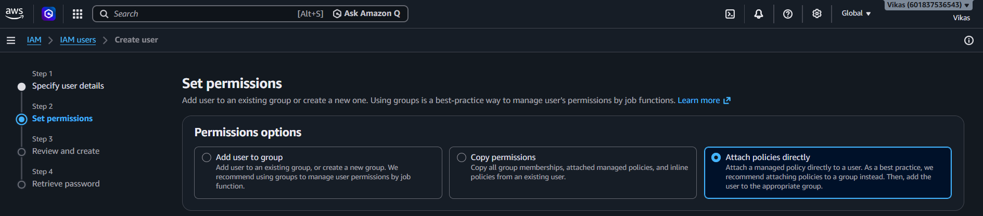

Step 4 – Choose Permissions Policy :-
- Define :- "AmazonS3FilesFullAccess" policy is selected for this user, giving it full access to S3 Files.
- Screenshot :-
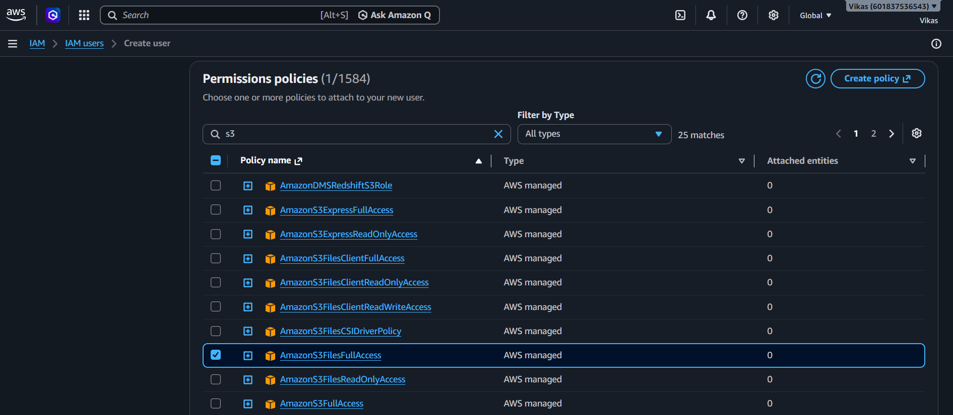

Step 5 – Permissions Boundary
- Define :- The optional permissions boundary step is skipped, moving ahead to the next step.
- Screenshot :-
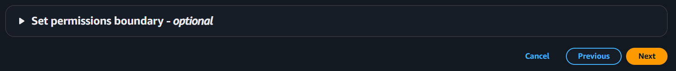
Step 6 – Review and Create :-
- Define :- A summary shows user "vk_01" with the "AmazonS3FilesFullAccess" policy attached, before creating the user.
- Screenshot :-
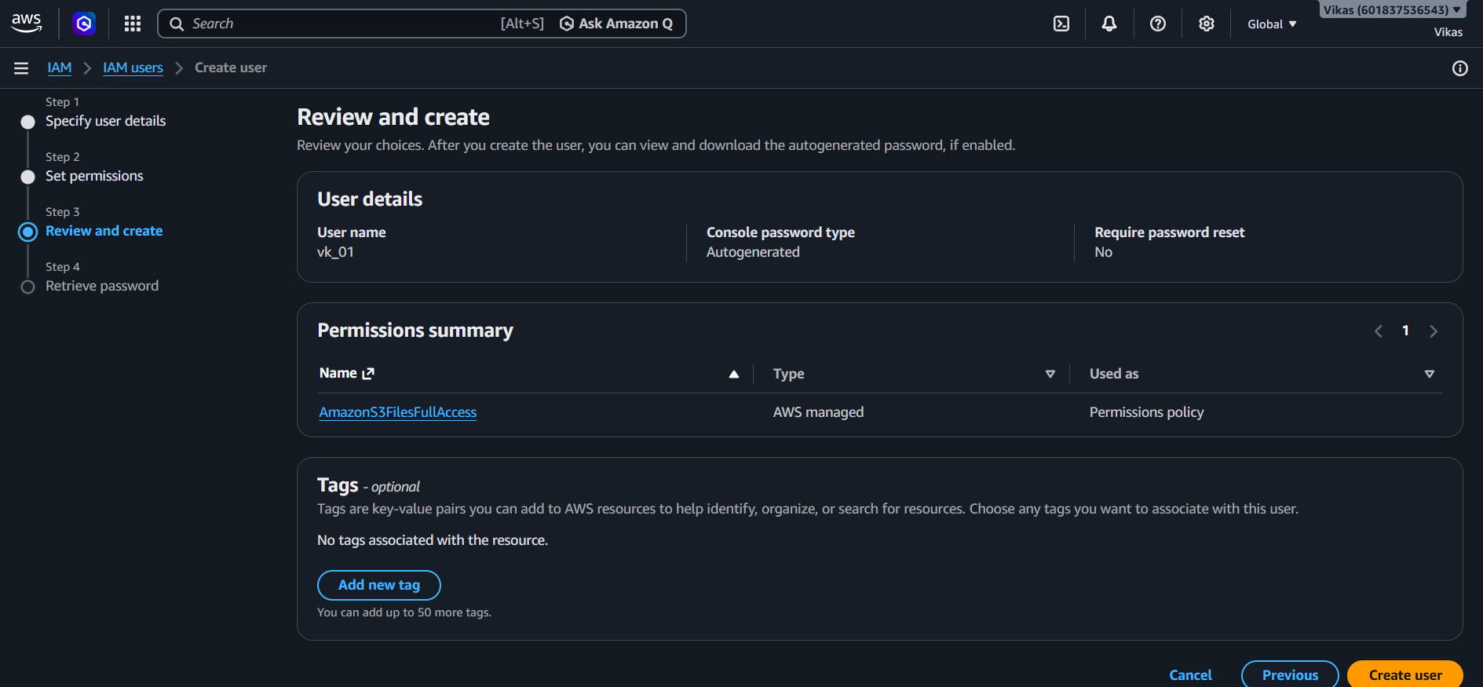

Step 7 – Retrieve Password :-
- Define :- User "vk_01" is created successfully, and the console sign-in URL, username, and password are shown.
- Screenshot :-
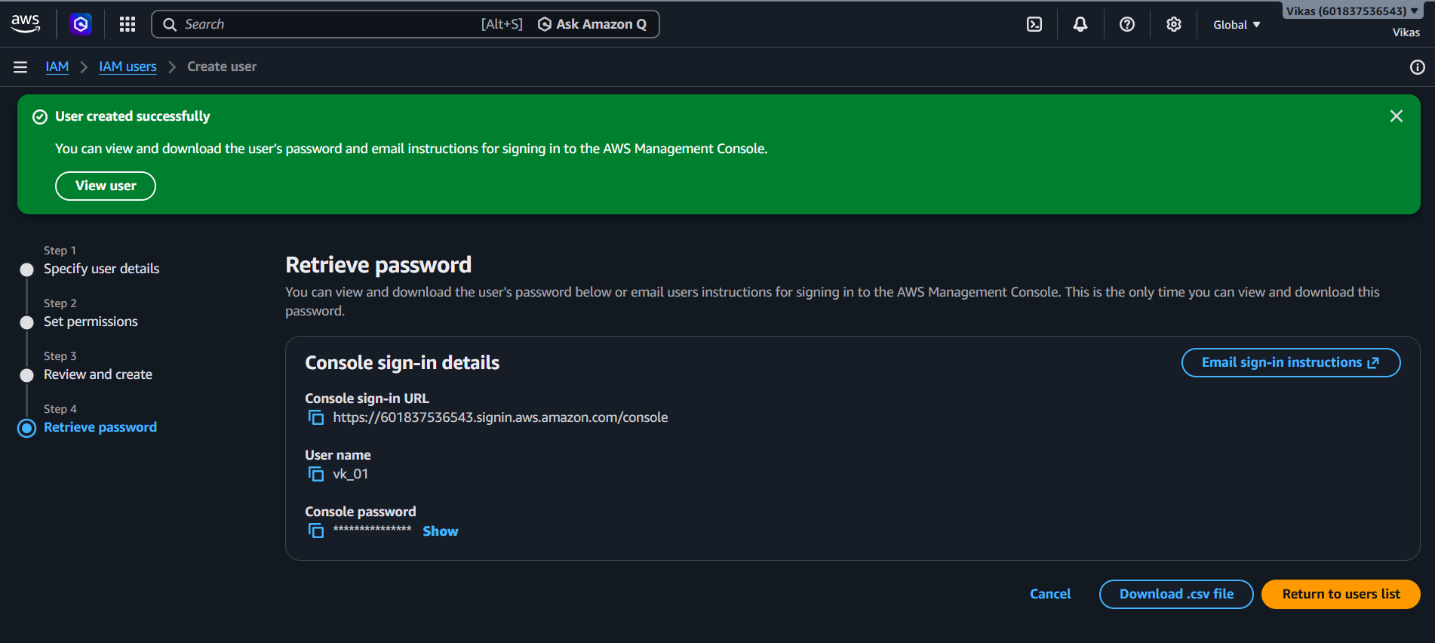
Step 8 – IAM User Sign In :-
- Define :- Using the account ID, username "vk_01", and password, this user logs into the AWS console separately from the main account.
- Screenshot :-
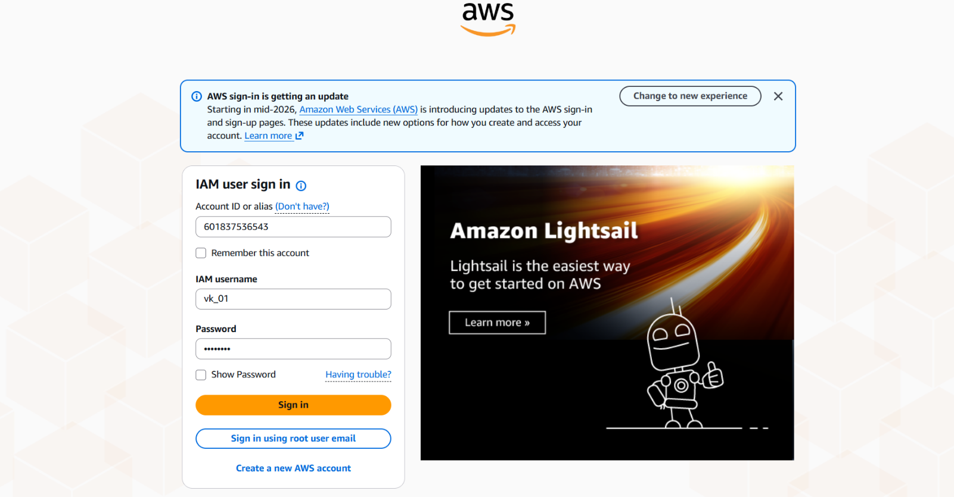

Step 9 – Limited Console Access :-
- Define :- After logging in as "vk_01", sections like AWS Health and Cost & usage show "Access denied", since this user only has limited permissions.
- Screenshot :-
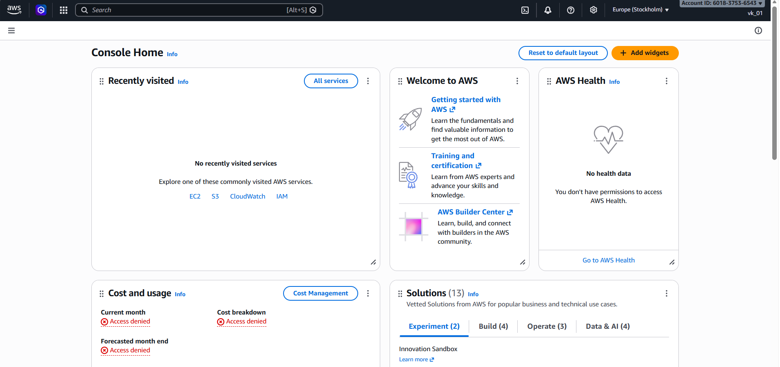
Step 10 – EC2 Access Denied :-
- Define :- Opening the EC2 dashboard shows "Access denied" everywhere, since this user was never given EC2 permissions.
- Screenshot :-
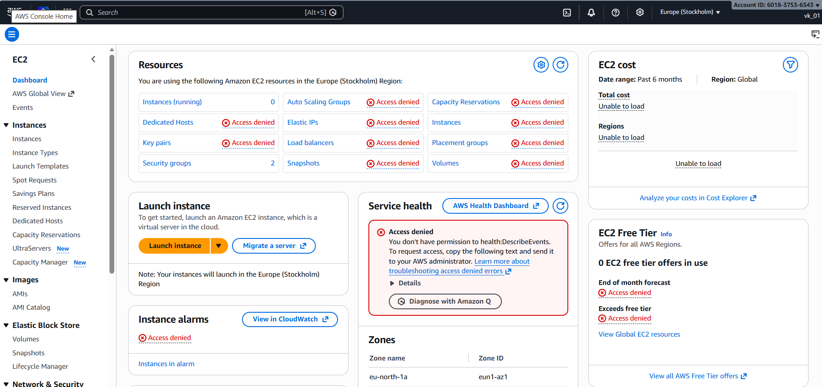

Step 11 – S3 Access Works :-
- Define :- The Amazon S3 page opens normally, confirming that this user's S3 permission is working as expected.
- Screenshot :-
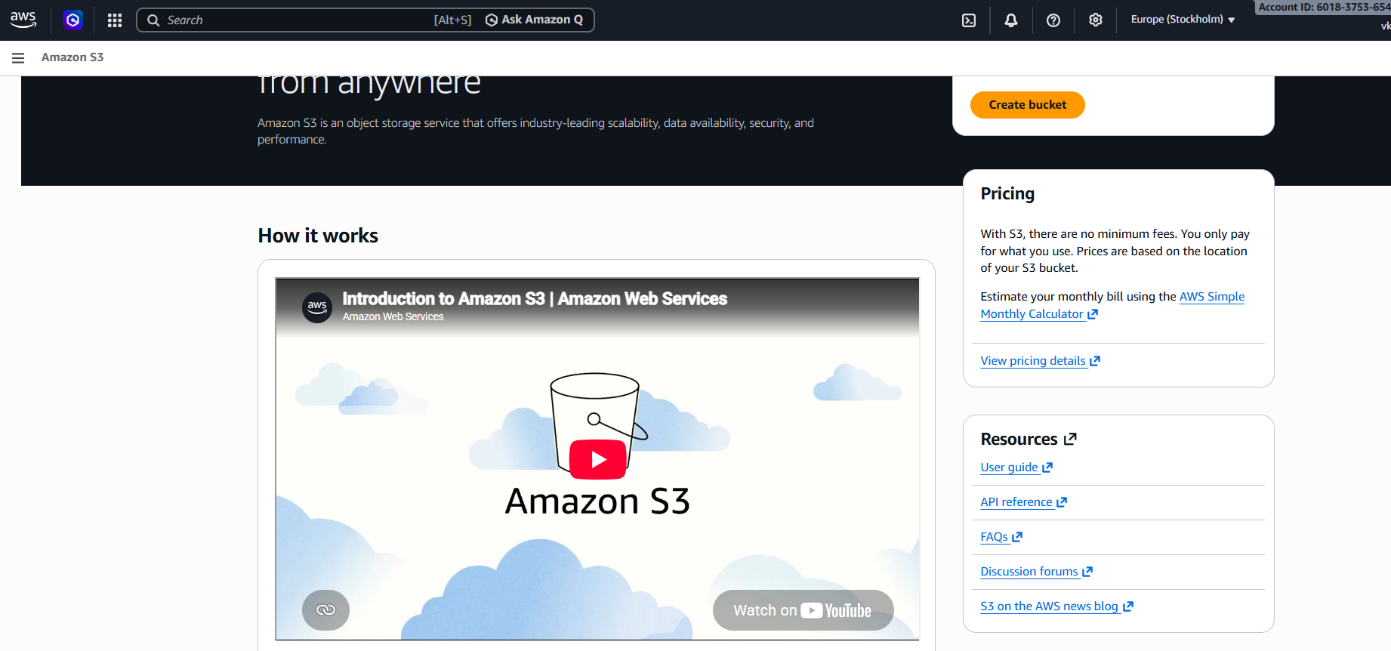
Step 12 – Multiple Users Created :-
- Define :- Four IAM users now exist — vk_01, vk_02, vk_03, and vk_04 — each created the same way, ready to be organized into groups.
- Screenshot :-
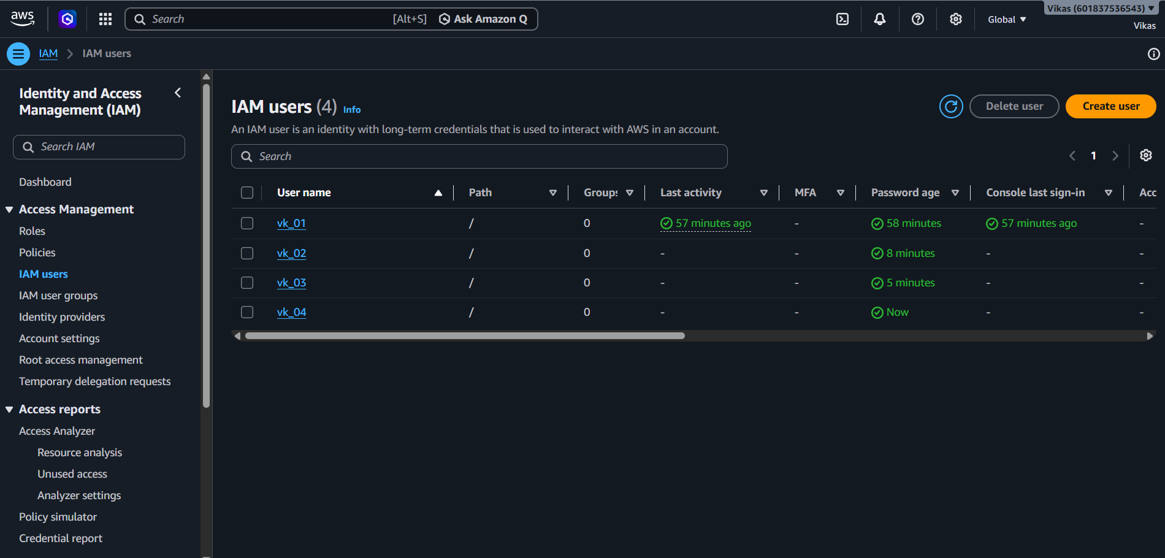

Step 13 – IAM User Groups (Empty) :-
- Define :- The IAM user groups page starts empty. A group lets the same permissions be applied to many users together, instead of one at a time.
- Screenshot :-
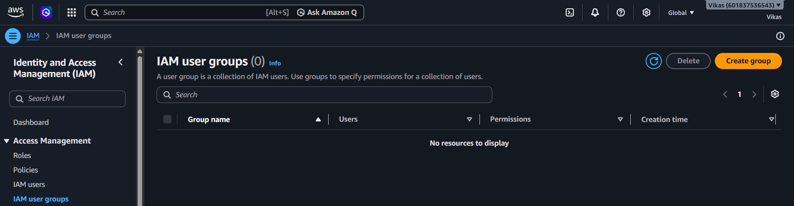

Step 14 – Add Users to Group (Before Selection) :-
- Define :- Before picking members, the "Add users to the group" list shows all 4 users — vk_01, vk_02, vk_03, and vk_04 — with none selected yet, ready to choose from.
- Screenshot :-
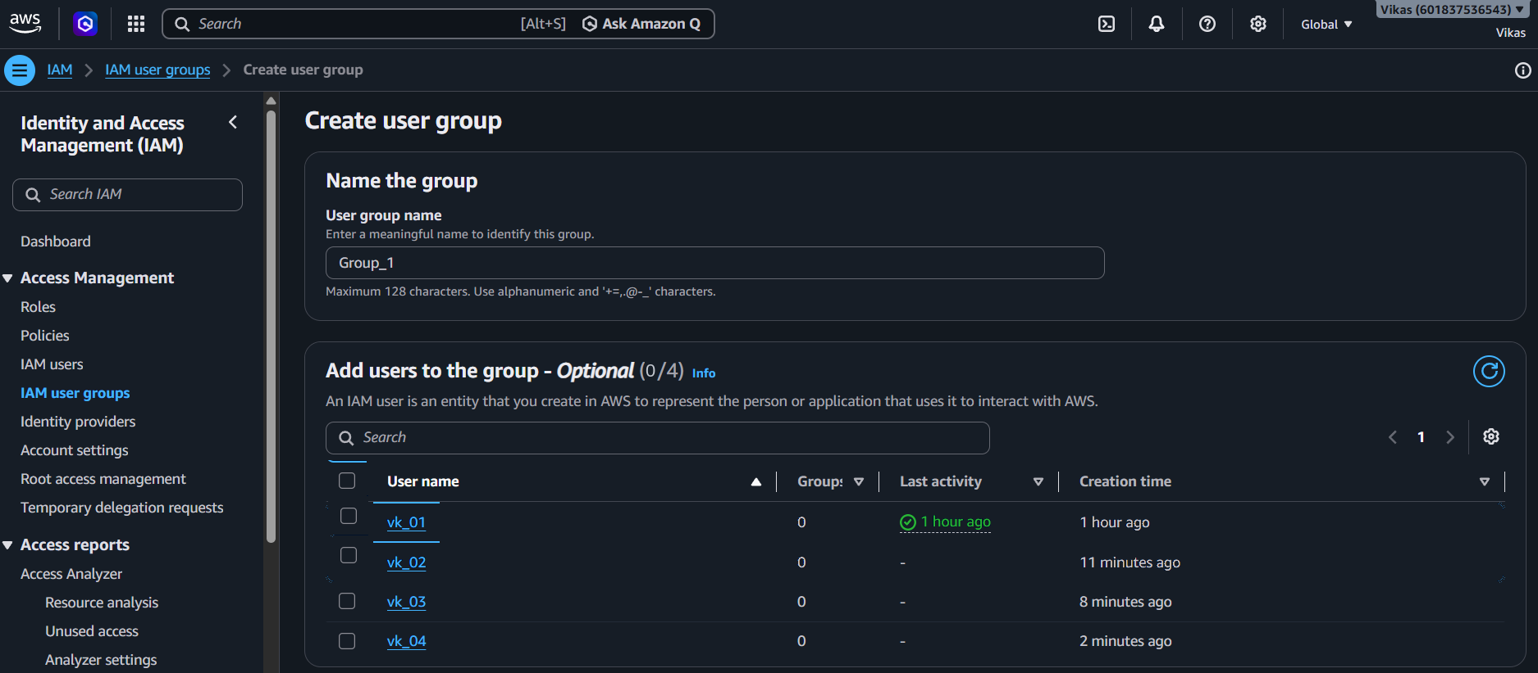

Step 15 – Create Group_1 & Add Users :-
- Define :- A group named "Group_1" is created, and users "vk_01" and "vk_02" are added to it.
- Screenshot :-
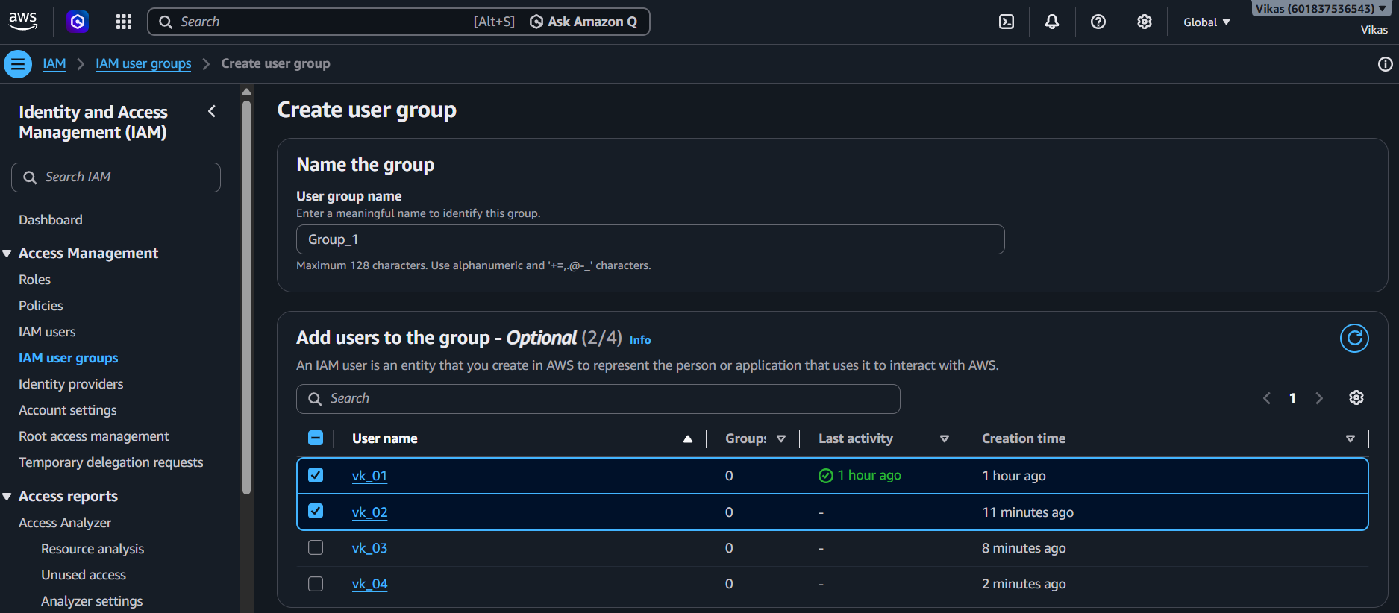

Step 16 – Attach Policy to Group_1 :-
- Define :- "AmazonS3FullAccess" policy is attached to Group_1, so both its members automatically get S3 access.
- Screenshot :-
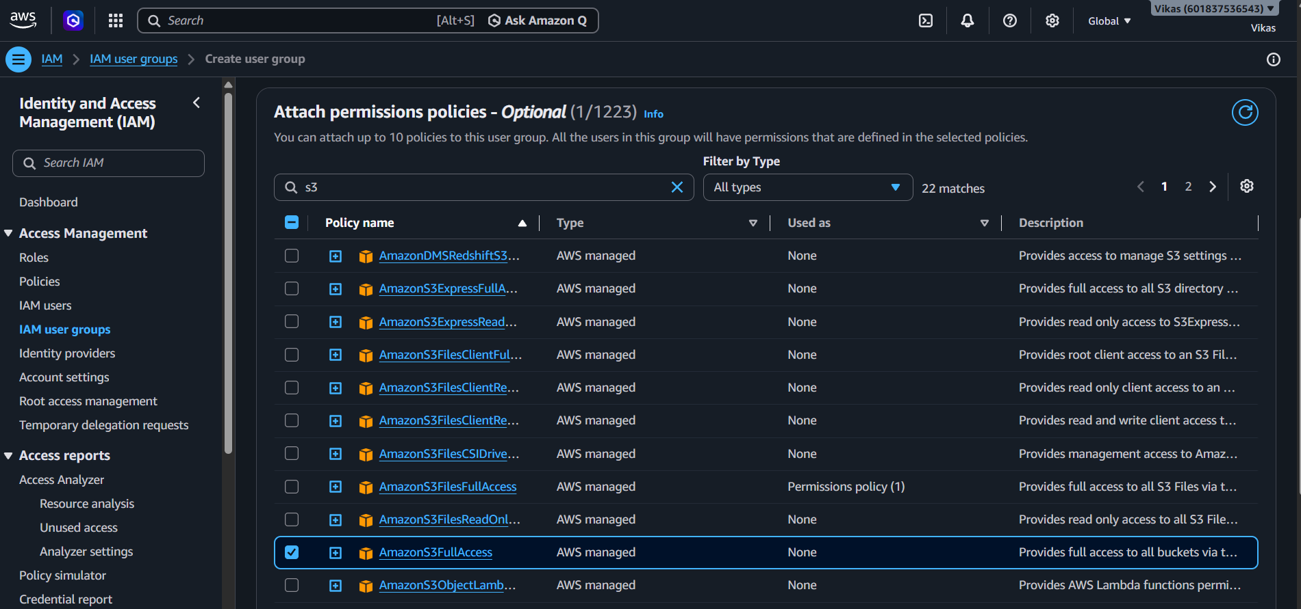

Step 17 – Create User Group :-
- Define :- The group is finalized by clicking "Create user group".
- Screenshot :-

Step 18 – Group_1 Created :-
- Define :- "Group_1" is created successfully with 2 users and S3 permissions defined for the whole group.
- Screenshot :-
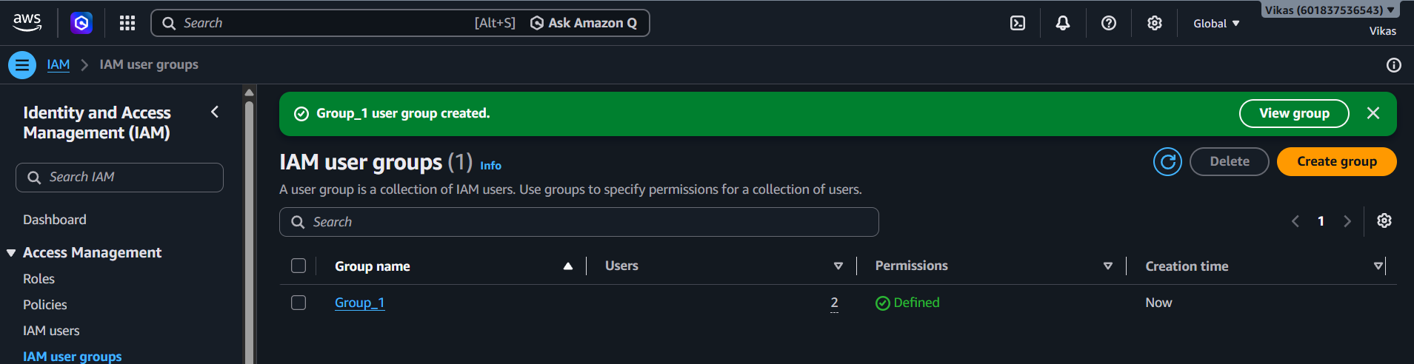

Step 19 – Create group_2 & Add Users :-
- Define :- A second group named "group_2" is created, and users "vk_03" and "vk_04" are added to it.
- Screenshot :-
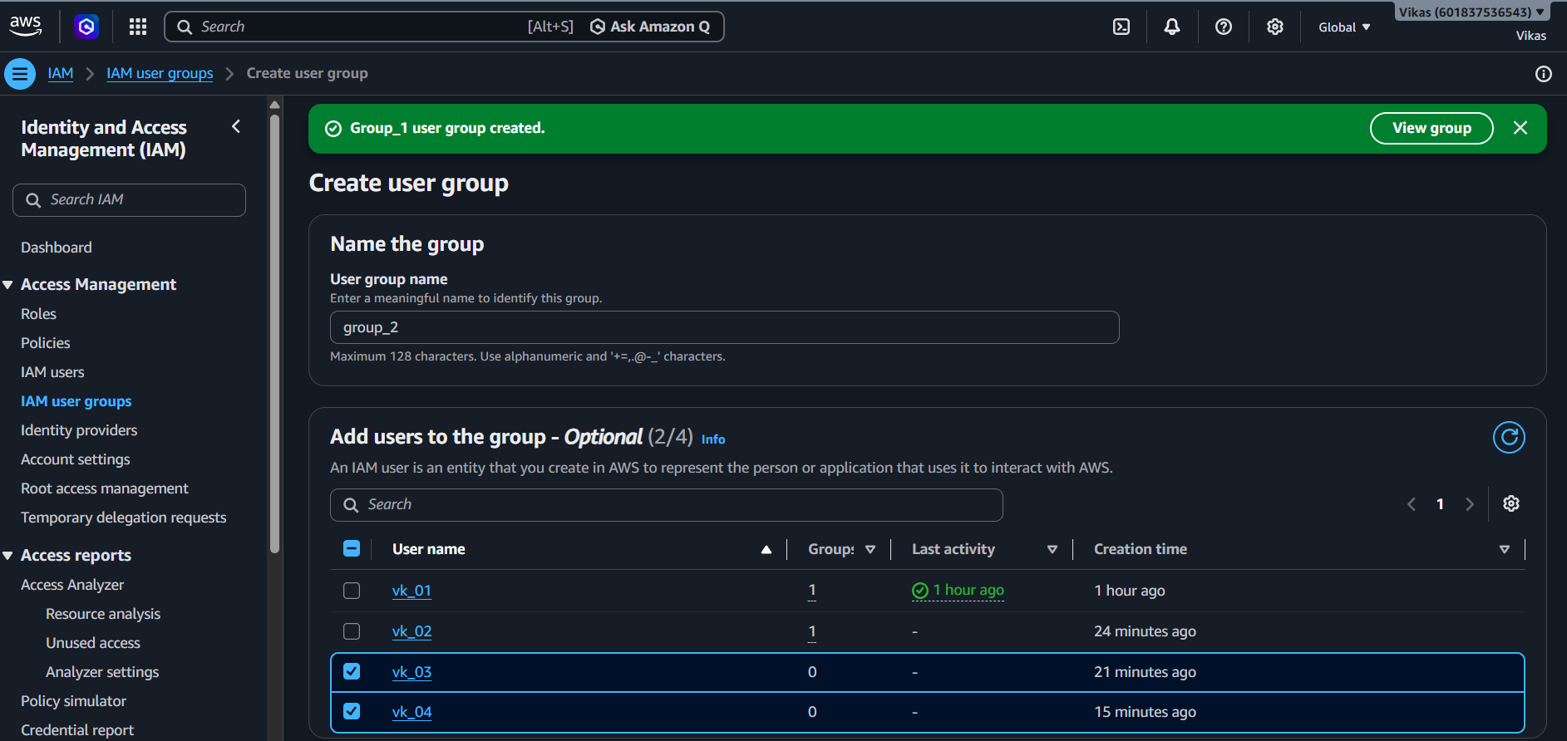

Step 20 – Attach Policy to group_2 :-
- Define :- "AmazonEC2FullAccess" policy is attached to group_2, so its members get EC2 access instead of S3.
- Screenshot :-
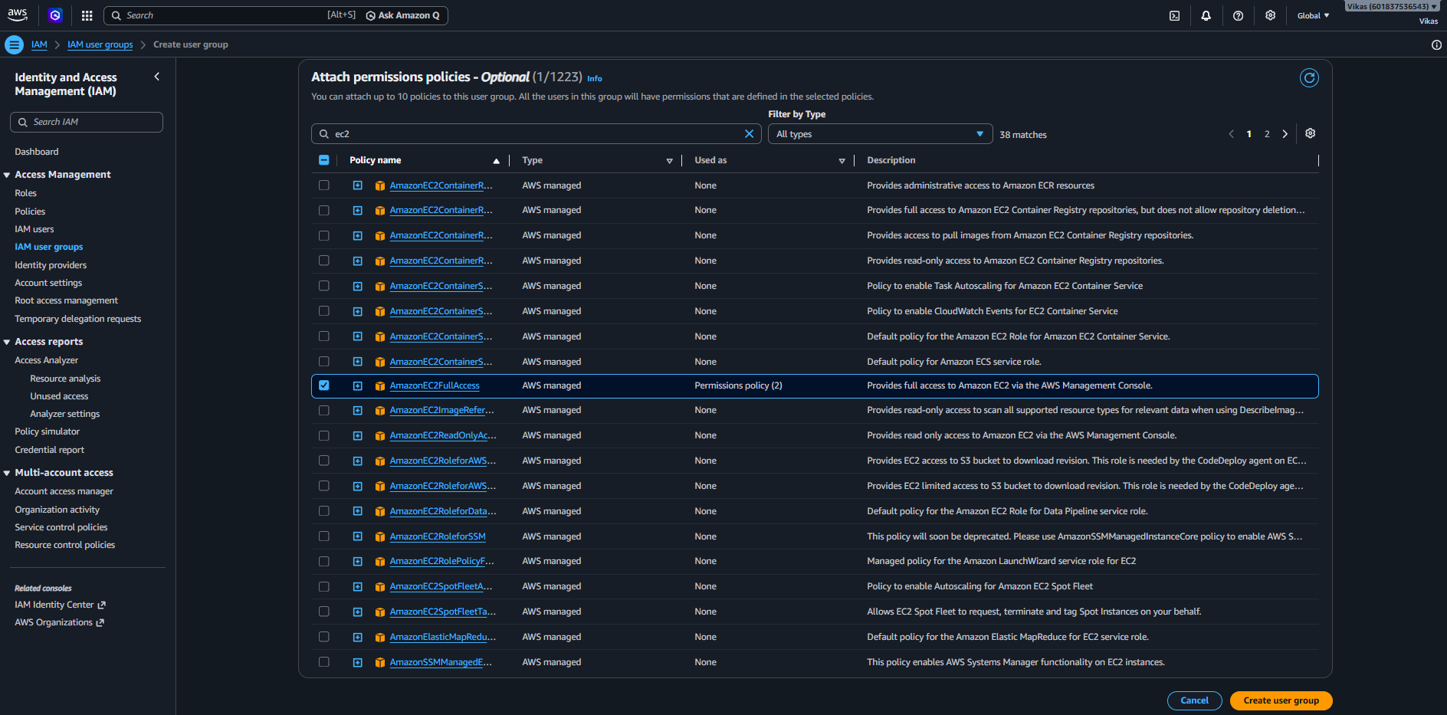
Step 21 – Both Groups Created :-
- Define :- Two groups now exist: Group_1 (S3 access, 2 users) and group_2 (EC2 access, 2 users) — showing how different sets of users can be given different permissions through groups.
- Screenshot :-
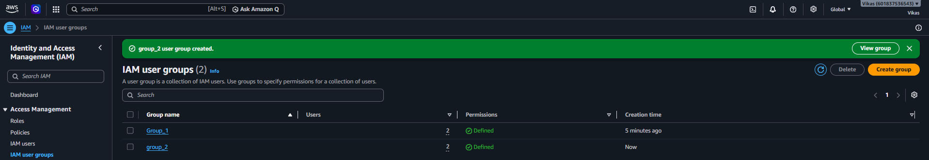

Conclusion
This document shows how to manage access for multiple users in AWS: individual users are created, and then grouped so that permissions (like S3 or EC2 access) can be given to many users at once through a single group, instead of setting up each user separately.

