Sending Notifications with Amazon SNS

Overview
This walkthrough shows how to use Amazon SNS (Simple Notification Service) to send a message to an email address. A topic is created, an email is subscribed to it, and then a message is published so it reaches that inbox.
Below is a simple, step-by-step look at the screenshots:

Step 1 – Amazon SNS Home Page
- Define :- The SNS landing page in the AWS console. A topic name "TEST" is entered to start creating a new topic. A topic works like a channel — anyone subscribed to it gets the messages sent there.
- Screenshot :-
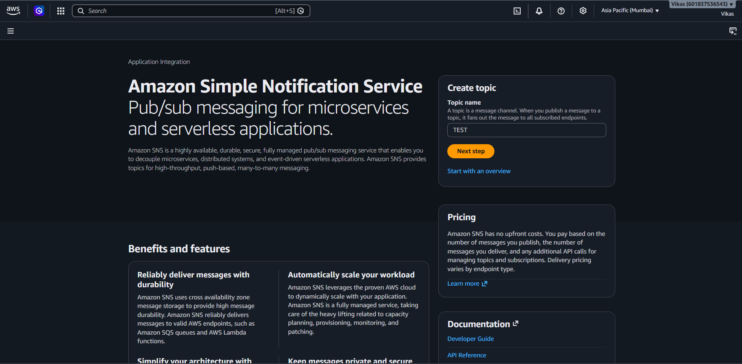

Step 2 – Create Topic (Type & Name)
- Define :- "Standard" type is selected, which allows many kinds of subscribers (email, SMS, SQS, Lambda, etc.) and best-effort message delivery. The topic name is set to "TEST".

- Screenshot :-
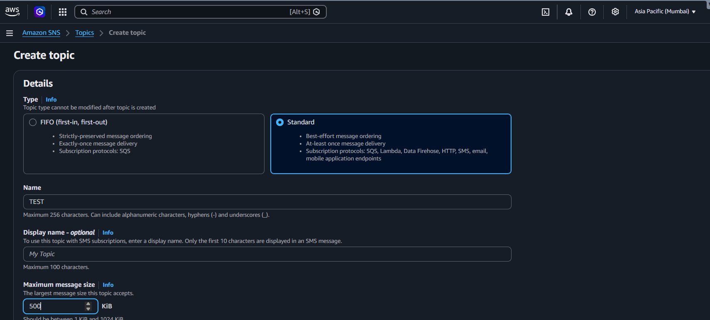

Step 3 – Optional Settings
- Define :- Extra settings like encryption, access policy, delivery retries, logging, and tags are left at their defaults, since they aren't needed for this basic setup.
- Screenshot :-
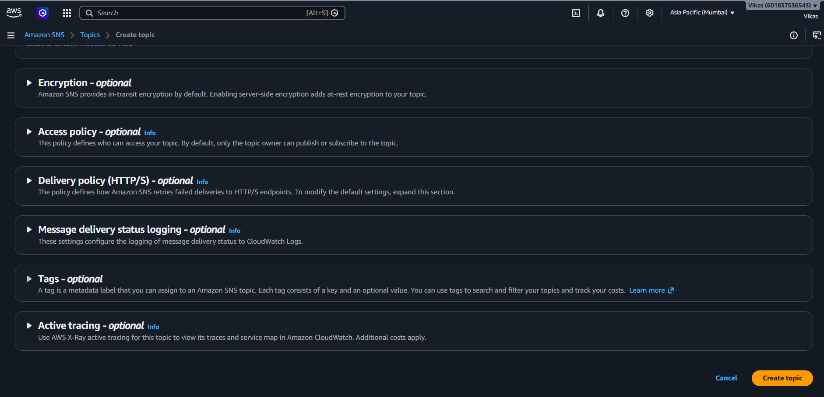

Step 4 – Topic Created
- Define :- Topic "TEST" is created successfully. Its details show the ARN (a unique ID for the topic), type, and owner — and no subscriptions exist yet.
- Screenshot :-
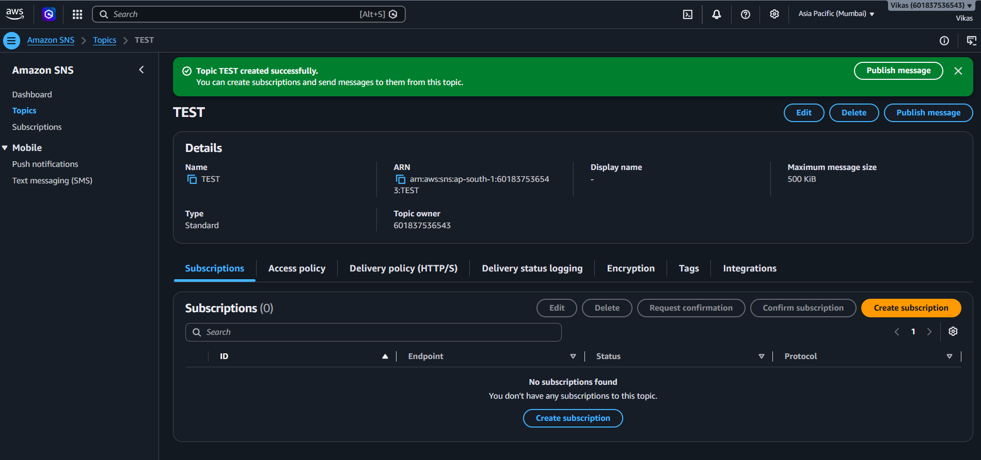

Step 5 – Create Subscription
- Define :- A subscription connects an endpoint to the topic. Here, Protocol is set to "Email" and an email address is entered, so that address will receive whatever is published to this topic.
- Screenshot :-
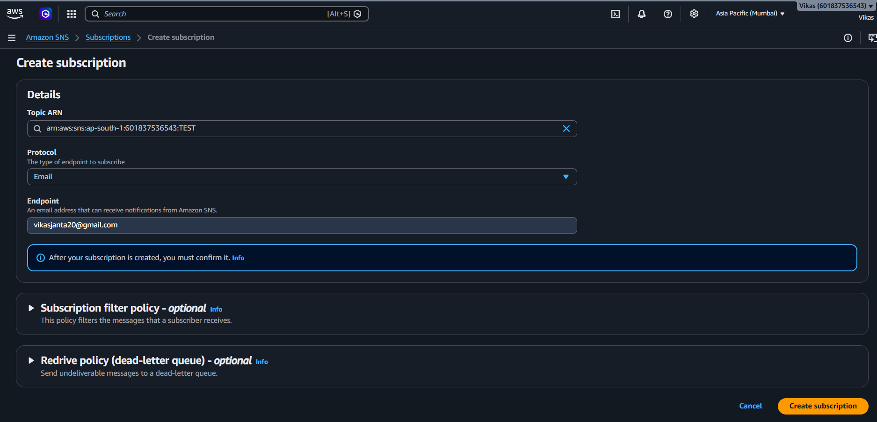
Step 6 – Subscription Pending Confirmation
- Define :- The subscription is created, but its status shows "Pending confirmation" — the email owner still needs to confirm before messages can actually be delivered.
- Screenshot :-
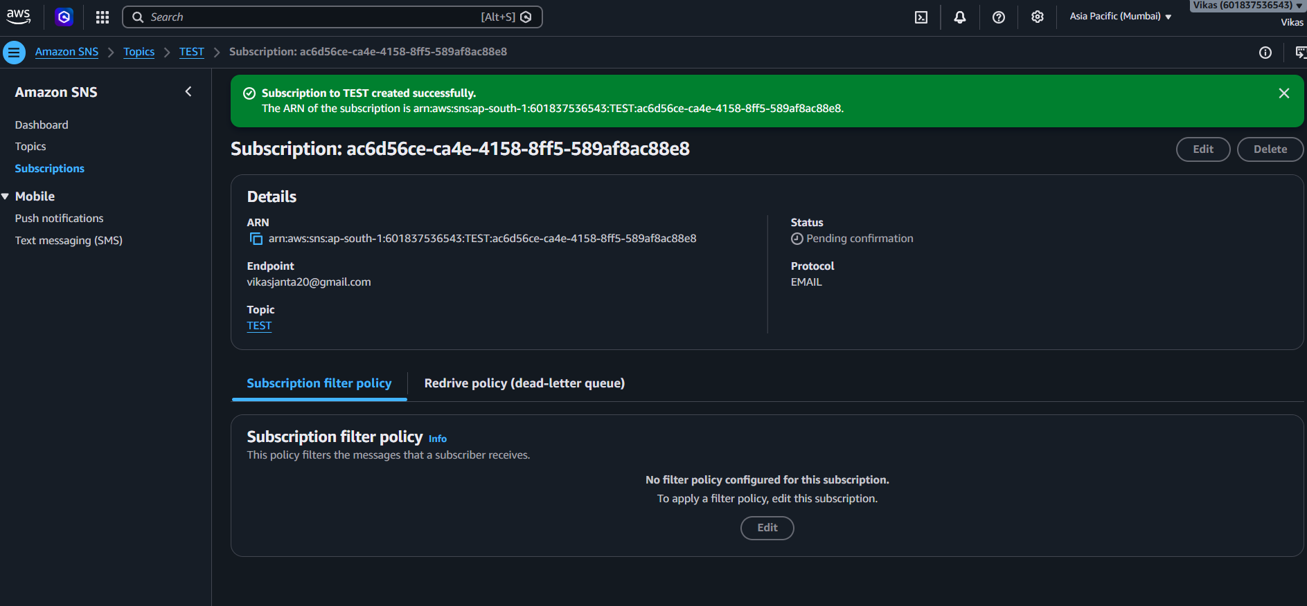

Step 7 – Confirmation Email Received
- Define :- An email from AWS Notifications arrives asking to confirm the subscription to the topic, with a "Confirm subscription" link to click.
- Screenshot :-
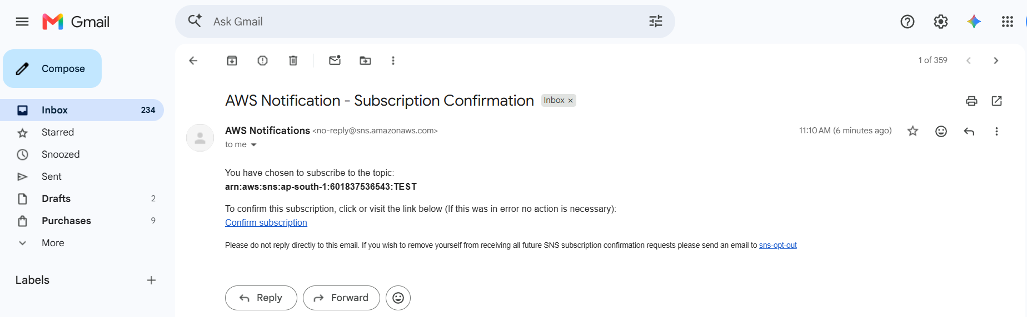
Step 8 – Subscription Confirmed
- Define :- After clicking the link, a confirmation page shows "Subscription confirmed!" — this email address is now officially subscribed to the topic.
- Screenshot :-
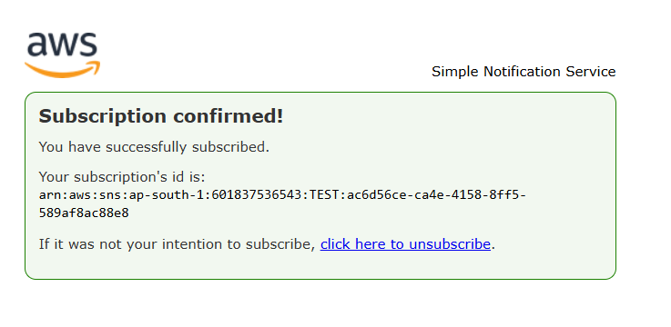

Step 9 – Topic List
- Define :- The Topics page now shows 1 topic, "TEST", ready to have messages published to it.
- Screenshot :-
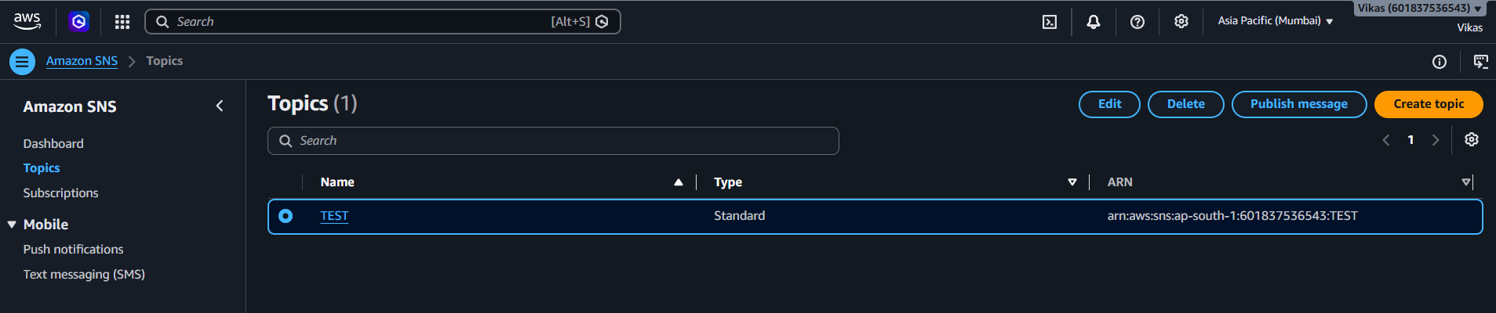

Step 10 – Publish Message (Subject)
- Define :- On the "Publish message to topic" page, a subject "ABC" is entered for the message that will be sent out.
- Screenshot :-
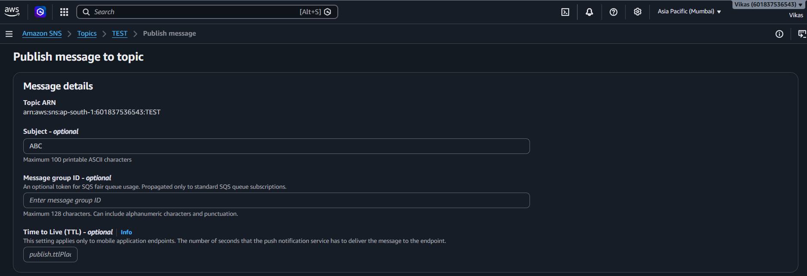
Step 11 – Publish Message (Body)
- Define :- The message body "Hello, how are you?" is typed in — this is the actual text that subscribers will receive.
- Screenshot :-
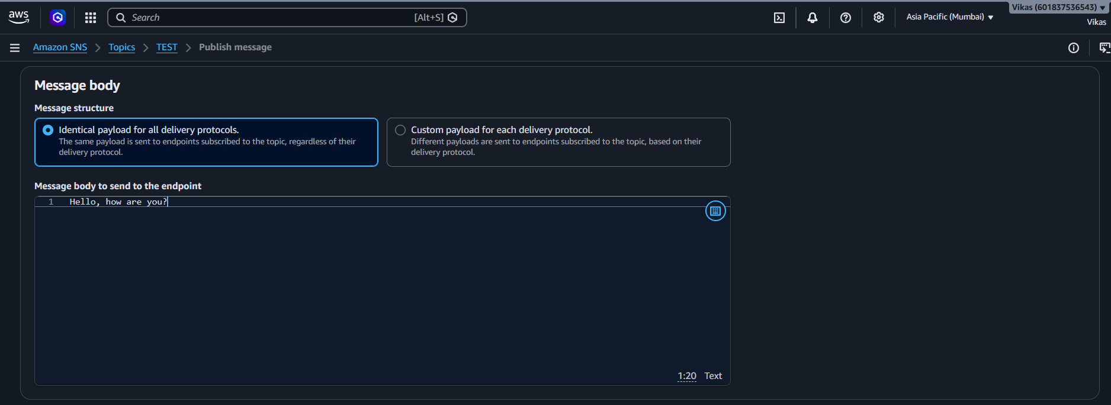

Step 12 – Message Attributes
- Define :- Message attributes (optional extra metadata) are left empty, and "Publish message" is clicked to send it out.
- Screenshot :-
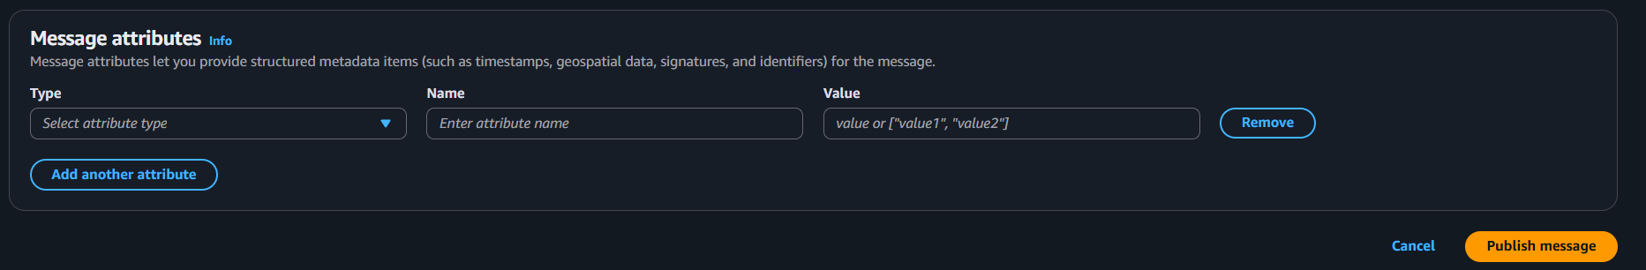

Step 13 – Message Published
- Define :- Confirmation message: "Message published to topic TEST successfully", along with a unique message ID for tracking.

- Screenshot :-
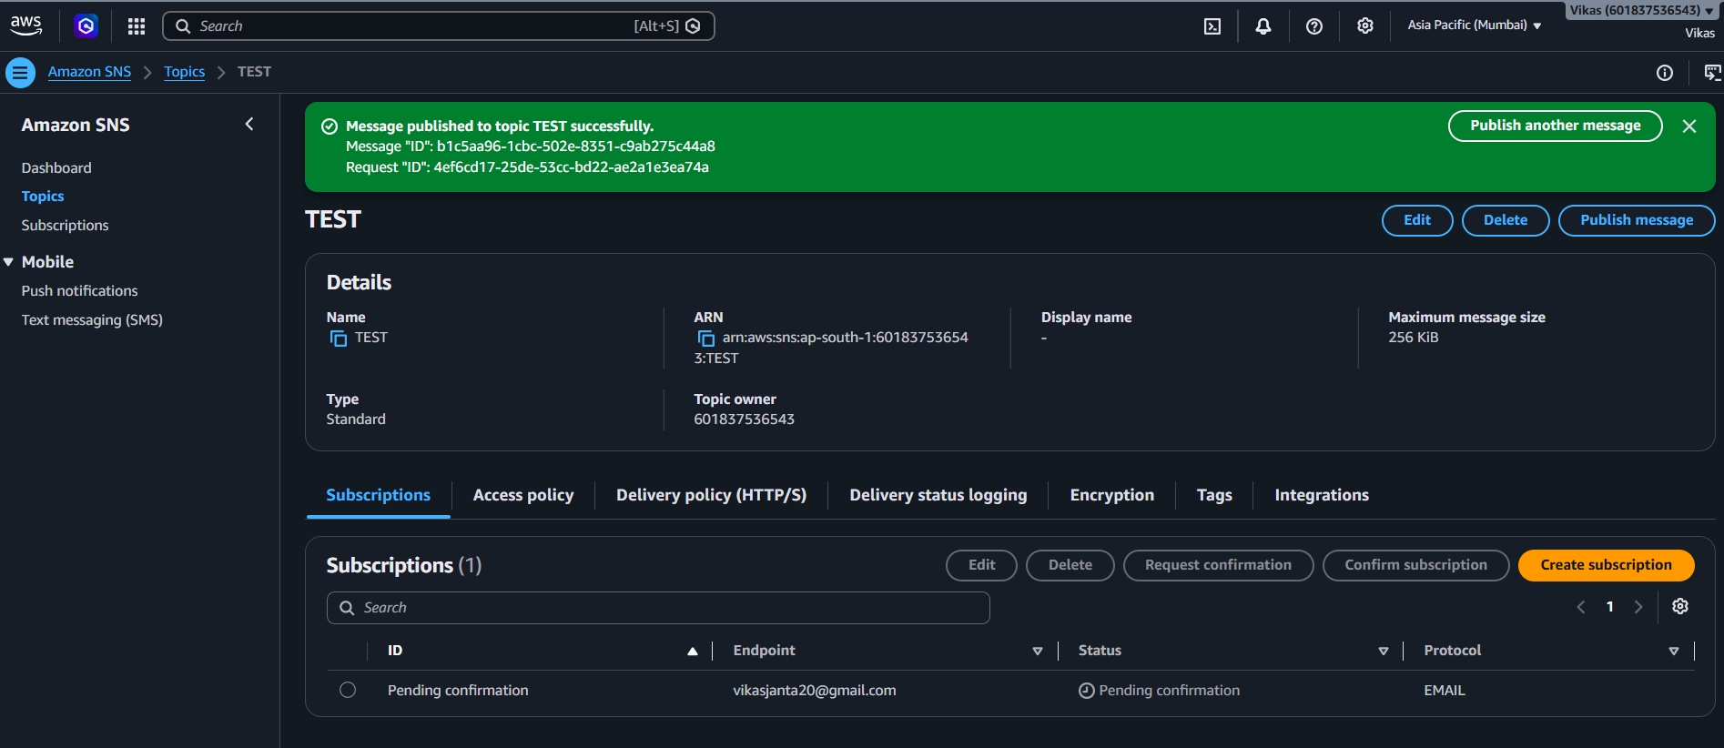

Step 14 – Notification Received
- Define :- The subscribed email inbox receives the message, showing subject "ABCD" and the body "Hello, how are you" — proving the notification was delivered end-to-end.
- Screenshot :-
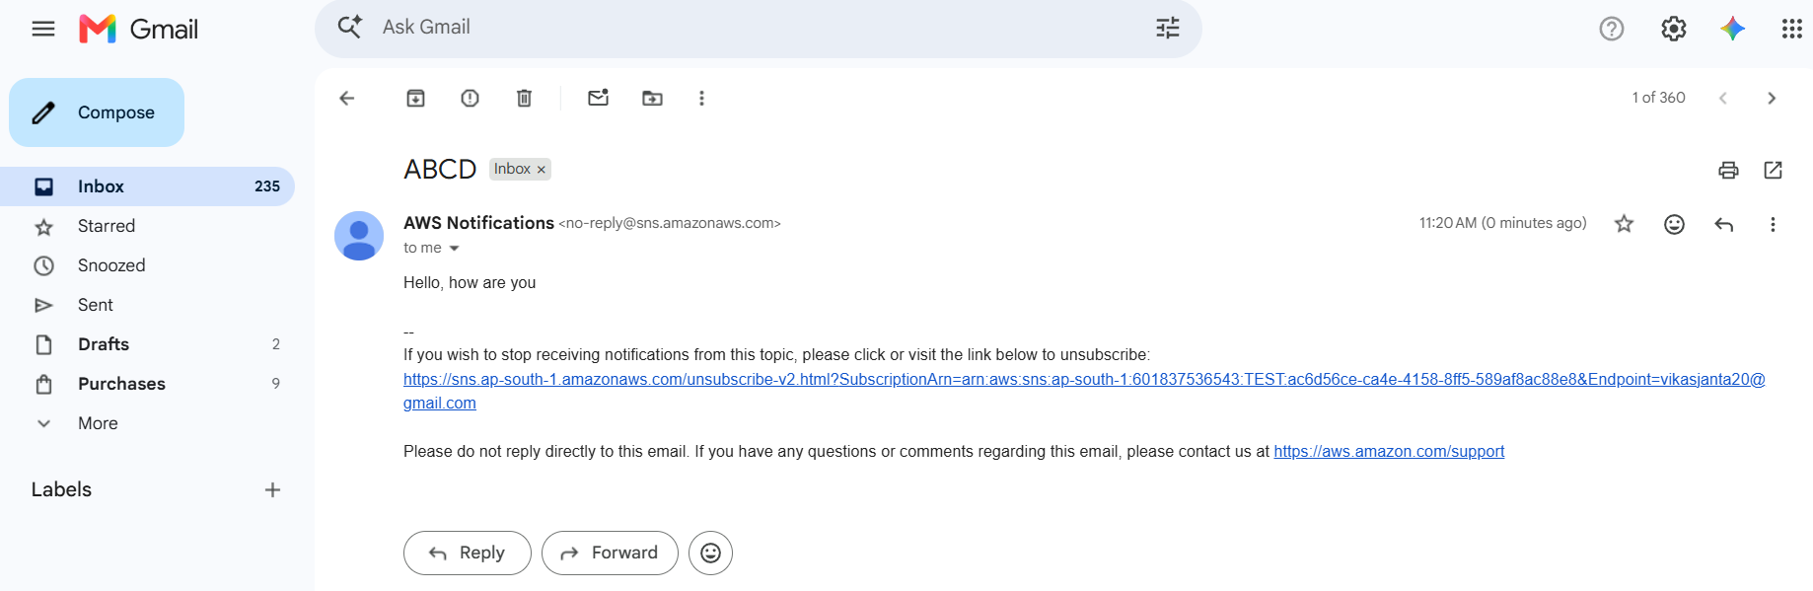

Step 15 – Subscription Removed
- Define :- Finally, using the unsubscribe link from the email, the subscription is removed, confirmed by the "Subscription removed!" message.

- Screenshot :-
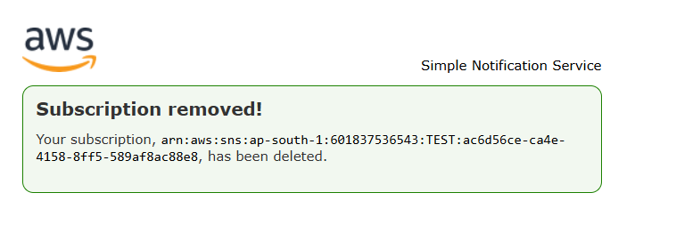

Conclusion
This document shows how Amazon SNS delivers notifications: a topic is created, an email is subscribed and confirmed, a message is published to the topic, and that message instantly lands in the subscriber's inbox — demonstrating simple pub/sub messaging in AWS.

