Amazon S3 – Bucket Creation & Upload Guide

Overview :-
Amazon S3 (Simple Storage Service) is AWS's object storage service. It lets you store and retrieve any amount of data from anywhere. Files are stored as "objects" inside containers called "buckets", with high scalability, availability, security and performance.
Below is a quick, step-by-step look at the screenshots:

Step 1 – Amazon S3 Home Page :-
- Define :- The S3 landing page in the AWS console. It shows the "Create a bucket" option along with pricing and resource links.
- Screenshot :-
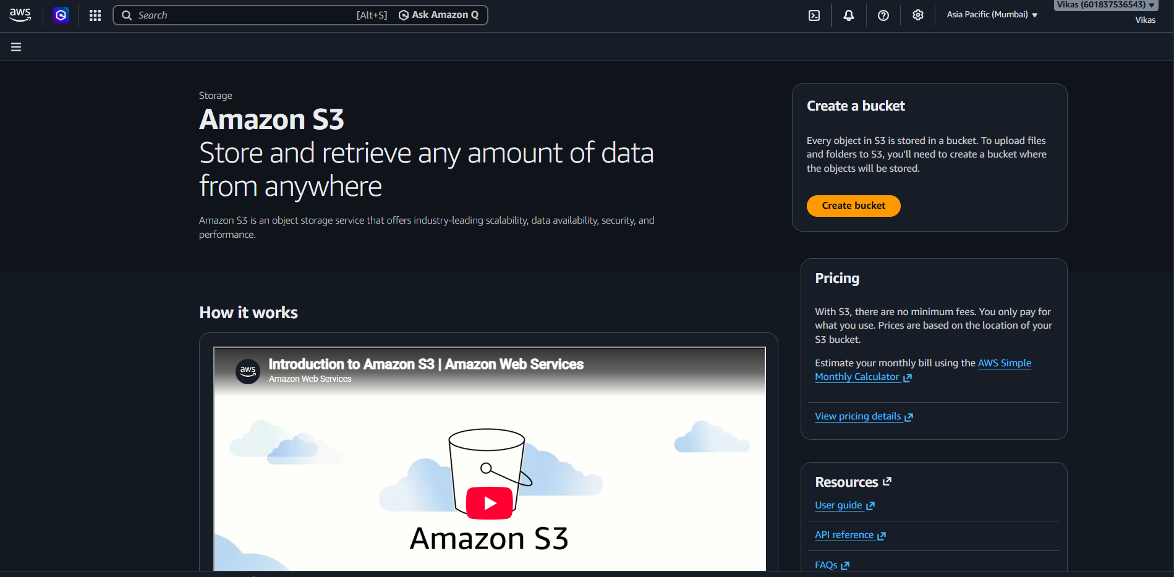

Step 2 – Create Bucket (General Configuration) :-
- Define :- Basic bucket settings: Region set to Mumbai, Bucket type set to General purpose, and bucket name entered as "vikas123-s".

- Screenshot :-

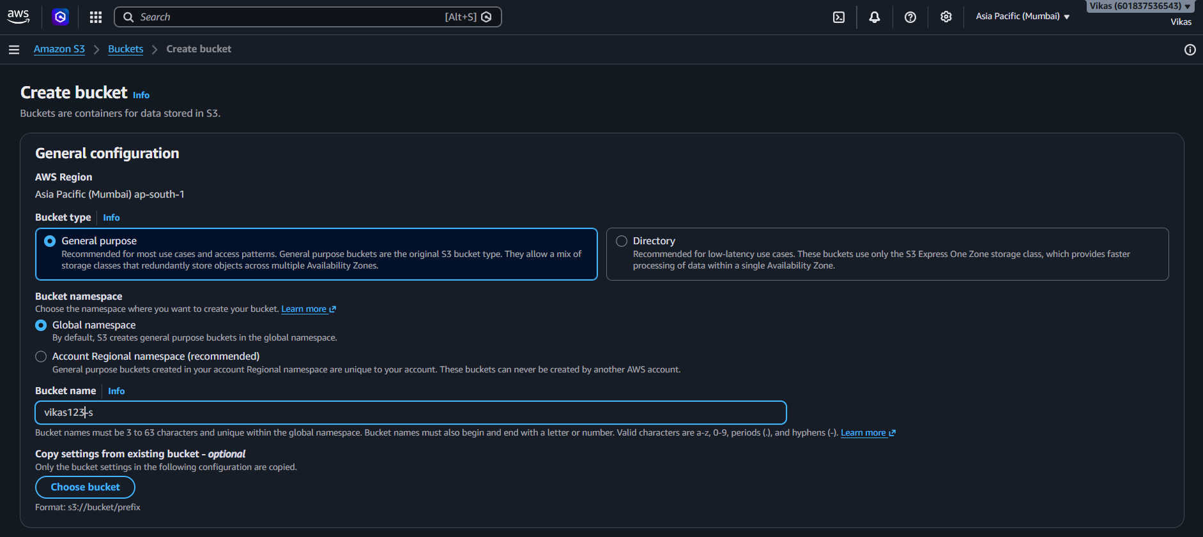

Step 3 – Object Ownership :-
- Define :- "ACLs disabled (recommended)" is selected, meaning only the account owner controls access — no separate ACLs needed.
- Screenshot :-
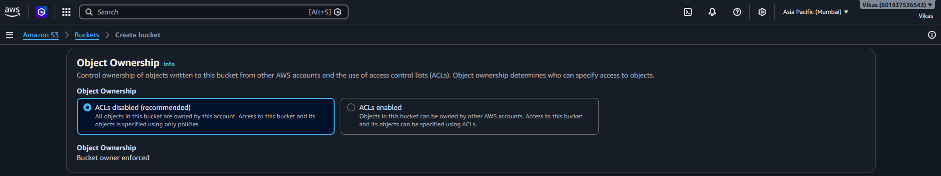

Step 4 – Block Public Access :-
- Define :- "Block all public access" is checked, so no one outside the account can access this data. This is the safe, recommended setting.
- Screenshot :-
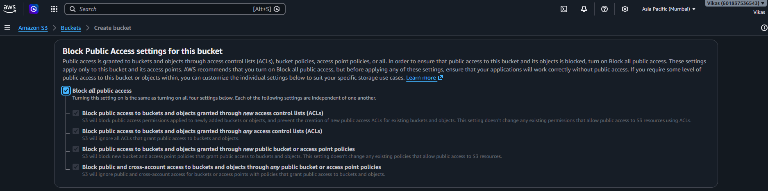

Step 5 – Bucket Versioning :-
- Define :- Versioning keeps multiple copies of a file for recovery. Here it is set to "Disable".
- Screenshot :-
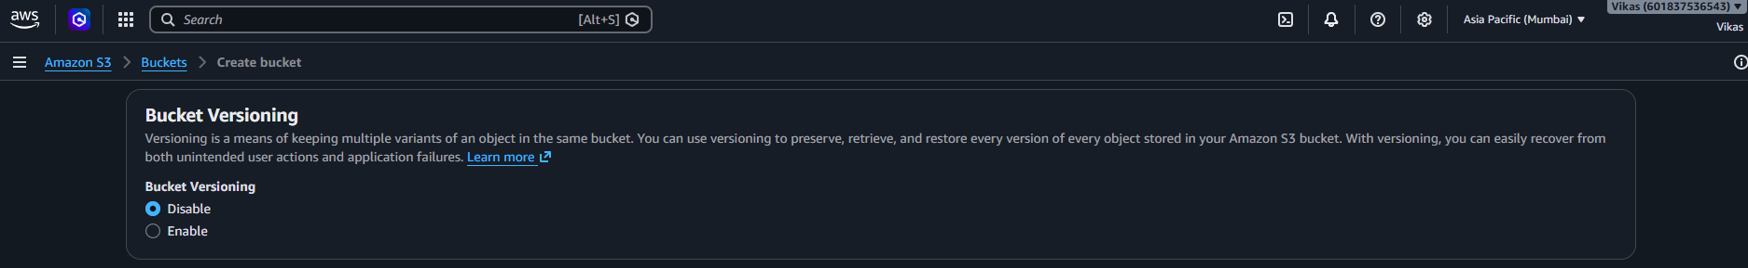

Step 6 – Tags & Default Encryption :-
- Define :- No tags added. Encryption is set to SSE-S3 (Amazon-managed keys) with Bucket Key enabled to reduce encryption cost. "Create bucket" completes the setup.
- Screenshot :-
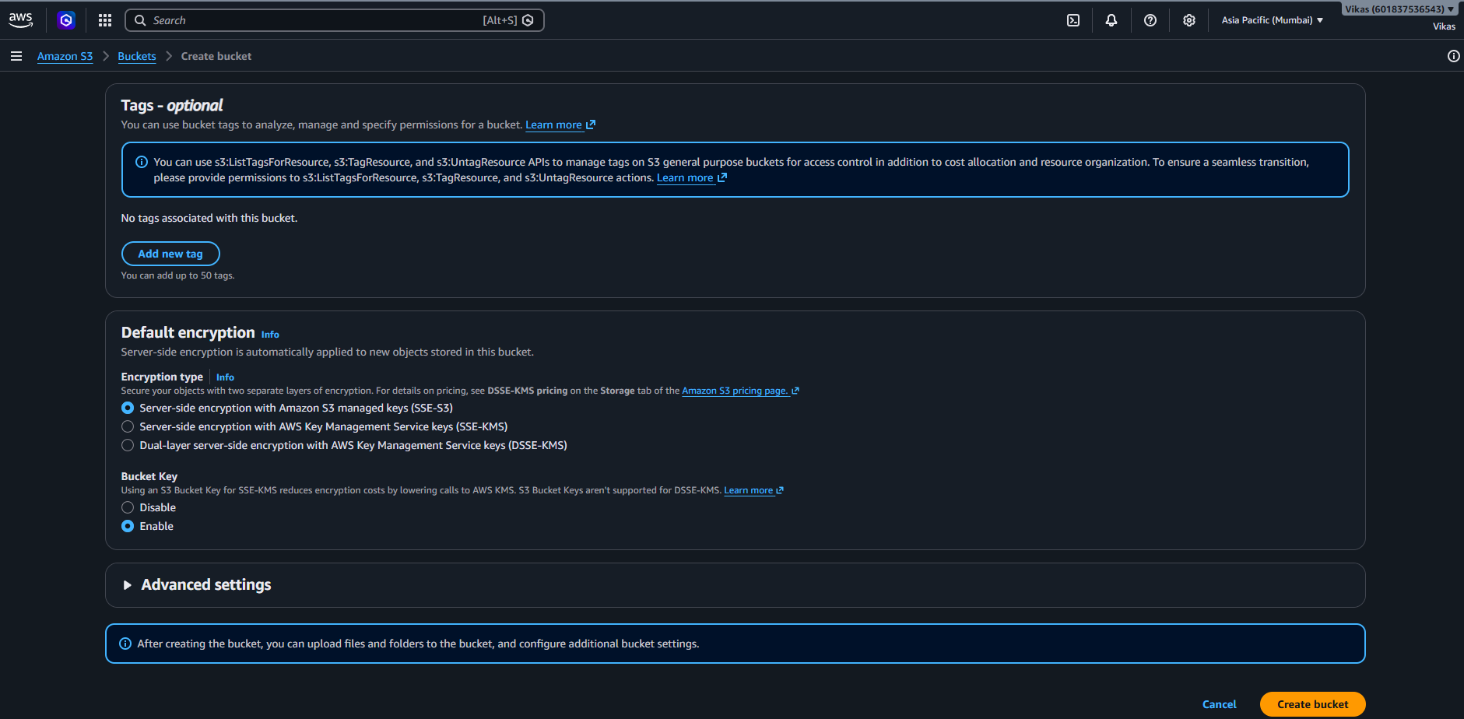
Step 7 – Bucket Created :-
- Define :- Confirmation message: bucket "vikas123-s" created successfully, currently empty with no objects.
- Screenshot :-
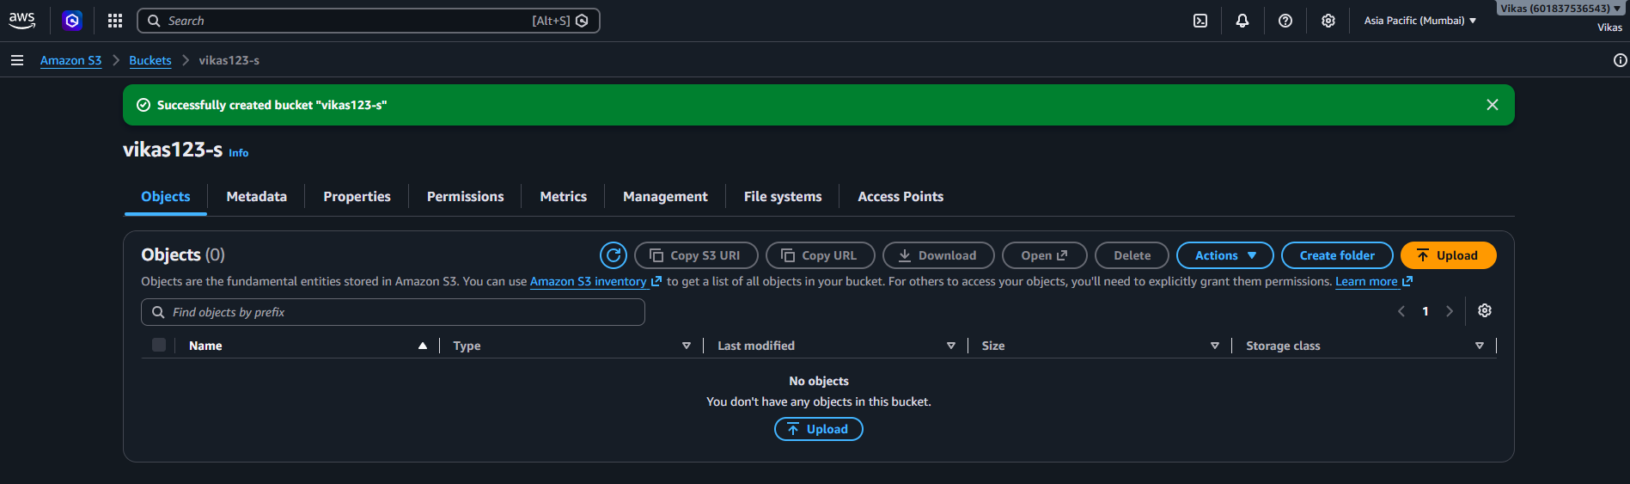

Step 8 – File Upload :-
- Define :- A file, "Amazon Simple Storage Service (S3).pdf" (98.7 KB), is selected for upload to s3://vikas123-s.
- Screenshot :-
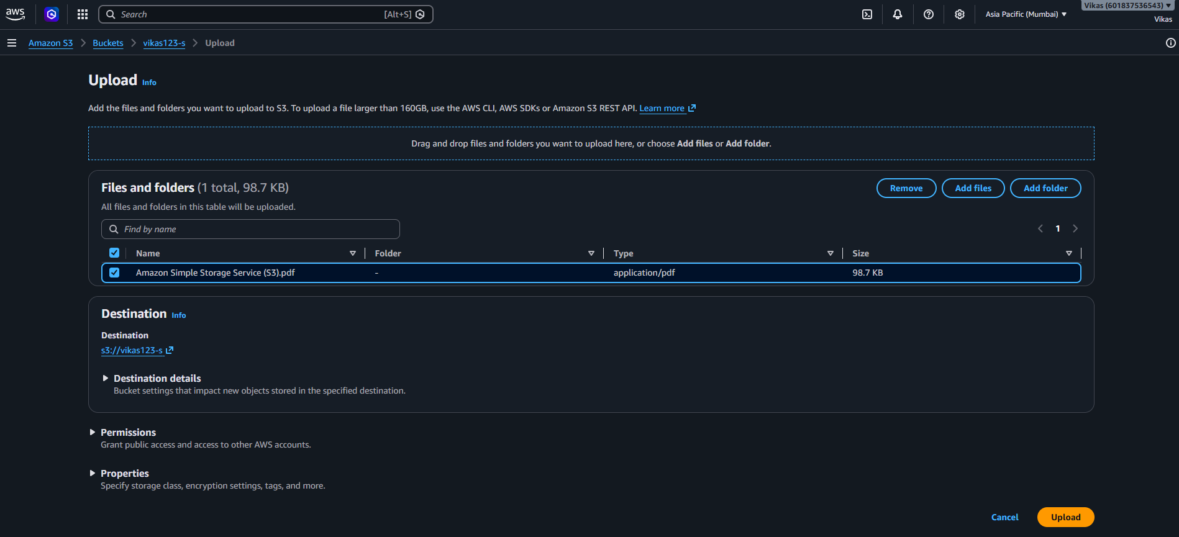

Step 9 – Upload Succeeded :-
- Define :- Upload completed: 1 file, 98.7 KB, 100% succeeded, 0 failed.
- Screenshot :-
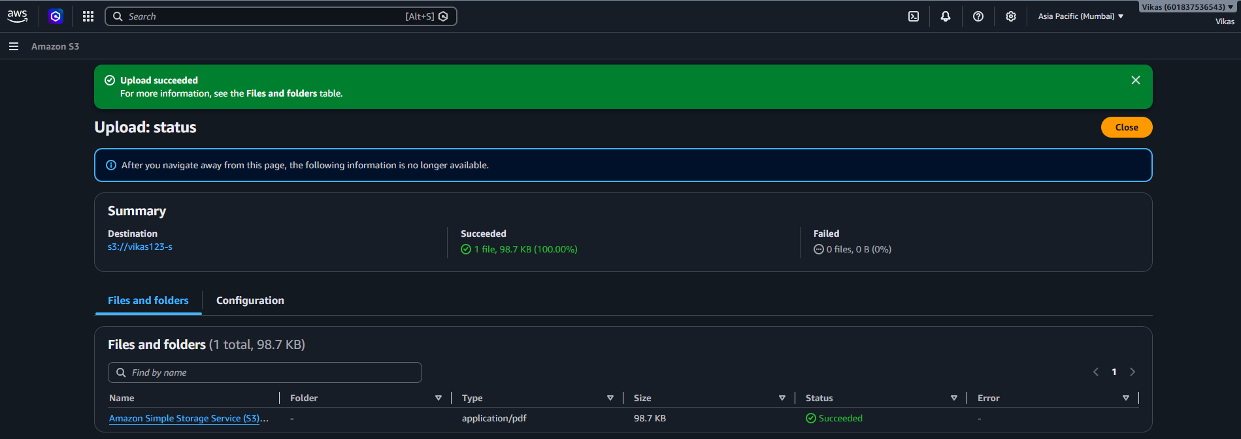

Conclusion :-
This document shows a simple S3 walkthrough: creating a bucket with secure defaults (public access blocked, ACLs disabled, encryption enabled), then uploading a file to it — all done through the console without any coding.

