Amazon S3 (Public Bucket Creation)

Overview
This walkthrough shows how to create a private Amazon S3 bucket. A private bucket keeps its files restricted so only the owner can access them — public access stays blocked.
Below is a simple, step-by-step look at the screenshots:
Step 1 – Create Bucket (General Configuration) :-
- Define :- Region set to Mumbai, Bucket type set to General purpose, and bucket name set to "vikas-pvt". Region decides where the data is stored, and the name is the bucket's unique address.
- Screenshot :-
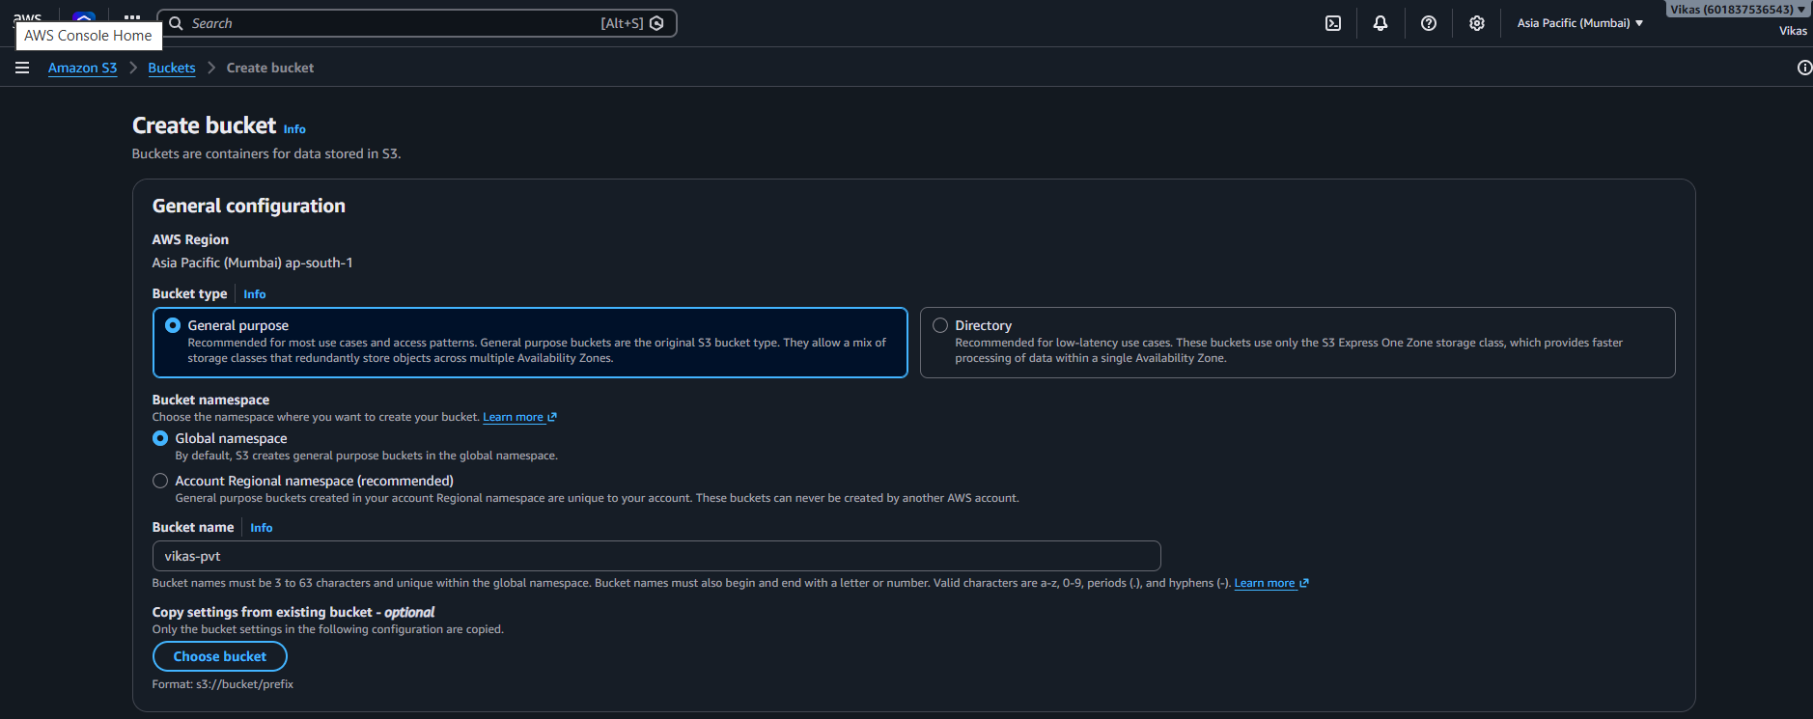

Step 2 – Object Ownership :-
- Define :- "ACLs enabled" is selected, which lets access be set on individual files, not just the whole bucket. "Bucket owner preferred" keeps the owner in control of every file.
- Screenshot :-
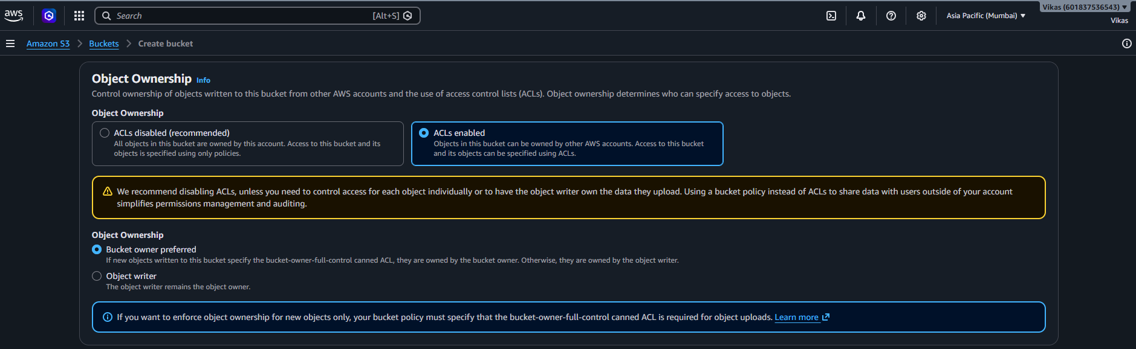

Step 3 – Block Public Access
- Define :- "Block all public access" is left unchecked for now, so specific files can be made public later if needed.
- Screenshot :-
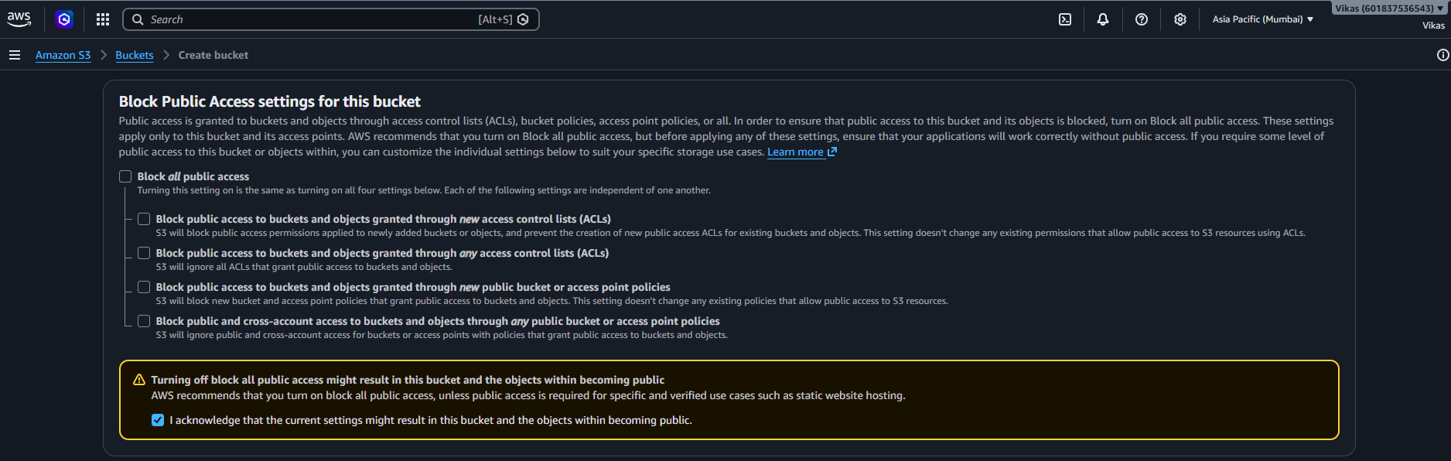

Step 4 – Bucket Versioning :-
- Define :- Versioning saves older copies of a file so you can recover them later. Here it is set to "Disable".
- Screenshot :-
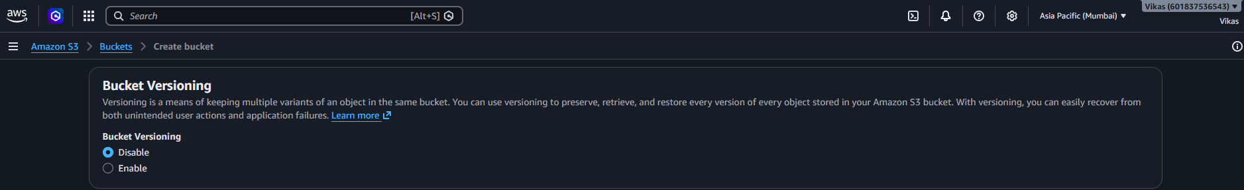
Step 5 – Tags & Default Encryption :-
- Define :- No tags added. Encryption (SSE-S3) is on, so AWS automatically protects every file. Bucket Key is enabled to keep encryption cost lower.
- Screenshot :-
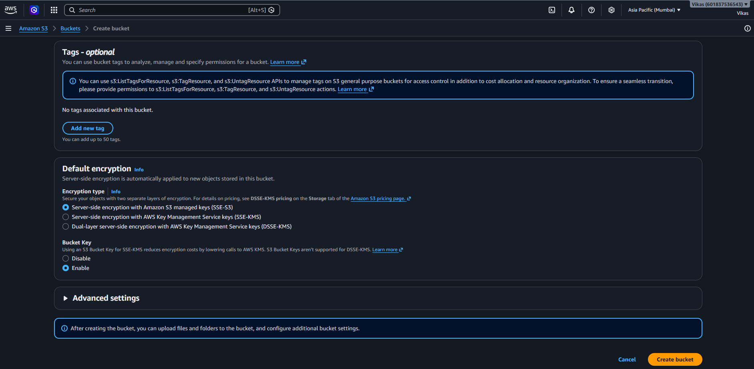

Step 6 – Bucket Created
- Define :- Bucket "vikas-pvt" is created successfully and is empty, ready for files.
- Screenshot :-
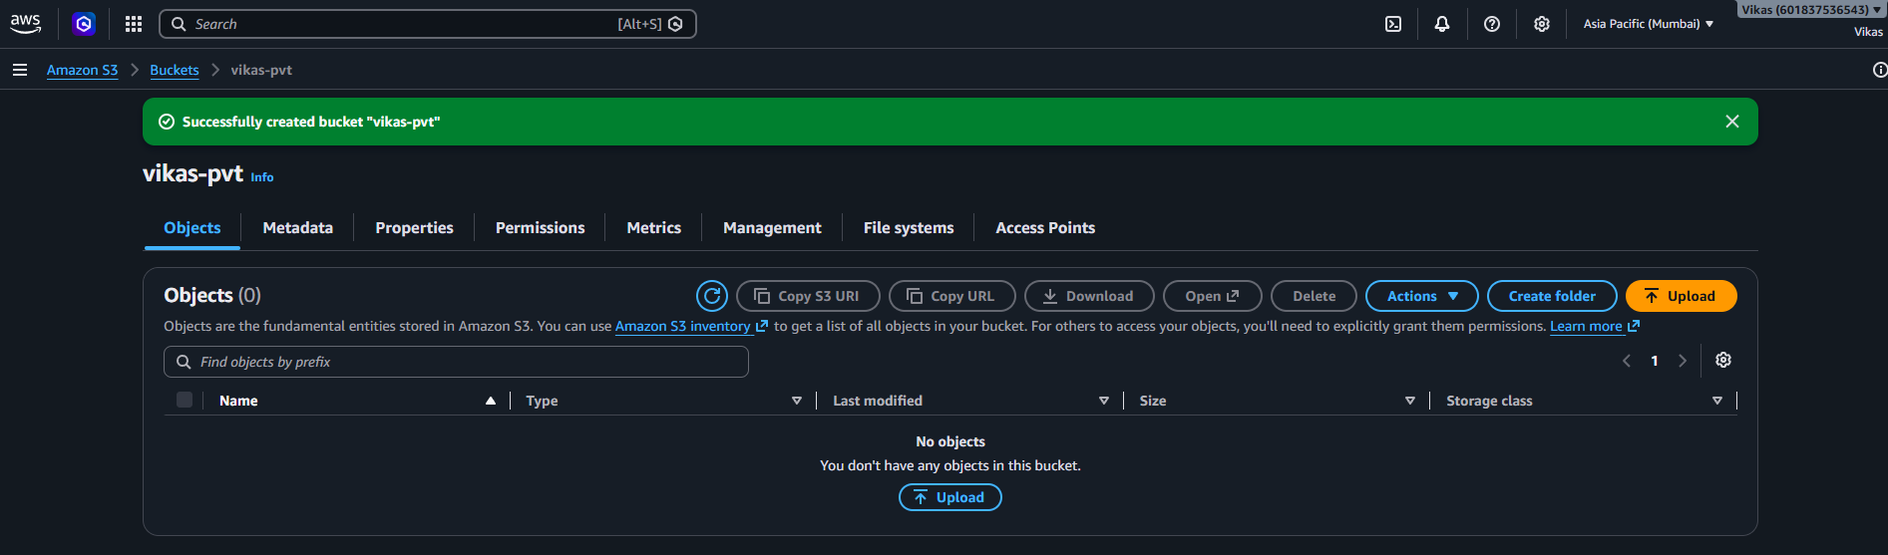

Step 7 – File Upload
- Define :- A HTMl file is selected to upload into the "vikas-pvt" bucket.
- Screenshot :-
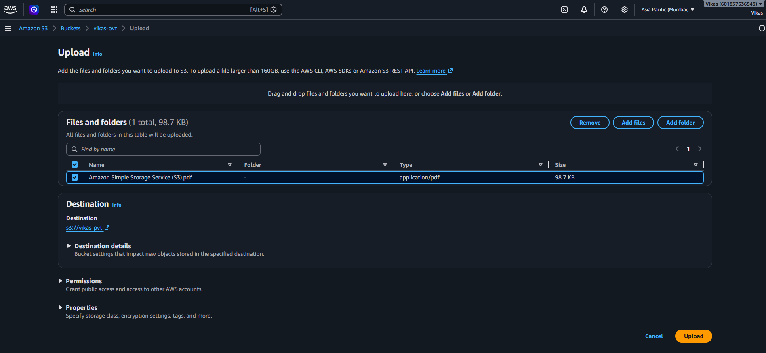

Step 8 – Upload Succeeded
- Define :- Upload done: 1 file, 98.7 KB, 100% successful.
- Screenshot :-
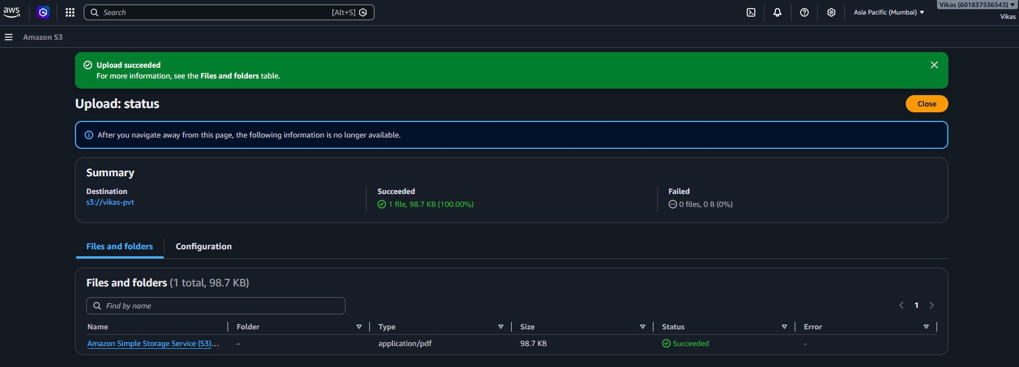

Step 9 – Make Public (Object Level)
- Define :- This screen can make just this one file public, so anyone with the link could open it — even though the bucket stays private.
- Screenshot :-
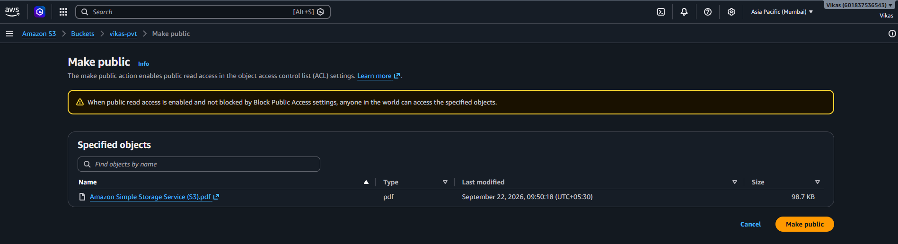

Step 10 – Permissions Overview
- Define :- The Permissions tab shows "Block all public access: On" — the bucket is currently public.
- Screenshot :-
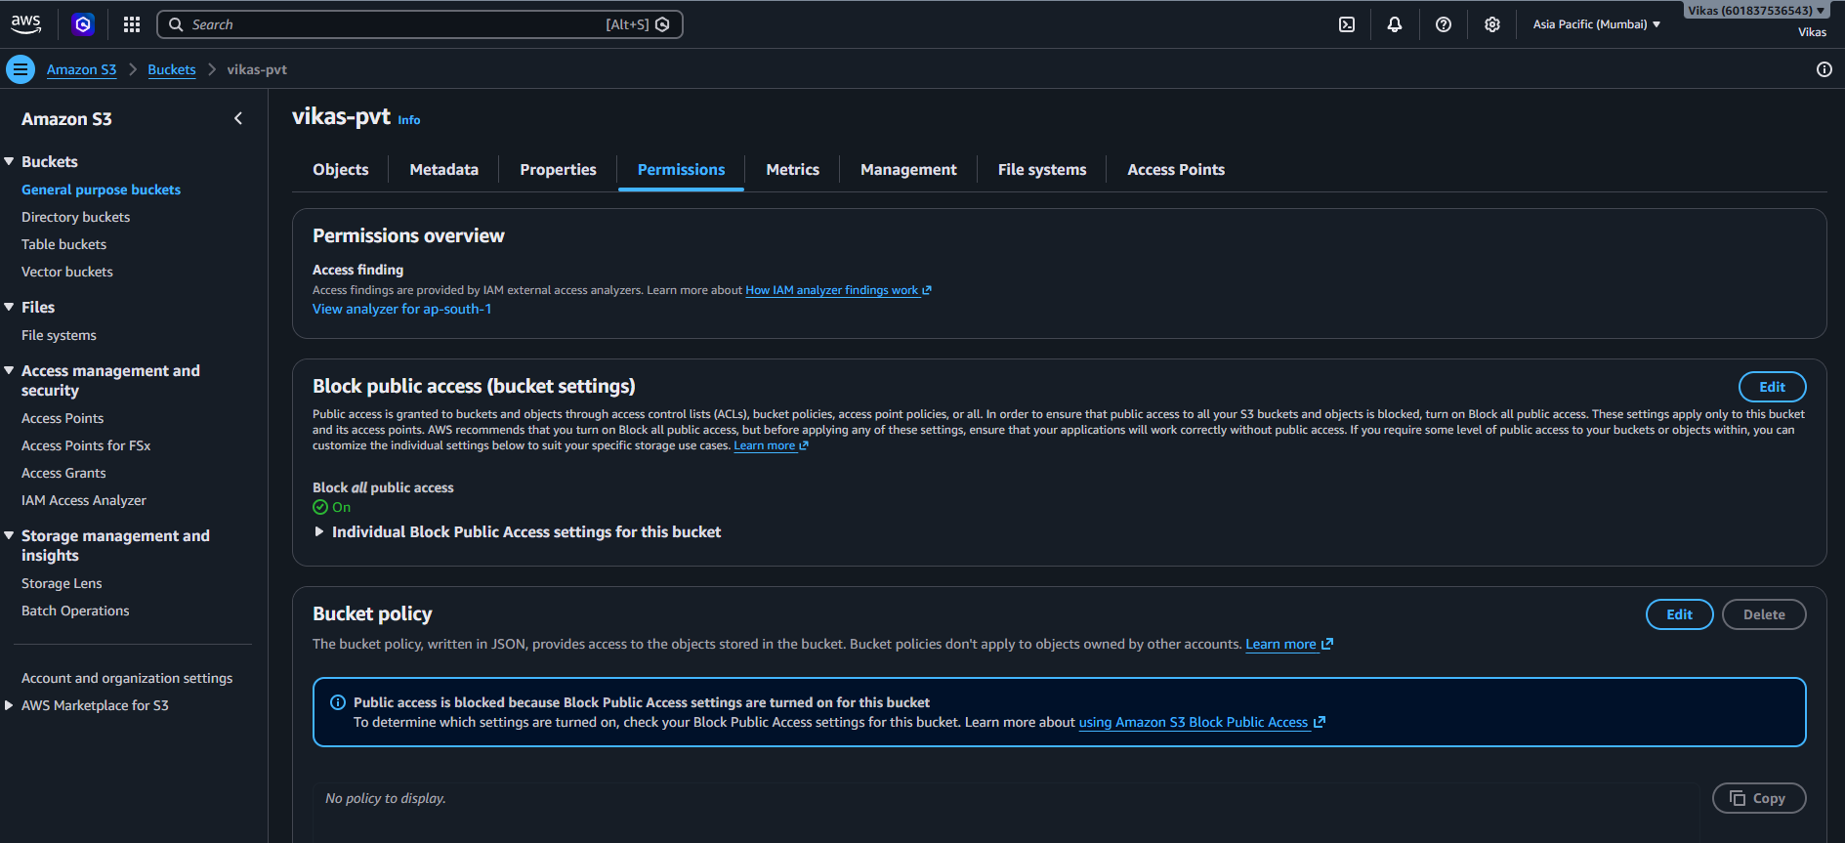

Step 11 – Edit Block Public Access
- Define :- All four block options are checked again to fully stop any public access to the bucket.
- Screenshot :-
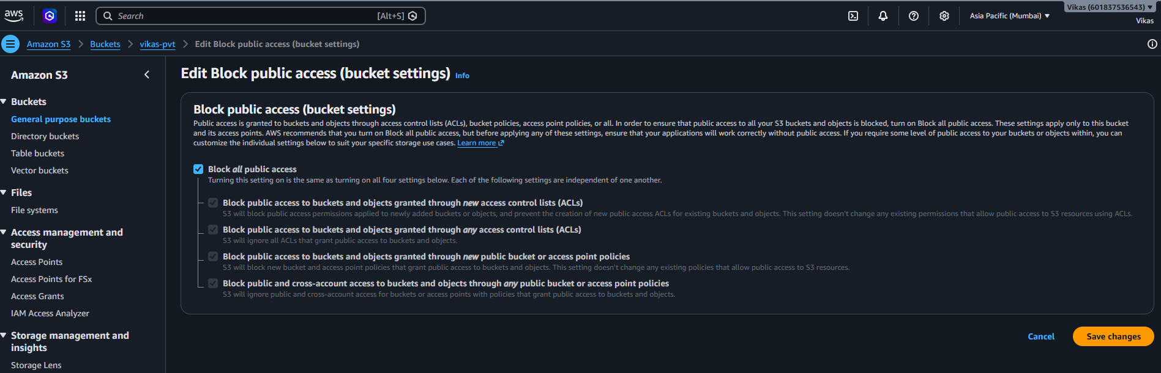

Step 12 – Confirm Changes
- Define :- Typing "confirm" is required before this security change is applied.
- Screenshot :-
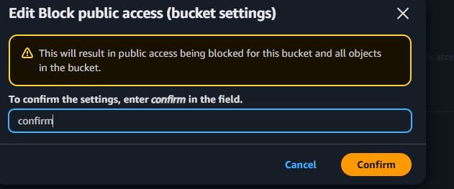

Step 13 – Block Public Access Re-enabled
- Define :- Success message: public access is blocked again, so the bucket stays private.
- Screenshot :-
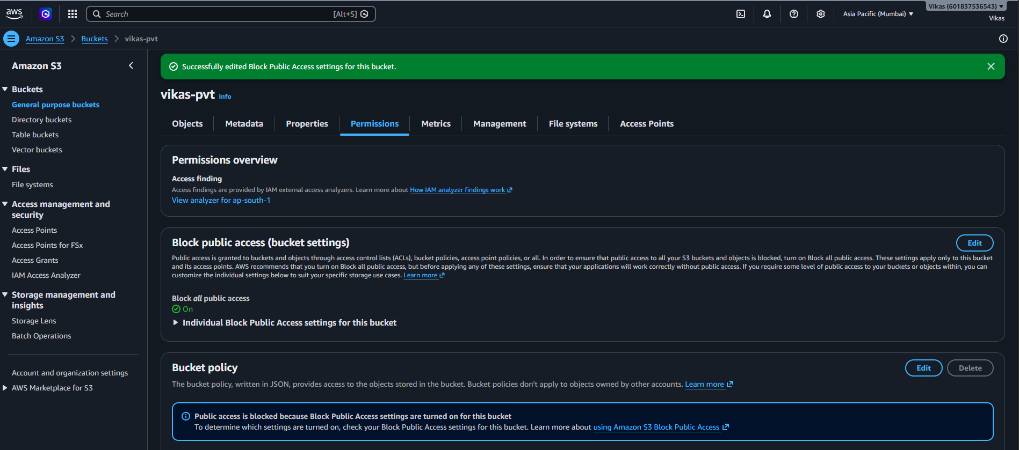

Step 14 – Object Access Updated
- Define :- Confirms the file's access setting was updated (1 object, 98.7 KB).
- Screenshot :-
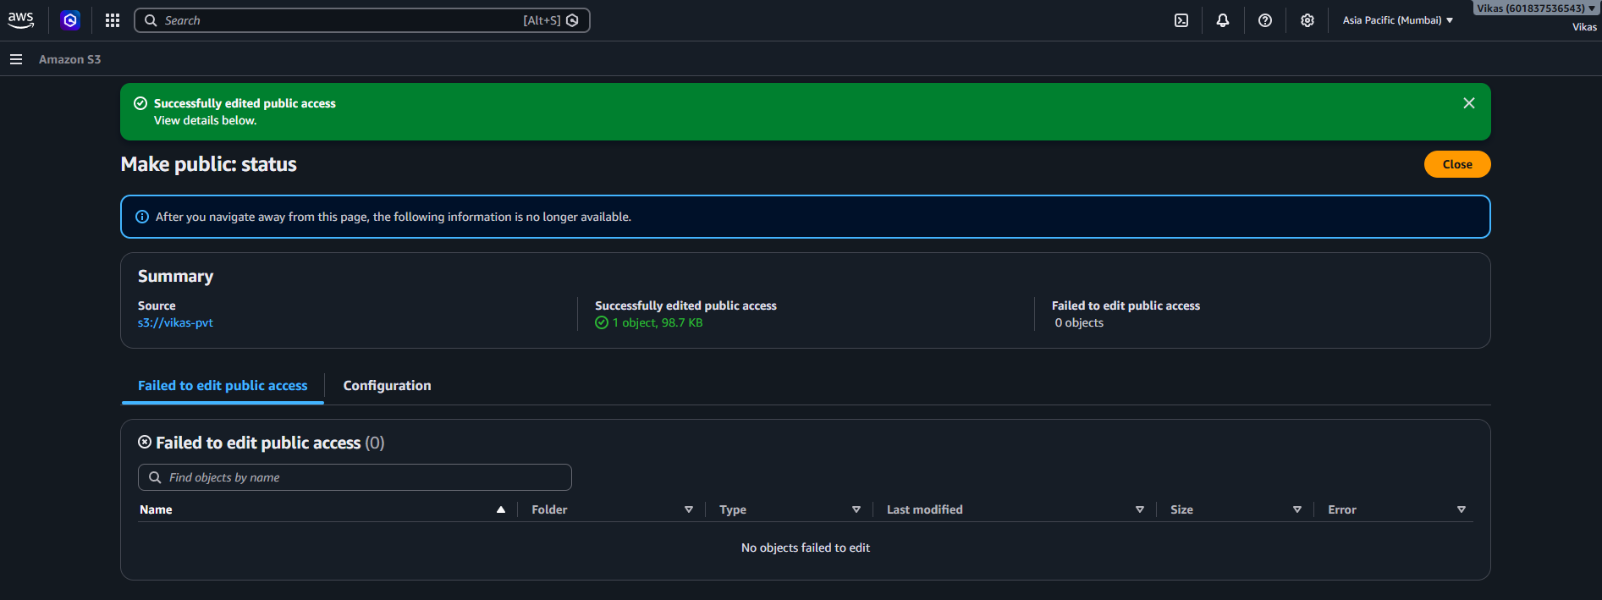

Conclusion
This shows the private bucket version: a bucket was created, a file was uploaded, making it public was tried, and then public access was blocked again — keeping the bucket private. This is the main difference from the earlier public bucket.

