Hosting a Static Website on Amazon S3

Overview
This walkthrough shows how to host a simple static website using an Amazon S3 bucket. A bucket is created, an HTML file is uploaded, and then Static Website Hosting is turned on so the page becomes viewable through a web link.
Below is a simple, step-by-step look at the screenshots:
Step 1 – Create Bucket (General Configuration) :-
- Define :- Region set to Mumbai, Bucket type set to General purpose, and a bucket name entered. This sets up the basic container that will later hold the website files.
- Screenshot :-
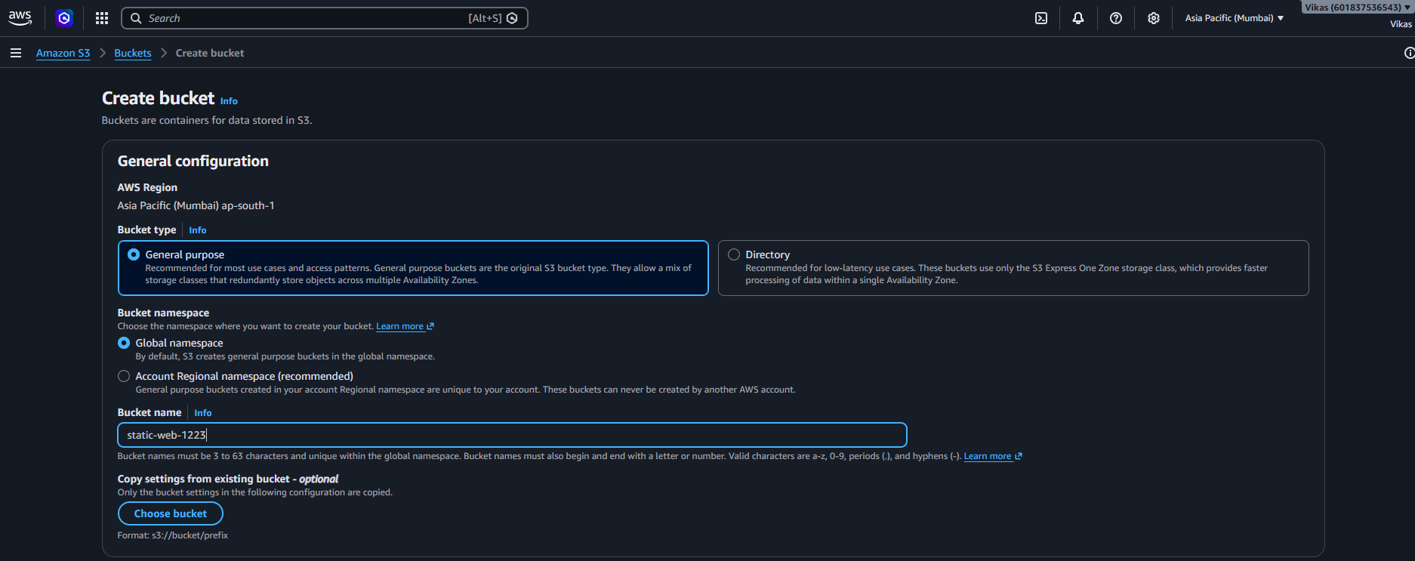

Step 2 – Object Ownership :-
- Define :- "ACLs enabled" is selected, which allows access to be set on individual files, not just the whole bucket.
- Screenshot :-
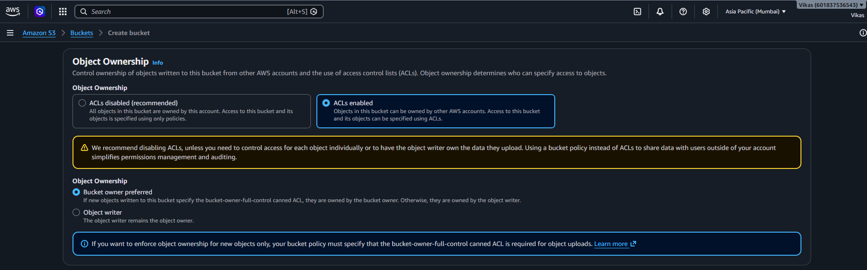
Step 3 – Block Public Access & Versioning :-
- Define :- "Block all public access" is left unchecked (acknowledged), since a website needs to be publicly viewable. Bucket Versioning is set to "Disable".
- Screenshot :-
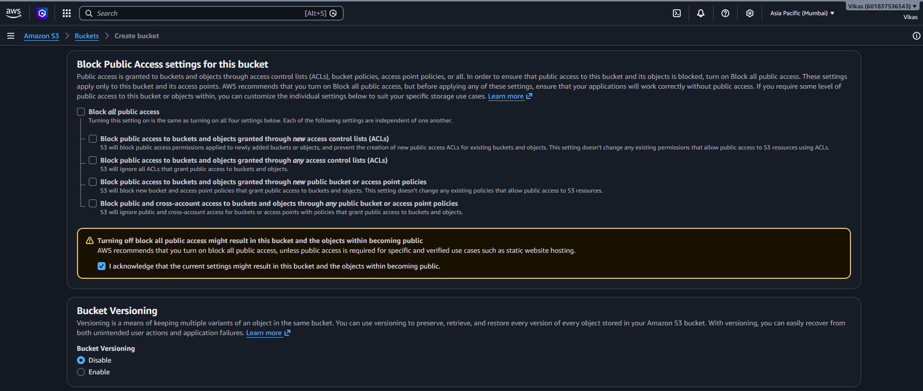

Step 4 – Tags & Default Encryption :-
- Define :- No tags added. Encryption (SSE-S3) is on, and Bucket Key is enabled to keep encryption cost lower.
- Screenshot :-
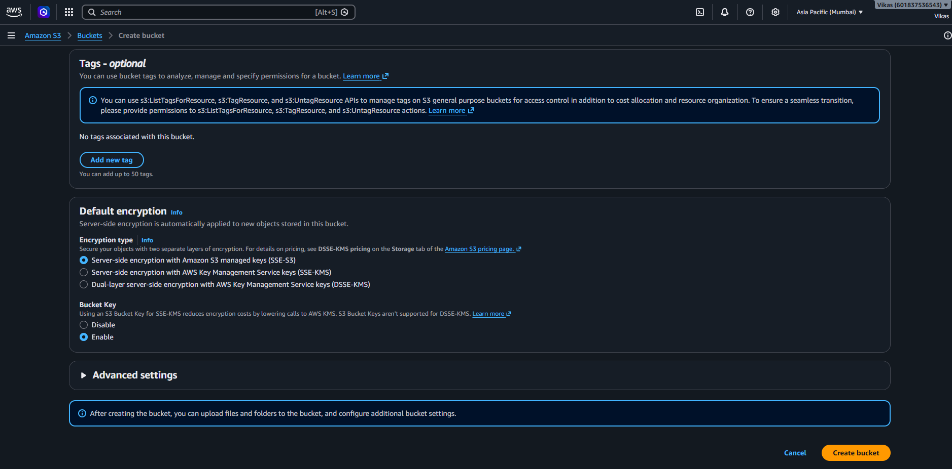
Step 5 – Bucket Created :-
- Define :- Bucket "vikas-1234-website" is created successfully and is empty, ready for the website files.
- Screenshot :-
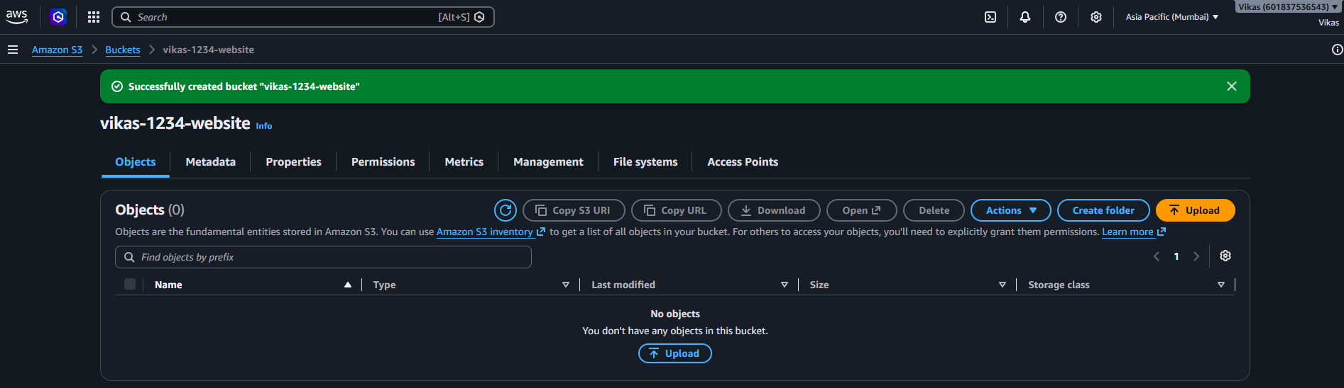

Step 6 – File Upload :-
- Define :- The website file "Website_HTML_Code.html" (8.0 KB) is selected to upload into the bucket.
- Screenshot :-
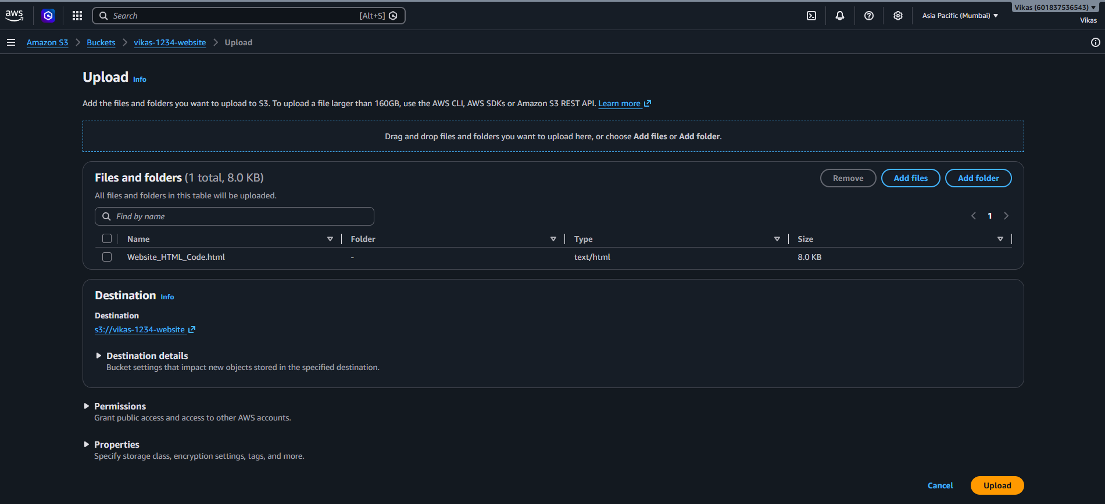

Step 7 – Upload Succeeded :-
- Define :- Upload done: 1 file, 8.0 KB, 100% successful.
- Screenshot :-
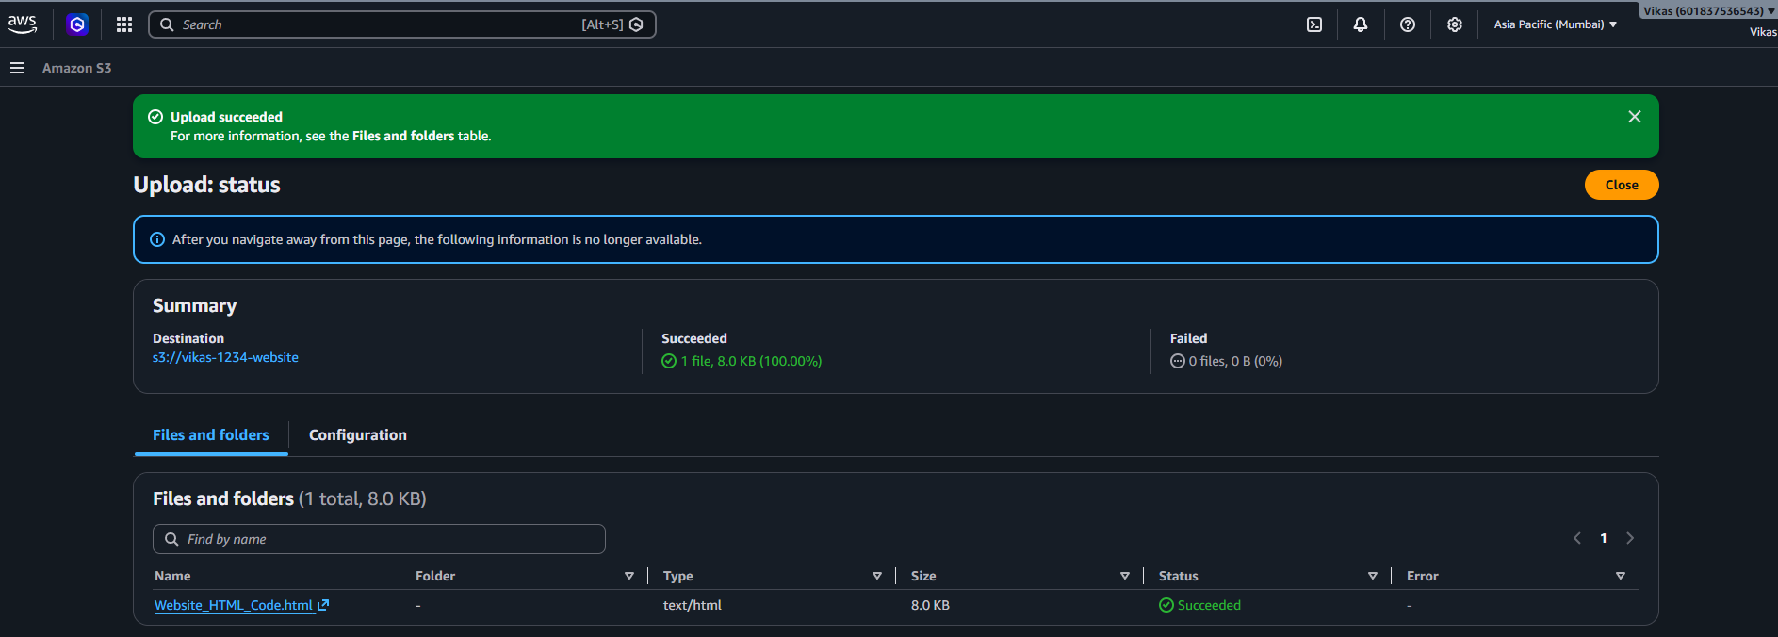

Step 8 – Access Denied (Before Hosting Setup) :-
- Define :- Opening the file link directly shows an "Access Denied" error, because the bucket isn't yet set up to serve the file publicly as a website.
- Screenshot :-
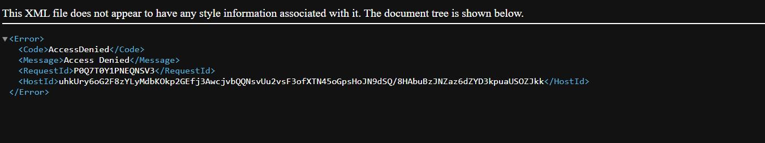

Step 9 – Enable Static Website Hosting :-
- Define :- Static website hosting is turned on, hosting type set to "Host a static website", and the index document set to "Website_HTML_Code" (the site's home page).
- Screenshot :-
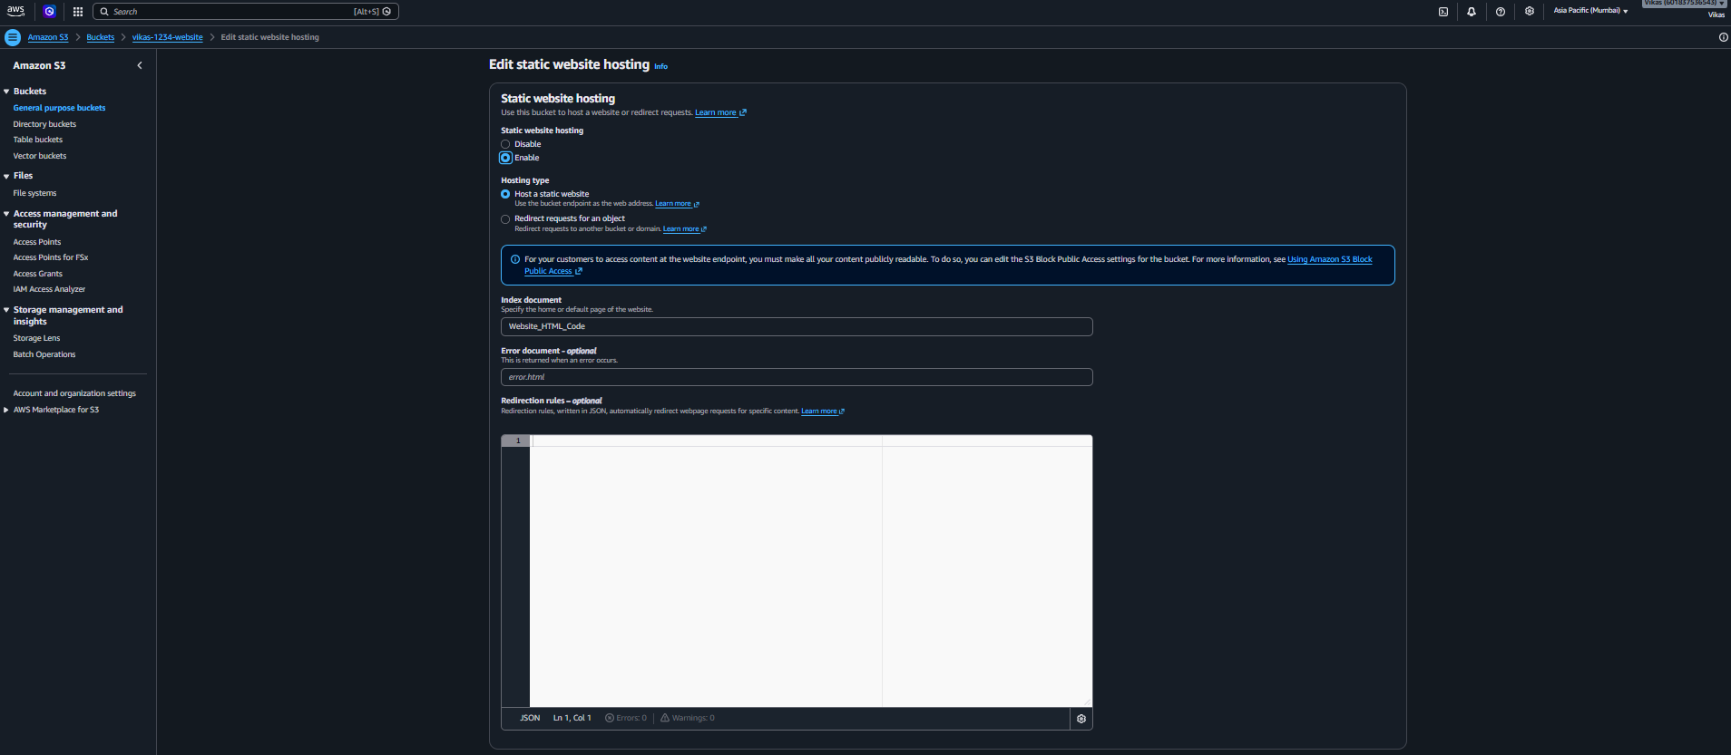

Step 10 – Hosting Enabled Successfully :-
- Define :- Confirmation message: static website hosting was set up successfully for the bucket.
- Screenshot :-
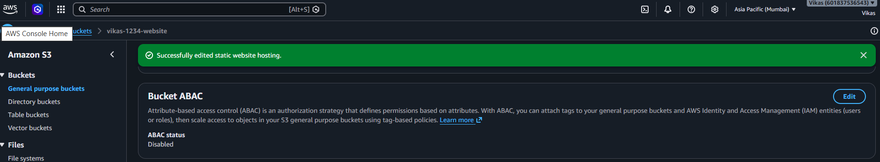

Step 11 – Website Live :-
- Define :- The final result: the HTML page now loads as a live website, showing the portfolio page with an intro, skills, and navigation menu.
- Screenshot :-
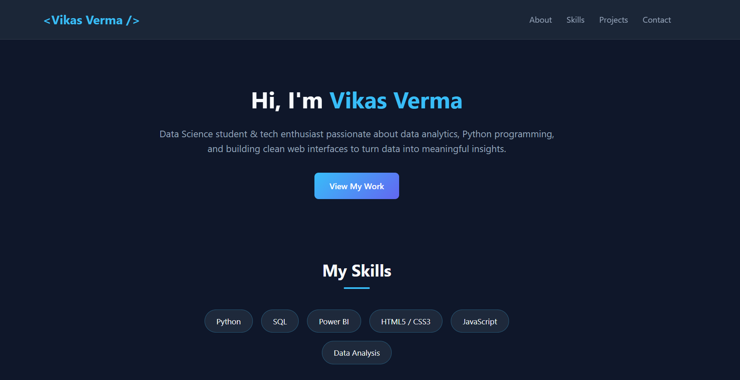

Conclusion
This document shows how a static website is hosted directly from an S3 bucket: creating the bucket, uploading the HTML file, and enabling Static Website Hosting so the page becomes accessible as a live website.

