Assignment_C

Query :- db.createCollection("students")
Query :- db.students.insertMany([
{student_id:1,name:"Amit",age:20,marks:85,department:"CSE",subjects:["DBMS","OS","CN"],email:"amit@gmail.com"},
{student_id:2,name:"Neha",age:22,marks:72,department:"ECE",subjects:["Signals","VLSI"],email:null}
{student_id:3,name:"Rahul",age:19,marks:90,department:"CSE",subjects:["DBMS","AI","ML"]},
{student_id:4,name:"Sneha",age:21,marks:65,department:"IT",subjects:["Web","DBMS"],email:"sneha@gmail.com"},
{student_id:5,name:"Karan",age:23,marks:78,department:"CSE",subjects:["CN","OS"],email:"karan@gmail.com"}])
Check_Query:- db.students.find()
Output :
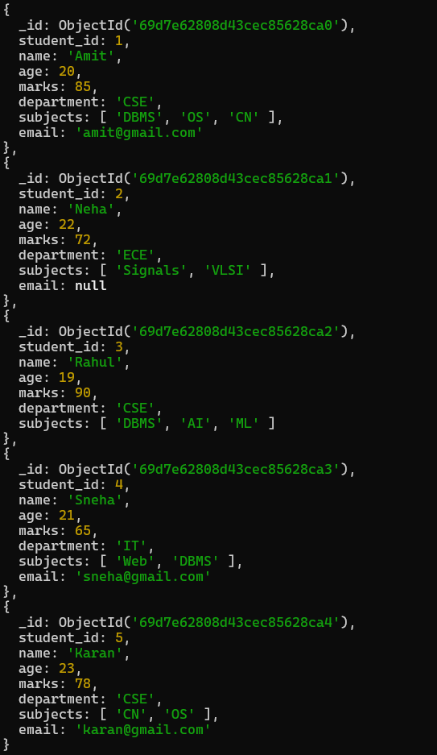
Q.1 Find students with marks greater than 80.
Query :- db.students.find({marks:{$gt:80}})
Output :-
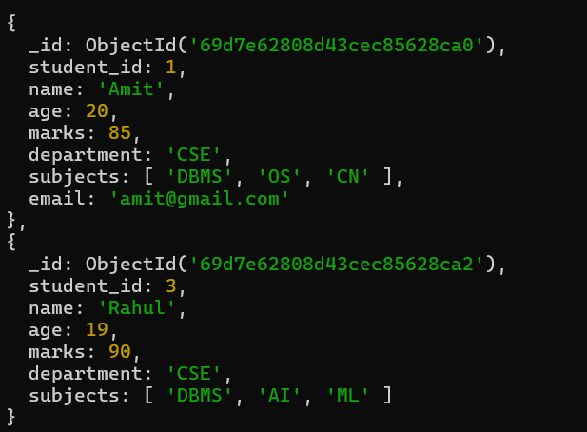

Q.2 Find students aged less than or equal to 20.
Query :- db.students.find({age:{$lte:20}})
Output ::
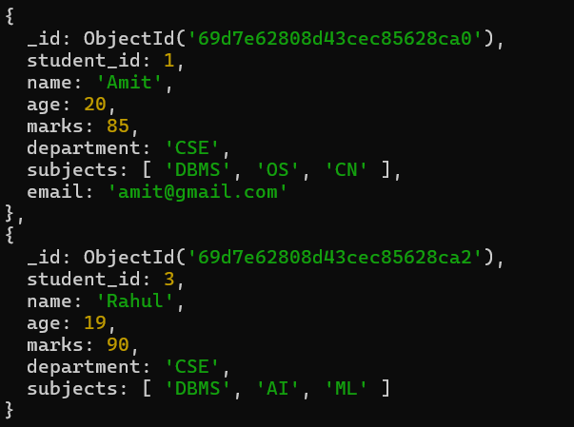
Q.3 Find students with marks between 70 and 85.
Query :- db.students.find({marks:{$gte: 70,$lte:85}})
Output :-
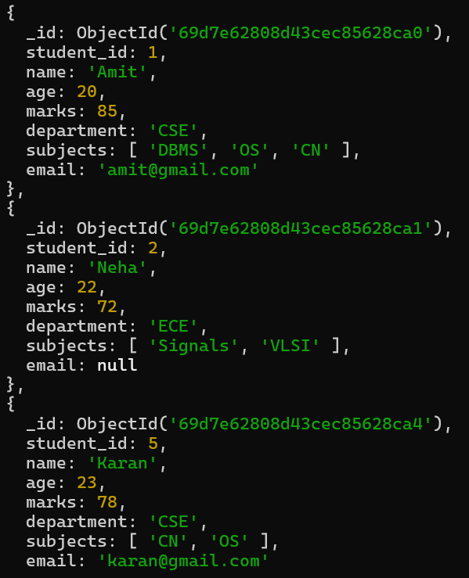

Q.4 Find students not belonging to CSE department.
Query :- db.students.find({department:{$ne:"CSE"}})
Output :-
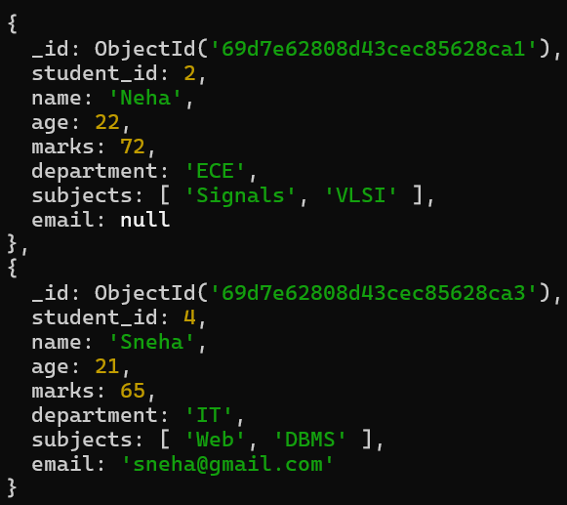

Q.5 Find students whose age is exactly 21.
Query :- db.students.find({age:{$eq:21}})
Output :-
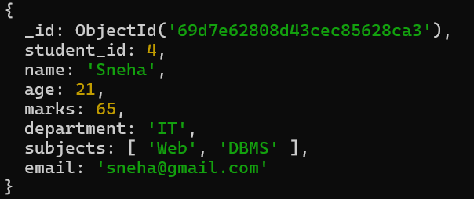
Q.6 Find students with marks less than 75.
Query :- db.students.find({marks:{$lt:75}})
Output :-
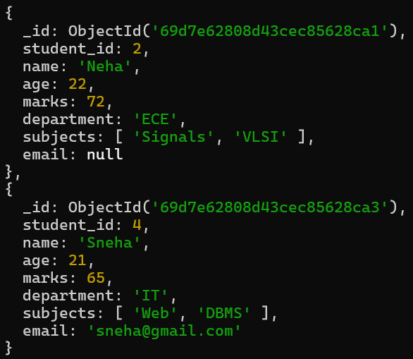

Q.7 Find students whose department is either CSE or IT.
Query :- db.students.find({department:{$in:["CSE","IT"]}})
Output :-
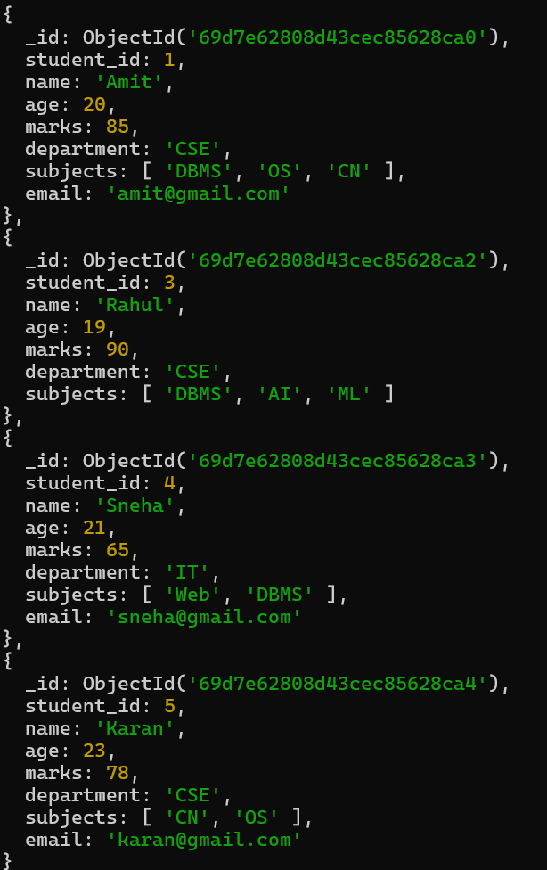
Q.8 Find CSE students with marks above 80.
Query:- db.students.find({department:"CSE",marks:{$gt:80}})
Output :-
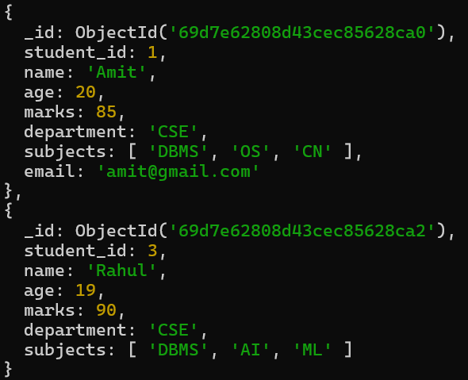

Q.9 Find students who are in CSE or have marks above 85.
Query :- db.students.find({$or:[{department:{$eq:"CSE"}},{marks:{$gt:85}}]})
Output :-

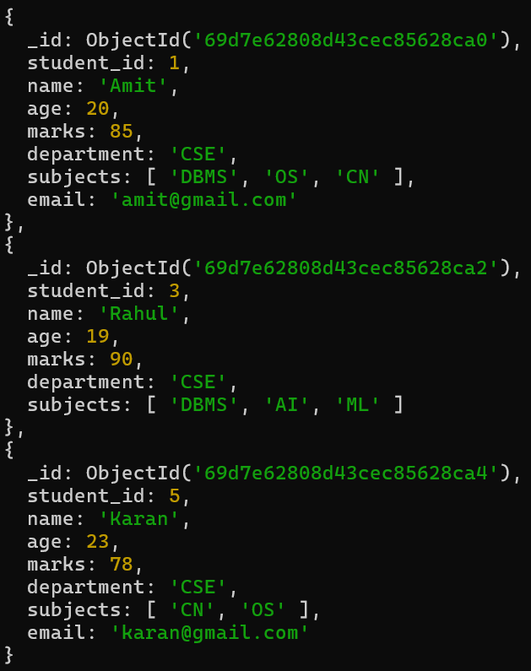

Q.10 Find students who are NOT in IT department.
Query :- db.students.find({department:{$ne:"IT"}})
Output :-
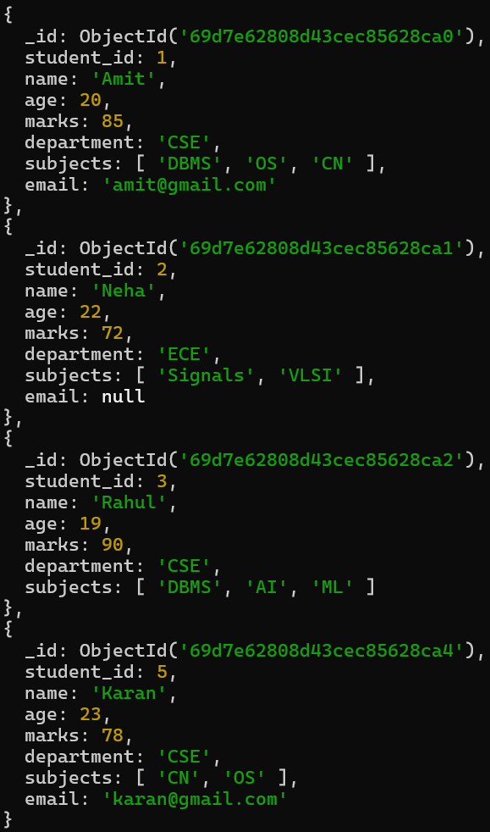
Q.11 Find students with marks not between 70 and 85.
Query :- db.students.find({marks:{$not:{$gt:70,$lt:85}}})
Output :-
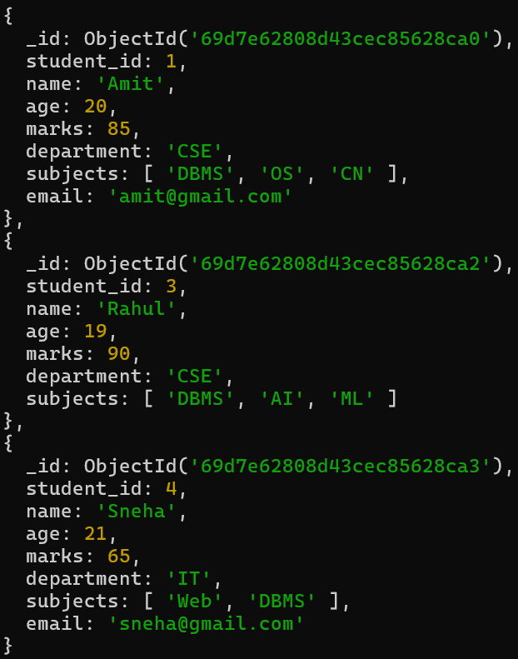

Q.12 Find students aged above 20 and not in ECE.
Query :- db.students.find({$and:[{age:{$gt:20}},{department:{$ne:"ECE"}}]})
Output :-
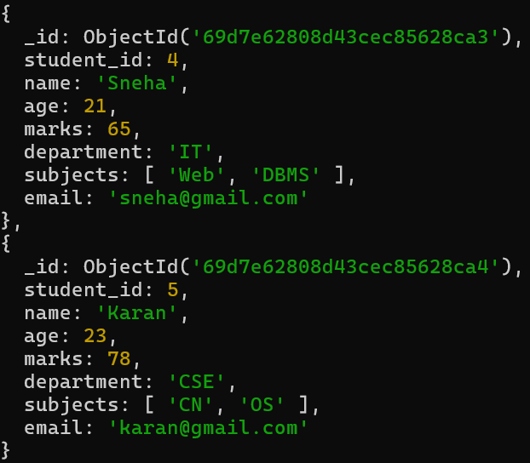

Q.13 Find students who are either IT students or have marks less than 70.
Query :- db.students.find({$or:[{department:{$eq:"IT"}},{marks:{$lt:70}}]})
Output :-
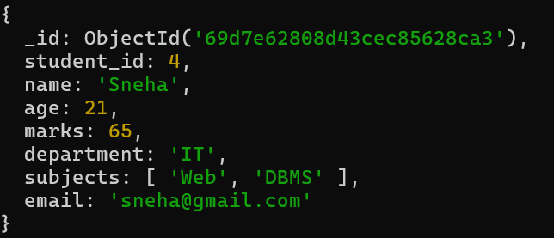
Q.14 Find students who are not CSE and not IT.
Query :- db.students.find({$and:[{department:{$ne:"CSE"}},{department:{$ne:"IT"}}]})
Output :-
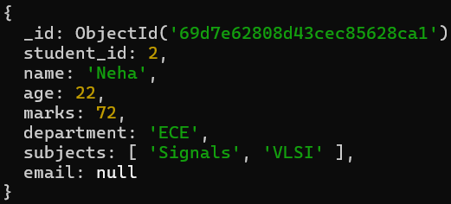
Q.15 Find students who have an email field.
Query :- db.students.find({email:{$exists:true}})
Output :-
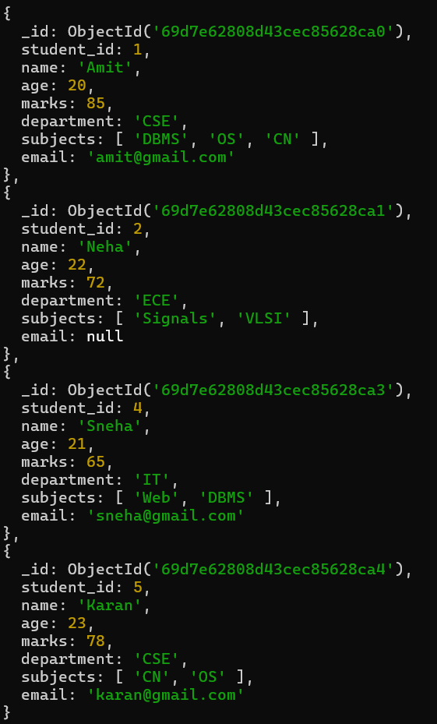
Q.16 Find students who do not have an email field.
Query :- db.students.find({email:{$exists:false}})
Output :-
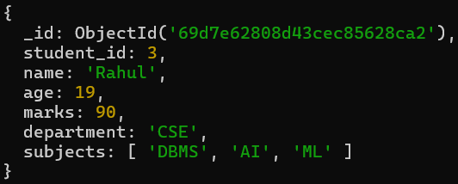

Q.17 Find students whose email value is null.
Query :- db.students.find({email:{$type:10}})
Output :-
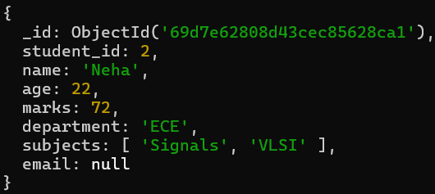

Q.18 Find students whose marks field is of type integer.
Query :- db.students.find({marks:{$type:"int"}})
Output :-
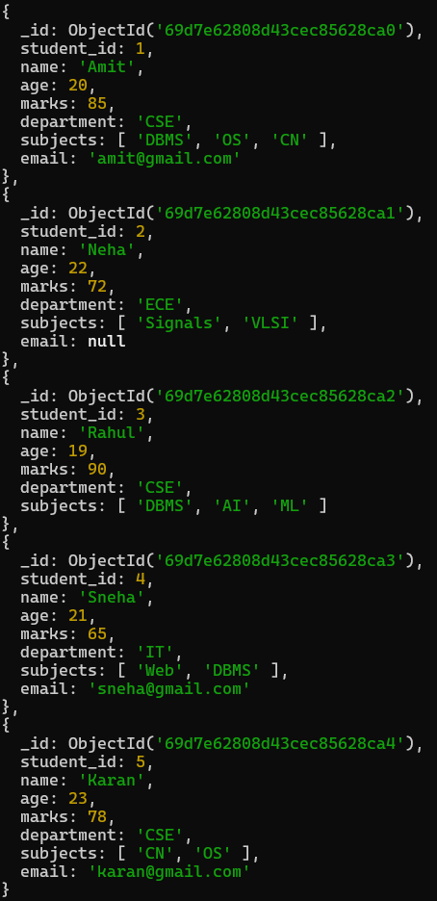

Q.19 Find students who have subjects’ field.
Query :- db.students.find({subjects:{$exists:true}})
Output :-
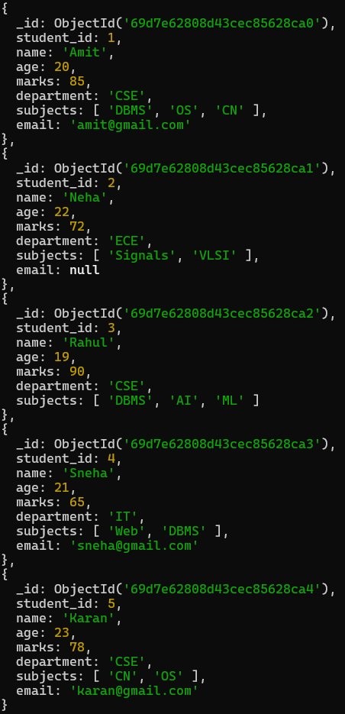
Q.20 Find students whose age field is missing.
Query :- db.students.find({age:{$exists:false}})

Q.21 Find students where marks modulo 5 equals 0.
Query :- db.students.find({marks:{$mod:[5,0]}})
Output :-
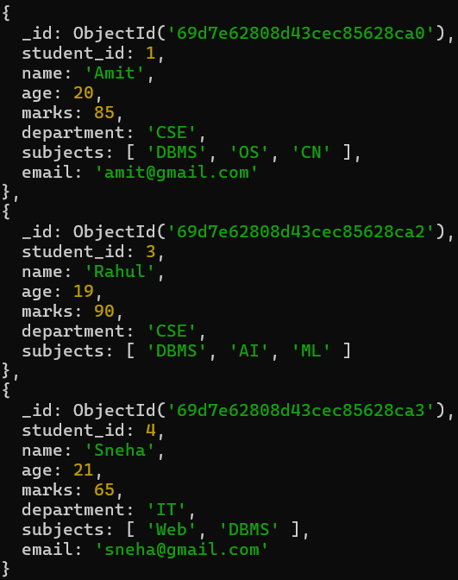
Q.22 Find students whose name starts with letter “A”.
Query :- db.students.find({name:{$regex:"A"}})
Output :-
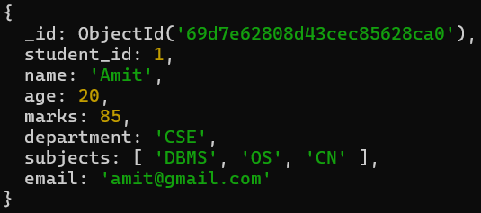

Q.23 Find students whose email ends with gmail.com.
Query :- db.students.find({email:{$regex:"gmail.com$"}})
Output :-
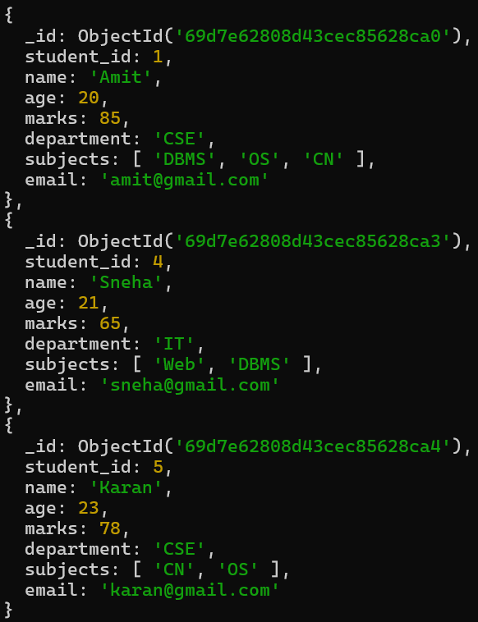
Q.24 Find students who have more than 2 subjects.
Query :- db.students.find({"subjects.2":{$exists:true}})
Output :-
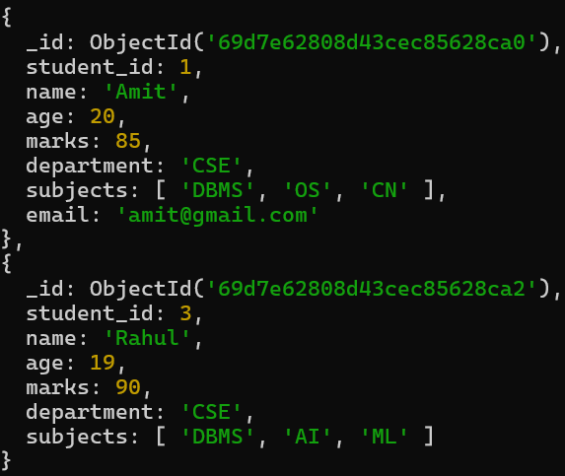

Q.25 Find students whose marks are greater than their age × 3.
Query :- db.students.find({$expr:{$gt:["$marks",{$multiply:["$age",3]}]}})
Output :-
