ASSIGNMENT_D

Query :- use companyDB
Query :- db.createCollection("employees")
Query :- db.employees.insertMany([
{emp_id:101,name:"Amit",department:"IT",skills:["Python","MongoDB","Docker"],projects:[{name:"HRMS",duration:6,technologies:["Python","MongoBD"]},{name:"Ecommerce",duration:8,technologies:["NodeJS","MongoDB"]}],salaries:[45000,48000,52000],certifications:["AWS","Azure"]},
{emp_id:102,name:"Neha",department:"HR",skills:["Communication","Recruitment"],projects:[{name:"HiringPortal",duration:4,technologies:["PHP","MySQL"]}],salaries:[35000,38000],certifications:["SHRM"]},
{emp_id:103,name:"Ravi",department:"Finance",skills:["Excel","Tally","SQL"],projects:[{name:"Accounting",duration:10,technologies:["SQL","PowerBI"]}],salaries:[40000,42000,46000],certifications:["CPA","CFA"]},
{emp_id:104,name:"Pooja",department:"IT",skills:["Java","Spring","MongoDB"],projects:[{name:"BankingApp",duration:12,technologies:["Java","MongoDB"]},{name:"CRM",duration:7,technologies:["Spring","MySQL"]}],salaries:[50000,54000,60000],certifications:["Oracle","AWS"]}])

Check Output :- db.employees.find()

Output :-
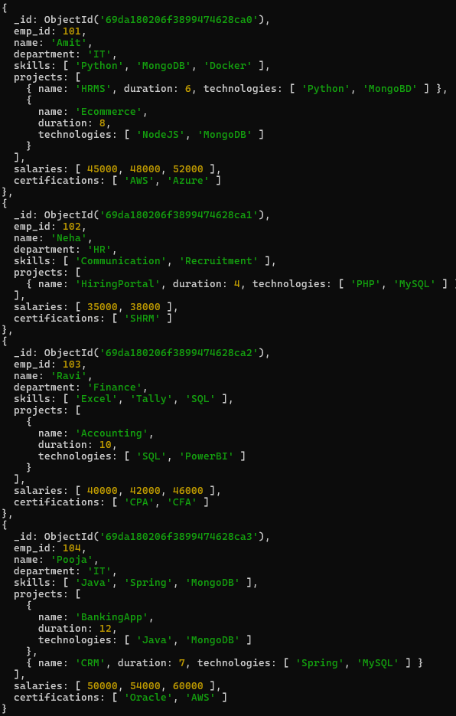

Q.1 Display all employees who have MongoDB skill
Query :- db.employees.find({skills:"MongoDB"})

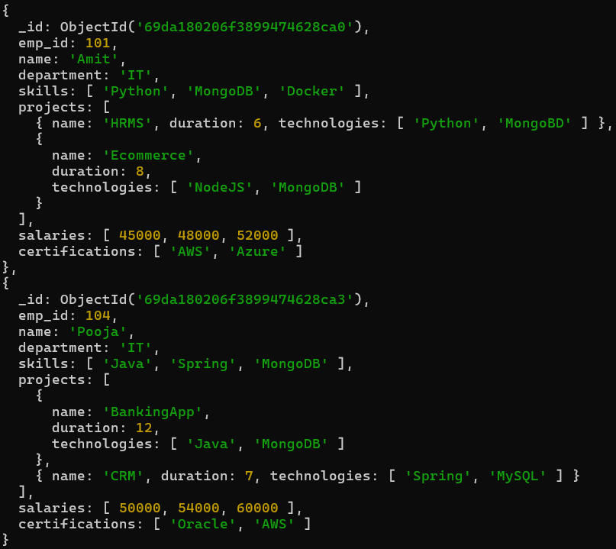

Q.2 Find employees having both Python and MongoDB skills
Query :- db.employees.find({$and:[{skills:"Python"},{skills:"MongoDB"}]})
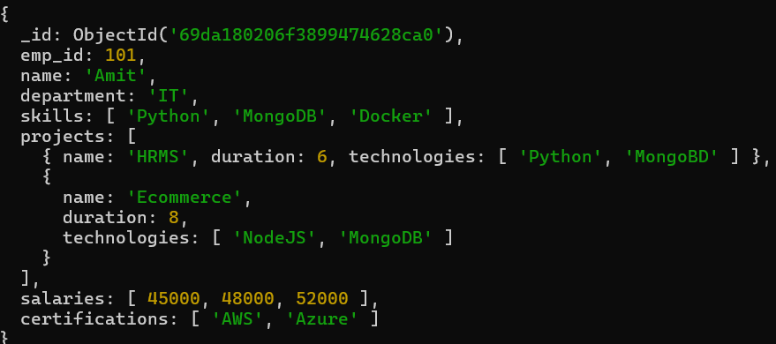
Q.3 Display employees with more than 2 skills
Query :- db.employees.find({"skills.2":{$exists:true}})
Output :-
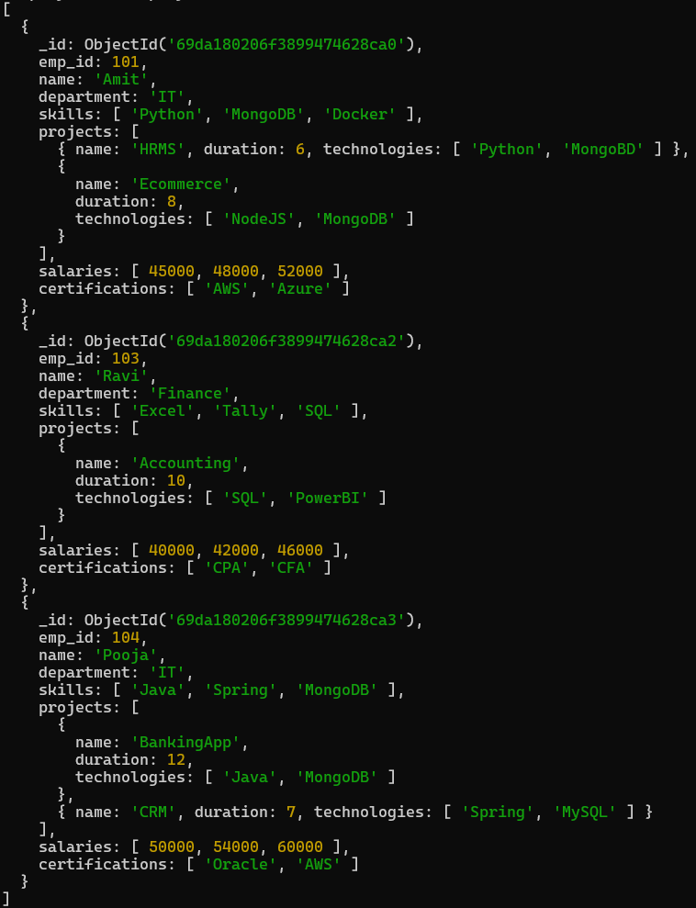

Q.4 Add a new skill "Kubernetes" to Amit
Query : - db.employees.updateOne({name:"Amit"},{$push:{skills:"Kubernetes"}})
Check Output : - db.employees.find()
Output : -
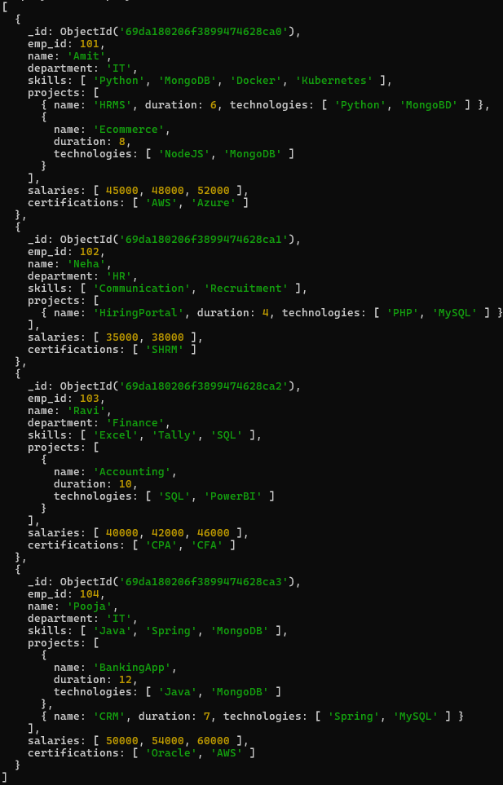
Q.5 Add multiple skills to Pooja
Query :- db.employees.updateOne({name:"Pooja"},{$push:{skills:{$each:["DSA","Excel","Machine Learning"]}}})
Check Output : - db.employees.find()
Output :-
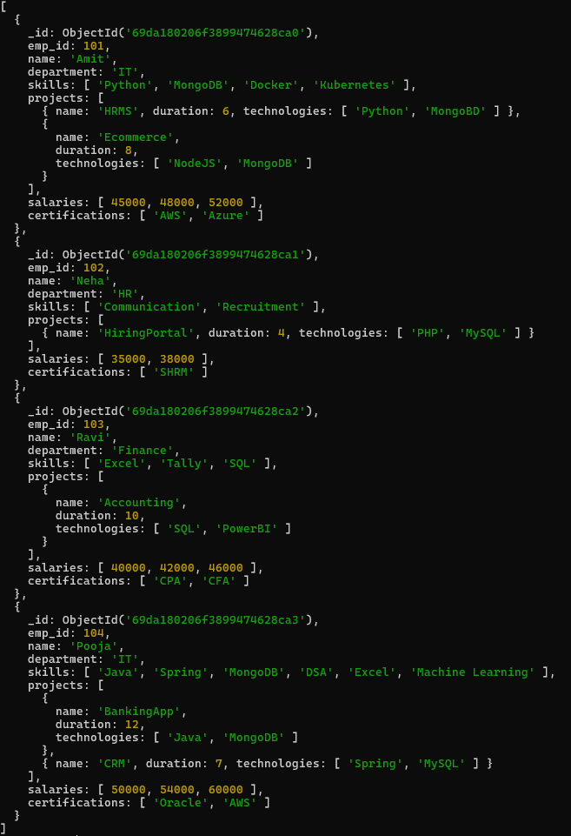
Q.6 Add a certification only if not already present
Query :- db.employees.updateMany({},{$addToSet:{certifications:"HCL"}})
Check Output :- db.employees.find()
Output :-
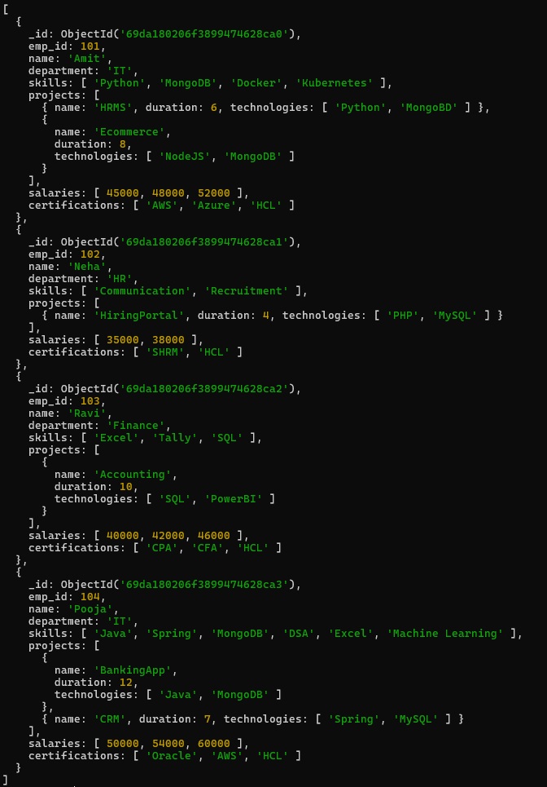
Q.7 Remove "Docker" skill from Amit
Query : - db.employees.updateOne({name:"Amit"},{$pull:{skills:"Docker"}})
Check Output : - db.employees.find()
Output :-
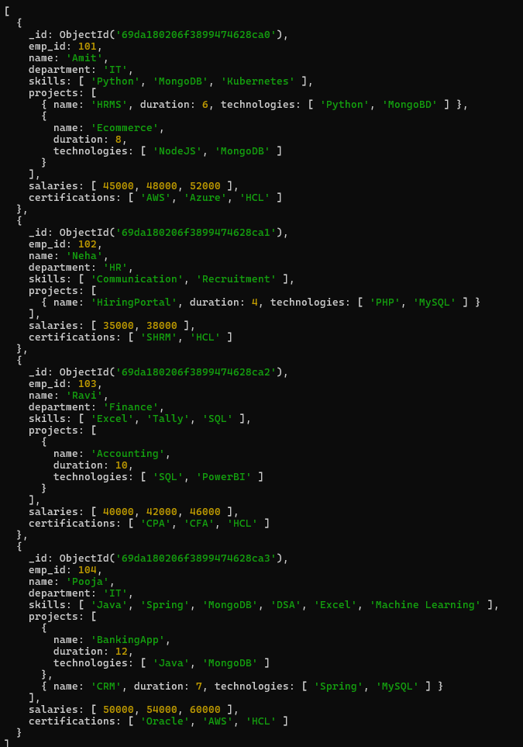
Q.8 Remove multiple salaries less than 45000
Query :- db.employees.updateMany({},{$pull:{salaries:{$lt:45000}}})
Check Output :- db.employees.find()
Output :-
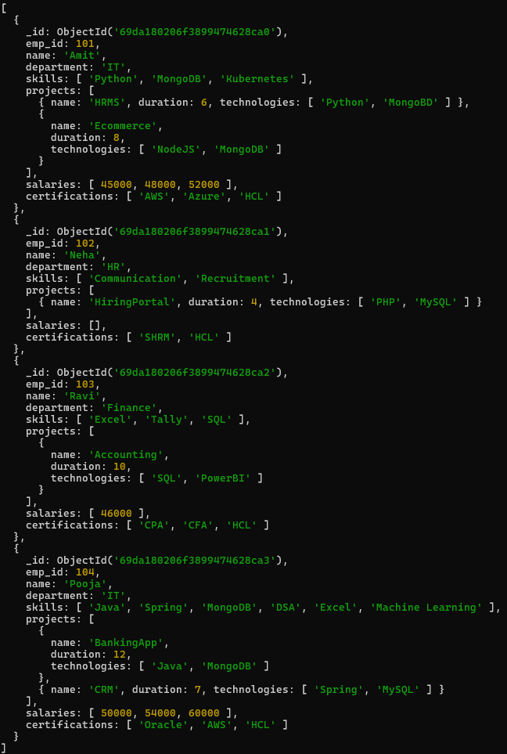
Q.9 Find employees who worked on MongoDB projects.
Query :- db.employees.find({projects:{$elemMatch:{technologies:"MongoDB"}}})
Output :- 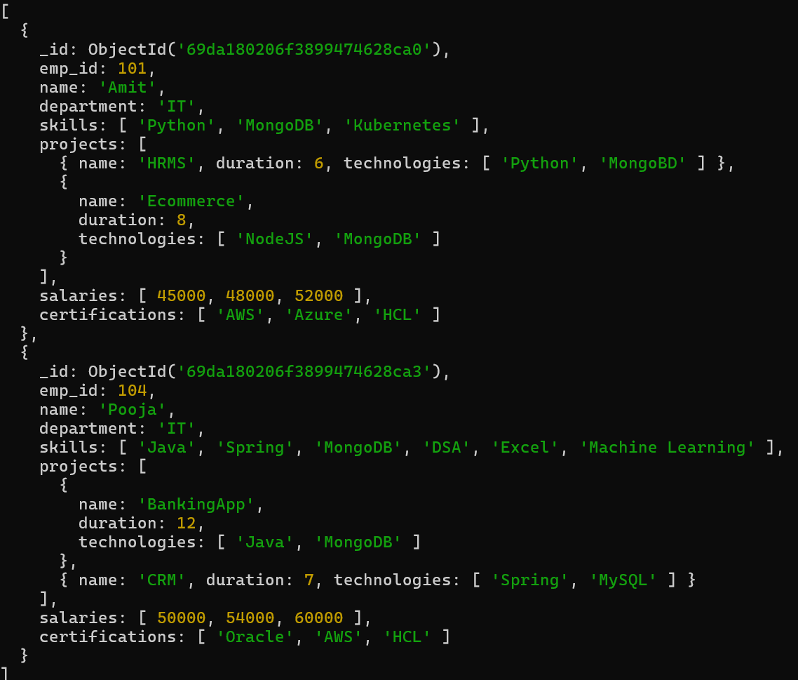

Q.10 Use $elemMatch to find project duration > 6 using MongoDB
Query :- db.employees.find({projects:{$elemMatch:{technologies:"MongoDB",duration:{$gt:6}}}})
Output :-
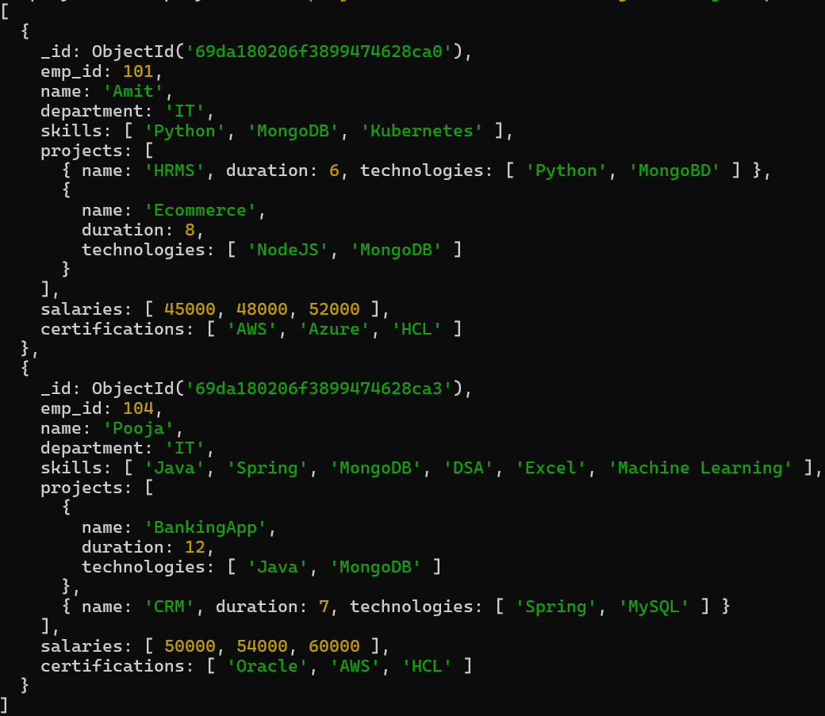

Q. 11 Count number of projects for each employee.
Query :- db.employees.aggregate({$project:{_id:0,name:1,totalProject:{$size:"$projects"}}})
Output :-
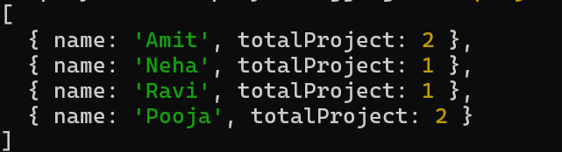

Q.12 Unwind skills array
Query :- db.employees.aggregate([{$unwind:"$skills"}])
Output :-
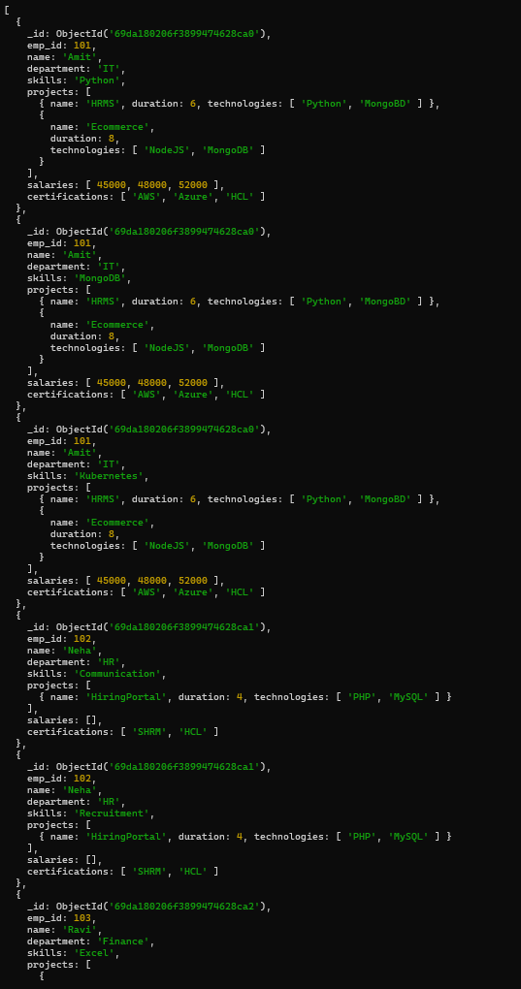

Q.13 List unique skills across company.
Query :- db.employees.distinct("skills")
Output :-
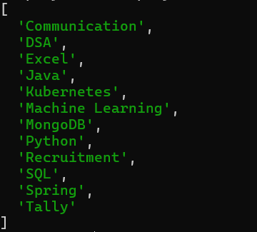

Q.14 Find employees with salary greater than 50000.
Query :- db.employees.find({salaries:{$gt:50000}})
Output :-
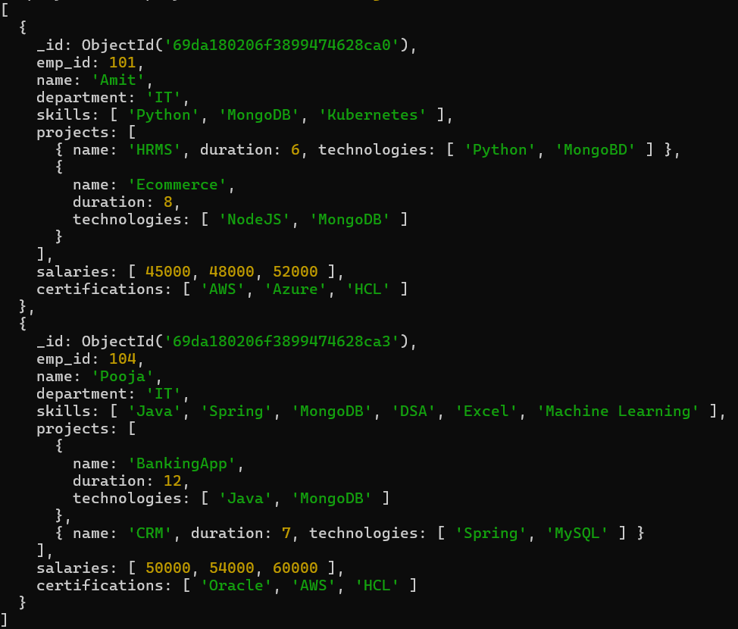
Q.15 Find employees with exactly 2 certifications.
Query :- db.employees.find({certifications:{$size:2}})
Output :-
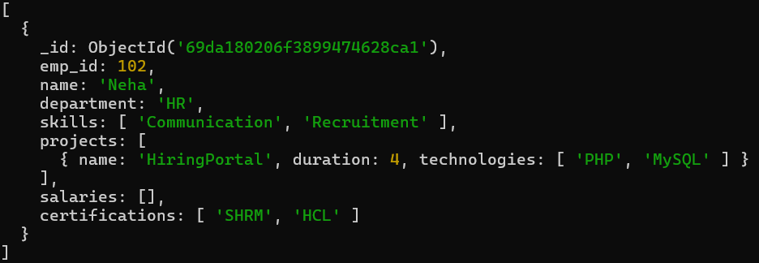

Q.16 Add new project to Ravi.
Query :- db.employees.updateOne({name:"Ravi"},{$push:{projects:{name:"System",duration:5,technologies:
["Java","Pyhton"]}}})
Check Query :- db.employees.find()
Output:-

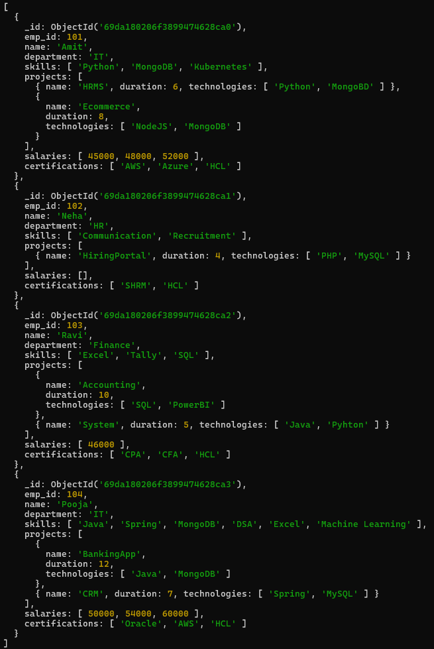

Q.17 Increase all salaries by 10% (array update)
Query :- db.employees.updateMany({},{$mul:{"salaries.$[]":1.1}})
Check Query :- db.employees.find()
Output :-
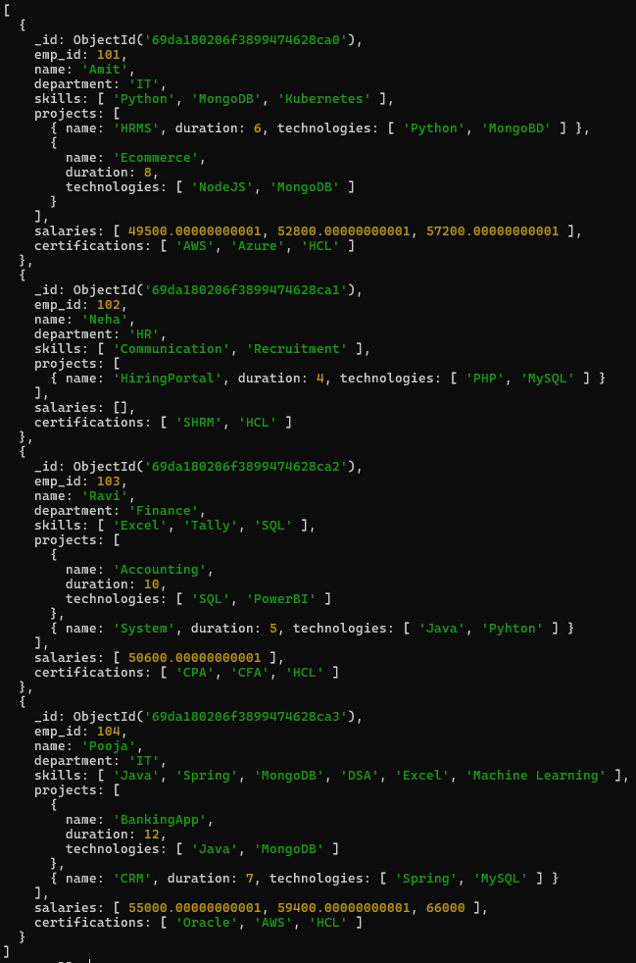
Q.18 Find highest salary of each employee
Query :- db.employees.aggregate([{$project:{_id:0,name:1,highestSalary:{$max:"$salaries"}}}])
Output :-
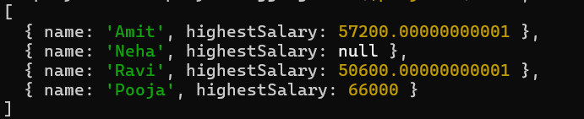
Q.19 Find average salary of employees.
Query :- db.employees.aggregate([{$project:{_id:0,name:1,avgSalary:{$avg:"$salaries"}}}])
Output :-
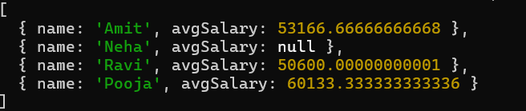

Q.20 Filter projects longer than 6 months.
Query :- db.employees.find({"projects.duration":{$gt:6}})
Output :-
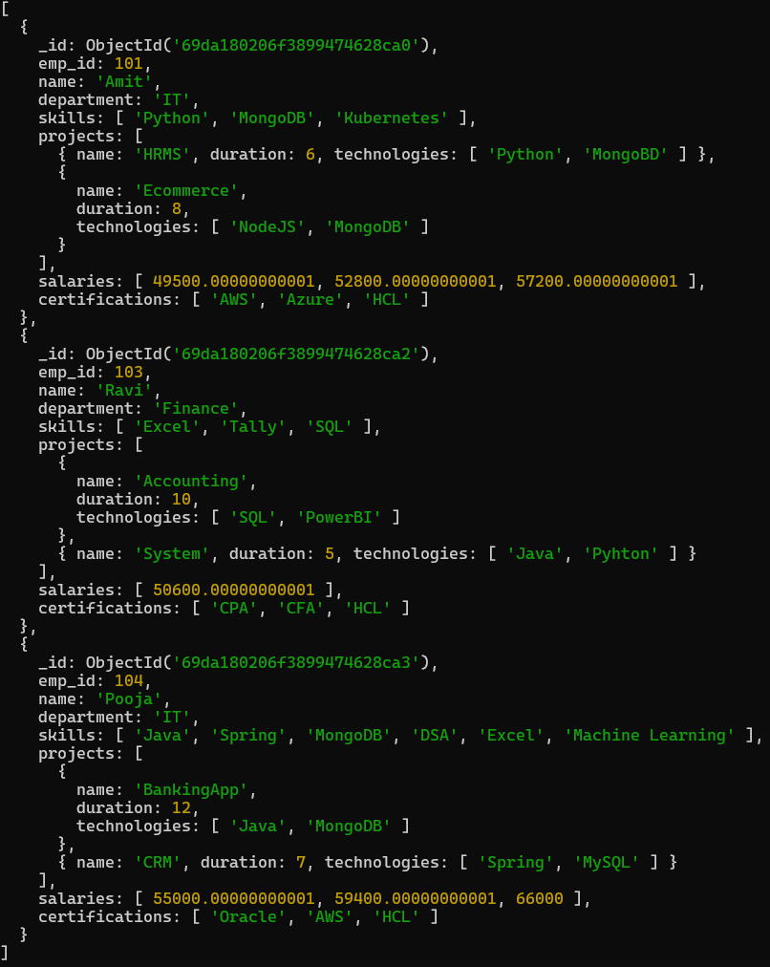
Q.21 Find employees who have any of these skills: Java or Python.
Query :- db.employees.find({$or:[{skills:{$eq:"Java"}},{skills:{$eq:"Python"}}]})
Output :- 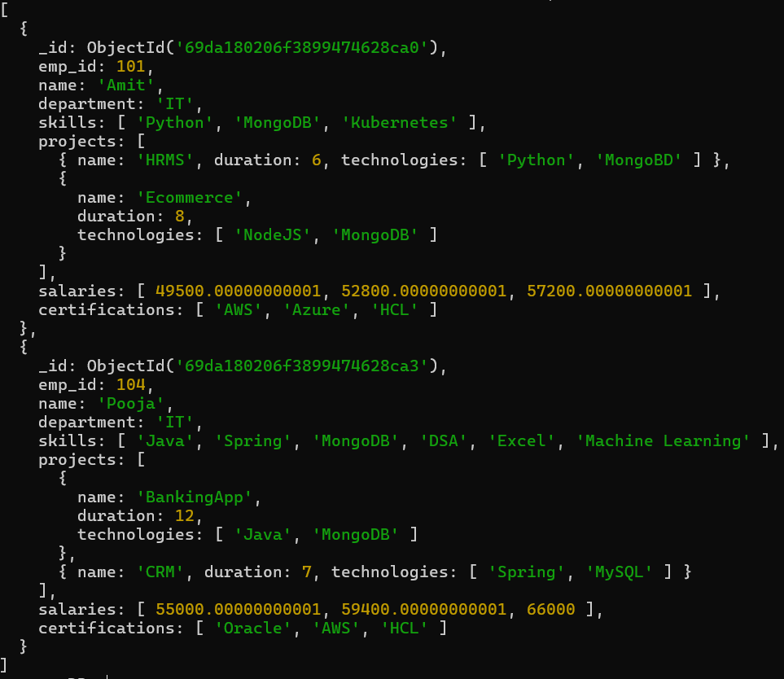

Q.22 Remove last salary entry.
Query :- db.employees.updateMany({},{$pop:{salaries:1}})
Check Query :- db.employees.find()
Output :-
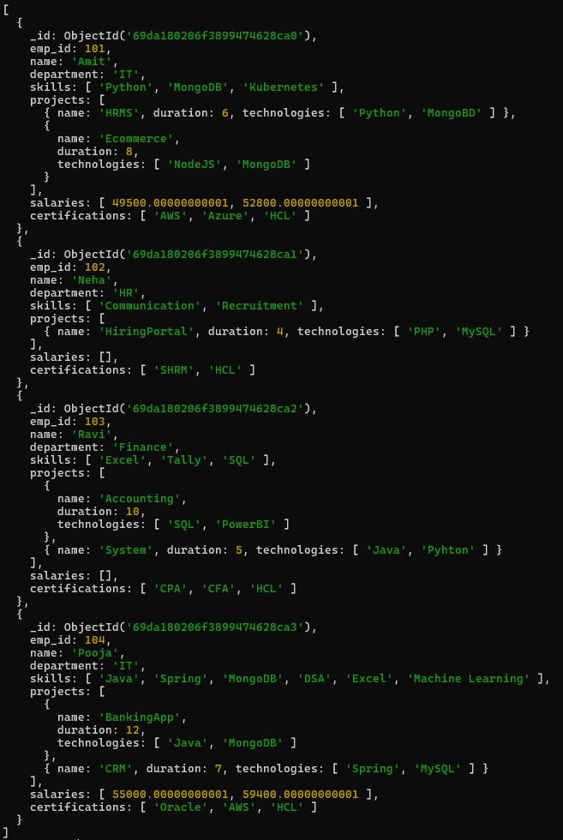

Q.23 Remove first salary entry.
Query :- db.employees.updateMany({},{$pop:{salaries:-1}})
Check Query :- db.employees.find()
Output :-
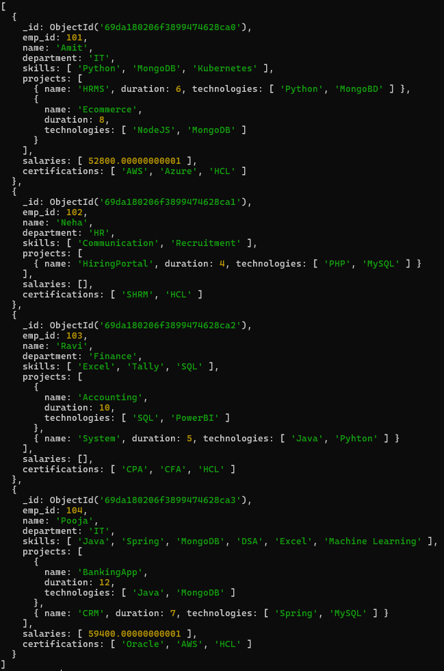

Q.24 Sort salaries array.
Query :- db.employees.updateMany({},{$push:{salaries:{$each:[], $sort:1}}})
Check Query :- db.employees.find()
Output :-
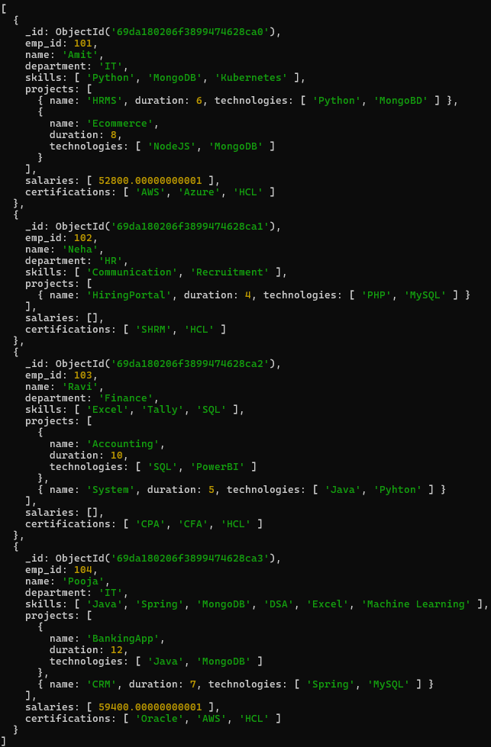

Q.25 Limit salaries array to last 2 entries.
Query :- db.employees.updateMany({},{$set:{salaries:{$slice:["$salaries",-2]}}})
Check Query :- db.employees.find()
Output :-
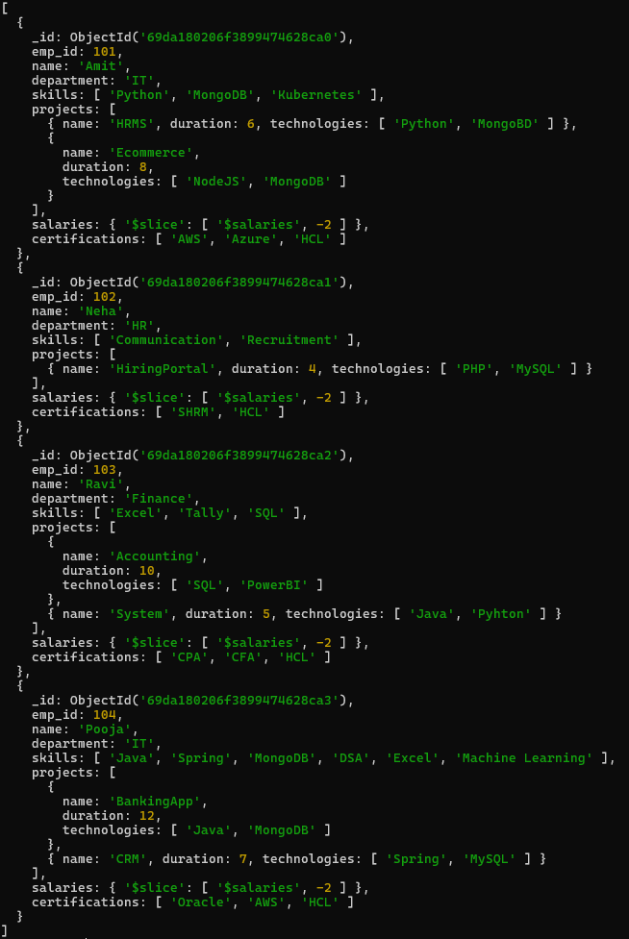

Q.26 Find total salary paid to each employee.
Query :- db.employees.aggregate({$project:{_id:0,name:1,totalSalaryPaid:{$sum:"$salaries"}}})
Output :-
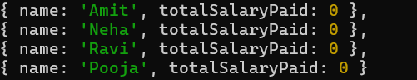
Q.27 Convert skills to uppercase.
Query :- db.employees.aggregate([{$project:{name:1,_id:0,skills:{$map:{input:"$skills",as:"s",in:{$toUpper:"$$s"}}}}}])
Output :- 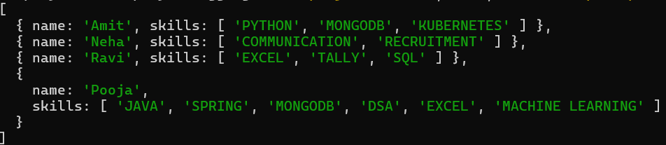

Q.28 Find employees with more than one project.
Query :- db.employees.find({"projects.1":{$exists:true}})
Output :- 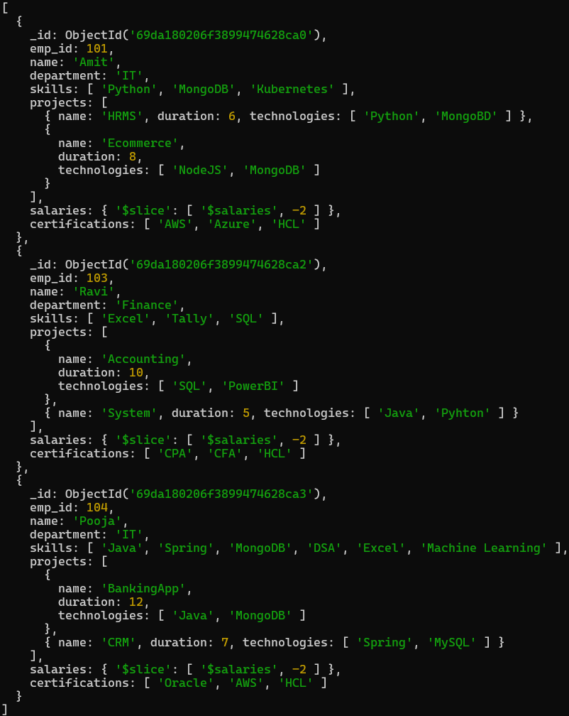
Q.29 Count employees per skill.
Query :- db.employees.aggregate([{$unwind:"$skills"},{$group:{_id:"$skills",count:{$sum:1}}}])
Query :-
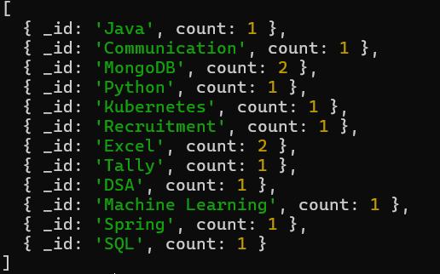

Q.30 Find employees whose all projects use MongoDB.
Query :- db.employees.find({"projects.technologies":"MongoDB"})
Output :- 