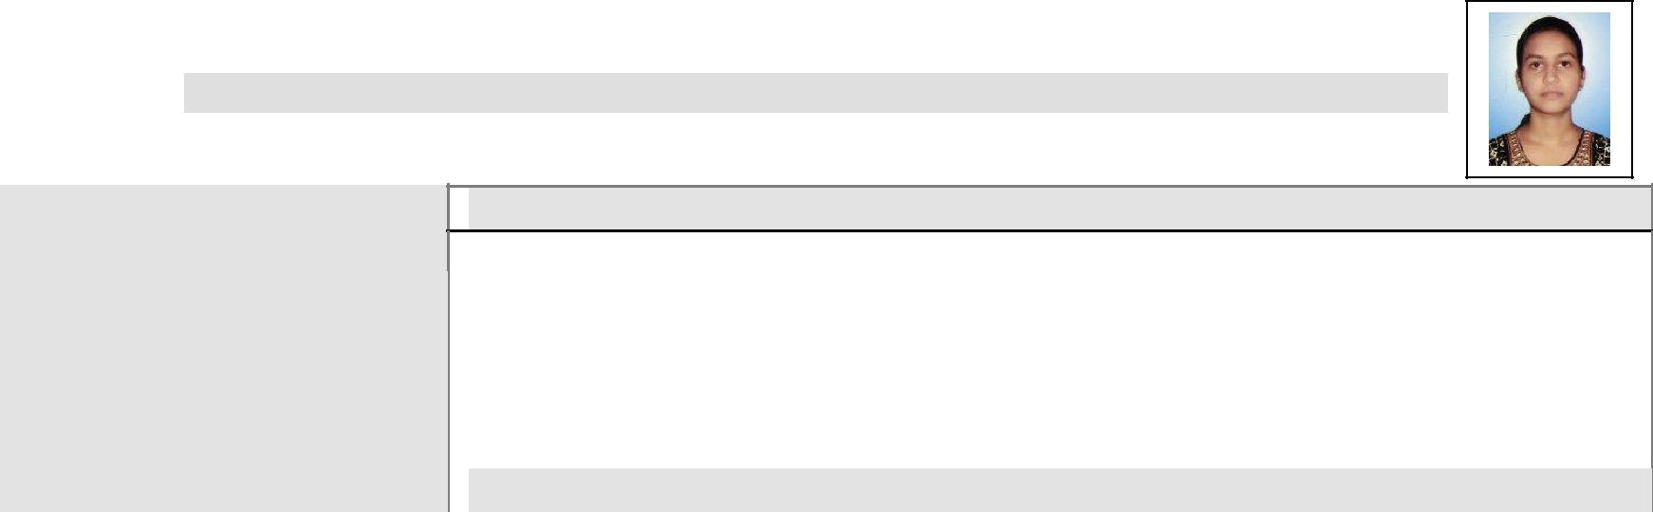 |  |  |  |  |  |  | CURRICULUM VITAE
 |  |  | OBJECTIVE
Deeksha Goel |  |  |  | • To achieve an excellence in my work & as well as at my workplace by my
M. TECH (Remote Sensing)
M. TECH (Remote Sensing) |  |  |  |  | hard work & dedication.
 |  |  |  | • To work in challenging situations and to take on them.
 |  |  |  | • To |  |  | learn continuously from the surroundings and apply my knowledge
ADDRESS- |  |  |  |  | whenever possible.
B1101 Angle Jupiter |  |  | EDUCATIONAL QUALIFICATION
Indirapuram, Ghaziabad (U.P.)-
201014
201014 |  |  |  | S.NO |  |  | Qualification/ | Year of | Specialization | Board/ | Division/
Mobile-+919457970845, |  |  |  |  |  |  | Degree | passing |  | University | Percentag
 |  |  |  | 1. |  |  | M.TECH | 2014 | Remote | Banasthali | ^{1st} (75.4%)
 |  |  |  |  |  |  |  |  | Sensing | University
 |  |  |  | 2. |  |  | B.TECH | 2012 | Electronics & | UPTU | 1 ^{st} (72%)
 |  |  |  |  |  |  |  |  | Communicatio
E-MAIL: |  |  |  |  |  |  |  |  | n Engineering
goel.deeksha249@gmail.com |  |  |  | 3. |  |  | 12th | 2008 | Science Stream | U.P. Board | 1 ^{st} (65.2%)
 |  |  |  | 4. |  |  | 10th | 2006 | Science Stream | U.P. Board | 1st (60.2%)


KEY SKILLS

Programming Language : C,C++,Core JAVA,VB.Net

Software : Erdas Imagine, ArcGIS, eCognition, ENVI, QGIS, SAGA, AutoCad

 | PROFESSIONAL TRAINING/ SEMINAR
 | • | 10 Month (July2013-April2014) Project Trainee at National Remote
 |  | Sensing Centre- Indian Space Research Organization, Hyderabad.
 | • | Off-campus outreach certification program on “Geoweb Services-
 |  | Technology and Applications” satellite based training for universities
 |  | sponsored by National Natural Resources Management System (NNRMS)-
 |  | IIRS-ISRO Dehradun from 11-02-2013 to 15-03-2013.
 | • Off-campus outreach certification |  | program | on “Remote Sensing,
 |  | Geographical Information System and Global positioning System”
 |  | satellite based training for universities sponsored by National Natural
 |  | Resources Management System (NNRMS)-IIRS-ISRO Dehradun from 06-
 |  | 08-2012 to 22-10-2012.
 | • | 1 Month (May-June2011) training at | Bharat | Electronics Limited,
- Kotdwara, Uttarakhand.

PERSONAL DATA

Husband’s Name: Mr. Arpit Garg

Date of Birth: 22/06/1992

Sex | : Female
Nationality | : Indian
Marital Status | : Married
Languages Known: English,
Hindi.

PROJECT WORK

M.Tech Project Details:

Project Title: Characterization of Fire Disturbance- Essential Climate Variables (ECVs) for selected Bio geographic zones using Remote Sensing and GIS.

Project Description: Characterization of Fire Disturbance- Essential Climate Variables includes primary variable (burnt area assessment) and supplementary variable (active fires and fire intensity).

Duration: 10 Month.

Organization & Guide: National Remote Sensing Centre- ISRO, Hyderabad under Dr.T.R.Kiran Chand, Scientist SD, Forestry and Ecology Group.

B.Tech Project Details:

Project Title: Password Secured GSM Jammer.

Project Description: The aim of the project is that to stop disrupting ringing is to install a device in such places which will inhibit the use of mobiles, i.e., make them obsolete.
Duration: 10 Month.

Organization & Guide: Veera College of Engineering, Bijnor under Mr.Bhupendra Singh, H.O.D., Dept. of Electronics & Communication Engineering.

PAPER PRESENTED

  - Goel, Deeksha; Pandey, Neha; Gupta Sejal (2015).”Proprietary and Open Source Geospatial Software”, Proceeding of National Conference on Open
Source GIS, at IIT-BHU, Varanasi. Oct 2015, ISBN: 978-81-931-2500-7.

  - Goel, Deeksha (2013). “Estimation of Watershed Parameters using GIS & Remote Sensing Techniques for Pulicat Lake”, National Conference on
Water resources Management, Hyderabad during 29-30 Nov 2013 by
- University of Hyderabad & Andhra Pradesh Geographical Society.

  - Goel, Deeksha (2013). “Proprietary and Open Source Geospatial Software”, National Conference of Strategies and Trends of Open Source
Software, Jodhpur during 22-23 March 2013.

EXTRACURRICULAR ACTIVITIES

  - Attended Users Interaction Meet 2014 at National Remote Sensing
- Centre-Indian Space Research Organization, Hyderabad.

  - Sub-coordinator of tech event in MAYUKH-2013 (tech-fest) of
- Banasthali University.

  - Participated in Hindi Vikas Sansthan Saharanpur Hindi Subod Pariksha with 2nd position in 2005 and 3rd position in 2007.

- • Participated in Uttar Pradesh Bharat Scouts Avam Guides Pratham Sopan.

  - Participated in Rashtriya Shaikshik Mahasangh Uttar Pradesh with 75%



Company- ABGISTech Pvt.Ltd.
Post- Sr. GIS Engineer
Duration- September 2015-Oct2016
Software Architecture- Erdas Imagine13, ArcGIS10.1, AutoCad

Organization- Birla Institute of Scientific Research, Jaipur.

Project Title- Space based Information Support for De-Centralized Planning. Post- Junior Research Fellow

Duration- August 2014- September 2015
Software Architecture- Erdas Imagine13, ArcGIS10.1, SAGA



Organization- National Remote Sensing Center - ISRO, Balanagar, Hyderabad Project Title- Characterization of Fire Disturbance- Essential Climate Variables (ECVs) for selected Bio geographic zones using Remote Sensing and GIS.

Post- Project Trainee
Duration- July 2013- April 2014
Software Architecture- Erdas Imagine13, ArcGIS10.1, eCognition, ENVI

DECLARATION
The information stated above is true to the best of my knowledge.

Date- 24-10-2019 Deeksha Goel

